Python for Data Science – Data speaks, Python listens!
by DataFlair Team · Updated ·
As you must know by now, it is a great choice to do data analysis using Python. This is why data scientists prefer Python.
Out there, there’s a battle taking place in minds of future Data scientists for choosing the best tools. Though there are quite a number of tools with many options, the close combat narrows down between two popular languages – Python and R.

Why Python over R for Data Science?
One of the push of choosing Python over R is from the variety of data science/data analytics libraries made available. Some of the libraries well known in the data science community – Pandas, StatsModels, NumPy, SciPy, and Scikit-Learn. It doesn’t stop there, some 72,000 of them in the Python Package Index (PyPI) and still growing constantly. After all these, I recommend you to check the difference between Python and R for better understanding
So, before we start our topic I recommend you to take a brief of what data science is?

What is Data Science?
Data science, aka data-driven science, is an interdisciplinary field of scientific methods, processes, and systems. It is used to extract knowledge or insights from data in various forms, either structured or unstructured. In this way, it is similar to data mining. With data at its heart, it employs a wide range of techniques on the data to extract essential insights from it.

Data science attracting beginners towards Python. How?
For this reason and others, Python is the most demanding for programmers. Data scientists coming from engineering or scientific backgrounds might feel a bit out of place the first time they try to use it for data analysis but when they do use it, they make most out of it. Python didn’t make its inroads to data science initially when it was conceived in the late 1980s. Tools for covering every aspect of scientific computing are now readily available in Python.
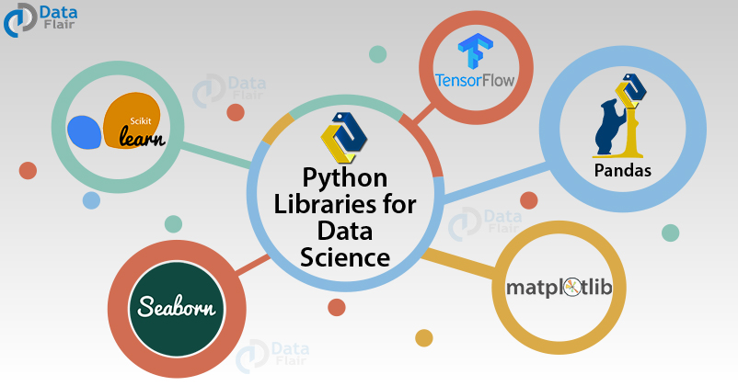
Python’s readability and simplicity make it comparatively easy to pick up. The number of dedicated and analytical libraries freely available for download today mean that data scientists present in every sector will find packages already tailored to their needs. As a jack of all trades, Python is not specialized to do statistical analysis, but in many cases, organizations already have heavily invested in extending it to that purpose as they saw advantages of standardizing on it. In short, we can say, Python has become the go-to language for data scientists. And you must start learning Python now! Our DataFlair team has designed a perfect self-paced course of Python for Data Science and the passionate learners like you. Get the course now and move a step ahead in the data science field.

Essential Python Libraries for Data Scientists
Data science has the early benefits of these extensions and libraries!

1. Python Pandas

Now the big daddy to all of them is Python Pandas. From importing data from spreadsheets to processing sets for time-series analysis, Pandas is used for everything. Pandas pretty much convert one data form to another on your fingertips. Hence, Pandas powerful data frames can perform both, basic cleanup and advance data manipulations.
“One of the reasons we like to use Pandas is because we like to stay in the Python ecosystem,” Burc Arpat, a quantitative engineering manager at Facebook.
Behind Python’s data science success story, one of the earliest libraries is Numpy (Numerical Python), on which Pandas is built. NumPy’s functions exposure is used in Pandas for advanced analysis. For more specialization, one can use Scipy which is scientifically equivalent to Numpy, offering tools and techniques for scientific data analysis.

a. NumPy
NumPy facilitates easy and efficient numeric computation. It has many other libraries built on top of it. Make sure to learn NumPy arrays.

b. SciPy
SciPy will give you all the tools you need for scientific and technical computing. It has modules for optimization, linear algebra, integration, interpolation, special functions, FFT, signal and image processing, ODE solvers, and other tasks.

2. Matplotlib
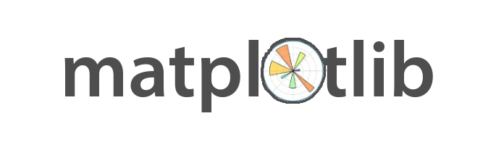
Python also provides powerful visualization libraries – Matplotlib. It can be used in all kinds of GUI toolkits such as python scripts, web applications as well as shell, etc. With this, you have the opportunity to use different types of plots and work with multiple plots.

3. Scikit – Learn & Pybrain
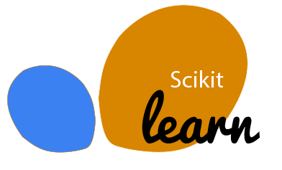
Scikit – Learn & Pybrain, one of the attractions of python where you implement machine learning. With the support of simple and efficient tools in this library which can be used for data analysis and data mining. Various algorithms have their back, like — logistic regression, time series, etc.

4. TensorFlow
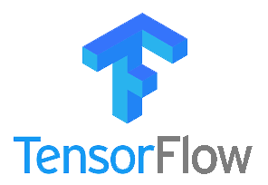
TensorFlow is the most popular tool for Machine Learning in Python. It was developed specifically for carrying out deep learning operations. The basic data structure of TensorFlow ecosystem are the tensors. As a matter of fact, the name of TensorFlow is derived from these tensors. TensorFlow is continuously evolving owing to an open-source community who have made it a pioneering toolkit for machine learning operations. It provides support for CPUs, GPUs as well as TPUs. Due to this, it provides lightning speed execution speed for various machine learning algorithms.
TensorFlow has numerous applications. This is mainly because of its high processing capability. It is used for the development of speech recognition product, recommendation systems, Generative Adversarial Networks, etc. TensorFlow is basically the standardized tool for performing Deep Learning operations.

5. Seaborn

Welcoming the next important library of Python for Data Science – Seaborn! So whatever and whenever you will be using Python for data science, the first thing that will click to and should click will be using matplotlib (for 2D visualization) & seaborn. They have many high-level interfaces and styles in default for drawing statistical graphics.
Python is an obvious language choice for Data Science. These above-stated libraries and other specialized one’s aid everything in python, from machine learning to neural networks to data processing. Hence this flexibility has become the main benefit of choosing python at every step of the way towards data science.


Python’s large community is taking Data Science to the top!
Another plus point to above all the extensions/ libraries and properties of python that contribute to “python being the choice” is the large community of data scientist, machine learning experts, and programmers who are not only working their heart out to make it easy to learn python but also provide datasets to test one’s mastery and skillset in python. So, whether you are a social scientist needing python for advanced data analysis or a growing developer who needs inspiration, one of the parts of this python community will be ready to help you!

Blog Home
- Courses
- Data Science
- Big Data
- Categories
- Interview Questions
- Job Portal
- Write For Us
Blog Home » Python Tutorials » Data Science Tutorial – Introduction to Data Science for Python
- 15

Data Science Tutorial – Introduction to Data Science for Python
by DataFlair Team · Updated ·

1. Data Science Tutorial – Objective
This Data Science tutorial aims to guide you to the world of data science and get you started with the basics like what is Data Science, History of Data Science, and Data Science Methodologies. Here, we will cover the Data Science Applications, a difference between Business Intelligence and Data Science. Along with this, we will discuss Life-Cycle of Data Science and Python Libraries.
So, let’s begin Data Science Tutorial.
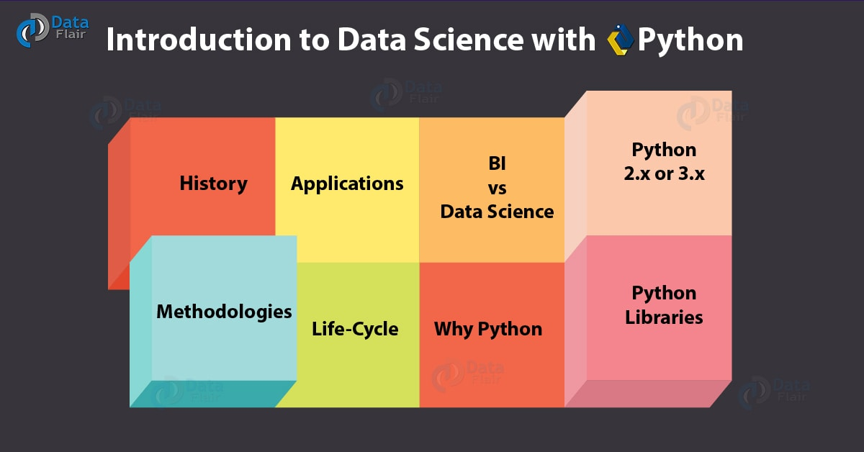
Data Science Tutorial – Introduction to Data Science with Python

2. What is Data Science?
Before we start the Data Science Tutorial, we should find out what data science really is.
Data science is a way to try and discover hidden patterns in raw data. To achieve this goal, it makes use of several algorithms, machine learning(ML) principles, and scientific methods. The insights it retrieves from data lie in forms structured and unstructured. So in a way, this is like data mining. Data science encompasses all- data analysis, statistics, and machine learning. With more practices being labelled into data science, the term itself becomes diluted beyond usefulness. This leads to variation in curricula for introductory data science courses worldwide.
Do you know the Best Data Scientist Certifications to Choose from

3. Data Science Tutorial – History
Through the recent hype that data science has picked up, we observe that it has been around for over thirty years. What one we could use as a synonym for practices like business analytics, business intelligence, or predictive modeling, now refers to a broad sense of dealing with data to find a relationship within it. To quote a timeline, it would go something like this:

a. In 90’s
- 1960- Peter Naur uses the term as a substitute for computer science.
- 1974- Peter Naur publishes Concise Survey of Computer Methods, uses a term in a survey of contemporary data processing methods.
- 1996- Biennial conference in Kobe; members of the IFCS (International Federation of Classification Societies include the term in the conference title.
- 1997- November- Professor C.F. Jeff Wu delivers inaugural lecture on the topic “Statistics=Data Science?”.

b. In 2000’s
- 2001- William S. Cleveland introduces data science as an independent discipline in article Data Science: An Action Plan for Expanding the Technical Areas of the Field of Statistics.
- 2002- April- The ICSU (International Council for Science): Committee on Data for Science and Technology (CODATA) starts Data Science Journal- this publication is to focus on issues pertaining to data systems- description, publication, application, and also legal issues.
- 2003- January- Columbia University publishes journal The Journal of Data Science- a platform that allows data workers to exchange ideas.
- 2005- National Science Board publishes Long-lived Digital Data Collections: Enabling Research and Education in the 21st Century- this provides a new definition to the term “data scientists”.
- 2007- Jim Gray, Turing awardee, envisions data-driven science as the fourth paradigm of science.
- 2012- Harvard Business Review article attributes coinage of the term to DJ Patil and Jeff Hammerbacher in 2008.
- 2013- IEEE launches a task force on Data Science and Advanced Analytics; first European Conference on Data Analysis (ECDA)organized in Luxembourg, European Association for Data Science (EuADS) comes into existence.
- 2014- IEEE launches first international conference International Conference on Data Science and Advanced Analytics; General Assembly launches student-paid Bootcamp, The Data Incubator launches data science fellowship for free.
- 2015- Springer launches International Journal on Data Science and Analytics.

4. Data Science Tutorial – Methodologies
In this Data Science Tutorial, we will cover the following Methodologies in data Science:
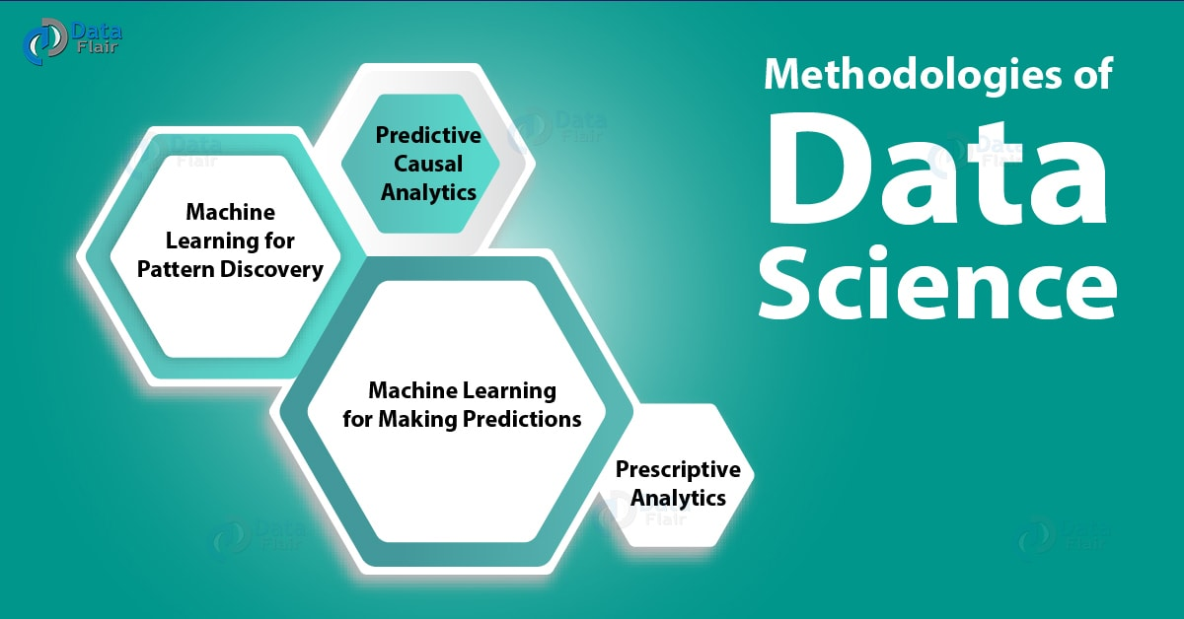
Data Science Tutorial – Methodologies of Data Science

a. Machine Learning for Pattern Discovery
With this, clustering comes into play. This is an algorithm to use to discover patterns; an unsupervised model. When you don’t have parameters on which to make predictions, clustering will let you find hidden patterns within a dataset.
One such use-case is to use clustering in a telephone company to determine tower locations for optimum signal strength.

b. Machine Learning for Making Predictions
When we have the data we need to train our machine, we can use supervised learning to deal with transactional data. Making use of machine learning algorithms, we can build a model and determine what trends the future will observe.

c. Predictive Causal Analytics
Causal analytics lets us make predictions based on a cause. This will tell us how probable an event is to hold occurrence in future. One use-case will be to perform such analytics on payment histories of customers in a bank. This tells us how likely customers are to reimburse loans.

d. Prescriptive Analytics
Predictive analysis will prescribe your actions and the outcomes associated with those. This intelligence lets it take decisions and modify those using dynamic parameters. For a use-case, let us suggest the self-driving car by Google. With the algorithms in place, it can decide when to speed up or slow down, when to turn, and which road to take.
Have a look at – 30 Most Popular Data Science Interview Questions

5. Data Science Applications
Let’s see some applications in this Data Science Tutorial:
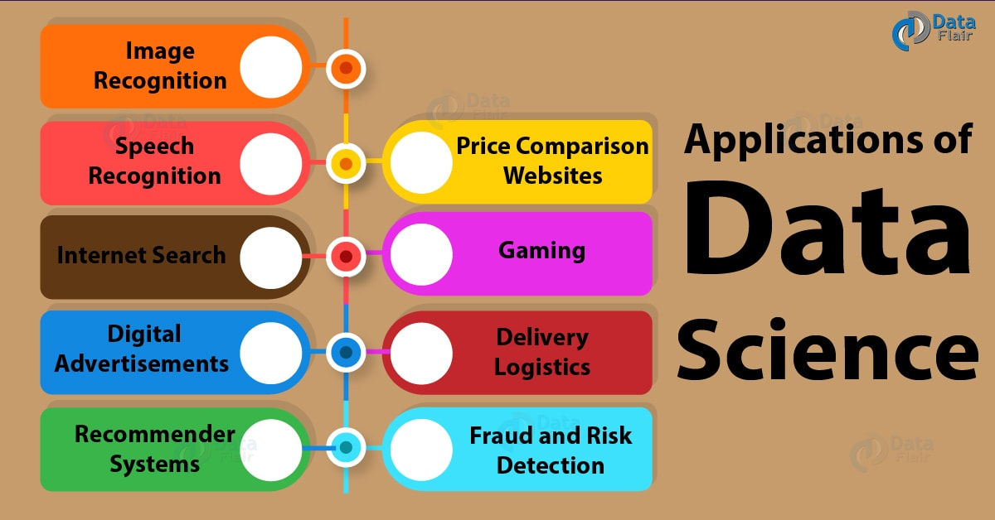
Data Science Tutorial – Data Science Applications

a. Image Recognition
Using the face recognition algorithm of data science, we can get a lot done. Did Facebook ever suggest people tag in your pictures? Have you tried the search-by-image feature from Google? Do you remember scanning a barcode to log in to WhatsApp Web using your smartphone?

b. Speech Recognition
Siri, Alexa, Cortana, Google Voice all make use of speech recognition to understand your commands. Attributing to issues like different accents and ambient noise, this isn’t always completely accurate, though intelligible most of the time. This facilitates luxury like speaking the content of a text to send, using your virtual assistant to set an alarm, or even use it to play music, inquire about the weather, or make a call.

c. Internet Search
Search engines like Google, Duckduckgo, Yahoo, and Bing make good use of data science to make fast, real-time searching possible.

d. Digital Advertisements
Data science algorithms let us understand customer behaviour. Using this information, we can put up relevant advertisements curated for each user. This also applies to advertisements as banners on websites and digital billboards at airports.

e. Recommender Systems
Names like Amazon and Youtube will throw in suggestions about similar products aside or below as you browse through a product or a video. This enriches the UX(user experience) and helps retain customers and users. This will also take into account the user’s search history and wishlist.
Let’s explore the Future of Data Science – Data Science Career Prospects

f. Price Comparison Websites
Websites like Junglee and PriceDekho let us compare prices for the same products across different platforms. This facility lets you make sure you grab the best deal. These websites work in the domains of technology, apparel, and policy among many others, and use APIs and RSS feeds to fetch data.

g. Gaming
As a player levels up, a machine learning algorithm can improve or upgrade itself. It is also possible for the opponent to analyze the player’s moves and add an element of difficulty to the game. Companies like Sony and Nintendo make use of this.

h. Delivery Logistics
Freight giants like UPS, FedEx, and DHL use practices of data science to discover optimal routes, delivery times, and transport modes among many others. A plus with logistics is the data obtained from the GPS devices installed.

i. Fraud and Risk Detection
Practices like customer profiling and past expenditures let us analyze whether there will be a failure. This lets banks avoid debts and losses.

6. Business Intelligence vs Data Science
Here, in this part of Data Science Tutorial, we discuss Data Science Vs BI. Business intelligence and data science aren’t exactly the same thing.
- BI works on structured data; data science works on both- structured and unstructured data.
- Where BI focuses on the past and the present, data science considers the present and the future.
- The approach to BI is statistics and visualization; that to data science is statistics, machine learning, graph analysis, and NLP.
- Some tools for BI are Pentaho, Microsoft BI, and R; those for data science are RapidMiner, BigML, and R.
Let’s Explore the Difference Between Data Science vs Data Analytics

7. Data Science Tutorial – Life-Cycle
The journey with data science goes through six phases-
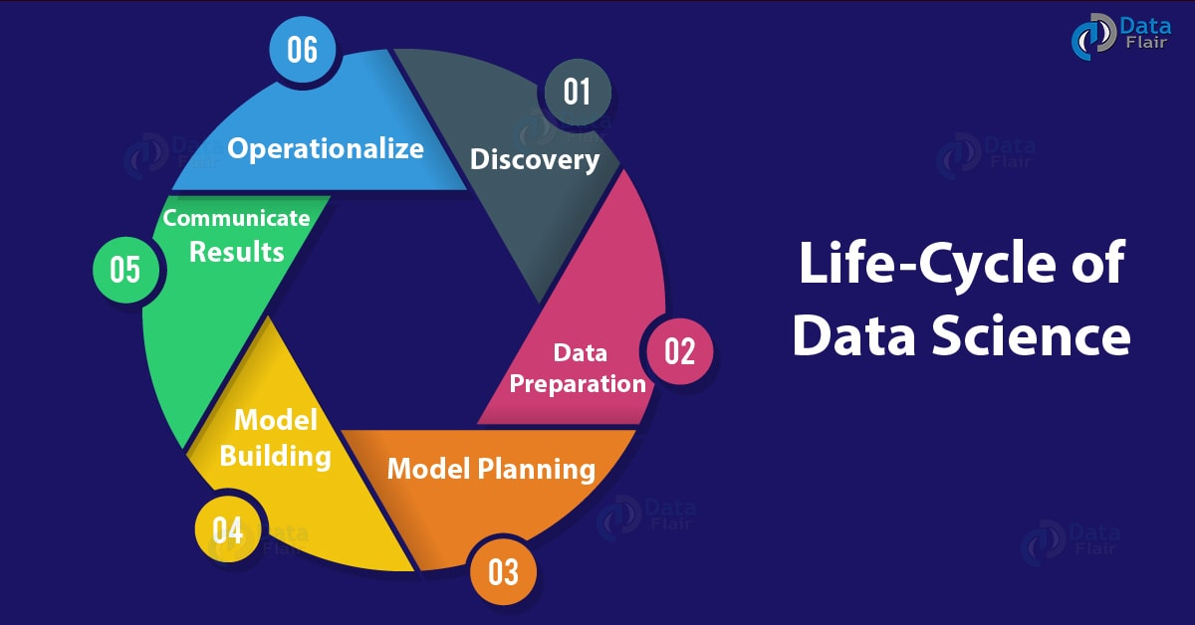
Data Science Tutorial – Introduction to Data Science with Python

a. Discovery
Before anything else, you should understand what the project requires. Also consider the specifications, the budget needed, and priorities. This is the phase where you frame the business problem and form initial hypotheses.

b. Data Preparation
In the preparation phase, you will need to perform analytics in an analytical sandbox. This is for an entire project. You will also extract, transform, load, and transform data into the sandbox.

c. Model Planning
In the third phase, you choose the methods you want to work with to find out how the variables relate to each other. This includes carrying out Exploratory Data Analytics (EDA) making use of statistical formulae and visualization tools.

d. Model Building
This phase includes developing datasets for training and testing. It also means you will have to analyze techniques like classification and clustering and determine whether the current infrastructure will do.

e. Communicate results
This is the second last phase in the cycle. You must determine whether your goals have been met. Document your findings, communicate to stakeholders, label the project a success or failure.
Do you know the Skills Needed to Become a Data Scientist

f. Operationalize
In the last phase, you must craft final reports, technical documents, and briefings
This Data Science Tutorial is dedicated to Python. So, let’s start Data Science for Python.

8. Data Science Tutorial – Why Python?
So, now you know what data science is all about. But why is Python the best choice for it? Here are a few reasons-
- Open-source and free.
- Easy to learn; intuitive.
- Fewer lines of code.
- Portability.
- Better productivity.
- Demand and popularity.
- Excellent online presence/ community.
- Support for many packages usable with analytics projects; can also use packages that can use code from other languages.
- It is faster than similar tools like R and MATLAB.
- Amazing memory management abilities.
Follow this link to know more about Why we learn Python Programming Language

9. Python 2.x or 3.x- Which should you go for?
Among a lot of other factors, the support for Python 2 ends officially on January 1st, 2020, so the future belongs to Python 3. Also, 95% of the libraries for data science are done being migrated from Python 2 to Python 3. Apart from that, Python 3 is cleaner and faster.
Well, then what about Python 2? It has its own perks- it is rich with a large online community and plenty of third-party libraries, and some features are backwards-compatible and work with both versions.
With the perks of each version listed, make your choices.

10. Data Science Tutorial – Python Libraries
For carrying out data analysis and other scientific computation, you will need any of the following libraries:
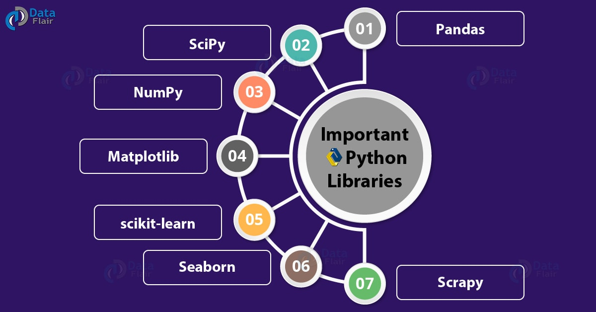
Data Science Tutorial – Data Science Libraries
a. Pandas
Pandas help us with munging and preparing data; it is great for operating on and maintaining structured data.
b. SciPy
SciPy (Scientific Python) stands on top of NumPy. With this library, we can carry out functionality like Linear Algebra, Fourier Transform, Optimization, and many others.
c. NumPy
NumPy (Numerical Python) is another library that lets us deal with features like linear algebra, Fourier transforms and advanced random number capabilities. One very import feature of NumPy is the n-dimensional array.
d. Matplotlib
Matplotlib will let you plot different kinds of graphs. These include pie charts, bar graphs, histograms, and even heat plots.
e. Scikit-learn
Scikit-learn is great for machine learning. It will let you statistically model and implement machine learning. The tools for these include clustering, regression, classification, and dimensionality reduction.
f. Seaborn
Seaborn is good with statistical data visualization. Making use of it, we can create useful and attractive graphics.
g. Scrapy
Scrapy will let you crawl the web. It begins on a home page and gets deeper within a website for information.
Follow this link to know more about Python Libraries in detail

11. Learning in Data Science Tutorial
Before you begin with data science Tutorials, we suggest you should brush up on the following:
- Variables in Python
- Operators in Python
- Dictionaries in Python
- Strings in Python
- Python Lists
- Python Tuples
So, this was all about Data Science Tutorial. Hope you like our explanation.

12. Conclusion
Hence, we complete this Data Science Tutorial, in which we learned: what is Data Science, History of Data Science, and Data Science Methodologies. In addition, we covered the Data Science Applications, BI Vs Data Science. At last, we discussed Life-Cycle of Data Science and Python Libraries. This will get you started with Python.
Got something else to add in this Data Science Tutorial? Drop it in the comments below.
Related Topic- Data Science Interview Questions-Answers
For reference
Tags: BI vs Data Sceiencedata scienceData Science ApplicationsData Science MethodologiesData Science PythonData Science TutorialData Science WikiHistory of Data ScienceLife-Cycle of Data SciencePython for data sciencePython librariesWhat is Data Science

Blog Home
- Courses
- Data Science
- Big Data
- Categories
- Interview Questions
- Job Portal
- Write For Us
Blog Home » Python Tutorials » Learn Python for Data Science – 9 Essential Steps to become a Python developer
- 0

Learn Python for Data Science – 9 Essential Steps to become a Python developer
by DataFlair Team · Updated ·
How to Learn Python for Data Science
If you’re reading this, you’re probably aware of the fact that Python is a general-purpose and very powerful programming language. It is used everywhere from scripting and web development to data science and machine learning. But what makes it a good choice for the same, and how can we master Python programming to get started with data science? Let’s find out.

Why learn Python for Data Science?
Python has a great set of libraries geared towards Data Science, like Pandas, NumPy, SciPy, Matplotlib, scikit-learn, TensorFlow, and Seaborn. These make work easy and let you focus on more important things. It is also very readable and has a simple syntax. Python is also open-source and has a very large community constantly involved in improving it. If you want to make a career in Data Science, Python is a good start; many data scientists begin with Python.

Steps to Learn Python for Data Science
Below, we list down a number of steps you can follow to learn Python for Data Science.

Step 1 – Strengthen the Python Basics
Python is a very easy language; it is a good choice for introducing university students to programming. It has a simple syntax. Python programs are easy to read, write, and understand. To get started with Python, first, learn the basics. These include types, expressions, variables, and string operations.
Strengthen your basics of Python from 240+ Python Tutorials by DataFlair

Step 2 – Understand Python Data Structures
After the basics, you need to understand various data structures like lists and tuples, and sets and dictionaries. You will use these when writing code in Python. This will also help you understand how things work in Python. Try a few exercises on these.

Step 3 – Master some Language Fundamentals
You now understand the basics of and data structures in Python. Now, let’s move on to some language fundamentals. Learn about conditions like if..else and if..elif..else, for- and while- loops, functions, and recursion. You should also learn about classes and objects, and about packages in Python.

Step 4 – Learn to Use Python to Work with Data
Now, let’s learn to use Python to work with data. This includes reading and writing files with Python. This also includes learning to use Pandas to read, work with, and save data using Pandas. You will also need to preprocess data.

Step 5 – Study to Analyze Data & Gain Insights
Learn to analyze data and gain insight from it using various Python libraries. This includes ndarray from NumPy, dataframe from Pandas, multiple functions and methods from SciPy, and various machine learning methods from scikit-learn. You will also often need to prepare and train models.

Step 6 – Enroll for a Certified Online Python Course
You can boost your learning with an online course on Python. DataFlair provides the best Certified Python Course for you to learn from. Here, you will find everything in one place so you can focus on learning. Enroll in this course and solve the practicals/assignments and projects. This will give you confidence and also some hands-on experience.

Step 7 – Grasp the Data Visualization Concept
Python has multiple options for choosing a library to perform visualization. Some of these are Matplotlib, Seaborn, ggplot, plotly, and Bokeh. You will need to learn to visualize data if you want to become a Data Scientist. This reveals patterns in data that are otherwise hidden.

Step 8 – Learn to Use Python Libraries
Like stated above, Python has many libraries geared toward Data Science and Machine Learning. These include SciPy, NumPy, Pandas, scikit-learn, Matplotlib, Seaborn, Theano, TensorFlow, Keras, and XGBoost. Learn about them and learn how to use them.

Step 9 – Work on Real-world Python Projects
Choose some personal projects and work on them. You can also get involved with some open-source public projects to improve your Python and Data Science skills.
Work on the Top Python Projects with Source Code and showcase your Python skills to recruiters

Summary
Now that you have your plan ready, are you excited to learn Python for Data Science with Data

Blog Home
- Courses
- Data Science
- Big Data
- Categories
- Interview Questions
- Job Portal
- Write For Us
Blog Home » Data Science Tutorials » Python Data Science Environment Setup
- 0

Python Data Science Environment Setup
by DataFlair Team · Updated ·

1. Data Science Environment Setup With Python
Today, in this Python Data Science tutorial, we will see Data Science Environment Setup for Python. Moreover, we will tell you about all that you need to install for Data Science Environment Setup, such as Python, Anaconda, Miniconda. Along with this, we will see how to set a virtual environment for Data Science Environment Setup and also importing Data Science Packages. Today, we will guide you to set up your machine so you can begin your journey with data science. Before you begin, we suggest you read up on Python Data Science Introduction to make things flow easier when you come back.
So, let’s start the Python data Science Environment Setup.
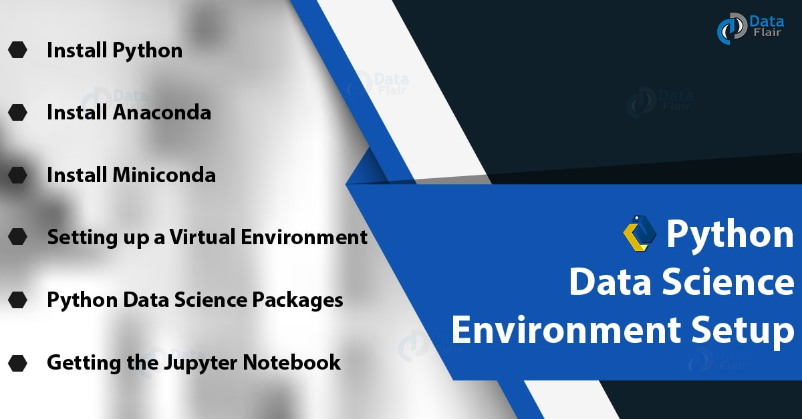
Python Data Science Environment Setup

2. Install Python
Before anything else, you should get Python on your machine. You can refer to the Step-by-Step Guide to Install Python on Windows for this.
While 2.7 is widely adopted, 3.x will take over the future and has already started to leave its mark. Apart from that, some software and features aren’t backward-compatible. So take your pick.

3. Getting Anaconda for Data Science Environment Setup

Data Science Environment Setup – Install Anaconda
Anaconda is a Python distribution for data science and machine learning. It is free and open-source and makes managing and deploying packages simple.
It has more than 1000 data science packages and the Conda package. Other tools it comes with are core Python, IPython, among others.

a. Anaconda Navigator
Anaconda ships with a virtual environment manager- the Anaconda Navigator. This is a desktop GUI that lets you launch applications and manage packages, environments, and channels for conda. This lets you bypass the command-line commands. The Navigator searches for a package on the Anaconda Cloud, or in a local repository for Anaconda, and installs, runs, and updates them. It has the following applications-
- Glueviz
- Jupyter Notebook
- JupyterLab
- Orange 3 App
- VSCode
- RStudio
- Rodeo
- Spyder
- QTConsole
Anaconda will give you two package managers- pip and conda. When some packages aren’t available with conda, you can use pip to install them. Note that using pip to install packages also available to conda may cause an installation error.

b. Installing Anaconda
To download an Anaconda distribution, you can use the official download page:
https://www.anaconda.com/download/
Here, you can select your platform and then choose the installer. For this, you can choose which version you want and whether 32-bit or 64-bit.
To install a package with conda, you can use the following command–
- conda install scipy

4. Install Miniconda
Miniconda is a minimal installer for conda; a small, bootstrap version of Anaconda. It is free and ships with conda, Python, and packages like pip and zlib. This lets you install more than 720 packages from conda. Since Miniconda is a lighter version of Anaconda, it lets you download faster.
To install Miniconda, you can get to the following page-
https://conda.io/miniconda.html
Here, choose your platform and then pick a 32-bit or a 64-bit installer according to the needs of your machine.

5. Setting up a Virtual Environment
Since, here, we talk about setting up a data science environment with Python, let’s find out what a virtual environment is. Well, a virtual environment lets us create different Python versions with the packages we want, or as the project needs. Such an environment helps us ensure that there are no clashes between the versions of packages and that of Python and its package managers. You should check out this blog on How to Create a Python Virtual Environment and Install Packages.
For now, let’s see how we can create one with Anaconda. Use the following command in your Anaconda prompt-
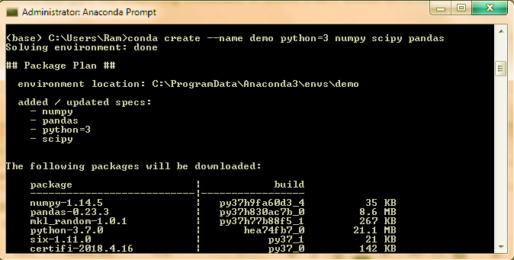
Data Science Environment Setup – setting up Virtual Environment
This should give you an idea of what the Anaconda prompt looks like. Now, to activate this environment, you can type-
- conda activate demo
This lets you start using it. Now to deactivate it, try-
- conda deactivate
The following command tells you all the environments that exist; the asterisk (*) marks the current-
- conda info -e

6. Important Python Data Science Packages
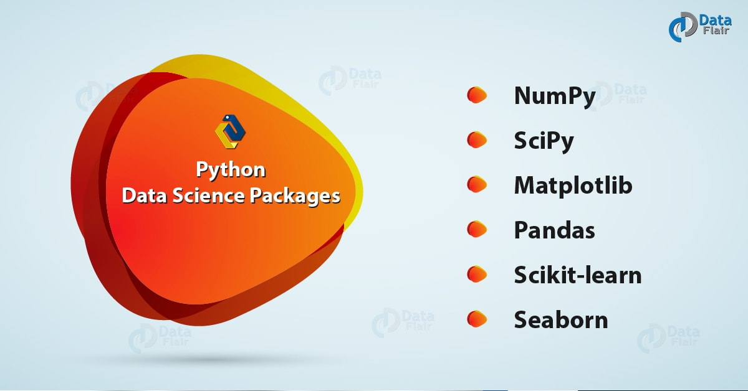
Important Python Data Science Packages
Working with data science, out of more than 1000 packages available, you will need a few that will let you implement the basic functionalities. Let’s take a quick look at some of those packages.

a. NumPy
Python data Science Packages – NumPy
As discussed ample times earlier, NumPy lets you deal with large, multi-dimensional arrays and matrices. To act on these, it also gives us various high-level mathematical functions.

b. SciPy
Python data Science Packages – SciPy
Scipy is a Python library for scientific and technical computin, and is free and open-source. Modules from SciPy include those for-
- Optimization
- Linear algebra
- Integration
- Interpolation
- Special functions
- FFT
- Signal and Image processing
- ODE solvers

c. Matplotlib
Python Data Science packages – Matplotlib
We’ve used Matplotlib so far to plot many of the figures we needed to get started with visualization. Some of these were bubble charts and scatter plots. This is a plotting library with Python and extends NumPy. With an object-oriented API, it lets you embed plots into applications. For this, it uses GUI toolkits like Tkinter, Qt, GTK+, and wxPython.

d. Pandas
Python Data Science Packages – Pandas
We have taken an extensive Pandas Tutorial. Now, it’s time for a quick recap. pandas is a software library for Python that is supposed to serve for data manipulation and analysis. It is free and lets you manipulate numerical tables and time series using data structures and operations.

e. scikit-learn
Python Data Science Packages – Scikit-learn
scikit-learn is a software machine learning library for Python. It is free and offers different algorithms for classification, regression, and clustering-
- Support Vector Machines
- Random forests
- Gradient boosting
- K-means
- DBSCAN
We usually use it alongside NumPy and SciPy.

f. seaborn
Finally, seaborn is a visualization library for Python and is based on matplotlib. It lets us perform data visualization in a statistical manner with a high-level interface that results in attractive graphics.
Let’s revise Python regular expression

7. How to Get Jupyter Notebook?
Data Science Environment Setup – getting Jupyter Notebook
As we saw earlier, the Jupyter Notebook ships with Anaconda. To run it, you can get in your virtual environment and type the following-
- jupyter notebook
You can also install it with pip-
- python3 -m pip install --upgrade pip
- python3 -m pip install jupyter
The notebook looks something like this-
Data Science Environment Setup – Jupyter Notebook
You can find this at http://localhost:8888/
Now to run Python here, you can create a new file. It looks like this-
Data Science Environment Setup – Jupyter Notebook
You can quit using the logout button at the top-right corner.
Let’s revise the Python Array Module
So, this was all in the Data Science Environment Setup with Python. Hope you like our explanation.

8. Conclusion: Data Science Environment Setup
Hence, in this Python Data Science Environment Setup tutorial, we discussed all that to need to install for data Science Environment Setup. Moreover, we look at Python packages as Numpy, Scipy, matplotlib. With this, we conclude our data Science environment setup tutorial, on how to set your machine up for data science. Still, if any query regarding Python Data Science Environment setup, feel free to drop your questions in comments below.
See also –
Python Charts
Tags: Getting the Jupyter Notebookhow to use condaImportant Data Science Packagesinstall anacondainstall Python for data scienceminiconda create environmentpython data science packages

Leave a Reply

*
*

This site is protected by reCAPTCHA and the Google Privacy Policy and Terms of Service apply.

Home About us Contact us Terms and Conditions Cancellation and Refund Privacy Policy Disclaimer Blogs Write For Us Careers Success Stories

Mastering Python for Data Science
Python – Data Cleansing & Operations

Popular Courses
Hadoop + Spark Course
Big Data Hadoop Course
Spark Scala Course
Apache Flink Course
Python Course

Popular Tutorials
Hadoop Tutorials
Spark Tutorials
Flink Tutorials
Tableau Tutorials
Power BI Tutorials
QlikView Tutorials

Popular Tutori

Blog Home
- Courses
- Data Science
- Big Data
- Categories
- Interview Questions
- Job Portal
- Write For Us
Blog Home » Python Tutorials » Python Data Cleansing by Pandas & Numpy | Python Data Operations
- 0

Python Data Cleansing by Pandas & Numpy | Python Data Operations
by DataFlair Team · Updated ·

1. Python Data Cleansing – Objective
In our last Python tutorial, we studied Aggregation and Data Wrangling with Python. Today, we will discuss Python Data Cleansing tutorial, aims to deliver a brief introduction to the operations of data cleansing and how to carry your data in Python Programming. For this purpose, we will use two libraries- pandas and numpy. Moreover, we will discuss different ways to cleanse the missing data.
So, let’s start the Python Data Cleansing.
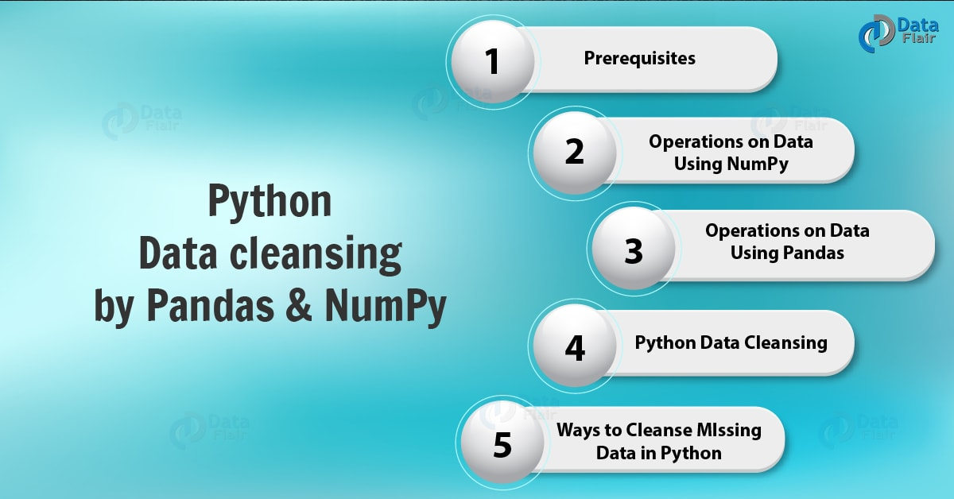
Python Data Cleansing by pandas & numpy | Python Data Operations

2. Python Data Cleansing – Prerequisites
As mentioned earlier, we will need two libraries for Python Data Cleansing – Python pandas and Python numpy.

a. Pandas
Python pandas is an excellent software library for manipulating data and analyzing it. It will let us manipulate numerical tables and time series using data structures and operations.
Python Data Cleansing – Python Pandas
You can install it using pip-
- C:\Users\lifei>pip install pandas
Do You Know What is Exception Handling in Python Programming

b. Numpy
Python numpy is another library we will use here. It lets us handle arrays and matrices, especially those multidimensional. It also provides several high-level mathematical functions to help us operate on these.
Python Data Cleansing – Python numpy
Use the following command in the command prompt to install Python numpy on your machine-
- C:\Users\lifei>pip install numpy

3. Python Data Cleansing Operations on Data using NumPy
Using Python NumPy, let’s create an array (an n-dimensional array).
- >>> import numpy as np
- >>> np.array(['a','b','c','d','e'],ndmin=2)
array([[‘a’, ‘b’, ‘c’, ‘d’, ‘e’]], dtype='<U1′)
- >>> np.array([['a','b'],['c','d','e']])<span style="background-color: #fafafa;color: #333333;font-family: Verdana, Geneva, sans-serif;font-size: 16px;font-weight: inherit"> </span>
array([list([‘a’, ‘b’]), list([‘c’, ‘d’, ‘e’])], dtype=object)
- >>> np.array(['a','b','c','d','e'],ndmin=1)<span style="background-color: #fafafa;color: #333333;font-family: Verdana, Geneva, sans-serif;font-size: 16px;font-weight: inherit"> </span>
array([‘a’, ‘b’, ‘c’, ‘d’, ‘e’], dtype='<U1′)
- >>> np.array([1,2,7,9,8],dtype=complex)<span style="background-color: #fafafa;color: #333333;font-family: Verdana, Geneva, sans-serif;font-size: 16px;font-weight: inherit"> </span>
array([1.+0.j, 2.+0.j, 7.+0.j, 9.+0.j, 8.+0.j])
While dtype lets us tell the interpreter of the data type to use, admin, lets us define the minimum dimension.
The following parameters will give us information about the array-
- >>> a=np.array(['a','b',2,'3.0'])
- >>> a
array([‘a’, ‘b’, ‘2’, ‘3.0’], dtype='<U3′)
- >>> type(a)
- <class 'numpy.ndarray'>
- >>> a.ndim
1
- >>> a.shape
- (4,)
- >>> a.size
4
- >>> a.dtype
- dtype('<U3')
Let’s Explore the Comparison Between Python Iterators and Generators
We can also perform operations like:
- >>> b=np.array([[1,2,3],[4,5,6]])
- >>> b
array([[1, 2, 3],
[4, 5, 6]])
- >>> b.flatten()
array([1, 2, 3, 4, 5, 6])
- >>> b.reshape(3,2)
array([[1, 2],
[3, 4],
[5, 6]])
- >>> b[:2,::2]
array([[1, 3],
[4, 6]])
- >>> b-4
array([[-3, -2, -1],
[ 0, 1, 2]])
- >>> b.sum()
21
- >>> b-2*b
array([[-1, -2, -3],
[-4, -5, -6]])
- >>> np.sort(np.array([[3,2,1],[5,2,4]]))
array([[1, 2, 3],
[2, 4, 5]])

4. Python Data Cleansing Operations on Data Using pandas
Pandas use three types to hold data- DataFrame, Panel, and Series.
Operations on Data Using Python pandas

a. DataFrame
Pandas DataFrame is a data structure that holds data in two dimensions- as rows and columns. We have the following syntax-
- pandas.DataFrame(data, index, columns, dtype, copy)
Now let’s try an example-
- >>> import pandas as pd
- >>> data={'Element':['Silver','Gold','Platinum','Copper'],'Atomic Number':[47,79,78,29]}
- >>> frame=pd.DataFrame(data,index=['element 1','element 2','element 3','element 4'])
- >>> frame
Python Pandas – DataFrame
Have a Look at Python Inheritance, Method Overloading and Method Overriding

b. Panel
Pandas panel holds data in three dimensions. Etymologically, the term panel data from one source for the name pandas. A panel has the following syntax:
pandas.Panel(data, items, major_axis, minor_axis, dtype, copy)
- >>> data={'Red':pd.DataFrame(np.random.randn(4,2)),
- 'Blue':pd.DataFrame(np.random.randn(4,3))}
- >>> pd.Panel(data)
<class ‘pandas.core.panel.Panel’>
Dimensions: 2 (items) x 4 (major_axis) x 3 (minor_axis)
Items axis: Blue to Red
Major_axis axis: 0 to 3
Minor_axis axis: 0 to 2

c. Series
Pandas Series holds data in one dimension, in a labeled format. The index is the set of axis labels we use.
It has the following syntax-
- pandas.Series(data, index, dtype, copy)
Let’s take an example.
- >>> data=np.array([1,2,3,3,4])
- >>> pd.Series(data)
0 1
1 2
2 3
3 3
4 4
dtype: int32
Let’s take another example.
- >>> pd.Series(np.array(['a','c','b']))
0 a
1 c
2 b
dtype: object
Using these data structures, we can manipulate data in many ways-
- >>> frame.iloc[0:2,:]
Python Data Cleansing by pandas & numpy | Python Data Operations
- >>> frame.describe()
Python Pandas – Series “Describe”
- >>> frame.rank()
Python Pandas – Series “Rank”
This is all for now; we will learn about the libraries pandas and numpy in their own tutorials.
Read about Python Iterables and Python Itertools with Examples

5. Python Data Cleansing
When some part of our data is missing, due to whichever reason, the accuracy of our predictions plummets. In our article on data wrangling and aggregation, we discussed missing data and how to drop it. Let’s see how we can deal with this issue.
In real-time situations like the comment section of our website. The name and email are mandatory, but the input for ‘website’ can be left empty. Some users may not run a website to be eligible to fill in this information. In ways like this and others, we may end up with missing data in some places. How should we go about with this? Let’s find out.
Python Pandas will depict a missing value as NaN, which is short for Not a Number. Simply using the reindex() method will fill in NaN for blank values.
- >>> frame=pd.DataFrame(np.random.randn(4,3),index=[1,2,4,7],columns=['A','B','C'])
- >>> frame.reindex([1,2,3,4,5,6,7])
Python Data Cleansing

a. Finding which columns have missing values
In the tutorial on wrangling, we saw how to find out which columns have missing values-
- >>> frame=frame.reindex([1,2,3,4,5,6,7])
- >>> frame['B'].isnull()
1 False
2 False
3 True
4 False
5 True
6 True
7 False
Name: B, dtype: bool

6. Ways to Cleanse Missing Data in Python
To perform a Python data cleansing, you can drop the missing values, replace them, replace each NaN with a scalar value, or fill forward or backward.
Ways to Cleanse Missing Data in Python

a. Dropping Missing Values
You can exclude missing values from your dataset using the dropna() method.
- >>> frame.dropna()
Ways for Python Data Cleansing – Dropping Missing Values
This defaults to dropping on axis=0, which excludes an entire row for an NaN value.
Do you know the Python Modules vs Packages

b. Replacing Missing Values
To replace each NaN we have in the dataset, we can use the replace() method.
- >>> from numpy import NaN
- >>> frame.replace({NaN:0.00})
Ways for Python Data Cleansing – Replacing Missing Values
This way, we can also replace any value that we find enough times in the dataset.

c. Replacing with a Scalar Value
We can use the fillna() method for this.
- >>> frame.fillna(7)
Ways for Python Data Cleansing – Replacing with a Scalar Value

d. Filling Forward or Backward
If we supply a method parameter to the fillna() method, we can fill forward or backward as we need. To fill forward, use the methods pad or fill, and to fill backward, use bfill and backfill.
- >>> frame.fillna(method='pad')
Ways for Python Data Cleansing – Filling Forward or Backward
- >>> frame.fillna(method='backfill')
Ways for Python Data Cleansing – Filling Forward or Backward
Follow the link to know about Python Property – The Problem and Solution

7. Python Data Cleansing – Other Operations
While cleaning data, we may also need to find out more about it and manipulate it. Below, we make use of some of these operations.
- >>> data={'Element':['Silver','Gold','Platinum','Copper'],'Atomic Number':[47,79,78,29]}
- >>> frame=pd.DataFrame(data,index=['element 1','element 2','element 3','element 4'])
- >>> frame
True
- >>> frame.head()
Python Data Cleansing by pandas & numpy | Python Data Operations
Data Cleansing Operations in Python
- >>> frame.tail(3)

a. Renaming Columns
To rename a column, you can use the rename() method.
- >>> frame.rename(columns={'Atomic Number':'Number','Element':'Name'},inplace=True)
- >>> frame
Let’s revise Python Multithreading: A Comprehensive Tutorial

b. Making Changes Stay
Also, throughout this tutorial “Python Data Cleansing”, the changes that we have made to the frames did not actually modify them. To make this happen, you can set the inplace=True parameter.
So, this was all about Python Data Cleansing Tutorial. Hope you like our explanation.

8. Conclusion
Hence, in this Python Data Cleansing, we learned how data is Cleans In Python Programming Language for this purpose, we used two libraries- pandas and numpy. Since data scientists spend 80% of their time cleaning and manipulating data, that makes it an essential skill to learn with data science. Tell us what you think in the comments below.
See Also – How Python Send Email Via SMTP
For reference
Tags: clean() pythoncleaning text data pythondata cleaning steps in pythonData Cleansing in PythonData Cleansing PythonPandas DataFramePandas PanelPandas SeriesPython Data CleansingPython Data Cleansing Tutorialpython for data analysisPython NumPyPython Pandas

Leave a Reply

*
*

This site is protected by reCAPTCHA and the Google Privacy Policy and Terms of Service apply.

Home About us Contact us Terms and Conditions Cancellation and Refund Privacy Policy Disclaimer Blogs Write For Us Careers Success Stories

Python – Data Science Installation
Python – Data File Formats
Python Tutorials
Python Data Cleansing by Pandas & Numpy | Python Data Operations
❮ Prev
Next ❯

Popular Courses
Hadoop + Spark Course
Big Data Hadoop Course
Spark Scala Course
Apache Flink Course
Python Course

Popular Tutorials
Hadoop Tutorials
Spark Tutorials
Flink Tutorials
Tableau Tutorials
Power BI Tutorials
QlikView Tutorials

Popular Tutorials
Data Science Tutorials
Machine Learning Tutorials
Python Tutorials
R Tutorials
SAS Tutorials
SQL Tutorials

DataFlair © 2020. All Rights Reserved.

We use cookies to provide the best services. By using our site, you comply with our cookies policy. Learn more

Blog Home
- Courses
- Data Science
- Big Data
- Categories
- Interview Questions
- Job Portal
- Write For Us
Blog Home » Python Tutorials » Python Data File Formats – How to Read CSV, JSON, and XLS Files
- 3

Python Data File Formats – How to Read CSV, JSON, and XLS Files
by DataFlair Team · Updated ·

1. How to Read CSV, JSON, and XLS Files
In our last python tutorial, we studied How to Work with Relational Database with Python. In this tutorial, we will discuss different types of Python Data File Formats: Python CSV, JSON, and XLS. Moreover, we will discuss how to read CSV, JSON, XLS files in Python Programming Language.
So, let’s see Python Data File Formats.
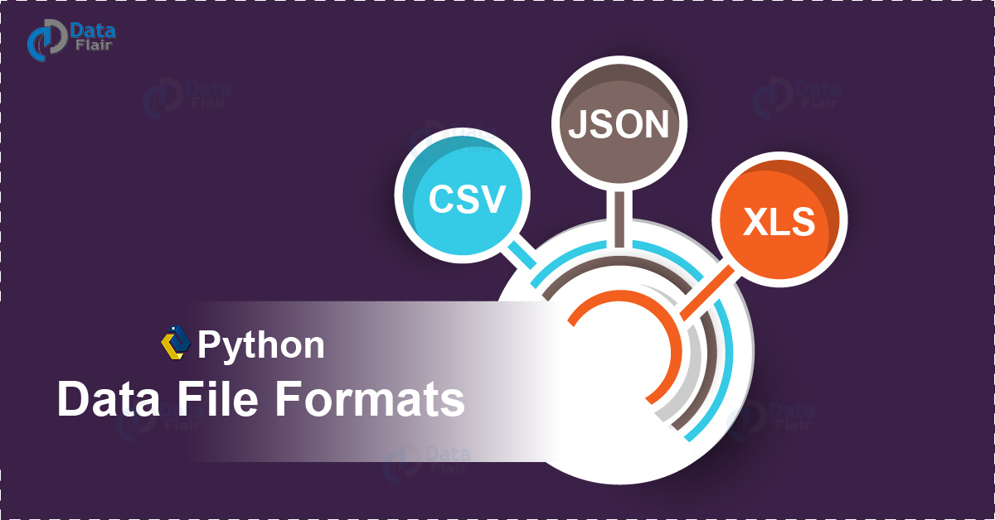
Python Data File Formats – How to Read CSV, JSON, and XLS Files

2. Python Data File Formats
Let’s first learn a little about the Python Data File formats we will be processing with.

a. Python Data File Formats – Python CSV
Python CSV data is a basic with data science. A Comma-Separated-Value file uses commas to separate values. You can look at it as a delimited text file that holds tabular data as plain text. One problem with this may arise when the data it holds contains a comma or a line break- we can use other delimiters like a tab stop. This Python data file format proves useful in exchanging data and in moving tabular data between programs. The extension for a CSV file is .csv.
Follow this link to know about File Handling In Python
Here’s a Python CSV file we will use for our demo-
id,title,timing,genre,rating
1,Dog with a Blog,17:30-18:00,Comedy,4.7
2,Liv and Maddie,18:00-18:30,Comedy,6.3
3,Girl Meets World,18:30-19:00,Comedy,7.2
4,KC Undercover,19:00-19:30,Comedy,6.1
5,Austin and Ally,19:30-20:00,Comedy,6
We saved this as schedule.csv on our Desktop. Remember to save as All files (*.*). When we open this file, it opens in Microsoft Excel by default on Windows-
Python Data File Formats – How to Read CSV, JSON, and XLS Files

b. Python Data File Formats – Python JSON
JSON stands for JavaScript Object Notation and is an open standard file format. While it holds attribute-value pairs and array data types, it uses human-readable text for this. This Python data file format is language-independent and we can use it in asynchronous browser-server communication. The extension for a Python JSON file is .json.
Python Data File Formats – How to Read CSV, JSON, and XLS Files
Let’s Explore Python Zipfile – Benefits, Modules, Objects
Here’s the JSON file in Python we will use for the demo-
- {
- "ID":["1","2","3","4","5"],
- "Title":["Dog with a Blog","Liv and Maddie","Girl Meets World","KC Undercover","Austin and Ally"],
- "Timing":["17:30-18:00","18:00-18:30","18:30-19:00","19:00-19:30","19:30-20:00"],
- "Genre":["Comedy","Comedy","Comedy","Comedy","Comedy"],
- "Rating":["4.7","6.3","7.2","6.1","6"]
- }
We save this as schedule.json on the Desktop.

c. Python Data File Formats – Python XLS
The extension for an Excel spreadsheet is .xlsx. This proves useful for data science; we create a workbook with two sheets in Microsoft Excel.
Sheet 1-
Python Data File Formats – How to Read CSV, JSON, and XLS Files
Sheet 2-
Python Data File Formats – How to Read CSV, JSON, and XLS Files
We save this workbook as schedule.xlsx on our Desktop.
Do you Know the XML Processing in Python 3

3. Prerequisites
To process these Python data file formats, we need the library pandas.
Python Data File Formats – How to Read CSV, JSON, and XLS Files
Install it using pip-
- >>> pip install pandas

4. How to Read CSV File in Python?
To read an entire file, rows, columns, or combinations of those, read on.
Python Data File Formats – How to Read CSV, JSON, and XLS Files

a. Reading an entire Python CSV File
To read an entire file, we can use the read_csv() function.
- >>> import pandas
- >>> import os
- >>> os.chdir('C:\\Users\\lifei\\Desktop')
- >>> print(pandas.read_csv('schedule.csv'))
Python Data File Formats – How to Read CSV, JSON, and XLS Files
Read about Python Tools – 4 Major Utilities

b. Reading rows for one column
Sometimes, we may only want to fetch certain rows at once for a certain column. We use the slicing operator for this. Read up on Python Operators.
- >>> data=pandas.read_csv('schedule.csv')
- >>> print(data[0:3]['title'])
Python Data File Formats – How to Read CSV, JSON, and XLS Files

c. Reading certain columns
Now we can also fetch only certain columns. For this, we use the .loc() method for multi-axis indexing.
- >>> data=pandas.read_csv('schedule.csv')
- >>> print(data.loc[:,['title','rating']])
Python CSV File – Reading certain columns

d. Reading certain rows and certain columns
Using the .loc() method, we can also fetch certain rows and certain columns:
- >>> data=pandas.read_csv('schedule.csv')
- >>> print(data.loc[[1,3],['title','rating']])
Python Data File Formats – How to Read CSV, JSON, and XLS Files

e. Reading certain columns for a range of rows
Now to fetch certain columns for a range of rows, we slightly change the previous syntax and use slicing instead of indices.
- data=pandas.read_csv('schedule.csv')
- >>> print(data.loc[1:3,['title','rating']])
Python CSV File – Reading certain columns for a range of rows
Let’s revise Python Generators and Generator Expressions

f. Using the Python CSV Module
You can also install the module CSV using pip, and then use the following code-
- >>> import csv
- >>> fields=rows=[]
- >>> with open('schedule.csv','r') as file:
- reader=csv.reader(file) #Reader object
- fields=next(reader)
- for row in reader:
- rows.append(row)
- print(f"You have {reader.line_num} rows") #Number of rows
- You have 6 rows
- >>> print(' '.join(field for field in fields)) #Field names
- id title timing genre rating
- >>> for row in rows[:6]:
- for col in row:
- print(col)
- print('\n')
1
Dog with a Blog
17:30-18:00
Comedy
4.7
2
Liv and Maddie
18:00-18:30
Comedy
6.3
3
Girl Meets World
18:30-19:00
Comedy
7.2
4
KC Undercover
19:00-19:30
Comedy
6.1
5
Austin and Ally
19:30-20:00
Comedy
6

5. How to Read JSON File in Python?
Python Data File Formats – How to Read CSV, JSON, and XLS Files
Let’s Discuss Python Decision Making Statements

a. Reading an entire Python JSON file
To read an entire JSN file in Python, we can use the read_json() function.
- >>> import pandas
- >>> print(pandas.read_csv('schedule.csv'))
Python Data File Formats – How to Read JSON Files

b. Reading certain rows and columns
And when you only want some rows and some columns, you can-
- >>> data=pandas.read_csv('schedule.csv')
- >>> data.loc[[1,3],['title','rating']]
Python JSON Files – Reading certain rows and columns

c. Reading rows and columns as records
You can also fetch the rows and columns as a sequence of records-
- >>> data=pandas.read_csv('schedule.csv')
- >>> print(data.to_json(orient='records',lines=True))
Python JSON File – Reading rows and columns as records

6. How to Read XLS File in Python?
Finally, let’s find out how to read Python XLS files.
Python Data File Formats – How to Read JSON File in Python

a. Reading an entire file
You can read an entire file using the read_excel() function.
- >>> import pandas
- >>> print(pandas.read_excel('schedule.xlsx'))
Python Data File Formats – How to Read XLS Files
Note- You may need to install a module for this-
C:\Users\lifei>pip install xlrd
Have a Look Python Sets and Booleans with Syntax and Examples

b. Reading certain rows and columns
When you only want to fetch certain rows and columns, you can use the .loc() method.
- >>> data=pandas.read_excel('schedule.xlsx')
- >>> print(data.loc[[1,3],['title','rating']])
Python XLS File – Reading certain rows and columns

c. Reading more than one sheet
- >>> with pandas.ExcelFile('schedule.xlsx') as book:
- s1=pandas.read_excel(book,'Sheet1')
- s2=pandas.read_excel(book,'Sheet2')
- >>> s1[0:5]['title']
Python XLS File – Reading more than one sheet
- >>> s2[0:5]['years']
Python XLS File – Reading more than one sheet

d. Using the Python XLRD Module
- >>> import xlrd
- >>> book=xlrd.open_workbook('schedule.xlsx')
- >>> sheet=book.sheet_by_index(0)
- >>> sheet.cell_value(0,0) #Value at cell at row 0 and column 0
- 'id'
- >>> sheet.nrows #Number of rows
- 6
- >>> sheet.ncols #Number of columns
- 5
- >>> for i in range(sheet.ncols):
- sheet.cell_value(0,i) #Column names
- 'id'
- 'title'
- 'timing'
- 'genre'
- 'rating'
- >>> sheet.row_values(1) #First row
- [1.0, 'Dog with a Blog', '17:30-18:00', 'Comedy', 4.7]
So, this was all about Python Data File Formats. Hope you like our explanation.

7. Conclusion
Hence, in this tutorial, we discussed different types of Python Data File Formats. In addition, we also learned how to process/read formats like CSV, JSON, and XLS files in Python. Leave your comments below and don’t forget to visit again for another tutorial tomorrow.
See Also – Recursion in Python with Examples
For reference
Tags: Python CSVPython JSONPython XLSread csv pythonReading CSV File in PythonReading JSON File in PythonReading more than one sheetReading rows for one columnReading XLS File in PythonUsing the csv moduleUsing the xlrd module

3 Responses
- Comments3
- Pingbacks0

Sudhi
July 12, 2018 at 7:33 pm
Hi
There is a mistake in in explaining how to read JSON file in Python ? The explanation seems a copy paste of “How to Read .csv file in Python?”
Could you please address it and provide the process to read a JSON file in python?
Appreciate it.
Reply
- pankaj
December 14, 2018 at 11:25 am
for json read file correct the statement its should be read_json instead of read_csv.
a. Reading an entire Python JSON file
To read an entire JSN file in Python, we can use the read_json() function.
>>> import pandas
>>> print(pandas.read_csv(‘schedule.csv’))
check this section.
Reply
- Shridhara
August 13, 2019 at 12:11 pm
Thanks!
Reply

Leave a Reply

*
*

This site is protected by reCAPTCHA and the Google Privacy Policy and Terms of Service apply.

Home About us Contact us Terms and Conditions Cancellation and Refund Privacy Policy Disclaimer Blogs Write For Us Careers Success Stories

Python – Data Cleansing & Operations
Python – Relational Database
Python Tutorials
Python Data File Formats – How to Read CSV, JSON, and XLS Files
❮ Prev
Next ❯

Popular Courses
Hadoop + Spark Course
Big Data Hadoop Course
Spark Scala Course
Apache Flink Course
Python Course

Popular Tutorials
Hadoop Tutorials
Spark Tutorials
Flink Tutorials
Tableau Tutorials
Power BI Tutorials
QlikView Tutorials

Popular Tutorials
Data Science Tutorials
Machine Learning Tutorials
Python Tutorials
R Tutorials
SAS Tutorials
SQL Tutorials
DataFlair © 2020. All Rights Reserved.

We use cookies to provide the best services. By using our site, you comply with our cookies policy. Learn more

Blog Home
- Courses
- Data Science
- Big Data
- Categories
- Interview Questions
- Job Portal
- Write For Us
Blog Home » Python Tutorials » How to Work with Relational Database with Python
- 0

How to Work with Relational Database with Python
by DataFlair Team · Updated ·

1. Python Relational Database
In our last Python Database tutorial, we checked how to work with NoSQL databases with Python. In the same way today we talk about working of Relational Database with Python Programming Language. Moreover, we will read some important prerequisites of Relational Database and how to read a relation table. Along with this, we will get to know how to delete an entire table and a single row in relation database with Python.
So, let start working with Relational Database with Python.
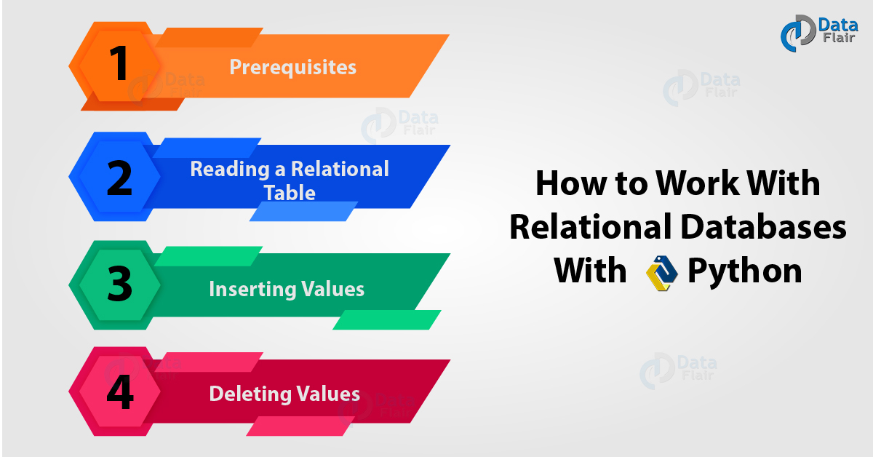
How to Work with Relational Database with Python

2. Prerequisites for Relational Database
For this demo, we need three things- sqlalchemy, pandas, and a CSV file.
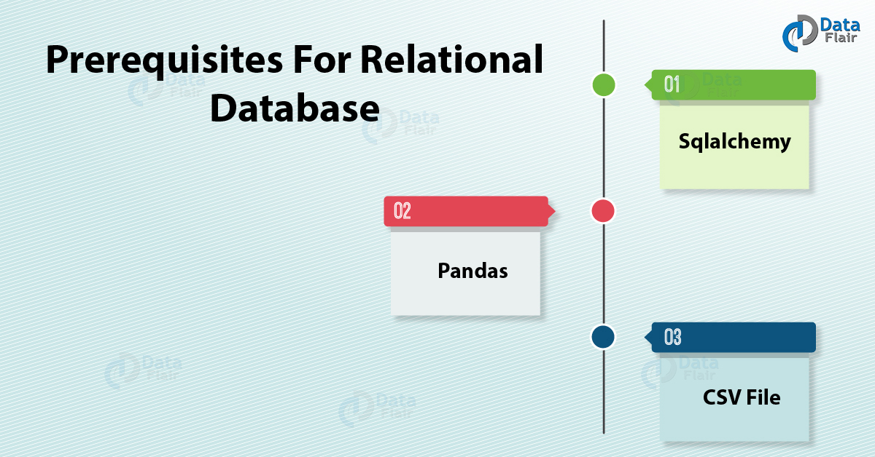
Prerequisites for Relational Database

a. SQLAlchemy

How to Work with Relational Database with Python
SQLAlchemy is an open-source toolkit and an object-relational mapper. You can download this using pip-
C:\Users\lifei>pip install sqlalchemy
Requirement already satisfied: sqlalchemy in c:\users\lifei\appdata\local\programs\python\python36\lib\site-packages (1.2.9)
Note- If your import works for the command line and not for the IDLE, then you may be running different versions of Python in the two. You can add this to the path in your IDLE-
- >>> sys.path.append('C:\\Users\\lifei\\AppData\\Local\\Programs\\Python\\Python36\\Lib\\site-packages')

b. Pandas
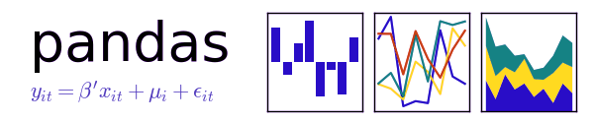
sqlalchemy, pandas, and a CSV file
Pandas is a Python library for data manipulation and analysis. You can download it using pip-
C:\Users\lifei>pip install pandas
Collecting pandas
Let’s Read a New Topic – Python 3 Extension Programming with C & Others Languages
Downloading https://files.pythonhosted.org/packages/ad/0b/f65a63cccc5e37a7af983fc87a8c9e56feb4998d8877f8f2af21f40bcf3c/pandas-0.23.1-cp36-cp36m-win_amd64.whl (10.5MB)
100% |████████████████████████████████| 10.5MB 385kB/s
Collecting pytz>=2011k (from pandas)
Downloading https://files.pythonhosted.org/packages/30/4e/27c34b62430286c6d59177a0842ed90dc789ce5d1ed740887653b898779a/pytz-2018.5-py2.py3-none-any.whl (510kB)
100% |████████████████████████████████| 512kB 385kB/s
Collecting numpy>=1.9.0 (from pandas)
Downloading https://files.pythonhosted.org/packages/0d/b7/0c804e0bcba6505f8392d042d5e333a5e06f308e019517111fbc7767a0bc/numpy-1.14.5-cp36-none-win_amd64.whl (13.4MB)
100% |████████████████████████████████| 13.4MB 461kB/s
Collecting python-dateutil>=2.5.0 (from pandas)
Downloading https://files.pythonhosted.org/packages/cf/f5/af2b09c957ace60dcfac112b669c45c8c97e32f94aa8b56da4c6d1682825/python_dateutil-2.7.3-py2.py3-none-any.whl (211kB)
100% |████████████████████████████████| 215kB 504kB/s
Requirement already satisfied: six>=1.5 in c:\users\lifei\appdata\local\programs\python\python36\lib\site-packages (from python-dateutil>=2.5.0->pandas) (1.11.0)
Installing collected packages: pytz, numpy, python-dateutil, pandas
Successfully installed numpy-1.14.5 pandas-0.23.1 python-dateutil-2.7.3 pytz-2018.5

c. A Sample CSV File
A Sample CSV File
To work with the relational databases, we download a sample CSV file from the web. Here’s what it looks like:
Prerequisites for Relational Database- A Sample CSV FileLet’s Explore Python Database Access – Python 3 MySQL

3. Reading a Relational Table
Now let’s try reading from this Relational table
- >>> from sqlalchemy import create_engine
- >>> import pandas
- >>> import os
- >>> os.chdir('C:\\Users\\lifei\\Desktop')
- >>> data=pandas.read_csv('samplecsv.csv',encoding="ISO-8859-1")
- >>> engine=create_engine('sqlite:///:memory:') #Create db engine
- >>> data.to_sql('data_table',engine) #Store dataframe as table
- >>> print(pandas.read_sql_query('SELECT * FROM data_table',engine))
This produces the following output:
Reading a Relational Table – Outputv

4. How to Insert Values in Relational Database with Python?
Now to add another row of content into Relational Database with Python, we use the following code:
- >>> from sqlalchemy import create_engine
- >>> from pandas.io import sql
- >>> import pandas
- >>> data=pandas.read_csv('samplecsv.csv',encoding="ISO-8859-1")
- >>> engine=create_engine('sqlite:///:memory:') #Create db engine
- >>> data.to_sql('data_table',engine) #Store dataframe as table
- >>> sql.execute('INSERT INTO data_table VALUES(?,?,?,?,?,?,?,?,?,?,?)',\
- engine,params=[(9,11,’Xerox 198’,'Frederick Jones',752,-321.57,2.2,9.8,'Nunavut','Paper',0.37)])
- <sqlalchemy.engine.result.ResultProxy object at 0x00FA3530>
- >>> print(pandas.read_sql_query('SELECT * FROM data_table',engine))
This produces the following output:
index 1 Eldon Base for stackable storage shelf, platinum \
0 0 2 1.7 Cubic Foot Compact “Cube” Office Refrigera…
1 1 3 Cardinal Slant-D® Ring Binder, Heavy Gauge Vinyl
2 2 4 R380
3 3 5 Holmes HEPA Air Purifier
4 4 6 G.E. Longer-Life Indoor Recessed Floodlight Bulbs
5 5 7 Angle-D Binders with Locking Rings, Label Holders
6 6 8 SAFCO Mobile Desk Side File, Wire Frame
7 7 9 SAFCO Commercial Wire Shelving, Black
8 8 10 Xerox 198
9 9 11 Xerox 198
Muhammed MacIntyre 3 -213.25 38.94 35 Nunavut \
0 Barry French 293 457.81 208.16 68.02 Nunavut
1 Barry French 293 46.71 8.69 2.99 Nunavut
2 Clay Rozendal 483 1198.97 195.99 3.99 Nunavut
3 Carlos Soltero 515 30.94 21.78 5.94 Nunavut
4 Carlos Soltero 515 4.43 6.64 4.95 Nunavut
5 Carl Jackson 613 -54.04 7.30 7.72 Nunavut
6 Carl Jackson 613 127.70 42.76 6.22 Nunavut
7 Monica Federle 643 -695.26 138.14 35.00 Nunavut
8 Dorothy Badders 678 -226.36 4.98 8.33 Nunavut
9 Frederick Jones 752 -321.57 2.20 9.80 Nunavut
Storage & Organization 0.8
0 Appliances 0.58
Have a Look at Difference Between Method and Function in Python

5. How to Delete Values in Relational Database with Python?
Relational Database with Python can delete values raw vise and delete the entire table. So, let’s see how it works.

a. Deleting the Entire Table
Now finally, we want to delete the entire file. How do we do that? Let’s find out.
- >>> from sqlalchemy import create_engine
- >>> from pandas.io import sql
- >>> import pandas
- >>> data=pandas.read_csv('samplecsv.csv',encoding="ISO-8859-1")
- >>> engine=create_engine('sqlite:///:memory:') #Create db engine
- >>> data.to_sql('data_table',engine) #Store dataframe as table
- >>> sql.execute('DELETE FROM data_table',engine)
- <sqlalchemy.engine.result.ResultProxy object at 0x00E6D9F0>
- >>> print(sql.read_sql_query('SELECT * FROM data_table',engine))
Empty DataFrame
Columns: [index, 1, Eldon Base for stackable storage shelf, platinum, Muhammed MacIntyre, 3, -213.25, 38.94, 35, Nunavut, Storage & Organization, 0.8]
Index: []

b. Deleting a Single Row
Now we don’t have column names in this CSV file, but we can use the first value to delete a row this way-
- >>> sql.execute('DELETE FROM data_table where 35=(?)',engine,params=[(9.80)])
- <sqlalchemy.engine.result.ResultProxy object at 0x00FA3170>
- >>> print(sql.read_sql_query('SELECT * FROM data_table',engine))
index 1 Eldon Base for stackable storage shelf, platinum \
0 0 2 1.7 Cubic Foot Compact “Cube” Office Refrigera…
1 1 3 Cardinal Slant-D® Ring Binder, Heavy Gauge Vinyl
2 2 4 R380
3 3 5 Holmes HEPA Air Purifier
4 4 6 G.E. Longer-Life Indoor Recessed Floodlight Bulbs
5 5 7 Angle-D Binders with Locking Rings, Label Holders
6 6 8 SAFCO Mobile Desk Side File, Wire Frame
7 7 9 SAFCO Commercial Wire Shelving, Black
8 8 10 Xerox 198
Muhammed MacIntyre 3 -213.25 38.94 35 Nunavut \
0 Barry French 293 457.81 208.16 68.02 Nunavut
1 Barry French 293 46.71 8.69 2.99 Nunavut
2 Clay Rozendal 483 1198.97 195.99 3.99 Nunavut
3 Carlos Soltero 515 30.94 21.78 5.94 Nunavut
4 Carlos Soltero 515 4.43 6.64 4.95 Nunavut
5 Carl Jackson 613 -54.04 7.30 7.72 Nunavut
6 Carl Jackson 613 127.70 42.76 6.22 Nunavut
7 Monica Federle 643 -695.26 138.14 35.00 Nunavut
8 Dorothy Badders 678 -226.36 4.98 8.33 Nunavut
Storage & Organization 0.8
0 Appliances 0.58
1 Binders and Binder Accessories 0.39
2 Telephones and Communication 0.58
3 Appliances 0.50
4 Office Furnishings 0.37
5 Binders and Binder Accessories 0.38
6 Storage & Organization NaN
7 Storage & Organization NaN
8 Paper 0.38
Follow this link for Python GUI Programming – Tkinter Tutorial
So, this was all about the Working of Relational Database with Python. Hope you like our explanation.

6. Conclusion
Hence, in this Python Relation Database tutorial, we learned about working of a relational database with Python. Now you can read CSV files, insert data into them, and delete data from them using simple SQL queries. Got any questions? Drop them in the comments below.
Related Topic- Top 30 Python Interview Questions and Answers in 2018
For reference
Tags: best python databaseCSV fileDeleting a entire tableDeleting a single rowExample of Relational DatabasePandaspython database apipython database librarypython database sqlitepython database tutorialPython Relational Databasepython simple databaseReading a Relational TableRelational Databases with Pythonsqlalchemyusing databases with python

Leave a Reply

*
*

This site is protected by reCAPTCHA and the Google Privacy Policy and Terms of Service apply.

Home About us Contact us Terms and Conditions Cancellation and Refund Privacy Policy Disclaimer Blogs Write For Us Careers Success Stories

Python – Data File Formats
Python – NoSQL Database
Python Tutorials
How to Work with Relational Database with Python
❮ Prev
Next ❯

Popular Courses
Hadoop + Spark Course
Big Data Hadoop Course
Spark Scala Course
Apache Flink Course
Python Course

Popular Tutorials
Hadoop Tutorials
Spark Tutorials
Flink Tutorials
Tableau Tutorials
Power BI Tutorials
QlikView Tutorials

Popular Tutorials
Data Science Tutorials
Machine Learning Tutorials
Python Tutorials
R Tutorials
SAS Tutorials
SQL Tutorials
DataFlair © 2020. All Rights Reserved.

We use cookies to provide the best services. By using our site, you comply with our cookies policy. Learn more

Blog Home
- Courses
- Data Science
- Big Data
- Categories
- Interview Questions
- Job Portal
- Write For Us
Blog Home » Python Tutorials » How to Work with NoSQL Database in Python using PyMongo
- 0

How to Work with NoSQL Database in Python using PyMongo
by DataFlair Team · Updated ·

1. Python NoSQL Database
In our last Python tutorial, we studied Python Database Access. Here, in this Python NoSQL Database tutorial, we will study the working of NoSQL Database in Python Programming Language. In addition, we will discuss the need and benefits of Python NoSQL Database. Along with this will study different types of NoSQL and different function like how to insert into, update, and delete data from a NoSQL database. We will use MongoDB for this. At last, we will cover the NoSQL vs SQL.
So, let’s start the NoSQL Database in Python.
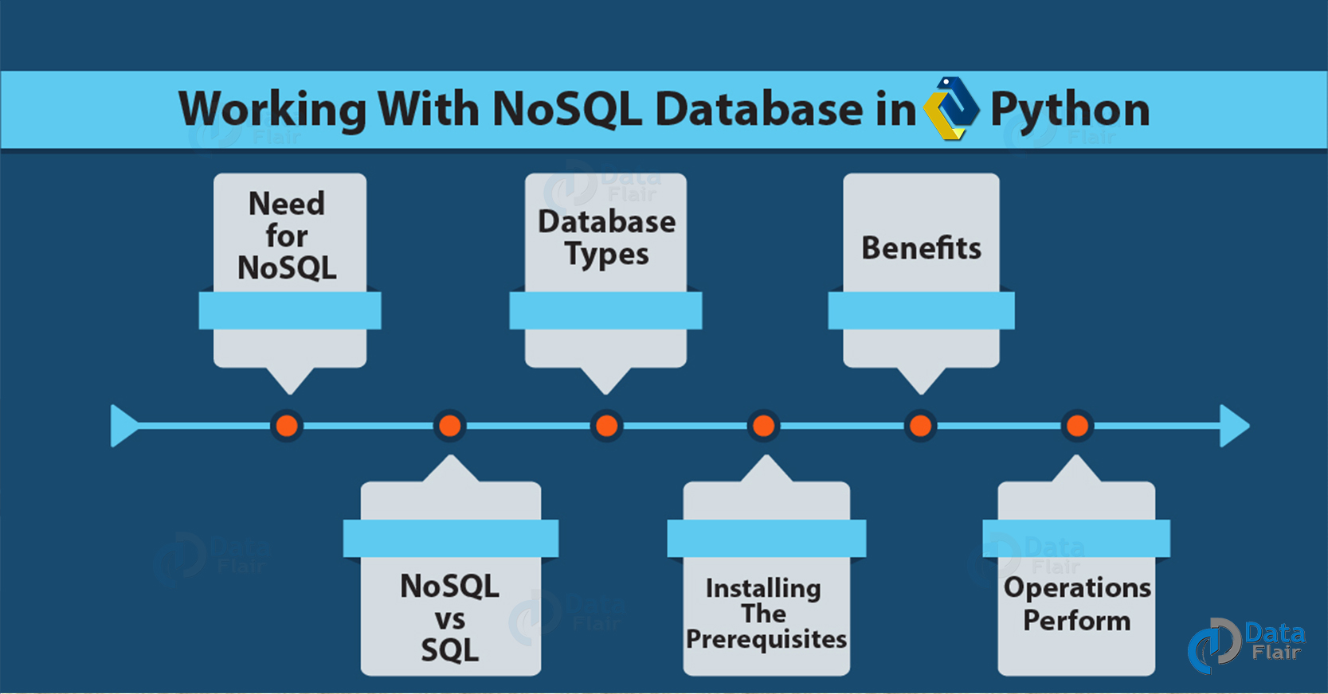
How to Work with NoSQL Database in Python using PyMongo

2. What is NoSQL Database?
Before beginning NoSQL Database in Python, let’s find out about NoSQL.
NoSQL expands to “Not Only SQL”. It lends us a way to store and retrieve data that we can model in forms other than relational (tables). NoSQL databases largely find use in applications involving big data and real-time uses. The reason we call them “Not Only SQL” is because they may support query languages that are SQL-like. We can use NoSQL to store data in forms like key-value, document, columnar, and graph. When working with large sets of distributed data, we use NoSQL.
Do you How to Copy a File n Python Programming Language

3. Need for NoSQL Database in Python
So, why do we need NoSQL?
- Instead of large monolithic servers and storage infrastructure, organizations now use cloud computing, open-source software, and commodity servers.
- Projects now adopt agile approaches instead of long waterfall traditions (Agility).
- There is a need to work with large volumes of data that changes type often. These types include unstructured, semi-structured, structured, and polymorphic data.
- The size of audiences has grown exponentially over the years (Scalability).

4. Database Types with NoSQL
As we’ve discussed before, we have four different types of data we can model with NoSQL Database in Python-
How to Work with NoSQL Database in Python using PyMongo

a. Document Databases
In a document database, each key pairs with a document. A document is a complex data structure and can hold any of the following- key-value pairs, key-array pairs, nested documents. These store semi-structured data.
We use these for applications like content management and mobile application data handling.

b. Graph Stores
A graph store holds knowledge about data networks. One such network is social connections. In a graph store, a node is like a record in a relational database, and an edge is like a connection between nodes. This lets it represent data relationships better. We use these for applications like CRM and reservation systems. Some examples are Neo4J and Giraph.

c. Key-Value Stores
A key-value store holds key-value pairs in its structure. This is the simplest NoSQL database. We use these in applications like session management and caching in web applications. Some examples include Riak, Redis, and Berkeley DB.

d. Wide-Column Stores
When we want to store columns together working with queries over large datasets, we can use wide-column stores. We also find these in SQL databases and they query large volumes faster. Some examples are Cassandra, HBase, and Google BigTable.
Read About Python Forensics – Hash Function, Virtualization

5. Benefits of Using NoSQL Database
This are the following advantages of NoSQL Database in Python, let’s discuss them one by one:
- Easy and flexible object-oriented programming.
- Large volumes of rapidly changing data- unstructured, structured, or semi-structured.
- Scale-out architecture that is geographically distributed.
- Agile sprints, frequent code pushes, quick schema iteration.

6. NoSQL vs SQL
So, how are these two different? Let’s see.
- Schemas are typically dynamic for NoSQL but fixed for SQL.
- NoSQL can have different kinds of database, as discussed, but SQL has only one.
- NoSQL came around in the late 2000s, SQL has been here since 1970s.
- For SQL, the data storage model is individual records, but for NoSQL, this depends on the database type.
- NoSQL has horizontal scaling; SQL has vertical.
- For NoSQL, development is open-source; for SQL, it is a combination of open-source and closed-source.
- The NoSQL DB used determines support for ACID transactions; SQL supports ACID transactions.
- Examples of NoSQL databases are MongoDB, Cassandra, Neo4J, and HBase; Those for SQL databases are MySQL, Oracle, Microsoft SQL Server, and Postgres.

7. Installing the Prerequisites of NoSQL Database in Python
In this Python NoSQL Database tutorial, we use the library pymongo. It is the official driver published by Mongo developers. You can install it this way:
C:\Users\lifei>pip install pymongo
Collecting pymongo
Downloading https://files.pythonhosted.org/packages/0f/54/ec07858c625460027536aefe8bbe1d0f319b62b5884ec8650e1c2649dccb/pymongo-3.7.0-cp36-cp36m-win_amd64.whl (309kB)
100% |████████████████████████████████| 317kB 392kB/s
Installing collected packages: pymongo
Successfully installed pymongo-3.7.0
This installs version 3.7.0, which is the latest version of pymongo at the time of writing the tutorial.
You will also need to install the MongoDB database.
Follow this link to know more about MongoDB Database

8. Operations Perform in NoSQL Database in Python
How to Work with NoSQL Database in Python using PyMongo

a. Insert Operation
To insert data into a NoSQL database in Python 3, we use the insert() method. This is the code we use in the command prompt (You could also run a script or simply use the interpreter):
- C:\Users\lifei>python
Python 3.6.5 (v3.6.5:f59c0932b4, Mar 28 2018, 17:00:18) [MSC v.1900 64 bit (AMD64)] on win32
Type “help”, “copyright”, “credits” or “license” for more information.
- >>> from pymongo import MongoClient
- >>> from pprint import pprint
- >>> client=MongoClient() #Choose client
- >>> db=client.test #Connect to DB
- >>> student=db.student
- >>> student_record={
- ... 'Name':'Ayushi Sharma',
- ... 'Enrolment':'0875CS191003',
- ... 'Age':'22'}
- >>> result=student.insert_one(student_record)
- >>> pprint(student.find_one({‘Age’:’22’}))
{u’Age’: u’22’,
u’Enrolment’: u’0875CS191003’,
u’Name’: u’Ayushi Sharma’,
u’_id’: ObjectId(‘7cyz7c2e72f5uh7829011e36’)}
Have a look The Best Article on Python’s Various Libraries

b. Update Operation
Now to update this data, we use the update() method.
- >>> from pymongo import MongoClient
- >>> from pprint import pprint
- >>> client=MongoClient() #Choose client
- >>> db=client.test #Connect to DB
- >>> student=db.student
- >>> db.student.update_one({'Age':'22'},
- ... {'$set': {'Name':'Ayushi Sharma',
- .. 'Enrolment':'0875CS191003',
- ... 'Age':'23'}}) #Choosing the record to update
- >>> pprint(student.find_one({‘Age’:’23’})
{u’Age’: u’23’,
u’Enrolment’: u’0875CS191003’,
u’Name’: u’Ayushi Sharma’,
u’_id’: ObjectId(‘7cyz7c2e72f5uh7829011e36’)}

c. Delete Operation
Now to delete this record, we can use the delete() method.
- >>> from pymongo import MongoClient
- >>> from pprint import pprint
- >>> client=MongoClient() #Choose client
- >>> db=client.test #Connect to DB
- >>> student=db.student
- >>> db.student.delete_one({‘Age’:’23’})
- >>> pprint(student.find_one({‘Age’:’23’})
None
Here, Python prints None because it can’t find that record in the database.
So, this was all about NoSQL Database in Python. Hope you like our explanation.

9. Conclusion
Hence, this gets you started with the basics of using NoSQL databases in Python using PyMongo. Leave your queries in the comments below.
See Also- Python Career Opportunities
For reference
Tags: Database Types with NoSQLDocument DatabasesGraph StoresKey-Value StoresNeed for NoSQL DatabaseNoSQL Database in PythonNoSQL vs SQLPython NoSQL DatabaseWide-Column StoresWorking NoSQL Python Database

Leave a Reply

*
*

This site is protected by reCAPTCHA and the Google Privacy Policy and Terms of Service apply.

Home About us Contact us Terms and Conditions Cancellation and Refund Privacy Policy Disclaimer Blogs Write For Us Careers Success Stories

Python – Relational Database
Python – Stemming & Lemmatization
Python Tutorials
How to Work with NoSQL Database in Python using PyMongo
❮ Prev
Next ❯

Popular Courses
Hadoop + Spark Course
Big Data Hadoop Course
Spark Scala Course
Apache Flink Course
Python Course

Popular Tutorials
Hadoop Tutorials
Spark Tutorials
Flink Tutorials
Tableau Tutorials
Power BI Tutorials
QlikView Tutorials

Popular Tutorials
Data Science Tutorials
Machine Learning Tutorials
Python Tutorials
R Tutorials
SAS Tutorials
SQL Tutorials
DataFlair © 2020. All Rights Reserved.

We use cookies to provide the best services. By using our site, you comply with our cookies policy. Learn more

Blog Home
- Courses
- Data Science
- Big Data
- Categories
- Interview Questions
- Job Portal
- Write For Us
Blog Home » Python Tutorials » Learn Python Stemming and Lemmatization – Python NLTK
- 2

Learn Python Stemming and Lemmatization – Python NLTK
by DataFlair Team · Updated ·

1. Python Stemming and Lemmatization
In this Python Stemming tutorial, we will discuss Stemming and Lemmatization in Python Programming Language– two basics when working with data science in Python. Moreover, we will discuss Python NLTK and Python Stemming examples. Along with this, we will learn Python Stemming vs Lemmatization.
So, let’s begin Python Stemming and Lemmatization.
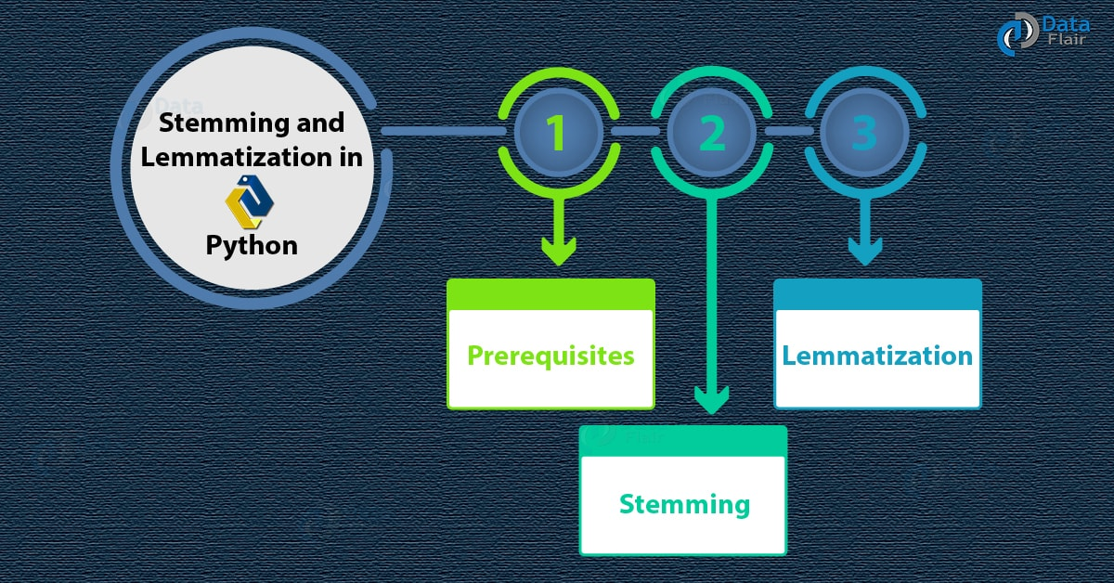
Python Stemming and Lemmatization – NLTK

2. Prerequisites for Python Stemming and Lemmatization
For our purpose, we will use the following library-

a. Python NLTK
Python NLTK is an acronym for Natural Language Toolkit. It is a set of libraries that let us perform Natural Language Processing (NLP) on English with Python. It lets us do so in a symbolic and statistical way. It also provides sample data and supports graphical representation.
Do you How Python Rename File – Single & Multiple Files With Example
You can install it using pip-
C:\Users\lifei>pip install nltk
Collecting nltk
Downloading
https://files.pythonhosted.org/packages/50/09/3b1755d528ad9156ee7243d52aa5cd2b809ef053a0f31b53d92853dd653a/nltk-3.3.0.zip (1.4MB)
100% |████████████████████████████████| 1.4MB 669kB/s
Requirement already satisfied: six in c:\users\lifei\appdata\local\programs\python\python36\lib\site-packages (from nltk) (1.11.0)
Installing collected packages: nltk
Running setup.py install for nltk … done
Successfully installed nltk-3.3

3. What is Python Stemming?
Python Stemming is the act of taking a word and reducing it into a stem. A stem is like a root for a word- that for writing is writing. But this doesn’t always have to be a word; words like study, studies, and studying all stem into the word studi, which isn’t actually a word.
Python Lemmatization and Stemming – Python NLTK
It is almost like these words are synonyms; this lets us normalize sentences and makes searching for words easier and faster. The Python stemming algorithms we have are often based on rules applying to suffix-stripping. The most common is the Porter-Stemmer, which has been around since 1979.
Read about Python Read And Write File – File Handling In Python

a. Python Stemming Individual Words
- >>>import nltk
- >>> from nltk.stem import PorterStemmer
- >>> words=['write','writer','writing','writers']
- >>> ps=PorterStemmer()
- >>> for word in words:
- print(f"{word}: {ps.stem(word)}")
Output-
write: write
writer: writer
writing: write
writers: writer
Now let’s try some more words.
- >>> ps.stem('written')
‘written’
- >>> ps.stem('wrote')
‘wrote’
- >>> ps.stem('writable')
‘writabl’
- >>> ps.stem('writes')
‘write’

b. Another Example of Python Stemming
Let’s try more words.
- >>> ps.stem('game')
‘game’
- >>> ps.stem('gaming')
‘game’
- >>> ps.stem('gamed')
‘game’
- >>> ps.stem('games')
‘game’
Let’s Explore Difference Between Method and Function in Python

c. Python Stemming an Entire Sentence
- >>> from nltk.tokenize import word_tokenize
- >>> nltk.download('punkt')
- >>> sentence='I am enjoying writing this tutorial; I love to write and I have written 266 words so far. I wrote more than you did; I am a writer.'
- >>> words=word_tokenize(sentence)
- >>> for word in words:
- print(f"{word}: {ps.stem(word)}")
I: I
am: am
enjoying: enjoy
writing: write
this: thi
tutorial: tutori
;: ;
I: I
love: love
to: to
write: write
and: and
I: I
have: have
written: written
266: 266
words: word
so: so
far: far
.: .
I: I
wrote: wrote
more: more
than: than
you: you
did: did
;: ;
I: I
am: am
a: a
writer: writer
.: .

4. What is Python Lemmatization?
Python Lemmatization lets us group together inflected forms of a word. It links words with similar meanings to one word and maps various words onto one root.
Let’s Discuss Python Regular Expressions | Python Regex Tutorial
What is Python Lemmatization?

a. Python Stemming vs Lemmatization
But how Python Lemmatization is different from stemming? While stemming can create words that do not actually exist, Python lemmatization will only ever result in words that do. lemmas are actual words.
- >>> ps.stem('indetify')
‘indetifi’
- >>> lemmatizer.lemmatize('identify')
‘identify’

b. Python Lemmatization Examples
- >>> from nltk.stem import WordNetLemmatizer
- >>> lemmatizer=WordNetLemmatizer()
- >>> nltk.download('wordnet')
- >>> lemmatizer.lemmatize('dogs')
‘dog’
- >>> lemmatizer.lemmatize('geese')
‘goose’
- >>> lemmatizer.lemmatize('cacti')
‘cactus’
- >>> lemmatizer.lemmatize('erasers')
‘eraser’
- >>> lemmatizer.lemmatize('children')
‘child’
- >>> lemmatizer.lemmatize('feet')
‘foot’
Let’s Learn Python Debugger with Examples

c. Using Pos
- >>> lemmatizer.lemmatize('better',pos='a')
‘good’
Here, pos is a speech parameter, which is noun by default. This means Python will try to find the closest noun.
- >>> lemmatizer.lemmatize('redder','a')
‘red’
Since, Python lemmatization considers whether a word is a noun, a verb, an adjective, an adverb, and so, Python needs to find out about a word’s context.
So, this was all about Stemming and Lemmatization in Python & Python NLTK. Hope you like our explanation.

5. Conclusion
Hence, in this Python tutorial, we studied Python Stemming and Lemmatization. In addition, we studied NLTK, an example of Stemming and Lemmatization in Python, and the difference between Python Stemming and Lemmatization. Tell us what you think about this Python Lemmatization and Stemming tutorial, in the comments Box.
Related Topic- CGI Programming in Python with Functions and Modules
For reference
Tags: lemmatization in PythonNatural Language Toolkitnltk lemmatizer posnltk stemmingPython lemmatizationPython NLTKPython stemmingspacy lemmatizerstanford lemmatizerStemming vs Lemmatization

2 Responses
- Comments2
- Pingbacks0

amilcar dsilva
January 18, 2019 at 9:40 am
What is the use of the word ‘punkt’ in the code snippet below?
Thanking you in advance for your explanation.
>>> from nltk.tokenize import word_tokenize
>>> nltk.download(‘punkt’)
>>> sentence=’I am enjoying writing this tutorial; I love to write and I have written 266 words so far. I wrote more than you did; I am a writer.’
>>> words=word_tokenize(sentence)
>>> for word in words:
print(f”{word}: {ps.stem(word)}”)
Reply
  - DataFlair Team
February 2, 2019 at 5:40 pm
Hello, Amilcar
Thanks for the appreciation and comment for Python Stremming. Here, Punkt is a sentence tokenizer that takes text and divides it into a list of sentences. It does so using an unsupervised algorithm, and before we use it, we must train it on a huge collection of plaintext.
Its purpose is to build a model for sentence-starter words, abbreviations, and collocations. For English, NLTK ships with a pre-trained Punkt tokenizer. In German, ‘punkt’ means ‘point’.
Hope, you find it useful!
Regards,
DataFlair
Reply

Leave a Reply

*
*

This site is protected by reCAPTCHA and the Google Privacy Policy and Terms of Service apply.

Home About us Contact us Terms and Conditions Cancellation and Refund Privacy Policy Disclaimer Blogs Write For Us Careers Success Stories

Python – NoSQL Database
Python – Aggregation & Data Wrangling
Python Tutorials
Learn Python Stemming and Lemmatization – Python NLTK
❮ Prev
Next ❯

Popular Courses
Hadoop + Spark Course
Big Data Hadoop Course
Spark Scala Course
Apache Flink Course
Python Course

Popular Tutorials
Hadoop Tutorials
Spark Tutorials
Flink Tutorials
Tableau Tutorials
Power BI Tutorials
QlikView Tutorials

Popular Tutorials
Data Science Tutorials
Machine Learning Tutorials
Python Tutorials
R Tutorials
SAS Tutorials
SQL Tutorials
DataFlair © 2020. All Rights Reserved.

We use cookies to provide the best services. By using our site, you comply with our cookies policy. Learn more

Blog Home
- Courses
- Data Science
- Big Data
- Categories
- Interview Questions
- Job Portal
- Write For Us
Blog Home » Python Tutorials » Learn Aggregation and Data Wrangling with Python
- 2

Learn Aggregation and Data Wrangling with Python
by DataFlair Team · Updated ·

1. Objective
Our previous tutorial, we talked about Python Django. Today in this Data Wrangling tutorial, we will see Python Aggregation and Data Wrangling with Python Programming Language. Moreover, we will discuss prerequisites & reasons to use Data Wrangling with Python. In addition, we discuss Dropping Missing Values, Grouping Data, Filtering Data, Pivoting Dataset, Shifted Datasets, Melted Data, Reducing into an ABT, Concatenating Data, Exporting Data, and Python Aggregate.
So, let’s start Aggregation and Data Wrangling with Python.
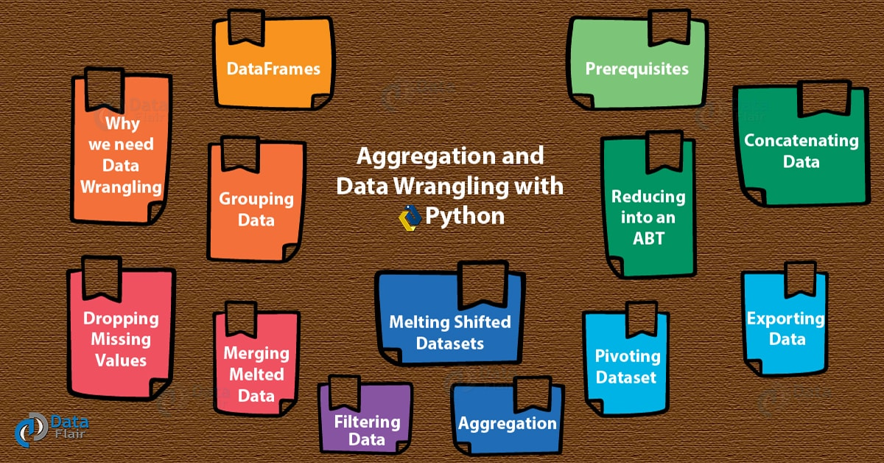
Aggregation and Data Wrangling with Python

2. A Brief on DataFrames
A DataFrame in pandas is a 2-dimensional data structure which holds data in a tabular sense. This means it lets us work in a context of rows and columns.
A dataframe is-
- Mutable.
- Capable of holding columns of different types.
- Capable of performing arithmetic operations on rows and columns.
- A holder of labeled axes for the rows and columns.
This is the DataFrame constructor we have-
pandas.DataFrame (data, index, columns, dtype, copy)
Read about Python Data File Formats – How to Read CSV, JSON, and XLS Files

3. Python Data Wrangling – Prerequisites

a. Python pandas
For aggregation and Data wrangling with Python, you will need the pandas’ library. It helps us with data manipulation and analysis. It has data structures and allows operations that we can use to manipulate numerical tables and time series.
Aggregation and Data Wrangling with Python
You can install it using the following command-
C:\Users\lifei>pip install pandas
At the time of writing, we use the version 0.23.1 of pandas.

b. Python NumPy
NumPy is another Python library that lets us handle large, multi-dimensional arrays and matrices. It also offers various high-level mathematical functions to help us deal with these.
Aggregation and Data Wrangling with Python
To install this, you can try the following command in the command prompt-
C:\Users\lifei>pip install numpy
Do you How to Work with NoSQL Database in Python using PyMongo

c. Python DataFrames
For our purpose, we will need two dataframes. We can create a DataFrame using any data type like list, dictionary, or series. We can also use a NumPy and array or another DataFrame to create it. Let’s use a dictionary for now.
- >>> one=pandas.DataFrame({
- 'emp_id':[1,2,3,4,5],
- 'dept_name':['duvet','bidet','footwear','clothing','electronics'],
- 'aisle':[1,2,3,4,5]})
- >>> first=pandas.DataFrame(one)
- >>> two=pandas.DataFrame({
- 'emp_id':[6,7,8,9,10],
- 'dept_name':['grocery','toys','laundry','frozen','stationery'],
- 'aisle':[6,2,2,9,10]})
- >>> second=pandas.DataFrame(two)
We also create a csv file with utf-8 format in Excel-
Aggregation and Data Wrangling with Python
We save this as supermarket.csv.

4. Why we need Data Wrangling with Python
Much data obtained from various sources are raw and unusable. This could be messy or incomplete. With data wrangling with Python, we can perform operations on raw data to clean it out to an extent. Wrangling is essential to data science. Let’s take a quick look at it.

5. Dropping Missing Values
As you can see, we have no aisle number for the frozen department in our csv file.
- >>> import os
- >>> os.chdir('C:\\Users\\lifei\\Desktop')
- >>> three=pandas.read_csv('supermarket.csv')
- >>> pandas.isnull(three).any()
- emp_id False
- dept_name False
- aisle True
- dtype: bool
This shows us that the ‘aisle’ column does have a missing value. The following command shows us the null values in the file-
- >>> three.head()
Aggregation and Data Wrangling with Python
Let’s Revise Python File I/O – Python Write to File and Read File
To drop this record, we use the following command-
- >>> three.dropna()
Data Wrangling with Python – Dropping Missing Values

6. Grouping Data
The pandas gorupby() method returns a DataFrameGroupBy object. Calling the method value_counts() returns the number of occurrences for each unique value in the column we specify.
- >>> three.groupby('aisle').dept_name.value_counts()
Data Wrangling with Python – Grouping Data
This tells us about the correlation between aisle number and department name. This lets us discover trends in data. In situations where we want to see trends by the city, we can group records by their geographical factors.

a. Finding unique values
For this, we can use the unique() method.
- >>> two.aisle.unique()
array([ 6, 2, 9, 10], dtype=int64)

b. Length of dataframe
Then len() function gives us the length of the dataframe.
- >>> len(two)
5
Do you know How I Used These 5 Steps to Learn Python for Data Science

7. Filtering Data
To gain a subset of data using some criterion, we can filter out parts we need.
Data Wrangling with Python – Filtering Data

a. Single Conditions
- >>> two[two['aisle']>3]
Filtering Data – Single Conditions
- >>> two[two['aisle']==2]
Filtering Data – Single Conditions

b. Multiple Conditions
- >>> two[(two['aisle']==2) & (two['dept_name']=='toys')]
Filtering Data – Multiple Conditions
Let’s Read about Python Counter – Python Collections Type

c. Describing your Data
- >>> (two[(two['aisle']==2) & (two['dept_name']=='toys')]).describe()
Filtering Data – Describing your Data

d. Filtering through Values
- >>> two[two.aisle.isin([2,7,9])]
Filtering through Values

8. Pivoting Dataset
Pivoting lets us reshape a DataFrame by column/index values. In other words, it produces a pivot table.
- >>> (two.pivot(index='emp_id',columns='aisle',values='dept_name')).tail()
Data Wrangling with Python – Pivoting Dataset
Providing a number to this tail() call will give us that many records.
- >>> (two.pivot(index='emp_id',columns='aisle',values='dept_name')).tail(3)
Data Wrangling with Python – Pivoting Dataset
a. Shifting a pivoted dataset
We can shift the DataFrame’s index by a certain number of periods using the shift() method.
- >>> (two.pivot(index='emp_id',columns='aisle',values='dept_name')).tail(3).shift(1)
Data Wrangling with Python – Shifting a pivoted dataset
Let’s Discuss Python Operator Overloading and Python Magic Methods

9. Melting Shifted Datasets
We can also melt a dataset (unpivot it).
- >>> (two.melt(id_vars=['emp_id'],value_name='dept_name')).tail()
Data Wrangling with Python – Melting Shifted Datasets

10. Merging Melted Data
We can join melted DataFrames into one Analytical Base Table using the merge() function.
- >>> melt1=two.melt(id_vars=['emp_id'],value_name='dept_name')
- >>> melt2=two.melt(id_vars=['emp_id'],value_name='aisle')
- >>> pandas.merge(melt1,melt2,on=['emp_id']).tail(1)
Aggregation and Data Wrangling with Python

11. Reducing into an ABT
Finally, to reduce this result into an analytical base table, we do the following:
- >>> from functools import reduce
- >>> base=two[['aisle','dept_name','emp_id']]
- >>> feature=[base]+[melt1,melt2]
- >>> abt=reduce(lambda left,right: pandas.merge(left,right,on=['emp_id']),[melt1,melt2])
- >>> abt.tail(1)
Data Wrangling with Python – Reducing into an ABT

12. Concatenating Data
We can concatenate datasets along an axis using the concat() method.
- >>> pandas.concat([one,two])
Concatenating Data
Have a look – Lessons on Python Sequences and Collections

13. Exporting Data
Finally, we can export our clean and filtered data to an Excel sheet.
- >>> res=pandas.concat([one,two])
- >>> res.to_excel('res.xlsx')

14. How Python Aggregate Data?
To apply aggregations on our datasets, we can use the Python numpy library along with pandas.
Learn Aggregation and Data Wrangling with Python
Let’s create a dataframe first.
- >>> df=pandas.DataFrame(numpy.random.randn(7,3),
- index=pandas.date_range('1/1/2000',periods=7),
- columns=['A','B','C'])
- >>> print(df)
How Python Aggregate Data
- >>> print(df.rolling(window=3,min_periods=1))
- Rolling [window=3,min_periods=1,center=False,axis=0]
Let’s explore The Best Article on Python’s Various Libraries

a. Python Aggregating an entire dataframe
We can aggregate an entire dataframe as-
- >>> r=df.rolling(window=3,min_periods=1)
- >>> r.aggregate(numpy.sum)
How Python Aggregate Data
As you can see, this keeps aggregating the previous value into itself. Another aggregation we can use is max-
- >>> r.aggregate(numpy.max)
Python Aggregating an entire dataframe
Other aggregations include mean, median, and min.

b. Python Aggregating one column
To aggregate just one column, we can use its index.
- >>> r['B'].aggregate(numpy.mean)
Python Aggregating one column
Let’s See the Python Property – The Problem and Solution

c. Python Aggregating multiple columns
We can also specify more than one column to aggregate.
- >>> r[['B','C']].aggregate(numpy.sum)
Python Aggregating multiple columns
So, this was all about Aggregation and Data Wrangling with Python. Hope you like our explanation.

15. Conclusion
Hence, this was how to clean your data with wrangling and then how to apply aggregations on it. Did we miss out on something in Aggregation and Data Wrangling with Python? Drop your suggestions in the comments.
See Also- List of 63 Python os Modules
For reference
Tags: data preparation in pythondata preprocessing code in pythondata preprocessing using pythondata wrangling examplesdata wrangling toolsdata wrangling with python pdfPython DataFramesPython NumPyPython PandasWhy we need Data Wrangling with Python

2 Responses
- Comments2
- Pingbacks0

Haresh
July 14, 2018 at 10:39 am
Hi,
Well written and informative post. Your points are clear and easy to understand. Thank you so much for this remarkable piece of content.
Well appreciated, and looking forward to more of such article.
Reply
  - Data Flair
July 30, 2018 at 7:23 am
Words Can’t Describe How Grateful We Are For Your Appreciation On “Aggregation and Data Wrangling with Python Tutorial”, We hope you learned How to drop missing Values & group and filter Data while performing – Python Aggregation and Data Wrangling.
You must read Python Stemming and Lemmatization, also related to Aggregation and Data Wrangling with Python Programming.
Reply

Leave a Reply

*
*

This site is protected by reCAPTCHA and the Google Privacy Policy and Terms of Service apply.

Home About us Contact us Terms and Conditions Cancellation and Refund Privacy Policy Disclaimer Blogs Write For Us Careers Success Stories

Python – Stemming & Lemmatization
Python – Statistics
Python Tutorials
Learn Aggregation and Data Wrangling with Python
❮ Prev
Next ❯

Popular Courses
Hadoop + Spark Course
Big Data Hadoop Course
Spark Scala Course
Apache Flink Course
Python Course

Popular Tutorials
Hadoop Tutorials
Spark Tutorials
Flink Tutorials
Tableau Tutorials
Power BI Tutorials
QlikView Tutorials

Popular Tutorials
Data Science Tutorials
Machine Learning Tutorials
Python Tutorials
R Tutorials
SAS Tutorials
SQL Tutorials
DataFlair © 2020. All Rights Reserved.

We use cookies to provide the best services. By using our site, you comply with our cookies policy. Learn more

Blog Home
- Courses
- Data Science
- Big Data
- Categories
- Interview Questions
- Job Portal
- Write For Us
Blog Home » Python Tutorials » Python Statistics – Python p-Value, Correlation, T-test, KS Test
- 5

Python Statistics – Python p-Value, Correlation, T-test, KS Test
by DataFlair Team · Updated ·

1. Python Statistics
In this Python Statistics tutorial, we will learn how to calculate the p-value and Correlation in Python. Moreover, we will discuss T-test and KS Test with example and code in Python Statistics.
So, let’s start the Python Statistics Tutorial.
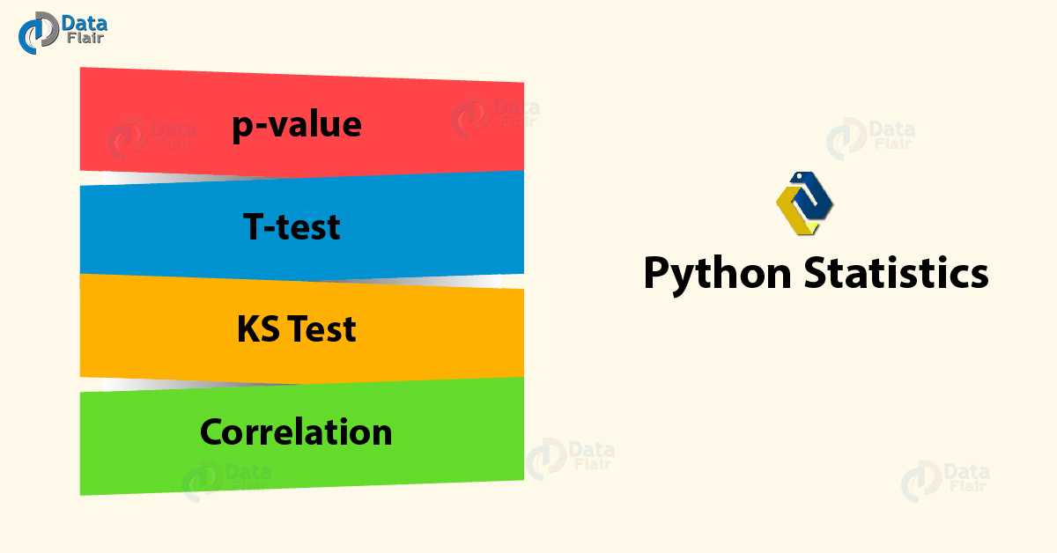
Python Statistics – p-Value, Correlation, T-test, KS Test

2. p-value in Python Statistics
When talking statistics, a p-value for a statistical model is the probability that when the null hypothesis is true, the statistical summary is equal to or greater than the actual observed results. This is also termed ‘probability value’ or ‘asymptotic significance’.
Do you know about Python Decorators
The null hypothesis states that two measured phenomena experience no relationship to each other. We denote this as H or H0. One such null hypothesis can be that the number of hours spent in the office affects the amount of salary paid. For a significance level of 5%, if the p-value falls lower than 5%, the null hypothesis is invalidated. Then it is discovered that the number of hours you spend in your office will not affect the amount of salary you will take home. Note that p-values can range from 0% to 100% and we write them in decimals. A p-value for 5% will be 0.05.
A smaller p-value bears more significance as it can tell you that the hypothesis may not explain the observation fairly. If one or more of these probabilities turn out to be less than or equal to α, the level of significance, we reject the null hypothesis. For a true null hypothesis, p can take on any value between 0 and 1 with equal likeliness. For a true alternative hypothesis, p-values likely fall closer to 0.
Python p-Value

3. T-test in Python Statistics
Let’s talk about T-tests. Such a test tells us whether a sample of numeric data strays or differs significantly from the population. It also talks about two samples- whether they’re different. In other words, it gives us the probability of difference between populations. The test involves a t-statistic. For small samples, we can use a T-test with two samples.
Python Statistics – Python T-test
Let’s discuss Python Generators

a. One-sample T-test with Python
Let’s try this on a single sample. The test will tell us whether means of the sample and the population are different. Consider the voting populace in India and in Gujarat. Does the average age of Gujarati voters differ from that of the population? Let’s find out.
- >>> import numpy as np
- >>> import pandas as pd
- >>> import scipy.stats as stats
- >>> import matplotlib.pyplot as plt
- >>> import math
- >>> np.random.seed(6)
- >>> population_ages1=stats.poisson.rvs(loc=18,mu=35,size=150000)
- >>> population_ages2=stats.poisson.rvs(loc=18,mu=10,size=100000)
- >>> population_ages=np.concatenate((population_ages1,population_ages2))
- >>> gujarat_ages1=stats.poisson.rvs(loc=18,mu=30,size=30)
- >>> gujarat_ages2=stats.poisson.rvs(loc=18,mu=10,size=20)
- >>> gujarat_ages=np.concatenate((gujarat_ages1,gujarat_ages2))
- >>> population_ages.mean()
43.000112
- >>> gujarat_ages.mean()
39.26
- >>> stats.ttest_1samp(a=gujarat_ages,popmean=population_ages.mean())
Ttest_1sampResult(statistic=-2.5742714883655027, pvalue=0.013118685425061678)
Now this value of -2.574 tells us how aberrant the sample mean is from the null hypothesis.

b. Two-sample T-test With Python
Such a test tells us whether two data samples have different means. Here, we take the null hypothesis that both groups have equal means. We don’t need a known population parameter for this.
Let’s revise Recursion in Python
- >>> np.random.seed(12)
- >>> maharashtra_ages1=stats.poisson.rvs(loc=18,mu=33,size=30)
- >>> maharashtra_ages2=stats.poisson.rvs(loc=18,mu=13,size=20)
- >>> maharashtra_ages=np.concatenate((maharashtra_ages1,maharashtra_ages2))
- >>> maharashtra_ages.mean()
42.26
- >>> stats.ttest_ind(a=gujarat_ages,b=maharashtra_ages,equal_var=False)
Ttest_indResult(statistic=-1.4415218453964938, pvalue=0.1526272389714945)
The value of 0.152 tells us there’s a 15.2% chance that the sample data is such far apart for two identical groups. This is greater than the 5% confidence level.

c. Paired T-test With Python
When you want to check how different samples from the same group are, you can go for a paired T-test. Let’s take an example.
- >>> np.random.seed(11)
- >>> before=stats.norm.rvs(scale=30,loc=250,size=100)
- >>> after=before+stats.norm.rvs(scale=5,loc=-1.25,size=100)
- >>> weight_df=pd.DataFrame({"weight_before":before,
- "weight_after":after,
- "weight_change":after-before})
- >>> weight_df.describe()
Paired Sample T-test
- >>> stats.ttest_rel(a=before,b=after)
Ttest_relResult(statistic=2.5720175998568284, pvalue=0.011596444318439857)
So, we see we have just 1% chances to find such huge differences between samples.
Do you know about Python Errors

4. KS Test in Python Statistics
This is the Kolmogorov-Smirnov test. It lets us test the hypothesis that the sample is a part of the standard t-distribution. Let’s take an example.
- >>> stats.kstest(x,'t',(10,))
KstestResult(statistic=0.023682909426459897, pvalue=0.6289865281325614)
- >>> stats.kstest(x,'norm')
KstestResult(statistic=0.019334747291889, pvalue=0.8488119233062457)
Pay attention to the p-values in both cases.

a. Two samples
What we saw above was the KS test for one sample. Let’s try two.
- >>> stats.ks_2samp(gujarat_ages,maharashtra_ages)
Ks_2sampResult(statistic=0.26, pvalue=0.056045859714424606)

5. Correlation in Python Statistics
This is a statistical relationship between two random variables (or bivariate data). This can be causal. It is a measure of how close two variables are to holding a linear relationship to each other. One such example will be the correlation between demand and supply for a product whose supply is limited.
Have a look at Exception Handling in Python
Correlation can denote a predictive relationship that we can exploit. To measure the degree of correlation, we can use constants like ρ or r. Benefits of correlation-
- Predicting one quantity from another
- Discovering the existence of a causal relationship
- Foundation for other modeling techniques

a. Example of Correlation In Python
Let’s take an example.
- >>> df=pd.read_csv('furniture.csv',index_col='Serial',parse_dates=True)
- >>> df['Gross']=df.Cost+df.Cost*10
- >>> df.describe()
Python Statistics – Correlation With Python
- >>> df.corr()
Example of Python Correlation
This gives us how each column correlates to another. You can also calculate the covariance in the following way-
- >>> df.cov()
Cost Gross
Cost 3.131608e+08 3.444769e+09
Gross 3.444769e+09 3.789246e+10

b. Plotting Correlation in Python
Let’s use seaborn to plot the correlation between columns of the ‘iris’ dataset.
Let’s revise Python Iterator
- >>> import seaborn as sn
- >>> df1=sn.load_dataset('iris')
- >>> sn.pairplot(df,kind='scatter')
<seaborn.axisgrid.PairGrid object at 0x06294090>
- >>> plt.show()
Plotting Correlation in Python

c. Saving the Results
We can export the result of a correlation as a CSV file.
- >>> d=df1.corr()
- >>> d.to_csv('iriscorrelation.csv')
This gives us the following CSV file-
Python Statistics – Saving the Results
So, this was all in Python Statistics. Hope you like our explanation.

6. Conclusion: Python Statistics
Hence, in this Python Statistics tutorial, we discussed the p-value, T-test, correlation, and KS test with Python. To conclude, we’ll say that a p-value is a numerical measure that tells you whether the sample data falls consistently with the null hypothesis. Correlation is an interdependence of variable quantities. Still, if any doubt regarding Python Statistics, ask in the comment tab.
See also –
Python Directory and Files
For reference
Tags: Correlation in Python Statisticscorrelation with PythonExample of Correlation In PythonKS Testone sample t-testp-value in Python Statisticspaired t-test PythonPaired T-test with PythonPlotting Correlation in PythonPython P valuePython StatisticsPython Statistics tutorialStatistics in Pythont test PythonT-test in Python Statisticstwo sample t-test

5 Responses
- Comments5
- Pingbacks0

Alkis Piskas
February 21, 2019 at 5:59 pm
This tutorial seems good but ‘minnesota_ages1’ and ‘minnesota_ages2’ are inexistent, so the code doesn’t work!
Reply
  - DataFlair Team
February 22, 2019 at 1:57 pm
Hi Alkis,
Thanks for connecting us through this Python Statistics tutorial.
Good catch, it should be gujarat_ages1 and gujarat_ages2. We have made the correction.
Regards,
DataFlair
Reply

- vimal prakash
January 11, 2020 at 4:51 pm
>>> sn.pairplot(df,kind=’scatter’)
seems it should be df1
Reply
  - DataFlair Team
January 25, 2020 at 5:00 pm
Hey Vimal Prakash,
Update the code. Change df to df1 in this single line.
Reply

- Ichsan
February 14, 2020 at 1:17 pm
Nice blog. I wanti to ask question. For example, we have code like this. I have 4 method to increase plant height.
Now, we want to check method’s significancy that affect height of plant
pair_t = dataframe.t_test_pairwise(‘C(Method)’)
pair_t.result_frame
I got p>|t| and pvalue-hs. Please tell me the different
Reply

Leave a Reply

*
*

This site is protected by reCAPTCHA and the Google Privacy Policy and Terms of Service apply.

Home About us Contact us Terms and Conditions Cancellation and Refund Privacy Policy Disclaimer Blogs Write For Us Careers Success Stories

Python – Aggregation & Data Wrangling
Python – Descriptive Statistics
Python Tutorials
Python Statistics – Python p-Value, Correlation, T-test, KS Test
❮ Prev
Next ❯

Popular Courses
Hadoop + Spark Course
Big Data Hadoop Course
Spark Scala Course
Apache Flink Course
Python Course

Popular Tutorials
Hadoop Tutorials
Spark Tutorials
Flink Tutorials
Tableau Tutorials
Power BI Tutorials
QlikView Tutorials

Popular Tutorials
Data Science Tutorials
Machine Learning Tutorials
Python Tutorials
R Tutorials
SAS Tutorials
SQL Tutorials
DataFlair © 2020. All Rights Reserved.

We use cookies to provide the best services. By using our site, you comply with our cookies policy. Learn more

Blog Home
- Courses
- Data Science
- Big Data
- Categories
- Interview Questions
- Job Portal
- Write For Us
Blog Home » Python Tutorials » Python Descriptive Statistics – Measuring Central Tendency & Variability
- 0

Python Descriptive Statistics – Measuring Central Tendency & Variability
by DataFlair Team · Updated ·

1. Objective
In our last tutorial, we studied Python Charts. Today, we will learn about Python Descriptive Statistics. In this Python Statistics tutorial, we will discuss what is Data Analysis, Central Tendency in Python: mean, median, and mode. Moreover, we will discuss Python Dispersion and Python Pandas Descriptive Statistics. Along with this, we will cover the variance in Python and how to calculate the variability for a set of values.
So, let’s begin the Python Descriptive Statistics Tutorial.
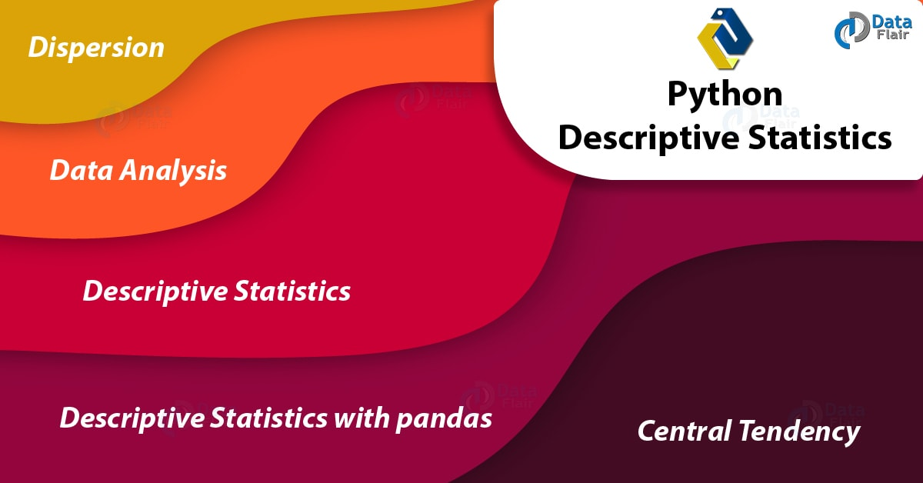
Python Descriptive Statistics – Measuring Central Tendency & Variability

2. Data Analysis
With data analysis, we use two main statistical methods- Descriptive and Inferential.
- Descriptive statistics uses tools like mean and standard deviation on a sample to summarize data.
- Inferential statistics, on the other hand, looks at data that can randomly vary, and then draw conclusions from it.
Some such variations include observational errors and sampling variation.
Do you know about Python Collection Module

3. Descriptive Statistics in Python
Python Descriptive Statistics process describes the basic features of data in a study. It delivers summaries on the sample and the measures and does not use the data to learn about the population it represents.
Under descriptive statistics, fall two sets of properties- central tendency and dispersion. Python Central tendency characterizes one central value for the entire distribution. Measures under this include mean, median, and mode. Python Dispersion is the term for a practice that characterizes how apart the members of the distribution are from the center and from each other. Variance/Standard Deviation is one such measure of variability.

4. Python Descriptive Statistics – Central Tendency in Python
We have seen what central tendency or central location is. Now let’s take a look at all the functions Python caters to us to calculate the central tendency for a distribution. For this, let’s import the Python statistics module.
- >>>import statistics as st
Python Descriptive Statistics – Central Tendency

a. mean()
This function returns the arithmetic average of the data it operates on. If called on an empty container of data, it raises a StatisticsError.
- >>> nums=[1,2,3,5,7,9]
- >>> st.mean(nums)
4.5
- >>> st.mean([-2,-4,7]) #Negative numbers
0.3333333333333333
- >>> from fractions import Fraction as fr
- >>> st.mean((fr(3,4),fr(5,7),fr(2,1))) #Fractions
Fraction(97, 84)
- >>> st.mean({1:"one",2:"two",3:"three"}) #Keys from a dictionary
2
Do you know the difference between Python Modules vs Packages

b. mode()
This function returns the most common value in a set of data. This gives us a great idea of where the center lies.
- >>> nums=[1,2,3,5,7,9,7,2,7,6]
- >>> st.mode(nums)
7
- >>> st.mode(['A','B','b','B','A','B'])
‘B’

c. median()
For data of odd length, this returns the middle item; for that of even length, it returns the average of the two middle items.
- >>> st.median(nums) #(5+6)/2
5.5

d. harmonic_mean()
This function returns the harmonic mean of the data. For three values a, b, and c, the harmonic mean is-
3/(1/a + 1/b +1/c)
It is a measure of the center; one such example would be speed.
- >>> st.harmonic_mean([2,4,9.7])
3.516616314199396
For the same set of data, the arithmetic mean would give us a value of 5.233333333333333.

e. median_low()
When the data is of an even length, this provides us the low median of the data. Otherwise, it returns the middle value.
- >>> st.median_low([1,2,4])
2
- >>> st.median_low([1,2,3,4])
2

f. median_high()
Like median_low, this returns the high median when the data is of an even length. Otherwise, it returns the middle value.
- >>> st.median_high([1,2,4])
2
- >>> st.median_high([1,2,3,4])
3
Let’s Learn CGI Programming in Python with Functions and Modules

g. median_grouped()
This function uses interpolation to return the median of grouped continuous data. This is the 50th percentile.
- >>> st.median([1,3,3,5,7])
3
- >>> st.median_grouped([1,3,3,5,7],interval=1)
3.25
- >>> st.median_grouped([1,3,3,5,7],interval=2)
3.5

5. Python Descriptive Statistics – Dispersion in Python
Dispersion/spread gives us an idea of how the data strays from the typical value.
Python Descriptive Statistics – Dispersion

a. variance()
This returns the variance of the sample. This is the second moment about the mean and a larger value denotes a rather spread-out set of data. You can use this when your data is a sample out of a population.
- >>> st.variance(nums)
7.433333333333334

b. pvariance()
This returns the population variance of data. Use this to calculate variance from an entire population.
- >>> st.pvariance(nums)
6.69

c. stdev()
This returns the standard deviation for the sample. This is equal to the square root of the sample variance.
- >>> st.stdev(nums)
2.7264140062238043
Read about Python Namespace and Variable Scope – Local and Global Variables

d. pstdev()
This returns the population standard deviation. This is the square root of population variance.
- >>> st.pstdev(nums)
2.5865034312755126
The statistics module defines one exception-
exception statistics.StatisticsError
This is a subclass of ValueError.

6. pandas with Descriptive Statistics in Python
We can do the same things using pandas too-
- >>> import pandas as pd
- >>> df=pd.DataFrame(nums)
- >>> df.mean()
0 4.9
dtype: float64
Follow this to know more about Python Pandas
- >>> df.mode()
0 7
- >>> df.std() #Standard deviation
0 2.726414
dtype: float64
- >>> df.skew()
0 -0.115956 #The distribution is symmetric
dtype: float64
A value less than -1 is skewed to the left; that greater than 1 is skewed to the right. A value between -1 and 1 is symmetric.
So, this was all about Python Descriptive Statistics Tutorial. Hope you like our explanation.

7. Conclusion
Hence, we studied Python Descriptive Statistics, in which we learned Central Tendency & Dispersion used in Python Statistics Module. In addition, we used the statistics and pandas modules for this. Did you find it easy to grasp? Leave your suggestions below.
Related Topic- Python NumPy Tutorial
For reference
Tags: Dispersion in Python StatisticsPython Descriptive StatisticsPython StatisticsPython Statistics Central TendencyPython Statistics DispersionPython Statistics ModulePython Statistics tutorialWorking of Data Analysis

Leave a Reply

*
*

This site is protected by reCAPTCHA and the Google Privacy Policy and Terms of Service apply.

Home About us Contact us Terms and Conditions Cancellation and Refund Privacy Policy Disclaimer Blogs Write For Us Careers Success Stories

Python – Statistics
Python – Probability Distributions
Python Tutorials
Python Descriptive Statistics – Measuring Central Tendency & Variability
❮ Prev
Next ❯

Popular Courses
Hadoop + Spark Course
Big Data Hadoop Course
Spark Scala Course
Apache Flink Course
Python Course

Popular Tutorials
Hadoop Tutorials
Spark Tutorials
Flink Tutorials
Tableau Tutorials
Power BI Tutorials
QlikView Tutorials

Popular Tutorials
Data Science Tutorials
Machine Learning Tutorials
Python Tutorials
R Tutorials
SAS Tutorials
SQL Tutorials
DataFlair © 2020. All Rights Reserved.

We use cookies to provide the best services. By using our site, you comply with our cookies policy. Learn more

Blog Home
- Courses
- Data Science
- Big Data
- Categories
- Interview Questions
- Job Portal
- Write For Us
Blog Home » Python Tutorials » Python Probability Distributions – Normal, Binomial, Poisson, Bernoulli
- 0

Python Probability Distributions – Normal, Binomial, Poisson, Bernoulli
by DataFlair Team · Updated ·

1. Python Probability Distributions – Objective
After studying Python Descriptive Statistics, now we are going to explore 4 Major Python Probability Distributions: Normal, Binomial, Poisson, and Bernoulli Distributions in Python. Moreover, we will learn how to implement these Python probability distributions with Python Programming.
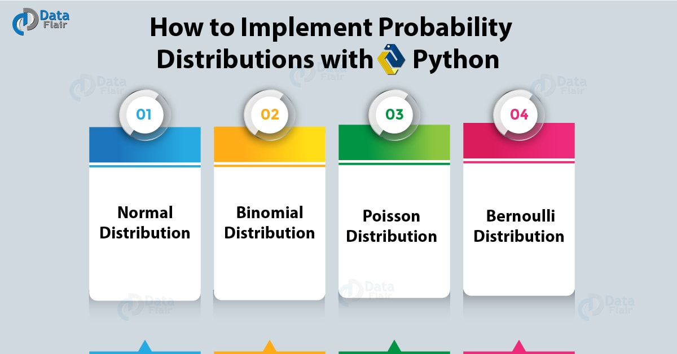
How to Implement Python Probability Distributions

2. What is Python Probability Distribution?
A probability distribution is a function under probability theory and statistics- one that gives us how probable different outcomes are in an experiment. It describes events in terms of their probabilities; this is out of all possible outcomes. Let’s take the probability distribution of a fair coin toss. Here, heads take a value of X=0.5 and tails gets X=0.5 too.
Two classes of such a distribution are discrete and continuous. The former represented by a probability mass function and the latter by a probability density function.
Do you know about Python Namedtuple

3. How to Implement Python Probability Distributions?
Let’s implement these types of Python Probability Distributions, let’s see them:

a. Normal Distribution in Python
Python normal distribution is a function that distributes random variables in a graph that is shaped as a symmetrical bell. It does so by arranging the probability distribution for each value. Let’s use Python numpy for this.
- >>> import scipy.stats
- >>> import numpy as np
- >>> import matplotlib.pyplot as plt
- >>> np.random.seed(1234)
- >>> samples=np.random.lognormal(mean=1.,sigma=.4,size=10000)
- >>> shape,loc,scale=scipy.stats.lognorm.fit(samples,floc=0)
- >>> num_bins=50
- >>> clr="#EFEFEF"
- >>> counts,edges,patches=plt.hist(samples,bins=num_bins,color=clr)
- >>> centers=0.5*(edges[:-1]+edges[1:])
- >>> cdf=scipy.stats.lognorm.cdf(edges,shape,loc=loc,scale=scale)
- >>> prob=np.diff(cdf)
- >>> plt.plot(centers,samples.size*prob,'k-',linewidth=2)
[<matplotlib.lines.Line2D object at 0x0359E890>]
- >>> plt.show()
Implement Python Probability Distributions – Normal Distribution in Python

b. Binomial Distribution in Python
Python binomial distribution tells us the probability of how often there will be a success in n independent experiments. Such experiments are yes-no questions. One example may be tossing a coin.
Let’s explore SciPy Tutorial – Linear Algebra, Benefits, Special Functions
- >>> import seaborn
- >>> from scipy.stats import binom
- >>> data=binom.rvs(n=17,p=0.7,loc=0,size=1010)
- >>> ax=seaborn.distplot(data,
- kde=True,
- color='pink',
- hist_kws={"linewidth": 22,'alpha':0.77})
- >>> ax.set(xlabel='Binomial',ylabel='Frequency')
[Text(0,0.5,’Frequency’), Text(0.5,0,’Binomial’)]
- >>> plt.show()
Implement Python Probability Distributions – Binomial Distribution in Python

c. Poisson Distribution in Python
Python Poisson distribution tells us about how probable it is that a certain number of events happen in a fixed interval of time or space. This assumes that these events happen at a constant rate and also independent of the last event.
- >>> import numpy as np
- >>> s=np.random.poisson(5, 10000)
- >>> import matplotlib.pyplot as plt
- >>> plt.hist(s,16,normed=True,color='Green')
(array([5.86666667e-03, 3.55200000e-02, 8.86400000e-02, 1.48906667e-01,
1.91573333e-01, 1.81440000e-01, 1.56160000e-01, 1.16586667e-01,
6.65600000e-02, 3.90400000e-02, 2.06933333e-02, 9.06666667e-03,
3.84000000e-03, 2.13333333e-03, 5.33333333e-04, 1.06666667e-04]), array([ 0. , 0.9375, 1.875 , 2.8125, 3.75 , 4.6875, 5.625 ,
6.5625, 7.5 , 8.4375, 9.375 , 10.3125, 11.25 , 12.1875,
13.125 , 14.0625, 15. ]), <a list of 16 Patch objects>)
Read about What is Python Interpreter – Environment, Invoking & Working
- >>> plt.show()
Implement Python Probability Distributions – Poisson Distribution in Python

d. Bernoulli Distribution in Python
Python Bernoulli Distribution is a case of binomial distribution where we conduct a single experiment. This is a discrete probability distribution with probability p for value 1 and probability q=1-p for value 0. p can be for success, yes, true, or one. Similarly, q=1-p can be for failure, no, false, or zero.
- >>> s=np.random.binomial(10,0.5,1000)
- >>> plt.hist(s,16,normed=True,color='Brown')
(array([0.00177778, 0.02311111, 0. , 0.08711111, 0. ,
0.18666667, 0. , 0.33777778, 0.45155556, 0. ,
0.37688889, 0. , 0.224 , 0. , 0.07466667,
0.01422222]), array([0. , 0.5625, 1.125 , 1.6875, 2.25 , 2.8125, 3.375 , 3.9375,
4.5 , 5.0625, 5.625 , 6.1875, 6.75 , 7.3125, 7.875 , 8.4375,
9. ]), <a list of 16 Patch objects>)
Do you know about Python Django Tutorial For Beginners
- >>> plt.show()
Implement Python Probability Distributions – Bernoulli Distribution in Python
So, this was all about Python Probability Distribution. Hope you like our explanation.

4. Conclusion
Hence, we studied Python Probability Distribution and its 4 types with an example. In addition, we learned how to implement these Python probability distributions. Furthermore, if you have any doubt, feel free to ask in the comment section.
Related Topic- How to Work with Relational Database
For reference
Tags: Binomial DistributionBinomial Distribution exampleImplement Probability DistributionsNominal Distributions examplePoisson Distribution examplePython Normal DistributionPython Probability DistributionWhat is the Probability Distribution

Leave a Reply

*
*

This site is protected by reCAPTCHA and the Google Privacy Policy and Terms of Service apply.

Home About us Contact us Terms and Conditions Cancellation and Refund Privacy Policy Disclaimer Blogs Write For Us Careers Success Stories

Python – Descriptive Statistics
Python Anaconda Tutorial
Python Tutorials
Python Probability Distributions – Normal, Binomial, Poisson, Bernoulli
❮ Prev
Next ❯

Popular Courses
Hadoop + Spark Course
Big Data Hadoop Course
Spark Scala Course
Apache Flink Course
Python Course

Popular Tutorials
Hadoop Tutorials
Spark Tutorials
Flink Tutorials
Tableau Tutorials
Power BI Tutorials
QlikView Tutorials

Popular Tutorials
Data Science Tutorials
Machine Learning Tutorials
Python Tutorials
R Tutorials
SAS Tutorials
SQL Tutorials
DataFlair © 2020. All Rights Reserved.

We use cookies to provide the best services. By using our site, you comply with our cookies policy. Learn more

Blog Home
- Courses
- Data Science
- Big Data
- Categories
- Interview Questions
- Job Portal
- Write For Us
Blog Home » Python Tutorials » Python Anaconda Tutorial – Learn the most popular Data Science platform
- 0

Python Anaconda Tutorial – Learn the most popular Data Science platform
by DataFlair Team ·
Anaconda is the world’s most popular Data Science platform for Data Scientists and IT professionals. In this Python Anaconda tutorial, you will learn about Anaconda and its benefits, the installation process and how you can work with Anaconda, and in the end, we will peek over the companies that are using Anaconda in their workflow.

What is Anaconda?
Some tutorials install packages with conda instead of pip. So what is conda?
Anaconda is a distribution of Python (and R). It is free and open-source and makes package management and deployment simpler. Keep reading to see how. It is the standard platform for Python data science and open-source machine learning. Anaconda is used by data scientists, IT professionals and business leaders.

Benefits of Using Python Anaconda
Why should you use Anaconda for your project? Well, it does have the following benefits:
- It is free and open-source
- It has more than 1500 Python/R data science packages
- Anaconda simplifies package management and deployment
- It has tools to easily collect data from sources using machine learning and AI
- It creates an environment that is easily manageable for deploying any project
- Anaconda is the industry standard for developing, testing and training on a single machine
- It has good community support- you can ask your questions there.
What you get
- Download more than 1500 Python/R data science packages
- Manage libraries, dependencies, and environments with conda
- Build and train ML and deep learning models with scikit-learn, TensorFlow and Theano
- Use Dask, NumPy, Pandas and Numba to analyze data scalably and fast
- Perform visualization with Matplotlib, Bokeh, Datashader, and Holoviews

Python Anaconda Installation
Next in the Python anaconda tutorial is its installation. The latest version of Anaconda at the time of writing is 2019.07. Follow these steps to download and install Anaconda on your machine:
1. Go to this link and download Anaconda for Windows, Mac, or Linux: – Download anaconda
You can download the installer for Python 3.7 or for Python 2.7 (at the time of writing). And you can download it for a 32-bit or 64-bit machine.
2. Click on the downloaded .exe to open it. This is the Anaconda setup. Click next.
3. Now, you’ll see the license agreement. Click on ‘I Agree’.
4. You can install it for all users or just for yourself. If you want to install it for all users, you need administrator privileges.
5. Choose where you want to install it. Here, you can see the available space and how much you need.
6. Now, you’ll get some advanced options. You can add Anaconda to your system’s PATH environment variable, and register it as the primary system Python 3.7. If you add it to PATH, it will be found before any other installation. Click on ‘Install’.
7. It will unpack some packages and extract some files on your machine. This will take a few minutes.
8. The installation is complete. Click Next.
9. This screen will inform you about PyCharm. Click Next.
10. The installation is complete. You can choose to get more information about Anaconda cloud and how to get started with Anaconda. Click Finish.
11. If you search for Anaconda now, you will see the following options:
- The Anaconda prompt
- Anaconda Navigator
- Anaconda Powershell prompt
- Spyder IDE
- and Jupyter Notebook
If you go to your command prompt and type ‘jupyter notebook’, it will open the Jupyter dashboard for you.
12. You can create a new notebook from the New menu at the top right.
This is your new notebook. You can type in this. To execute a statement or multiple statements at once, press Shift+Enter. Pressing only Enter will only take you to the next line.

Installing Python Anaconda Libraries
You have successfully installed Anaconda. Now, how will you install libraries or packages with it? Let’s see how.
Open the Anaconda Prompt and use the ‘conda install command’ with the package name.
You must check top python libraries
Now, you can install this package.

Anaconda Navigator
Anaconda Navigator is a desktop GUI that ships with Anaconda and lets you launch applications and manage conda packages, environments, and channels without having to use a command-line interface. It can search for packages in a local Anaconda repository or on Anaconda Cloud. With Navigator, you don’t need to type commands in a terminal, it lets you work with packages and environments with just a click.
With Navigator, you can access:
- JupyterLab
- Jupyter Notebook
- QTConsole
- Spyder
- VSCode
- Glueviz
- Orange 3 App
- Rodeo
- RStudio
At the time of writing, the latest version of Anaconda is 1.9.7.

What Companies are Using Anaconda?
Anaconda is trusted by these leading companies around the world:
- BMW
- Cisco
- Citi Bank
- HSBC
- GlaxoSmithKline
- GE Power
- Samsung
- Zurich
- Brookhaven
- City of Boston
- Columbia University
- CloudQuant
- IQT
- Lloyds Banking Group
- Otto Group
- Machinalis
- Marshall Wace
- Mayo Clinic
- Micron
- Molex
- National Grid
- PIMCO
- US Army Corps of Engineers
- West Health
- US Securities and Exchange Commission
- SunTrust
- Banco Pichincha
- ComEd
- RENNER
- elo
- But even other than these, Anaconda has more than 15 million users worldwide.

Conclusion
In this Python Anaconda tutorial, we learned about Anaconda and how to work with it. We saw its benefits, installation, and some companies that use it.
Hope you liked the tutorial.
Refer to our Free Python Tutorials Library to get a deep insight into Python programming.
Tags: anaconda downloadAnaconda NavigatorBenefits of anacondainstall anacondaPython anacondaPython Anaconda InstallationPython anaconda tutorialWhat is anaconda

Leave a Reply

*
*

This site is protected by reCAPTCHA and the Google Privacy Policy and Terms of Service apply.

Home About us Contact us Terms and Conditions Cancellation and Refund Privacy Policy Disclaimer Blogs Write For Us Careers Success Stories

Python – Probability Distributions
Python – Matplotlib
Python Tutorials
Python Anaconda Tutorial – Learn the most popular Data Science platform
❮ Prev
Next ❯

Popular Courses
Hadoop + Spark Course
Big Data Hadoop Course
Spark Scala Course
Apache Flink Course
Python Course

Popular Tutorials
Hadoop Tutorials
Spark Tutorials
Flink Tutorials
Tableau Tutorials
Power BI Tutorials
QlikView Tutorials

Popular Tutorials
Data Science Tutorials
Machine Learning Tutorials
Python Tutorials
R Tutorials
SAS Tutorials
SQL Tutorials
DataFlair © 2020. All Rights Reserved.

We use cookies to provide the best services. By using our site, you comply with our cookies policy. Learn more

Blog Home
- Courses
- Data Science
- Big Data
- Categories
- Interview Questions
- Job Portal
- Write For Us
Blog Home » Python Tutorials » Python Matplotlib Tutorial – Python Plotting For Beginners
- 0

Python Matplotlib Tutorial – Python Plotting For Beginners
by DataFlair Team · Updated ·

1. Python Matplotlib Tutorial – Objective
In our previous tutorial, Python Data Cleansing. Today, we’ll play around with Python Matplotlib Tutorial and Python Plot. Moreover, we will discuss Pyplot, Keyword String, and Categorical Variables of Python Plotting. At last, we will cover Line properties and some Python Matplotlib example.
So, let’s start Python Matplotlib Tutorial.
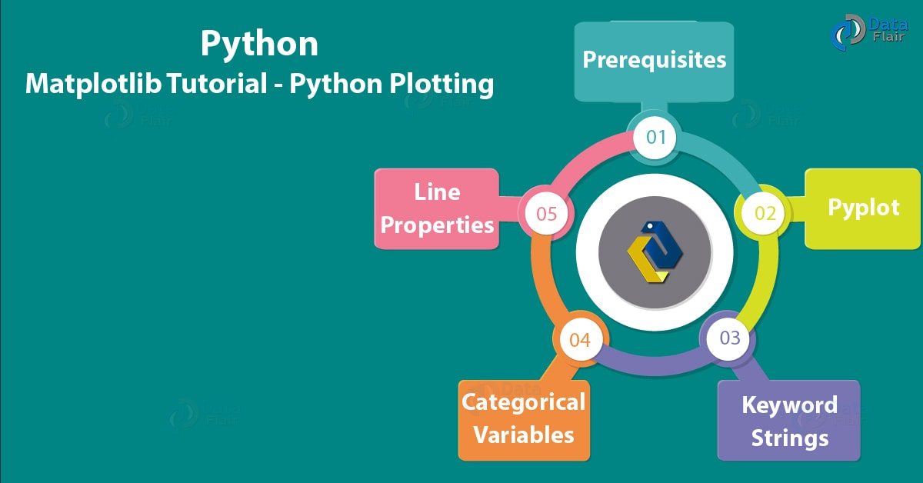
Python Matplotlib Tutorial – Python Plotting For Beginners

2. What is Python Matplotlib?
Working across platforms, when you want to conceive publication quality figures in hardcopy formats and interactive environments, you use matplotlib. This is a library for 2-dimensional plotting with Python.
Some plots it will let us build are:
- Plots
- Histograms
- Error charts
- Power spectra
- Bar charts
- Scatter Plots
Some features of Python Plot supports-
- Font properties
- Axes properties
- Line styles
Follow this link to know about Python Packages

3. Python Matplotlib Tutorial – Prerequisites
For our Python Matplotlib tutorial, we will need two Python libraries.

a. Python Matplotlib
We’ve already discussed this in section 2. To install it, you can use the following command-
- C:\Users\lifei>pip install matplotlib

b. Pandas
Pandas is another Python library we will use here. It lets us manipulate and analyze data using data structures and operations on numerical tables and time series.
Matplotlib Tutorial – Python Plotting
You can install it with the following command-
- C:\Users\lifei>pip install pandas

4. Python Matplotlib Tutorial – Pyplot
It has a pyplot interface. This holds command-like functions that let us alter a figure.

a. plot()
You can use the plot() method to create a plot of points on the graph.
- >>> import matplotlib.pyplot as plt
- >>> plt.plot([2,3,4,5])
[<matplotlib.lines.Line2D object at 0x00FD5650>]
- >>> plt.xlabel('Actual birth weight')
Text(0.5,0,’Actual birth weight’)
- >>> plt.ylabel('Estimated birth weight')
Text(0,0.5,’Estimated birth weight’)
- >>> plt.show()
Let’s explore Python Property – The Problem and Solution
Python Matplotlib Tutorial – Python Plotting
Here, the methods xlabel() and ylabel() let us set labels for the x and y-axes respectively. It takes values from our list of parameters for the y-axis; for the x-axis, it uses 0.0, 1.0, 2.0, and 3.0 for the four points.
We can give it more than one list of parameters-
- >>> plt.plot([2,3,4,5],[3,8,10,12])
[<matplotlib.lines.Line2D object at 0x0153EFF0>]
- >>> plt.show()
Python Matplotlib Tutorial – Python Plotting
This takes the first list for x-axis and the second for the y-axis.

b. Formatting your Python Plot
A third argument will let you choose the color and the line type of the plot in Python Programming Language. The default format string gives us a solid blue line, as we’ve seen in the examples so far. This is ‘b-‘. You see, these strings are from MATLAB.
- >>> plt.plot([2,3,4,5],[3,8,10,12],'gs')
[<matplotlib.lines.Line2D object at 0x01AD1050>]
- >>> plt.axis([0,7,0,21])
[0, 7, 0, 21]
- >>> plt.show()
Python Matplotlib Tutorial – Python Plotting
Formatting your Python PlotThe axis() method lets us set the viewport for the axes in terms of xmin, xmax, ymin, and ymax. The format string ‘gs’ here gives us green squares. Similarly, we can plot green, red, and blue orbs, squares, and triangles too. Let’s take another example.
Read about CGI Programming in Python with Functions and Modules
- >>> import numpy as np
- >>> t=np.arange(0,5,0.2)
- >>> plt.plot(t,t,'r--',t,t**3,'b^',t,t**2,'gs')
[<matplotlib.lines.Line2D object at 0x0A66B670>, <matplotlib.lines.Line2D object at 0x0A66B7B0>, <matplotlib.lines.Line2D object at 0x0A66BA90>]
- >>> plt.show()
Matplotlib Tutorial – Python Plotting

5. Python Matplotlib Keyword Strings
Using a data keyword argument, we can produce Python plots with strings that relate to some variables. We can access these variables with strings.
- >>> data={'a':np.arange(50),
- 'c':np.random.randint(0,50,50),
- 'd':np.random.randn(50)}
- >>> data['b']=data['a']+10*np.random.randn(50)
- >>> data['d']=np.abs(data['d'])*100
- >>> plt.scatter('a','b',c='c',s='d',data=data)
<matplotlib.collections.PathCollection object at 0x0A7E8AD0>
- >>> plt.show()
Matplotlib Tutorial -Keyword Strings

6. Categorical Variables to Python Plotting
We can pass categorical variables to Python plotting functions.
- >>> names=["Dingos","Wild Cats","Tigers"]
- >>> values=[1,11,111]
- >>> plt.figure(1,figsize=(9,3))
<Figure size 900×300 with 0 Axes>
- >>> plt.subplot(131)
<matplotlib.axes._subplots.AxesSubplot object at 0x00FD5B30>
- >>> plt.bar(names,values)
<BarContainer object of 3 artists>
- >>> plt.subplot(132)
<matplotlib.axes._subplots.AxesSubplot object at 0x01889610>
- >>> plt.scatter(names,values)
<matplotlib.collections.PathCollection object at 0x0A191AB0>
- >>> plt.subplot(133)
<matplotlib.axes._subplots.AxesSubplot object at 0x0A171110>
- >>> plt.plot(names,values)
[<matplotlib.lines.Line2D object at 0x0A1ADE30>]
- >>> plt.suptitle('Varsity')
Text(0.5,0.98,’Varsity’)
- >>> plt.show()
Python Matplotlib Tutorial – Python Plotting
Python Matplotlib Tutorial – Categorical Variables to Python Plotting
Do you know How Python Send Email Via SMTP | SMTP Server

7. Some Line Properties of Matplotlib
Using some keyword arguments, we can alter how a graph looks. Let’s look at some.
Python Matplotlib Tutorial – Line Properties

a. Linewidth
- >>> plt.plot([1,2,3],[2,4,9],linewidth=4.0)
[<matplotlib.lines.Line2D object at 0x010D05D0>]
- >>> plt.show()
Python Matplotlib Tutorial – Linewidth

b. Alpha
We can use the alpha channel to create prettier plots by softening colors.
- >>> plt.plot([1,2,3],[2,4,9],alpha=5.5)
[<matplotlib.lines.Line2D object at 0x00BC9310>]
- >>> plt.show()
Python Matplotlib Tutorial – Alpha

c. Antialiased
If you’ll look closely, the lines look quite smooth. But we can turn antialiasing off- this will show us the aliasing in the lines.
- >>> plt.plot([1,2,3],[2,4,9],antialiased=True)
[<matplotlib.lines.Line2D object at 0x087278B0>]
- >>> plt.show()
Python Matplotlib Tutorial – Antialiased
Let’s read about Image Processing with SciPy and NumPy in Python

d. Color or c
You can set the color of the plot with this parameter.
- >>> plt.plot([1,2,3],[2,4,9],color='Chartreuse')
[<matplotlib.lines.Line2D object at 0x0AE98D70>]
- >>> plt.show()
Matplotlib Tutorial – Color

e. Dashes
- >>> plt.plot([1,2,3],[2,4,9],dashes=[1,2,4,4])
[<matplotlib.lines.Line2D object at 0x099ED290>]
- >>> plt.show()
Python Dashes

f. Linestyle or ls
You can choose the style of line you want for your plot.
- >>> plt.plot([1,2,3],[2,4,9],linestyle='steps')
[<matplotlib.lines.Line2D object at 0x00B816D0>]
- >>> plt.show()
Python Matplotlib Tutorial – Linestyle or ls
- >>> plt.plot([1,2,3],[2,4,9],linestyle=':')
[<matplotlib.lines.Line2D object at 0x0AC892D0>]
- >>> plt.show()
Matplotlib Tutorial – Python Linestyle or ls
Let’s explore Python Database Access – Python 3 MySQL

g. Marker
A marker will let you select what symbol you want to display at breakpoints and bends.
- >>> plt.plot([1,2,3],[2,4,9],marker='+')
[<matplotlib.lines.Line2D object at 0x01018790>]
- >>> plt.show()
Python Marker

h. Markeredgecolor
You can also decide on a color for your markers’ edges.
- >>> plt.plot([1,2,3],[2,4,9],marker='+',markeredgecolor='brown')
[<matplotlib.lines.Line2D object at 0x01280110>]
- >>> plt.show()
Matplotlib Tutorial – Markeredgecolor

i. Markeredgewidth
This lets us decide how thick we want our markers to be.
- >>> plt.plot([1,2,3],[2,4,9],marker='+',markeredgewidth=0.4)
[<matplotlib.lines.Line2D object at 0x0AE54290>]
- >>> plt.show()
Matplotlib Tutorial – Markeredgewidth
Let’s Learn Aggregation and Data Wrangling with Python

j. Markerfacecolor and Markersize
This will let you choose which color to fill in your marker and what size to keep it.
- >>> plt.plot([1,2,3],[2,4,9],marker='.',markerfacecolor='orange',markersize=13.0)
[<matplotlib.lines.Line2D object at 0x0AE9BC10>]
- >>> plt.show()
Python Matplotlib Tutorial – Markerfacecolor and Markersize

k. Markevery
This parameter lets us decide at what parameters we want to put markers.
Python Markevery
- plt.plot([1,2,3],[2,4,9],marker='.',markerfacecolor='orange',markersize=13.0,markevery=2)
[<matplotlib.lines.Line2D object at 0x0103C8B0>]
- >>> plt.show()
- >>> plt.plot([1,2,3],
[2,4,9],marker=’.’,markerfacecolor=’orange’,markersize=13.0,markevery=3) [<matplotlib.lines.Line2D object at 0x01025F10>]
- >>> plt.show()
Matplotlib Tutorial – Python Markevery

l. Zorder
This lets us decide which plots will show up in the front and which to send to back.
- >>> plt.plot([1,2,3],[2,4,9],zorder=1,linewidth=4)
[<matplotlib.lines.Line2D object at 0x01255E70>]
- >>> plt.plot([1,2,6,9],[2,4,9,10],zorder=2,linewidth=4)
[<matplotlib.lines.Line2D object at 0x01255770>]
- >>> plt.show()
Matplotlib Tutorial – Python Plotting
In this graph, in the area enclosed by the points (1,2) and (2,4), both plots cover the same points, but the one in orange is in the front. This is because we give it a higher zorder. This is like z-index in CSS.
Let’s Know about Python Stemming and Lemmatization – NLTK

8. Showing a Grid in Python Plot
You can use the grid() method to toggle a grid in your plot.
- >>> plt.grid(True)
- >>> plt.plot([1,2,6,9],[2,4,9,10],zorder=2,linewidth=4)
[<matplotlib.lines.Line2D object at 0x00DC02B0>]
- >>> plt.show()
Showing a Grid in Python Plot
So, this was all about Python Matplotlib Tutorial. Hope you like our explanation.

9. Conclusion
Hence, we have studied, Matplotlib, which is the Python Libraries used for Python Plot and much more. Furthermore, if you have any information regarding, feel free to share with us.
Related Topic- Python Django
For reference
Tags: AlphaAntialiasedCategorical Variables to Python PlottingColor or cDashesFormatting your Python PlotLinestyle or lsLinewidthMarkerMarkeredgecolorMarkeredgewidthMarkerfacecolor and MarkersizeMarkeveryMatplotlib in Python ProgrammingPyplotPython Matplotlib TutorialPython PlottingShowing a Grid in Python PlotWhat is Python Matplotlibzorder

Leave a Reply

*
*

This site is protected by reCAPTCHA and the Google Privacy Policy and Terms of Service apply.

Home About us Contact us Terms and Conditions Cancellation and Refund Privacy Policy Disclaimer Blogs Write For Us Careers Success Stories

Python Anaconda Tutorial
Python – Scatter & Box Plots
Python Tutorials
Python Matplotlib Tutorial – Python Plotting For Beginners
❮ Prev
Next ❯

Popular Courses
Hadoop + Spark Course
Big Data Hadoop Course
Spark Scala Course
Apache Flink Course
Python Course

Popular Tutorials
Hadoop Tutorials
Spark Tutorials
Flink Tutorials
Tableau Tutorials
Power BI Tutorials
QlikView Tutorials

Popular Tutorials
Data Science Tutorials
Machine Learning Tutorials
Python Tutorials
R Tutorials
SAS Tutorials
SQL Tutorials
DataFlair © 2020. All Rights Reserved.

We use cookies to provide the best services. By using our site, you comply with our cookies policy. Learn more

Blog Home
- Courses
- Data Science
- Big Data
- Categories
- Interview Questions
- Job Portal
- Write For Us
Blog Home » Python Tutorials » Create Python Scatter Plot & Python BoxPlot (Using Matplotlib)
- 0

Create Python Scatter Plot & Python BoxPlot (Using Matplotlib)
by DataFlair Team · Updated ·

1. Python Scatter & BoxPlot
In our Last tutorial, we discussed Python Charts – Bubble & 3D Charts. Today, we will talk Python Scatter Plot. In addition, we will learn how to draw a Scatter Plot in Python Programming. Moreover, we will cover how to create Python Box Plot using Matplotlib.
Let’s begin the Python Scatter Plot.

How to Create Python Scatter Plot & Python BoxPlot

2. How to Create Python BoxPlot Using Matplotlib?
Python box plot tells us how distributed a dataset is. Another use is to analyze how distributed data is across datasets. Such a plot creates a box-and-whisker plot and summarizes many different numeric variables. Let’s first take an example so we can explain its structure better.
- >>> import matplotlib.pyplot as plt
- >>> np.random.seed(10)
- >>> one=np.random.normal(100,10,200)
- >>> two=np.random.normal(80, 30, 200)
- >>> three=np.random.normal(90, 20, 200)
- >>> four=np.random.normal(70, 25, 200)
- >>> to_plot=[one,two,three,four]
- >>> fig=plt.figure(1,figsize=(9,6))
- >>> ax=fig.add_subplot(111)
- >>> bp=ax.boxplot(to_plot)
- >>> fig.savefig('boxplot.png',bbox_inches='tight')
Top 35 Python Interview Questions and Answer
This saves the following figure-
Creating Python BoxPlot (Using Matplotlib)
Structure-
- The box denotes the dataset’s quartiles.
- The whiskers extend and denote the rest of the distribution.
- A function of the inter-quartile range determine the points that are outliers.
The input to this can be a list, a NumPy array, a pandas Series object, an array, a list of vectors, a long-form DataFrame, or a wide-form DataFrame.
Let’s take another example.
- >>> ax = sn.boxplot(x="day", y="total_bill", hue="smoker",data=tips, palette="Set3")
- >>> plt.show()
Creating Python BoxPlot (Using Matplotlib)

3. How to Create a Python Scatter Plot?
Python Scatter Plot, let us denote how two or more objects related to each other.
How to Create Scatter Plot in Python?
It also lets us identify outliers- values that stray from all others.
- >>> np.random.seed(19680801)
- >>> N=50
- >>> x=y=colors=np.random.rand(N)
- >>> area = (30 * np.random.rand(N))**2
- >>> plt.scatter(x, y, s=area, c=colors, alpha=0.5)
<matplotlib.collections.PathCollection object at 0x095BB6D0>
Do you know how to Implement Python Switch Case Statement
- >>> plt.show()
Creating Scatter Plot in Python using plt.plot

a. Python Scatter Plot using plt.plot
- >>> x=np.linspace(0,10,30)
- >>> from scipy import sin
- >>> y=np.sin(x)
- >>> plt.plot(x,y,'o',color='purple')
[<matplotlib.lines.Line2D object at 0x080D3890>]
- >>> plt.show()
Creating Scatter Plot in Python using plt.plot
- >>> plt.plot(x,y,'-ok')
[<matplotlib.lines.Line2D object at 0x08094F30>]
- >>> plt.show()
Python Scatter Plot using plt.plot
- >>> plt.plot(x,y,'-p',color='green',
- markersize=15,linewidth=4,
- markerfacecolor='white',
- markeredgecolor='gray',
- markeredgewidth=1)
[<matplotlib.lines.Line2D object at 0x0811A4B0>]
Do you know how to Python Rename File – Single & Multiple Files
- >>> plt.show()
Draw Python Scatter Plots | Python BoxPlot (Using Matplotlib)

b. More than one plot
- >>> plt.plot(np.random.rand(20),'*')
[<matplotlib.lines.Line2D object at 0x08158A30>]
- >>> plt.plot(np.random.rand(20),'o')
[<matplotlib.lines.Line2D object at 0x08158D90>]D
- >>> plt.show()
Draw More than one Scatter Plot in Python
So, this was all about Python Scatter Plot. Hope you like our explanation.

4. Conclusion
Hence, we learned how to create Python box plots and scatter plot with matplotlib. Stay tuned for more charts. Leave your opinions in the comments below.
Related Topic- Python Stemming and Lemmatization
For reference
Tags: BoxPlot in PythonHow to Draw Python BoxPlotHow to Draw Python Scatter PlotMore than one plotPython BoxPlotPython Scatter PlotScatter Plot in PythonScatter plot using plt.plot

Leave a Reply

*
*

This site is protected by reCAPTCHA and the Google Privacy Policy and Terms of Service apply.

Home About us Contact us Terms and Conditions Cancellation and Refund Privacy Policy Disclaimer Blogs Write For Us Careers Success Stories

Python – Matplotlib
Python – Bubble & 3D Charts
Python Tutorials
Create Python Scatter Plot & Python BoxPlot (Using Matplotlib)
❮ Prev
Next ❯

Popular Courses
Hadoop + Spark Course
Big Data Hadoop Course
Spark Scala Course
Apache Flink Course
Python Course

Popular Tutorials
Hadoop Tutorials
Spark Tutorials
Flink Tutorials
Tableau Tutorials
Power BI Tutorials
QlikView Tutorials

Popular Tutorials
Data Science Tutorials
Machine Learning Tutorials
Python Tutorials
R Tutorials
SAS Tutorials
SQL Tutorials
DataFlair © 2020. All Rights Reserved.

We use cookies to provide the best services. By using our site, you comply with our cookies policy. Learn more

Blog Home
- Courses
- Data Science
- Big Data
- Categories
- Interview Questions
- Job Portal
- Write For Us
Blog Home » Python Tutorials » Python Charts – Bubble, 3D Charts with Properties of Chart
- 0

Python Charts – Bubble, 3D Charts with Properties of Chart
by DataFlair Team · Updated ·

1. Python Charts – Objective
In our last tutorial, we studied Python Array Module. Today, we will take a quick look at Python Charts. Here, we will cover the Python Bubble Charts and 3D charts in Python. Then, we’ll learn about the properties of Python charts and will try to style those charts in Python programming.
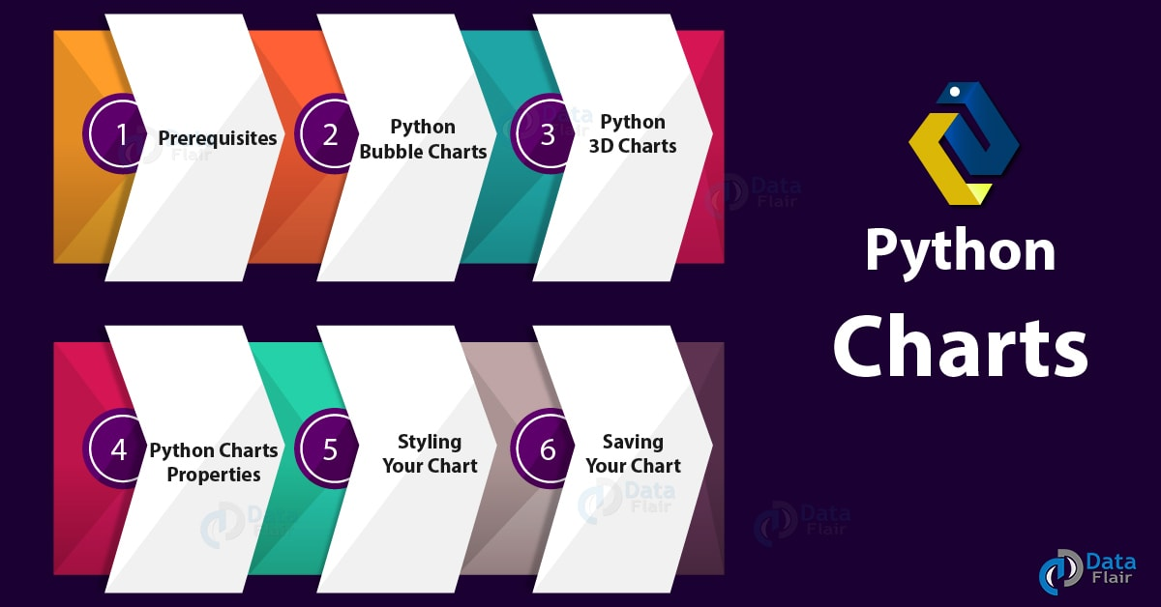
Python Charts – Bubble, 3D Charts with Properties of Chart

2. Prerequisites for Python Charts
For this Python Chart tutorial, we will import three libraries- matplotlib, numpy, and pandas.
You can install these Python Libraries using the following commands-
- pip install matplotlib
- pip install numpy
- pip install pandas
You can import these as-
- >>> from matplotlib import pyplot as plt
- >>> import numpy as np
- >>> import pandas as pd
Do you know about Python Modules vs Packages

3. Python Bubble Charts
First, let’s talk about bubble charts in Python. Such a chart is a scatter plot with an extra dimension, which makes it apparently 3-dimensional. This means larger bubbles denotes higher values. Let’s build a Python bubble plot.
Python Charts – Python Bubble Charts
- >>> x=np.random.rand(30)
- >>> y=np.random.rand(30)
- >>> z=np.random.rand(50)
- >>> plt.scatter(x,y,s=z*777) #s is for global size
<matplotlib.collections.PathCollection object at 0x0863FAD0>
- >>> plt.show()
Python Charts – Python Bubble Charts

a. Setting bubble color
Using the color parameter, you can assign a color to your bubbles chart.
- >>> plt.scatter(x,y,s=z*777,c='Chartreuse')
<matplotlib.collections.PathCollection object at 0x0A258DB0>
- >>> plt.show()
Python Charts – Setting bubble color
You can even assign random colors to different bubbles chart in Python.
- >>> colors=np.random.rand(30)
- >>> plt.scatter(x,y,s=z*777,c=colors,alpha=0.5) #alpha for transparency
<matplotlib.collections.PathCollection object at 0x0A295EF0>
Read about Python Datetime Module with Quick Examples
- >>> plt.show()
Python Charts – Setting bubble color

b. Setting bubble shape
You can also choose what shape to apply to your bubbles chart.
- >>> plt.scatter(x,y,s=z*3001,marker='D')
<matplotlib.collections.PathCollection object at 0x0A2D0E70>
- >>> plt.show()
Python Charts – Setting bubble shape
- >>> plt.scatter(x,y,s=z*3001,marker='<',color='brown')
<matplotlib.collections.PathCollection object at 0x09E15A50>
- >>> plt.show()
Setting bubble shape
- >>> plt.scatter(x,y,s=z*3001,marker='*',color='pink')
<matplotlib.collections.PathCollection object at 0x09E508F0>
Have a Look at Python Forensics – Hash Function, Virtualization & much more
- >>> plt.show()
Setting bubble shape
- >>> plt.scatter(x,y,s=z*3001,marker='8',color='lavender')
<matplotlib.collections.PathCollection object at 0x08B9AC90>
- >>> plt.show()
Setting bubble shape

c. Setting the edges for your Python bubbles charts
You can also set edges to your Python bubbles chart.
- >>> plt.scatter(x,y,s=z*4000,c="beige",alpha=0.4,linewidth=7)
<matplotlib.collections.PathCollection object at 0x094035B0>
Do you know how to Implement Python Switch Case Statement
- >>> plt.show()
Setting the edges for your bubbles charts
- >>> plt.scatter(x,y,s=z*4000,c="beige",linewidth=7,edgecolors='brown')
<matplotlib.collections.PathCollection object at 0x0A1EADD0>
>>> plt.show()
Setting the edges for your bubbles charts

d. Mapping a color to a plot
Let’s try mapping greys to it.
- >>>plt.scatter(x,y,s=z*2000,c=x,cmap="Greys",alpha=0.4,edgecolors="grey",linewidth=2)
<matplotlib.collections.PathCollection object at 0x08AB91F0>
- >>> plt.show()
Mapping a color to a plot

4. Python 3D Charts
It is possible to render your Python charts in three dimensions. Here’s how we do that with Python 3D charts.
Let’s Learn Python Database Access – Python 3 MySQL
a. Python 3D Scatterplots
Here, we use the mplot3D toolkit from Python Matplotlib.
- >>> from mpl_toolkits.mplot3d import Axes3D
- >>> df=pd.DataFrame({'X':range(1,111),'Y':np.random.randn(110)*13+range(1,111), 'Z':(np.random.randn(110)*13+range(1,111))*2})
- >>> fig=plt.figure()
- >>> ax=fig.add_subplot(121,projection='3d')
- >>> ax.scatter(df['X'],df['Y'],df['Z'],c='pink',s=60)
<mpl_toolkits.mplot3d.art3d.Path3DCollection object at 0x0A126CF0>
- >>> ax.view_init(27,200)
- >>> plt.show()
Python 3D Scatterplots

5. Python Charts Properties
Let’s demonstrate these online Python graphs.
Python Bubble Charts
- >>> x=np.arange(0,7)
- >>> from scipy import sin
- >>> y=sin(x)
- >>> plt.plot(x,y)
[<matplotlib.lines.Line2D object at 0x0BEE0150>]
- >>> plt.show()
Properties of Charts in Python

a. Titling the graph and labeling the axes
Using the title(), xlabel(), and ylabel() methods, we can do the needful.
- >>> plt.title('Sine Wave')
Text(0.5,1,’Sine Wave’)
- >>> plt.xlabel('x')
Text(0.5,0,’x’)
- >>> plt.ylabel('y')
Text(0,0.5,’y’)
- >>> plt.plot(x,y)
[<matplotlib.lines.Line2D object at 0x043BDC70>]
- >>> plt.show()
Titling the graph and labeling the axes
Let’s Discuss Python Data File Formats – How to Read CSV, JSON, and XLS Files

b. Setting line color and type
To set the line color, you use a Unicode character in the parameter list-
- >>> plt.plot(x,y,'g')
[<matplotlib.lines.Line2D object at 0x045E6FF0>]
Setting line color and type
Now to set the line type, we can-
- >>> plt.plot(x,y,'*')
[<matplotlib.lines.Line2D object at 0x0A0A4350>]
- >>> plt.show()
Setting line color and type
Now, what if we wanted to set both at once?
- >>> plt.plot(x,y,'*g')
[<matplotlib.lines.Line2D object at 0x0A10B810>]
Follow this link to know about Python Data Cleansing by Pandas & Numpy
- >>> plt.show()
Charts in Python- Setting line color and type
‘g*’ gives us the same output.

6. Styling your Python Chart
Apart from fiddling with the properties of your charts in Python, you can also style it in a few different ways. Let’s see how.
Styling your Python Chart

a. Adding Annotations
It is possible to drop in a label in your charts in Python wherever you want.
- >>> x=np.arange(0,7)
- >>> y=sin(x)
- >>> plt.plot(x,y)
[<matplotlib.lines.Line2D object at 0x076DCB90>]
- >>> plt.annotate(xy=[3.5,0],s='The curve') #You can add the annotations before plotting if you want
Text(3.5,0,’The curve’)
- >>> plt.show()
Styling your Chart- Adding Annotations
Let’s Read about Python File I/O – Python Write to File and Read File

b. Adding Legends
- >>> x=np.arange(0,7)
- >>> y=sin(x)
- >>> z=np.cos(x)
- >>> plt.plot(x,y)
[<matplotlib.lines.Line2D object at 0x07D24530>]
- >>> plt.plot(x,z)
[<matplotlib.lines.Line2D object at 0x07D248F0>]
- >>> plt.legend(['Sine','Cosine'],loc=3)
<matplotlib.legend.Legend object at 0x07D249D0>
- >>> plt.show()
Styling your Chart – Adding Legends

7. How to Save Python Charts File?
Finally, let’s see what you can do when you want to save a Python chart you’ve just created.
- >>> plt.scatter(x,y,s=z*3001,marker='*',color='pink')
<matplotlib.collections.PathCollection object at 0x07D402F0>
- >>> plt.savefig('pinkstars.pdf',format='pdf')
Python Charts File
How to Save Python Charts File Now we want to save this as a png. There is no need to make another call to plot(); simply save it.
Do you know about Python Multiple Inheritance – Python MRO
Saving Python Charts File
So, this was all about Python Charts Tutorial. Hope you like our explanation.

8. Conclusion
Hence, with this, we sum up our Python Charts tutorial on bubble charts and 3D charts in Python. Now you also know how to style Charts in Python, to make them aesthetically better and also aid understanding. Are there any more topics you would like us to write on? Let us know in the comments below.
Related Topic – Python Generator vs Iterator
For reference
Tags: 3D Charts In pythonBubble Charts in PythonCharts in Python 'Charts Properties in PythonHow to Save Python Charts FilePython 3D ChartsPython 3D ScatterplotsPython Bubble ChartsPython Bubble PlotPython ChartsPython Charts PropertiesPython GraphSaving Python Charts FileStyling your Python Chart

Leave a Reply

*
*

This site is protected by reCAPTCHA and the Google Privacy Policy and Terms of Service apply.

Home About us Contact us Terms and Conditions Cancellation and Refund Privacy Policy Disclaimer Blogs Write For Us Careers Success Stories

Python – Scatter & Box Plots
Python – Heatmap & Word Cloud
Python Tutorials
Python Charts – Bubble, 3D Charts with Properties of Chart
❮ Prev
Next ❯

Popular Courses
Hadoop + Spark Course
Big Data Hadoop Course
Spark Scala Course
Apache Flink Course
Python Course

Popular Tutorials
Hadoop Tutorials
Spark Tutorials
Flink Tutorials
Tableau Tutorials
Power BI Tutorials
QlikView Tutorials

Popular Tutorials
Data Science Tutorials
Machine Learning Tutorials
Python Tutorials
R Tutorials
SAS Tutorials
SQL Tutorials
DataFlair © 2020. All Rights Reserved.

We use cookies to provide the best services. By using our site, you comply with our cookies policy. Learn more

Blog Home
- Courses
- Data Science
- Big Data
- Categories
- Interview Questions
- Job Portal
- Write For Us
Blog Home » Python Tutorials » Python Heatmap | Word Cloud Python with Example
- 0

Python Heatmap | Word Cloud Python with Example
by DataFlair Team · Updated ·

1. Python Heatmap & Word Cloud
Next in our series of graphs and plots with Python is Python Heatmaps and Word Cloud. Moreover, we will see what is Python Heatmap and what is Python Word Cloud. Also, we will discuss Python heatmap example and Word Cloud Python Example.
So, let’s start with creating a Python Heatmap.
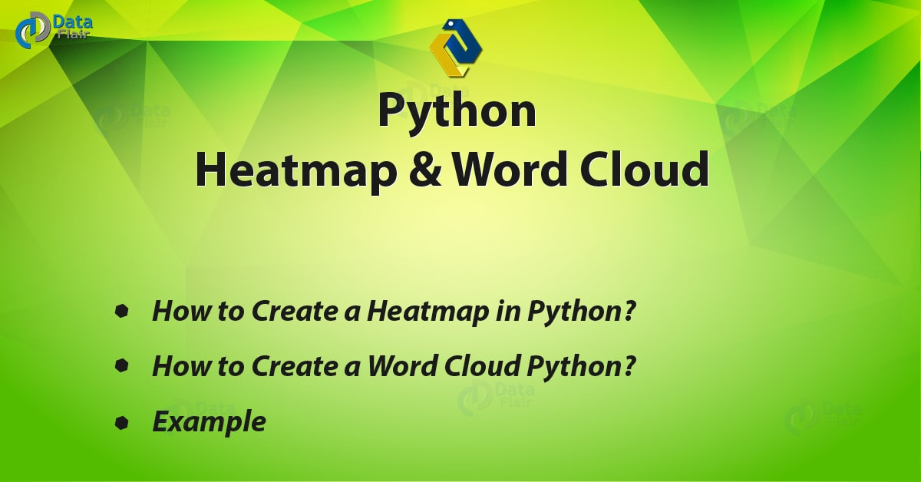
Python Heatmap |Python Word Cloud – Example

2. How to Create a Heatmap in Python?
So, what is a heat map? A way of representing data as a matrix of values. Basically, using different colors to represent data, it gives you a general view of the numerical data. Some manipulations when working with heatmaps. Python Heatmap includes normalizing the matrices, performing cluster analysis, choosing a color palette, and permuting rows and columns to place similar values nearby.
Do you know about Python Numpy

a. A Simple Python Heatmap Example
First, let’s make a simple heat map to get an idea of what it is.
- >>> import seaborn as sn
- >>> import numpy as np
- >>> import pandas as pd
- >>> df=pd.DataFrame(np.random.random((7,7)),columns=['a','b','c','d','e','f','g'])
- >>> sn.heatmap(df)
<matplotlib.axes._subplots.AxesSubplot object at 0x078DAA10>
- >>> import matplotlib.pyplot as plt
- >>> plt.show()
Python Heatmap example
Here, we create a DataFrame, and then call the heatmap() method on it borrowing from seaborn.

b. Annotating your Python heatmap
You can add an annotation to every cell of your Python heatmap.
- >>> sn.heatmap(df,annot=True,annot_kws={'size':7})
<matplotlib.axes._subplots.AxesSubplot object at 0x078529D0>
- >>> plt.show()
Python Heatmap Annotation
Here, annot_kws lets us set the size of the annotations with the ‘size’ parameter. We set it to 7 for this demo.

c. Adding Grid Lines
It is possible to add grid lines to your Python heatmap. In the following piece of code, we add pink grid lines of thickness 2.5.
Let’s discuss Python Scipy
- >>> sn.heatmap(df,linewidths=2.5,linecolor='pink')
<matplotlib.axes._subplots.AxesSubplot object at 0x07AFD970>
- >>> plt.show()
rid lines in Python Heatmap

d. Removing X or Y labels
In the next piece of code, we remove the x tick labels from the map.
- >>> sn.heatmap(df,xticklabels=False)
<matplotlib.axes._subplots.AxesSubplot object at 0x07B5F0D0>
- >>> plt.show()
Removing labels in Python Heatmap

e. Removing the color bar
The vertical bar at the extreme right of this Python Heatmap tells us what values the colors represent. But we can choose to not display it.
Let’s revise Python Array Module
- >>> sn.heatmap(df,cbar=False)
<matplotlib.axes._subplots.AxesSubplot object at 0x08083090>
- >>> plt.show()
Removing color bar in Heatmap

f. Keeping only a few labels
Basically, when there are too many cells/labels, there may be overlapping. To avoid this, you can give a value x to the xticklabels parameter. It then shows labels every x labels.
- >>> sn.heatmap(df,xticklabels=2)
<matplotlib.axes._subplots.AxesSubplot object at 0x082E4C70>
- >>> plt.show()
Keeping few labels inPython heatmap

g. Choosing a color theme for your heatmap
Let’s try a green.
- >>> sn.heatmap(df,cmap='Greens')
<matplotlib.axes._subplots.AxesSubplot object at 0x0AF5D510>
Read Python Descriptive Statistics
- >>> plt.show()
Heatmap – Color Theme
Now, let’s try blue and purple.
- >>> sn.heatmap(df,cmap='BuPu')
<matplotlib.axes._subplots.AxesSubplot object at 0x0B0CFAB0>
- >>> plt.show()
Heatmap Python – Color theme
Yellow, green, and blue-
- >>> sn.heatmap(df,cmap='YlGnBu')
<matplotlib.axes._subplots.AxesSubplot object at 0x0B26F1D0>
- >>> plt.show()
Heatmap in Python – Color Theme
Red, yellow, blue-
- >>> sn.heatmap(df,cmap='RdYlBu')
<matplotlib.axes._subplots.AxesSubplot object at 0x09DF3A70>
Have a look at Python Interpreter
- >>> plt.show()
Heatmap Python – Color theme

h. Plotting a discrete heatmap
Plotting a discrete heatmap
For discrete data, you can choose to plot it with a Python heatmap.

i. Normalizing a column
So, consider the following piece of code-
- >>> df=pd.DataFrame(np.random.randn(7,7)*4+3)
- >>> df[1]=df[1]+37
- >>> sn.heatmap(df,cmap='plasma')
<matplotlib.axes._subplots.AxesSubplot object at 0x09E1FC90>
- >>> plt.show()
Normalizing a column in heatmap Python
Now, in this plot, 1 has considerably higher values. To get around this, we normalize it.
- >>> df_norm=(df-df.mean())/df.std()
- >>> sn.heatmap(df_norm,cmap='plasma')
<matplotlib.axes._subplots.AxesSubplot object at 0x07EDEDD0>
Do you know about Python Matplotlib
- >>> plt.show()
Normalizing a column in heatmap Python

3. How to Create a Word Cloud Python?
A word cloud in Python visually represents text data. Also called a tag cloud, it uses different font sizes and colors to highlight the importance of each word. This way, the most prominent terms will come across to the user. We will use the word cloud library here.

a. A simple Word Cloud Python Example
- >>> from wordcloud import WordCloud
- >>> text=("Python Python Python C Java JavaScript jQuery jQuery R Python Python SQL HTML Lisp Java Ruby jQuery Python Python Django Scala Python JavaScript jQuery")
- >>> wordcloud=WordCloud(width=500,height=500,margin=1).generate(text)
- >>> plt.imshow(wordcloud,interpolation='bilinear')
<matplotlib.image.AxesImage object at 0x09D1CC50>
- >>> plt.axis('off')
(-0.5, 499.5, 499.5, -0.5)
- >>> plt.margins(x=0,y=0)
- >>> plt.show()
Word Cloud Python Example

b. Setting the font size
Now, you can set a maximum and minimum font size for your Word cloud Python.
- >>> wordcloud=WordCloud(width=500,height=500,max_font_size=30, min_font_size=10,margin=1).generate(text)
- >>> plt.imshow(wordcloud,interpolation='bilinear')
<matplotlib.image.AxesImage object at 0x0832CB70>
- >>> plt.axis('off')
(-0.5, 499.5, 499.5, -0.5)
Learn Aggregation and Data Wrangling with Python
- >>> plt.margins(x=0,y=0)
- >>> plt.show()
Setting the font size in Word Cloud Python

c. Limit the number of words
Now, let’s see what happens if we don’t call the axis() and margins() methods.
- >>> wordcloud=WordCloud(width=500,height=500,max_words=4,margin=1).generate(text)
- >>> plt.imshow(wordcloud,interpolation='bilinear')
<matplotlib.image.AxesImage object at 0x07EDECD0>
- >>> plt.show()
Python Word cloud – Limit the number of words

d. Exclude some words
Generally, it is possible to use only some words from the text.
- >>> wordcloud=WordCloud(width=500,height=500,stopwords=['Java','Django']).generate(text)
- >>> plt.imshow(wordcloud,interpolation='bilinear')
<matplotlib.image.AxesImage object at 0x09E14030>
- >>> plt.axis('off')
(-0.5, 499.5, 499.5, -0.5)
- >>> plt.margins(x=0,y=0)
- >>> plt.show()
Python Word cloud – Exclude some words

e. Change the background
Now, you can set the background to a certain color.
Want to learn about Python Django
- >>> wordcloud=WordCloud(height=500,width=500, background_color='darkturquoise').generate(text)
- >>> plt.imshow(wordcloud,interpolation='bilinear')
<matplotlib.image.AxesImage object at 0x079B7190>
- >>> plt.axis('off') <span style="font-weight: 400"> </span>
(-0.5, 499.5, 499.5, -0.5)
- >>> plt.margins(x=0,y=0)
- >>> plt.show()
Change the background in Word cloud Python

f. Setting word color
Now, how about changing the color of words?
- >>> wordcloud=WordCloud(height=500,width=500,background_color='white', colormap='plasma').generate(text)
- >>> plt.imshow(wordcloud,interpolation='bilinear')
<matplotlib.image.AxesImage object at 0x080AA830>
- >>> plt.axis('off')
(-0.5, 499.5, 499.5, -0.5)
- >>> plt.show()
Setting word color in Python Word Cloud

g. Shaping a word cloud
Now, it is possible to set a Python word cloud for a custom shape. Let’s use a diamond:
Shaping a word cloud Python
- >>> from PIL import Image
- >>> mask=np.array(Image.open('diamond.png'))
- >>> wordcloud=WordCloud(mask=mask).generate(text)
- >>> plt.imshow(wordcloud)
<matplotlib.image.AxesImage object at 0x07852630>
Let’s explore Python data File formats
- >>> plt.axis('off')
(-0.5, 488.5, 438.5, -0.5)
- >>> plt.show()
Shaping a word cloud Python
So, this was all in Python Heatmap. Hope you like our explanation of Word Cloud Python.

4. Conclusion
Hence in this Python Heatmap tutorial, we discussed what is heat map and how to create a Python Heatmap. Moreover, we discussed Word Cloud Python. In this, we saw what is Word cloud and how to make Word Cloud? Also, we saw the Word Cloud Python Example. So this is how we create heat maps and word clouds in Python. For this, we used the libraries matplotlib and word cloud in this tutorial. Still, if any doubt regarding Python Heatmap, ask in the comment tab.
See also –
Python Charts
For reference
Tags: heatmapheatmap examplesheatmap PythonHeatmap Python Pandashow to create a Heatmaphow to create a word cloudhow to make a word cloudPython HeatmapPython Heatmap from matrixwhat is Heat mapwhat is word cloudword cloudword cloud pythonword cloud Python example

Leave a Reply

*
*

This site is protected by reCAPTCHA and the Google Privacy Policy and Terms of Service apply.

Home About us Contact us Terms and Conditions Cancellation and Refund Privacy Policy Disclaimer Blogs Write For Us Careers Success Stories

Python – Bubble & 3D Charts
Python – Histogram & Bar Plot
Python Tutorials
Python Heatmap | Word Cloud Python with Example
❮ Prev
Next ❯

Popular Courses
Hadoop + Spark Course
Big Data Hadoop Course
Spark Scala Course
Apache Flink Course
Python Course

Popular Tutorials
Hadoop Tutorials
Spark Tutorials
Flink Tutorials
Tableau Tutorials
Power BI Tutorials
QlikView Tutorials

Popular Tutorials
Data Science Tutorials
Machine Learning Tutorials
Python Tutorials
R Tutorials
SAS Tutorials
SQL Tutorials
DataFlair © 2020. All Rights Reserved.

We use cookies to provide the best services. By using our site, you comply with our cookies policy. Learn more

Blog Home
- Courses
- Data Science
- Big Data
- Categories
- Interview Questions
- Job Portal
- Write For Us
Blog Home » Python Tutorials » Python Histogram | Python Bar Plot (Matplotlib & Seaborn)
- 0

Python Histogram | Python Bar Plot (Matplotlib & Seaborn)
by DataFlair Team · Updated ·

1. Objective
Today, we will see how can we create Python Histogram and Python Bar Plot using Matplotlib and Seaborn Python libraries. Moreover, in this Python Histogram and Bar Plotting Tutorial, we will understand Histograms and Bars in Python with the help of example and graphs.
So, let’s understand the Histogram and Bar Plot in Python.
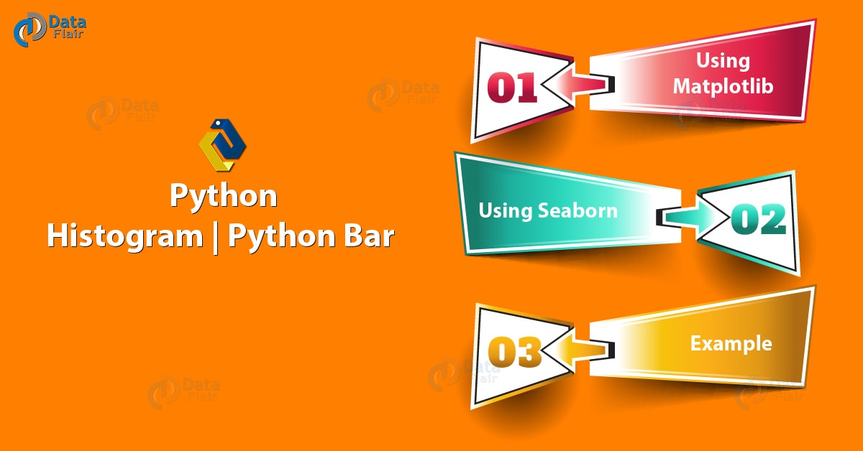
Python Histogram | Python Bar Plot (Matplotlib & Seaborn)

2. Python Histogram
A histogram is a graph that represents the way numerical data is represented. The input to it is a numerical variable, which it separates into bins on the x-axis. This is a vector of numbers and can be a list or a DataFrame column. A higher bar represents more observations per bin. Also, the number of bins decides the shape of the histogram.
Do you know about Python Packages

a. Example of Python Histogram
Let’s begin with a simple Matplotlib Histogram Example.
- >>> import seaborn as sn
- >>> df=sn.load_dataset(‘iris’)
- >>> sn.distplot(df['sepal_length'])
<matplotlib.axes._subplots.AxesSubplot object at 0x07837230
- >>> import matplotlib.pyplot as plt
- >>> plt.show()
Python Matplotlib Histogram Example
- >>> sn.distplot(df['sepal_length'],bins=25)
<matplotlib.axes._subplots.AxesSubplot object at 0x07837230>
- >>> plt.show()
Python Matplotlib Histogram Example
To plot this without Seaborn, we can do the following-
- >>> import numpy as np
- >>> from matplotlib import colors
- >>> from matplotlib.ticker import PercentFormatter
- >>> np.random.seed(19720810)
- >>> N=100000
- >>> n_bins=20
- >>> x=np.random.randn(N)
- >>> y=.7*x+np.random.randn(100000)+7
- >>> fig,axs=plt.subplots(1,2,sharey=True,tight_layout=True)
- >>> axs[0].hist(x,bins=n_bins)
- >>> axs[1].hist(y,bins=n_bins)
- >>> plt.show()
Example – Matplotlib Histogram in Python

b. Displaying Only The Histogram
We can choose to show or hide the Python Histogram, the rug, and the kernel density. Let’s try displaying only the Python Histogram for now.
Let’s revise Python Web Framework
- >>> sn.distplot(a=df['sepal_length'],hist=True,kde=False,rug=False)
<matplotlib.axes._subplots.AxesSubplot object at 0x0955C310>
- >>> plt.show()
Displaying Only The Histogram

c. Displaying Histogram, Rug, and Kernel Density
Now let’s try displaying all three.
- >>> sn.distplot(a=df['sepal_length'],hist=True,kde=True,rug=True)
<matplotlib.axes._subplots.AxesSubplot object at 0x09526EB0>
- >>> plt.show()
Displaying Histogram, Rug, and Kernel Density

d. Customizing the rug
Let’s set the rug to red.
Let’s learn about Python Datetime Module
- >>> sn.distplot(a=df['sepal_length'],rug=True,rug_kws={'color':'r','alpha':0.35,'linewidth':5})
<matplotlib.axes._subplots.AxesSubplot object at 0x07B18BD0>
- >>> plt.show()
Customizing the rug

e. Customizing the density distribution
Using keywords for kernel density, we can customize the density distribution.
- >>> sn.distplot(a=df['sepal_length'],kde=True,kde_kws={'color':'r','alpha':0.35,'linewidth':5})
<matplotlib.axes._subplots.AxesSubplot object at 0x07E5B7D0>
- >>> plt.show()
Customizing the density distribution

f. Vertical Python Histogram
Now let’s try making a vertical Python Histogram.
Let’s learn about Python Numpy
- >>> sn.distplot(df['sepal_length'],color='lightpink',vertical=True)
<matplotlib.axes._subplots.AxesSubplot object at 0x07DCD6D0>
- >>> plt.show()
Vertical Python Histogram

g. Python Histogram with multiple variables
We can view together the histograms for multiple numeric variables.
- >>> sn.distplot(df['sepal_length'],color='skyblue',label='Sepal length')
<matplotlib.axes._subplots.AxesSubplot object at 0x0849ABB0>
- >>> sn.distplot(df['sepal_width'],color='lightpink',label='Sepal width')
<matplotlib.axes._subplots.AxesSubplot object at 0x0849ABB0>
- >>> plt.show()
Multiple variables with Histogram in Python

3. Python Bar Plot
A bar plot in Python, also known as a bar chart, represents how a numerical variable relates to a categorical variable.
Let’s have a look at Python Pandas

a. Example of Python Bar Plot
Let’s take a quick Matplotlib Bar Chart Example.
- >>> import numpy as np
- >>> import matplotlib.pyplot as plt
- >>> marks=[79,45,22,89,95]
- >>> bars=('Roll 1','Roll 2','Roll 3','Roll 4','Roll 5')
- >>> y=np.arange(len(bars))
- >>> plt.bar(y,marks,color=’g’)
<BarContainer object of 5 artists>
- >>> plt.xticks(y,bars)
([<matplotlib.axis.XTick object at 0x0942EFD0>, <matplotlib.axis.XTick object at 0x0942E3B0>, <matplotlib.axis.XTick object at 0x0942E2B0>, <matplotlib.axis.XTick object at 0x079E60B0>, <matplotlib.axis.XTick object at 0x079E62F0>], <a list of 5 Text xticklabel objects>)
- >>> plt.show()
Example of Python Bar Plot

b. Setting a Different Color for Each Bar
Let’s try five different colors for the bars.
- >>> plt.bar(y,marks,color=['cyan','skyblue','lightpink','brown','black'])
<BarContainer object of 5 artists>
- >>> plt.xticks(y,bars)
([<matplotlib.axis.XTick object at 0x0947B570>, <matplotlib.axis.XTick object at 0x0947B170>, <matplotlib.axis.XTick object at 0x0946EC90>, <matplotlib.axis.XTick object at 0x094954B0>, <matplotlib.axis.XTick object at 0x09495850>], <a list of 5 Text xticklabel objects>)
- >>> plt.show()
Python Bar Chart – Setting Different Color For Each Bar

c. Setting Border Color
And now for the border color, we use the parameter edgecolor.
Learn Python Data Science Tutorial
- >>> plt.bar(y,marks,color=(0.2,0.4,0.2,0.7),edgecolor='deeppink')
<BarContainer object of 5 artists>
- >>> plt.xticks(y,bars)
([<matplotlib.axis.XTick object at 0x094A7FB0>, <matplotlib.axis.XTick object at 0x094A7BB0>, <matplotlib.axis.XTick object at 0x094A7770>, <matplotlib.axis.XTick object at 0x09426050>, <matplotlib.axis.XTick object at 0x094261F0>], <a list of 5 Text xticklabel objects>)
- >>> plt.show()
Python Bar Plot – Setting Border Color

d. Horizontal Python Bar Plot
How about a horizontal bar Plot?
- >>> plt.barh(y,marks)
<BarContainer object of 5 artists>
- >>> plt.yticks(y,bars)
([<matplotlib.axis.YTick object at 0x084DFC70>, <matplotlib.axis.YTick object at 0x09409B90>, <matplotlib.axis.YTick object at 0x09409CF0>, <matplotlib.axis.YTick object at 0x09413D70>, <matplotlib.axis.YTick object at 0x09413790>], <a list of 5 Text yticklabel objects>)
- >>> plt.show()
Horizontal Python Bar Plot

e. Adding Title and Axis Labels
Let’s call it Sample graph, with roll numbers on the x axis and marks on the y axis.
Do you know Python Interpreter environment
- >>> plt.bar(y,marks,color=(0.5,0.1,0.5,0.6))
<BarContainer object of 5 artists>
- >>> plt.title('Sample graph')
Text(0.5,1,’Sample graph’)
- >>> plt.xlabel('Roll numbers')
Text(0.5,0,’Roll numbers’)
- >>> plt.ylabel('Marks')
Text(0,0.5,’Marks’)
- >>> plt.ylim(0,100)
(0, 100)
- >>> plt.xticks(y,bars)
([<matplotlib.axis.XTick object at 0x07E991F0>, <matplotlib.axis.XTick object at 0x07E99FD0>, <matplotlib.axis.XTick object at 0x07E999F0>, <matplotlib.axis.XTick object at 0x07E5B1B0>, <matplotlib.axis.XTick object at 0x07DF2CF0>], <a list of 5 Text xticklabel objects>)
Let’s discuss Python Data File Formats
- >>> plt.show()
Adding Title and Axis Labels in Python Bar Plot
So, this was all in Python Histogram and Bar Plot using Matplotlib library. Hope you like our explanation.

4. Conclusion
Hence, in this Python Histogram tutorial, we conclude two important topics with plotting- histograms and bar plots in Python. While they seem similar, they’re two different things. Moreover, we discussed example of Histogram in Python and Python bar Plotting example. Still, if any doubt regarding Python Bar Plot, ask in the comment tab.
For example
Tags: Displaying HistogramExample of Python Bar PlotsExample of Python HistogramHistogram in Pythonkernel densityMatplotlib Bar Chart ExampleMatplotlib Histogram ExamplePython bar PlotsPython HistogramPython matplotlibPython seabornRug

Leave a Reply

*
*

This site is protected by reCAPTCHA and the Google Privacy Policy and Terms of Service apply.

Home About us Contact us Terms and Conditions Cancellation and Refund Privacy Policy Disclaimer Blogs Write For Us Careers Success Stories

Python – Heatmap & Word Cloud
Python – Geographical Map & Graph
Python Tutorials
Python Histogram | Python Bar Plot (Matplotlib & Seaborn)
❮ Prev
Next ❯

Popular Courses
Hadoop + Spark Course
Big Data Hadoop Course
Spark Scala Course
Apache Flink Course
Python Course

Popular Tutorials
Hadoop Tutorials
Spark Tutorials
Flink Tutorials
Tableau Tutorials
Power BI Tutorials
QlikView Tutorials

Popular Tutorials
Data Science Tutorials
Machine Learning Tutorials
Python Tutorials
R Tutorials
SAS Tutorials
SQL Tutorials
DataFlair © 2020. All Rights Reserved.

We use cookies to provide the best services. By using our site, you comply with our cookies policy. Learn more

Blog Home
- Courses
- Data Science
- Big Data
- Categories
- Interview Questions
- Job Portal
- Write For Us
Blog Home » Python Tutorials » Python Geographic Maps & Graph Data
- 0

Python Geographic Maps & Graph Data
by DataFlair Team · Updated ·

1. Objective
Today, in this Python tutorial, we will discuss Python Geographic Maps and Graph Data. Moreover, we will see how to handle geographical and graph data using Python and its libraries. We will use Matplotlib and Cartopy among other libraries to plot Geographic Maps and Graph Data.
So, let’s start Exploring Python Geographic Maps.
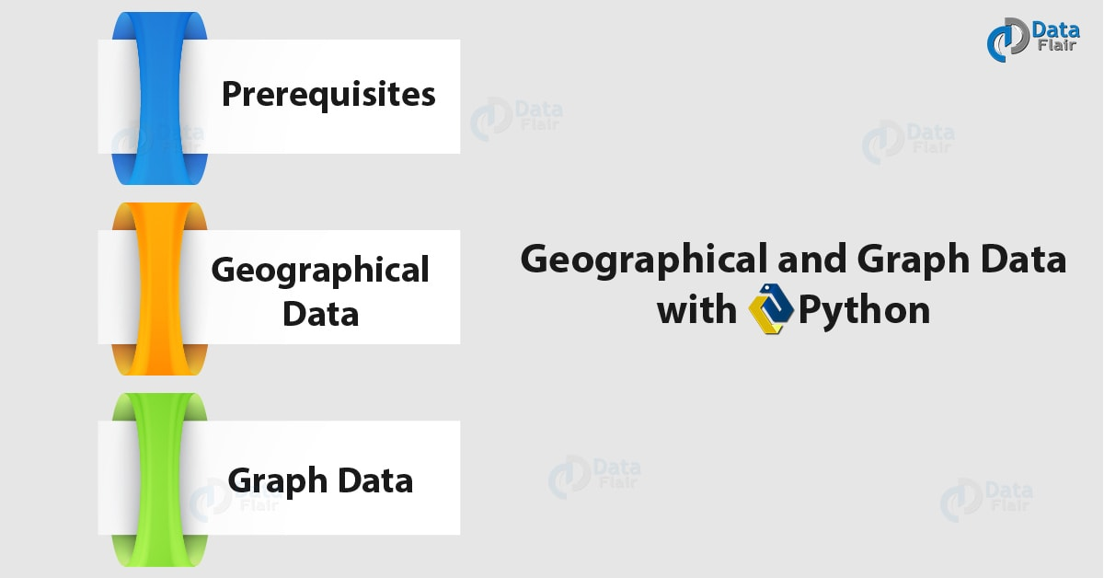
Python Geographic Maps & Graph Data

2. Prerequisites for Python Geographic Maps and Graph Data
Do you know about Python Heatmap
We need the following libraries for this Python Geographic Maps and Graph Data-

a. Cartopy
Python Geographic Maps – Cartopy
Cartopy is a Python package for cartography. It will let you process geospatial data, analyze it, and produce maps. As a Python package, it uses NumPy, PROJ.4, and Shapely, and stands on top of Matplotlib. Some of its key features-
- Object-oriented projection definitions.
- Publication quality maps.
- Ability to transform points, lines, polygons, vectors, and images.
You can install it using pip-
- pip install Cartopy
Note that you may need to install Microsoft Visual C++ Build Tools 14.0 or higher for this.
You can import it as-
- >>> import cartopy

b. Other modules
There are some other modules we will use here-
- pip install Matplotlib
- >>> import matplotlib.pyplot as plt
We will import other modules on the way as we’ll need them.

3. Python Geographic Maps
Python will let us draw Geographical maps. Let’s see how.

a. A simple map
Let’s first simply draw a map and fill it in later.
- >>> import cartopy.crs as ccrs
- >>> ax=plt.axes(projection=ccrs.PlateCarree()) #Using the PlateCarree projection
- >>> ax.coastlines() #Display the coastlines
<cartopy.mpl.feature_artist.FeatureArtist object at 0x06DA3DF0>
- >>> plt.show()
Python Geographic Maps – Simple Map

b. Other projections
- >>> ax=plt.axes(projection=ccrs.Orthographic())
- >>> ax.stock_img() #Add the stock world map image to the plot
<matplotlib.image.AxesImage object at 0x07427410>
Learn Python data Science environment Setup
- >>> plt.show()
Python Geographic Maps
We have several other projections like Mollweide, Robinson, Sinusoidal, and Gnomonic among many others.

c. Adding data
Let’s try to plot Romania to Indore, India in a map.
- >>> ax=plt.axes(projection=ccrs.AlbersEqualArea())
- >>> ax.stock_img()
<matplotlib.image.AxesImage object at 0x077466B0>
- >>> ro_lon,ro_lat=25,46 #Coordinates/ longitude and latitude
- >>> ind_lon,ind_lat=75.8,22.7
- >>> plt.plot([ro_lon,ind_lon],[ro_lat,ind_lat], color='green',linewidth=2,marker='*',transform=ccrs.Geodetic(),) #Green line
[<matplotlib.lines.Line2D object at 0x077469B0>]
- >>> plt.plot([ro_lon,ind_lon],[ro_lat,ind_lat], color='gray',linestyle='--',transform=ccrs.PlateCarree(),) #Gray, dashed line
[<matplotlib.lines.Line2D object at 0x07746E10>]
Let’s revise Python Pandas
- >>> plt.text(ro_lon-3,ro_lat-12,'Romania',
- horizontalalignment='right',
- transform=ccrs.Geodetic()) #Text- Romania
Text(22,34,’Romania’)
- >>> plt.text(ind_lon+3,ind_lat-12,'Indore',
- horizontalalignment='right',
- transform=ccrs.Geodetic()) #Text- Indore
Text(78.8,10.7,’Indore’)
- >>> plt.show()
Python Geographic Maps – Adding Data
The Geodetic coordinate system is spherical, but since we use AlbersEqualArea, that makes the green line appear straight on the plot. Similarly, the gray line is a PlateCarree but appears spherical.
Now, let’s try adding sky blue pins to a map.
Let’s discuss Python Scipy Tutorial
- >>> fig=plt.figure(figsize=(16,12))
- >>> ax=fig.add_subplot(1,1,1,projection=ccrs.PlateCarree())
- >>> ax.set_extent((10,144,70,-30))
- >>> ax.stock_img()
<matplotlib.image.AxesImage object at 0x06D75D90>
- >>> ax.coastlines()
<cartopy.mpl.feature_artist.FeatureArtist object at 0x06D75C70>
- >>> ax.tissot(facecolor='skyblue',alpha=0.6)
<cartopy.mpl.feature_artist.FeatureArtist object at 0x06D7E210>
- >>> plt.show()
Python Geographic maps – Adding Data

d. Contour plots
A contour plot represents a 3D surface on a 2D format by plotting contours (constant z slices). Let’s try making one.
Learn Aggregation with Python
- >>> from netCDF4 import Dataset as netcdf_dataset
- >>> import numpy as np
- >>> from cartopy import config
- >>> import os
- >>> fname=os.path.join(config["repo_data_dir"],
- 'netcdf', 'HadISST1_SST_update.nc'
- )
- >>> dataset=netcdf_dataset(fname)
- >>> sst=dataset.variables['sst'][0,:,:]
- >>> lats=dataset.variables['lat'][:]
- >>> lons=dataset.variables['lon'][:]
- >>> ax=plt.axes(projection=ccrs.PlateCarree())
- >>> plt.contourf(lons,lats,sst,60,
- transform=ccrs.PlateCarree())
<matplotlib.contour.QuadContourSet object at 0x0B39E830>
- >>> ax.coastlines()
<cartopy.mpl.feature_artist.FeatureArtist object at 0x0BC6BBD0>
- >>> plt.show()
Python Geographic Maps – Contour Plus

4. Python Graph Data
Moving on to graph data, let’s see how Python will let us represent a compressed sparse graph. This is abbreviated as CSGraph. Let’s talk about a few concepts it encompasses.
Let’s discuss how to work with NoSQL database

a. Sparse graphs
A sparse graph is a set of nodes that are linked together. Such a graph can represent anything of social network connections to points in a high-dimensional distribution.
To represent such data, we can use a sparse matrix G. Let’s keep it size NxN. The value of the connection between any two notes i and j will be G[i,j]. Now a sparse graph will hold zeros for most of its members. This means that for most of its nodes, there exist only a few connections.
Some algorithms we use for this are-
- Isomap- This is a manifold learning algorithm that needs to find the shortest paths in a graph
- Hierarchical clustering- This is a clustering algorithm and is based on minimum spanning trees
- Spectral decomposition- This is a projection algorithm and is based on sparse graph laplacians

b. Example – Word Ladder
This is a word game by Lewis Carroll. In this game, players switch letters in words to get from one word to another; they do this one letter at once. Let’s take an example.
wade-> fade-> faze-> gaze-> gate-> date-> hate
In cases like such, when we want to find the shortest possible path from one word to another, we can use the sparse graph submodule.
Do you Know about Python Data File Formats
- >>> wordlist="hello how are you can you read this without punctuation do you think this is something what is the meaning of life".split()
- >>> wordlist=[word for word in wordlist if len(word) == 3]
- >>> wordlist=[word for word in wordlist if word[0].islower()]
- >>> wordlist=[word for word in wordlist if word.isalpha()]
- >>> wordlist = list(map(str.lower, wordlist))
- >>> len(wordlist)
7
- >>> import numpy as np
- >>> wordlist=np.asarray(wordlist)
- >>> wordlist.dtype
dtype(‘<U3’)
- >>> wordlist.sort()
- >>> i1=wordlist.searchsorted('wade')
- >>> i2=wordlist.searchsorted('hate')
- >>> wordlist[i1]
‘you’
- >>> wordlist[i2]
‘how’
- >>> wordlist
array([‘are’, ‘can’, ‘how’, ‘the’, ‘you’, ‘you’, ‘you’], dtype='<U3′)
So, this was all in python Geographic Maps. hope you like our explanation of Python Graphs Data.

5. Conclusion
Hence, in this python Geographic Maps tutorial, we discussed graph plotting with Python. Moreover, we discussed Python Graph Data. Some of the libraries we used were Cartopy and Matplotlib.
See also –
Python 3 Extension Programming
For reference
Tags: CartopyGeographic mapsgeographical plotting with pythonGraph data in pythonGraph data With pythonMatplotlibPython Geographic dataPython Geographic plotsPython Graph data

Leave a Reply

*
*

This site is protected by reCAPTCHA and the Google Privacy Policy and Terms of Service apply.

Home About us Contact us Terms and Conditions Cancellation and Refund Privacy Policy Disclaimer Blogs Write For Us Careers Success Stories

Python – Histogram & Bar Plot
Python – Time Series
Python Tutorials
Python Geographic Maps & Graph Data
❮ Prev
Next ❯

Popular Courses
Hadoop + Spark Course
Big Data Hadoop Course
Spark Scala Course
Apache Flink Course
Python Course

Popular Tutorials
Hadoop Tutorials
Spark Tutorials
Flink Tutorials
Tableau Tutorials
Power BI Tutorials
QlikView Tutorials

Popular Tutorials
Data Science Tutorials
Machine Learning Tutorials
Python Tutorials
R Tutorials
SAS Tutorials
SQL Tutorials
DataFlair © 2020. All Rights Reserved.

We use cookies to provide the best services. By using our site, you comply with our cookies policy. Learn more

Blog Home
- Courses
- Data Science
- Big Data
- Categories
- Interview Questions
- Job Portal
- Write For Us
Blog Home » Python Tutorials » Python Time Series Analysis – Line, Histogram, Density Plotting
- 0

Python Time Series Analysis – Line, Histogram, Density Plotting
by DataFlair Team · Updated ·

1. Time Series Analysis in Python
In this Python tutorial, we will learn about Python Time Series Analysis. Moreover, we will see how to plot the Python Time Series in different forms like the line graph, Python histogram, density plot, autocorrelation plot, and lag plot.
So, let’s begin the Python Time Series Analysis.
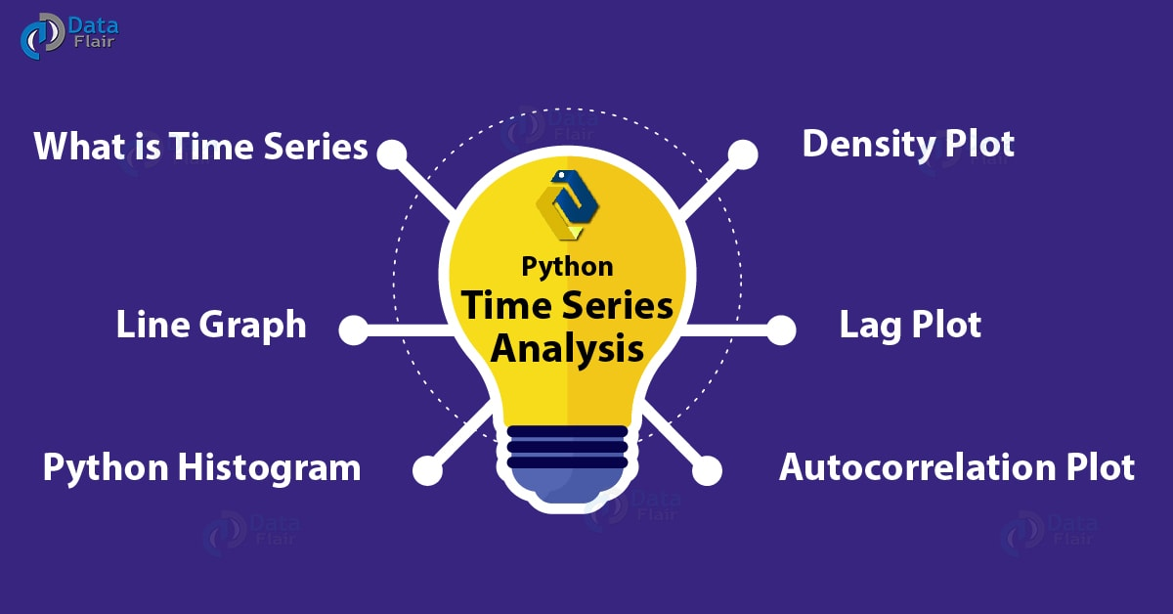
Python Time Series Analysis – Line, Histogram, Density Plotting

2. What is Time Series in Python?
Consider a sequence of points of data. Suppose we look at the rate of Dollar($) to Indian Rupee. We can link each point of data with a timestamp. Let’s try plotting for this rate over a period of one week. Let’s use Python pandas for this.

a. Data to Use in Python Time Series Analysis
We save the following data in a CSV file–
Date, Rate
18-07-2018, 68.625
19-07-2018, 68.9453
20-07-2018, 68.745
21-07-2018, 68.747
22-07-2018, 68.7415
23-07-2018, 68.9449
24-07-2018, 68.9486
We save this as dollartorupee.csv.
Do you know about Python NumPy?

b. Plotting a Python Line Chart/Graph
Let’s use this data to plot a simple line graph with this.
- >>> from pandas import Series
- >>> from matplotlib import pyplot
- >>> series=Series.from_csv('dollartorupee.csv',header=0)
- >>> series.plot()
<matplotlib.axes._subplots.AxesSubplot object at 0x031948D0>
- >>> pyplot.show()
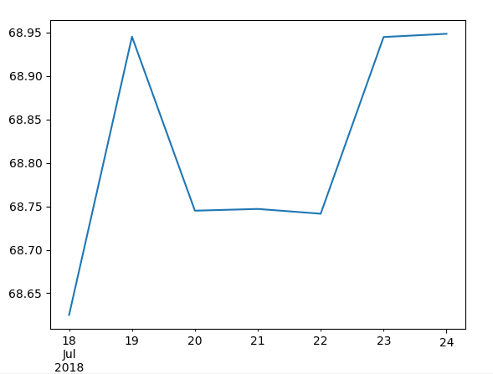
Plotting a Line Graph in Time Series Python Analysis
We can use a line style with this-
Learn more about Python SciPy
- >>> series.plot(style='k.')
<matplotlib.axes._subplots.AxesSubplot object at 0x033969B0>
- >>> pyplot.show()
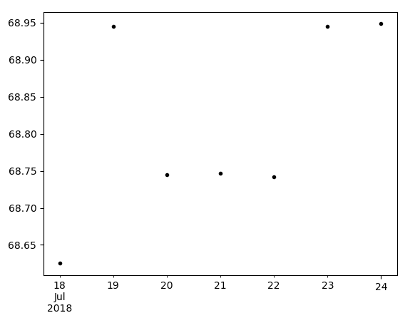
Plotting a Line Graph

3. Plotting a Python Histogram
Now to plot a Python histogram, we can try the hist() method.
- >>> series.hist()
<matplotlib.axes._subplots.AxesSubplot object at 0x05D683D0>
- >>> pyplot.show()
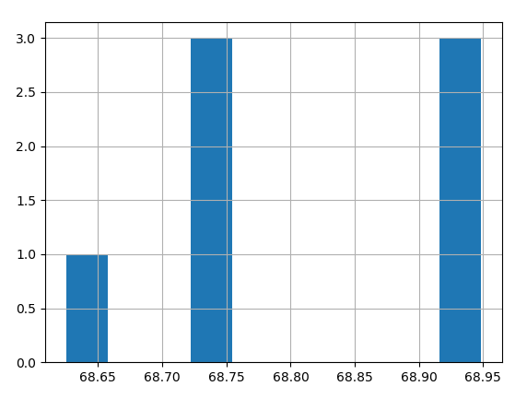
Plotting a Python Histogram in Time Series Python Analysis

4. Plotting a Density Plot in Python Time Series
What if we want to find out the density of the rate values for the entire week?
- >>> series.plot(kind='kde')
<matplotlib.axes._subplots.AxesSubplot object at 0x03194C70>
Let’s discuss Python Interpreter
- >>> pyplot.show()
Plotting a Density Plot in Time Series Python Analysis

5. Autocorrelation Plot in Python Time Series
This gives us how the elements of the series correlate to each other.
- >>> from pandas.tools.plotting import autocorrelation_plot
- >>> autocorrelation_plot(series)
<matplotlib.axes._subplots.AxesSubplot object at 0x08C5CA90>
- >>> pyplot.show()
Autocorrelation Plot in Time Series Python Analysis

6. Plotting a Lag Plot in Python Time Series
Such a plot tells us whether a time series is random. If you can identify a structure in the plot, the data isn’t random.
Do you know about Python Matplotlib
- >>> from pandas.tools.plotting import lag_plot
- >>> lag_plot(series)
<matplotlib.axes._subplots.AxesSubplot object at 0x08EF4FF0>
- >>> pyplot.show()
Plotting a Lag Plot in Time Series in Python Analysis
So, this was all in Time Series Analysis in Python. Hope you like our explanation.

7. Conclusion
Hence, in this Python Time Series tutorial, we discussed what is Time Series, Time Series Analysis in Python and plotting in Python Time Series Analysis. With this, we conclude our tutorial on time series. Now you know how to plot it in different forms. Got any questions? Leave them in the comments below.
See also –
Python Django
For reference
Tags: Python Line chartPython time seriesPython Time Series analysisPython Time series examplePython Time Series libraryTime series analysis in PythonTime series in PythonTime series PythonWhat is Python Time Serieswhat is Time series

Leave a Reply

*
*

This site is protected by reCAPTCHA and the Google Privacy Policy and Terms of Service apply.

Home About us Contact us Terms and Conditions Cancellation and Refund Privacy Policy Disclaimer Blogs Write For Us Careers Success Stories

Python – Geographical Map & Graph
Python – Linear Regression
Python Tutorials
Python Time Series Analysis – Line, Histogram, Density Plotting
❮ Prev
Next ❯

Popular Courses
Hadoop + Spark Course
Big Data Hadoop Course
Spark Scala Course
Apache Flink Course
Python Course

Popular Tutorials
Hadoop Tutorials
Spark Tutorials
Flink Tutorials
Tableau Tutorials
Power BI Tutorials
QlikView Tutorials

Popular Tutorials
Data Science Tutorials
Machine Learning Tutorials
Python Tutorials
R Tutorials
SAS Tutorials
SQL Tutorials
DataFlair © 2020. All Rights Reserved.

We use cookies to provide the best services. By using our site, you comply with our cookies policy. Learn more

Blog Home
- Courses
- Data Science
- Big Data
- Categories
- Interview Questions
- Job Portal
- Write For Us
Blog Home » Python Tutorials » Python Linear Regression | Chi-Square Test In Python
- 0

Python Linear Regression | Chi-Square Test In Python
by DataFlair Team · Updated ·

1. Python Linear Regression – Object
Today, in this Python tutorial, we will discuss Python Linear Regression and Chi-Square Test in Python. Moreover, we will understand the meaning of Linear Regression and Chi-Square in Python. Also, we will look at Python Linear Regression Example and Chi-square example.
So, let’s start with Python Linear Regression.
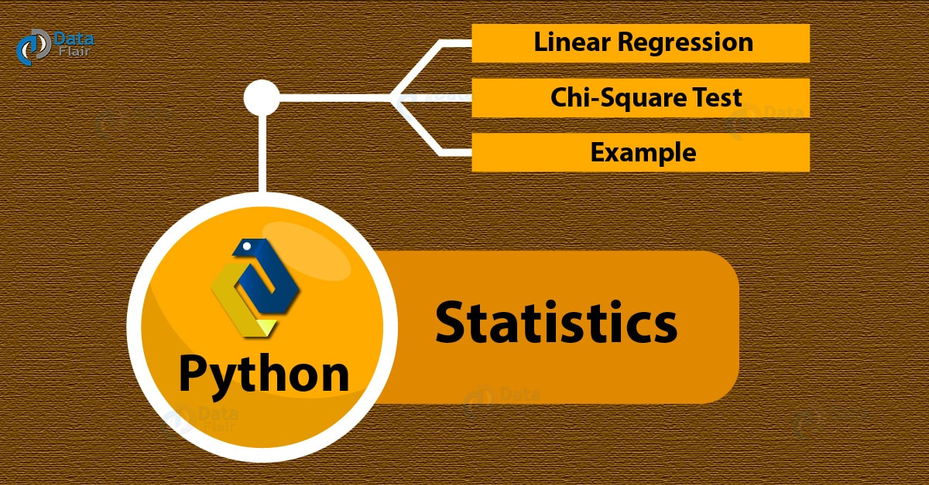
Python Linear Regression | Chi-Square Test In Python

2. Python Linear Regression
Linear regression is a way to model the relationship that a scalar response(a dependent variable) has with explanatory variable(s)(independent variables). Depending on whether we have one or more explanatory variables, we term it simple linear regression and multiple linear regression in Python.
Do you know about Python SciPy
To model relationships, we use linear predictor functions with unknown model parameters; we call these linear models in Python.
We will use Seaborn to plot a Python linear regression here.

a. Python Linear Regression Example
Let’s take a simple example of Python Linear Regression.
- >>> import seaborn as sn
- >>> import matplotlib.pyplot as plt
- >>> sn.set(color_codes=True)
- >>> tips=sn.load_dataset('tips')
- >>> ax=sn.regplot(x='total_bill',y='tip',data=tips)
- >>> plt.show()
Python Linear Regression Example

b. How to Customize the Color in Python Linear Regression?
Now let’s color it green.
Have a look at Python NumPy
- >>> import numpy as np
- >>> np.random.seed(7)
- >>> mean,cov=[3,5],[(1.3,.8),(.8,1.1)]
- >>> x,y=np.random.multivariate_normal(mean,cov,77).T
- >>> ax=sn.regplot(x=x,y=y,color='g')
- >>> plt.show()
Customizing the colour in Linear regression in Python Programming Language

c. Plotting with Pandas Series, Customizing Markers
Now, we’ll use two Python Pandas Series to plot Python linear regression.
- >>> import pandas as pd
- >>> x,y=pd.Series(x,name='x'),pd.Series(y,name='y')
- >>> ax=sn.regplot(x=x,y=y,marker='*')
Customizing the color in Python Linear regression

d. Setting a Confidence Interval
To set the confidence interval, we use the ci parameter. The confidence interval is a range of values that make it probable that a parameter’s value lies within it.
Let’s discuss Python Heatmap
- >>> ax=sn.regplot(x=x,y=y,ci=68)
- >>> plt.show()
Setting a Confidence Interval

e. Adding Jitter
You can add some jitter in the x or y directions.
- >>> ax=sn.regplot(x='size',y='total_bill',data=tips,y_jitter=.1,color='g')
- >>> plt.show()
Adding Jitter in Python Linear Regression

f. Plotting With a Continuous Variable Divided into Discrete Bins
Let’s revise the Python Charts
Let’s create 5 bins and make the plot.
- >>> ax=sn.regplot(x=x,y=y,x_bins=5)
- >>> plt.show()
Plotting With a Continuous Variable Divided into Discrete Bins

3. What is the Chi-Square Test?
This is a statistical hypothesis test that uses a chi-squared distribution as a sampling distribution for the test statistic when we have a true null hypothesis. In other words, it is a way to assess how a set of observed values fits in with the values expected in theory- the goodness of fit.
You must know about Python Data Science
The test tells us whether, in one or more categories, the expected frequencies differ significantly from the observed frequencies. We also write it as χ2 test. In this test, we classify observations into mutually exclusive classes. A null hypothesis tells us how probable it is that an observation falls into the corresponding class. With this test, we aim to determine how likely an observation made is, while assuming that the null hypothesis is true. This Chi-Square test tells us whether two categorical variables depend on each other.

a. Python Chi-Square Example
Let’s take an example.
- >>> from scipy import stats
- >>> import numpy as np
- >>> import matplotlib.pyplot as plt
- >>> x=np.linspace(0,10,100)
- >>> fig,ax=plt.subplots(1,1)
- >>> linestyles=['--','-.',':','-']
- >>> degrees_of_freedom=[1,3,7,5]
- >>> for df,ls in zip(degrees_of_freedom,linestyles):
- ax.plot(x,stats.chi2.pdf(x,df),linestyle=ls)<span style="font-family: Verdana, Geneva, sans-serif"> </span>
[<matplotlib.lines.Line2D object at 0x060314D0>]
[<matplotlib.lines.Line2D object at 0x06031590>]
[<matplotlib.lines.Line2D object at 0x060318B0>]
[<matplotlib.lines.Line2D object at 0x06031B50>]
- >>> plt.xlim(0,7)
(0, 7)
- >>> plt.ylim(0,0.5)
(0, 0.5)
Let’s discuss Python Compilers
- >>> plt.show()
This code plots four line plots for us-
Python Chi-Square Example

b. scipy.stats.chisquare
This calculates a one-way chi-square test for us. It has the following syntax-
- scipy.stats.chisquare(f_obs,f_exp=None,ddof=0,axis=0)
Consider the null hypothesis that the categorical data in question has the given frequencies. The Chi-square test tests this.
It has the following parameters-
- f_obs: array_like- In this, we specify the observed frequencies in every category
- f_exp: array_like, optional- This holds the expected frequencies in every category; each category is equally likely by default
- ddof: int, optional- This holds the adjustment value to the degrees of freedom for the p-value
- axis: int or None, optional- This is the axis of the broadcast result of f_obs and f_exp; we apply the test along with this
It has the following return values-
- chisq: float or ndarray- This is the chi-squared test statistic
- p: float or ndarray- This is the p-value of the test
Do you know about Python Geographic maps
This is the formula for the chi-square statistic-
sum((observed-expected)2/expected)

c. Examples of scipy.stats.chisquare
Let’s take a few simple examples.
- >>> from scipy.stats import chisquare
- >>> chisquare([6,8,6,4,2,2])
Power_divergenceResult(statistic=6.285714285714286, pvalue=0.27940194154949133)
- Providing expected frequencies
- >>> chisquare([6,8,6,4,2,2],f_exp=[6,6,6,6,6,8])
Power_divergenceResult(statistic=8.5, pvalue=0.13074778927442537)
- 2D observed frequencies
- >>> data=np.array([[6,8,6,4,2,2],[12,10,6,11,10,12]]).T
- >>> chisquare(data)
Power_divergenceResult(statistic=array([6.28571429, 2.44262295]), pvalue=array([0.27940194, 0.78511028]))
- Setting axis to None
- >>> chisquare(np.array([[6,8,6,4,2,2],[12,8,6,10,7,8]]),axis=None)
Power_divergenceResult(statistic=14.72151898734177, pvalue=0.1956041745113551)
Learn Python Scatter Plot
- >>> chisquare(np.array([[6,8,6,4,2,2],[12,8,6,10,7,8]]).ravel())
Power_divergenceResult(statistic=14.72151898734177, pvalue=0.1956041745113551)
- Altering the degrees of freedom
- >>> chisquare([6,8,6,4,2,2],ddof=1)
Power_divergenceResult(statistic=6.285714285714286, pvalue=0.17880285265458937)
- Calculating p-values by broadcasting the chi-squared statistic with ddof
- >>> chisquare([6,8,6,4,2,2],ddof=[0,1,2])
Power_divergenceResult(statistic=6.285714285714286, pvalue=array([0.27940194, 0.17880285, 0.09850749]))
So, this was all in Python Linear Regression. Hope you like our explanation of Python Chi-Square Test.

4. Conclusion
Hence, in this Python Statistics tutorial, we discussed Python Linear Regression and Python Chi-Square Test. Moreover, we saw the example of Python Linear Regression and chi-square test. Still, if any doubt regarding Python Linear Regression, ask in the comment tab.
See also –
Python Matplotlib
For reference
Tags: Chi square test in PythonExample of Chi Square TestLinear Regression Pythonmultiple linear regressionPythob Chi Square testPython Linear regressionPython Regressionsimple linear regressionwhat is Chi Square test

Leave a Reply

*
*

This site is protected by reCAPTCHA and the Google Privacy Policy and Terms of Service apply.

Home About us Contact us Terms and Conditions Cancellation and Refund Privacy Policy Disclaimer Blogs Write For Us Careers Success Stories

Python – Time Series
Python – Importance for ML
Python Tutorials
Python Linear Regression | Chi-Square Test In Python
❮ Prev
Next ❯

Popular Courses
Hadoop + Spark Course
Big Data Hadoop Course
Spark Scala Course
Apache Flink Course
Python Course

Popular Tutorials
Hadoop Tutorials
Spark Tutorials
Flink Tutorials
Tableau Tutorials
Power BI Tutorials
QlikView Tutorials

Popular Tutorials
Data Science Tutorials
Machine Learning Tutorials
Python Tutorials
R Tutorials
SAS Tutorials
SQL Tutorials
DataFlair © 2020. All Rights Reserved.

We use cookies to provide the best services. By using our site, you comply with our cookies policy. Learn more

Blog Home
- Courses
- Data Science
- Big Data
- Categories
- Interview Questions
- Job Portal
- Write For Us
Blog Home » Python Tutorials » Python for Machine Learning – Know the importance in Machine Learning Projects
- 0

Python for Machine Learning – Know the importance in Machine Learning Projects
by DataFlair Team · Updated ·
Machine learning is nothing but using data to make a machine to make intelligent decisions. It is based on recognizing and learning through patterns in data. Intelligent algorithms are then built by extracting, processing, defining, cleaning, arranging and then understanding the data. To perform such tedious tasks, why should one use Python? The answer is simple – It is easy to understand! Adding Python to the implementation process has helped engineers to validate various ideas. and that’s why today DataFlair has come up with a new topic – The importance of Python for Machine Learning.
Before we start with the tutorial, it is recommended to save the link Python Master Guide

Machine Learning with Python
Consider using Python for machine learning. Now all the questions like- How can these experiences be made real? Or What programming language will be best for this conversion? All of these will vanish away. Python offers all the skillsets that are required for a machine learning or AI project – stability, flexibility and a large number of tools. Python helps developers to be productive and confident about the product that they are manufacturing, from the stages of development to deployment and till the maintenance stage. These add to the popularity of the Python language.

Why Python for Machine Learning?
Below are some of the reasons which will tell you why everyone is using Python for machine learning –

1. Simple and consistent
Python’s simple syntax allows developers to write codes that are reliable, concise and readable. This allows them to only struggle with the solution of the problem and not the code syntax, increasing the productivity of the overall process of development. This simplicity becomes appealing to other developers and urges them to learn python. It’s greater human understanding makes it easier for coders/developers to invent various functional models.
Multiple developments and Collaborative implementation type of projects majorly use Python as the language for code. Prototypes are built faster as the complex machine learning tasks and the testing process can be done quickly. While we find the reason behind greater functionality- frameworks, libraries, and extensions are the reasons that come back as responses.
Now, another reason to learn Python for machine learning is the amazing libraries and frameworks of Python.

2. Libraries and Frameworks
To help developers in the development process, a number of python libraries and frameworks get involved. It is nothing but a pre-written code that can be used to solve a common programming problem. Python has a rich bank of libraries for machine learning, some of them are- TensorFlow, Keras, and Scikit-learn, Numpy, Scipy, Pandas, Seaborn, etc. In these NumPy and Scipy are specifically for scientific and advance computing respectively. Pandas generally used for Data analysis and Seaborn specifically for data visualization. With these pre-defined codes the speed of development increase to an appreciable level.

3. Platform Independence
It basically means one can freely shift from one machine to another without making changes to the actual code (or with minimal changes). This functionality is allowed by python’s framework. This is also one of the keys to the popularity of the python language. It supports many platforms such as- Windows, macOS, and Linux. Most of the companies use their own machine containing powerful GPUs to train their machine learning models. Python being platform-independent can make this overall training very cheap and easier.

4. Great Community Base
The fact is well that Python’s community has grown across the globe, and especially in the world of machine learning and data science. There are active communities that contribute to the large exchange of information which involves solutions to problems. For any problem you come across, chances are very high that someone out there has already gone through that same problem and solved it successfully. Hence you can find guidance and bits of advice at any level of doubt. You won’t be the only one who went through it. Also, you may come to know some of the best results according to your specifications, all you need to do it to turn to the huge python community.
Ready to learn Python Programming?
Take DataFlair’s self-paced Python training and become the next developer

Summary
Machine learning has made a massive effect on the current world we are living in, with new applications emerging all the time. Developers are choosing Python at every step of problem-solving. While there are programming languages other than python that be used for AI projects, but python is cutting edges of all, with significant considerations. According to the people who practice python, they believe – python is a language that is well suited for machine learning and AI. And if you are still wondering why, read this twice! And choose python for your next AI project.
Tags: Introduction to machine learning with PythonMachine Learning using PythonPython for machine learningWhy Python for Machine Learning

Leave a Reply

*
*

This site is protected by reCAPTCHA and the Google Privacy Policy and Terms of Service apply.

Home About us Contact us Terms and Conditions Cancellation and Refund Privacy Policy Disclaimer Blogs Write For Us Careers Success Stories

Python – Linear Regression
Python ML – Tutorial
Python Tutorials
Python for Machine Learning – Know the importance in Machine Learning Projects
❮ Prev
Next ❯

Popular Courses
Hadoop + Spark Course
Big Data Hadoop Course
Spark Scala Course
Apache Flink Course
Python Course

Popular Tutorials
Hadoop Tutorials
Spark Tutorials
Flink Tutorials
Tableau Tutorials
Power BI Tutorials
QlikView Tutorials

Popular Tutorials
Data Science Tutorials
Machine Learning Tutorials
Python Tutorials
R Tutorials
SAS Tutorials
SQL Tutorials
DataFlair © 2020. All Rights Reserved.

We use cookies to provide the best services. By using our site, you comply with our cookies policy. Learn more

Blog Home
- Courses
- Data Science
- Big Data
- Categories
- Interview Questions
- Job Portal
- Write For Us
Blog Home » Machine Learning Tutorials » Python Machine Learning Tutorial – Tasks and Applications
- 0

Python Machine Learning Tutorial – Tasks and Applications
by DataFlair Team · Updated ·

1. Python Machine Learning Tutorial
In this Python Machine Learning Tutorial, we will introduce you to machine learning with Python. Moreover, we will discuss Python Machine Learning tasks, steps, and applications. Then, we will take a look at 10 tech giants that adapt Python Machine Learning to improve what they do.
So, let’s start the Python Machine Learning Tutorial.
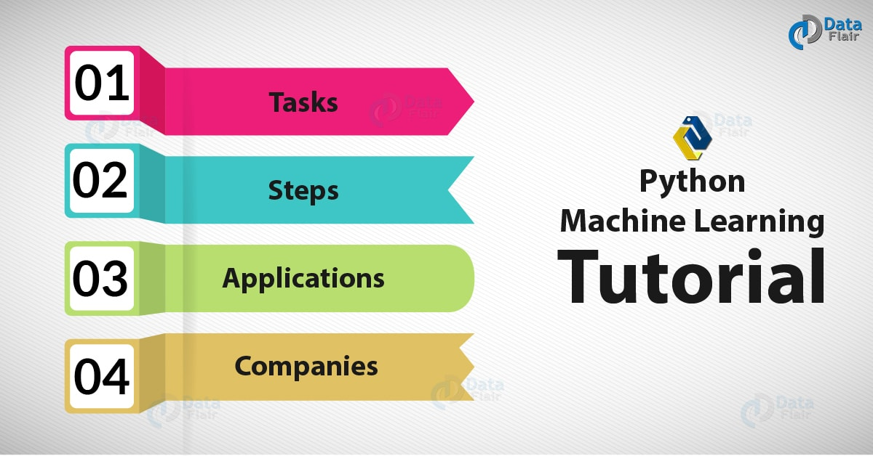
Python Machine Learning Tutorial – Tasks and Applications

2. Introduction to Machine Learning With Python
In this Python Machine Learning Tutorial, Machine Learning also termed ML. It is a subset of AI (Artificial Intelligence) and aims to grants computers the ability to learn by making use of statistical techniques. It deals with algorithms that can look at data to learn from it and make predictions.
Do you know about statistics in Python

3. Tasks in Machine Learning Using Python
With Python Machine Learning, we divide the tasks of Machine Learning Algorithms in Python into two broad categories- Supervised and Unsupervised.
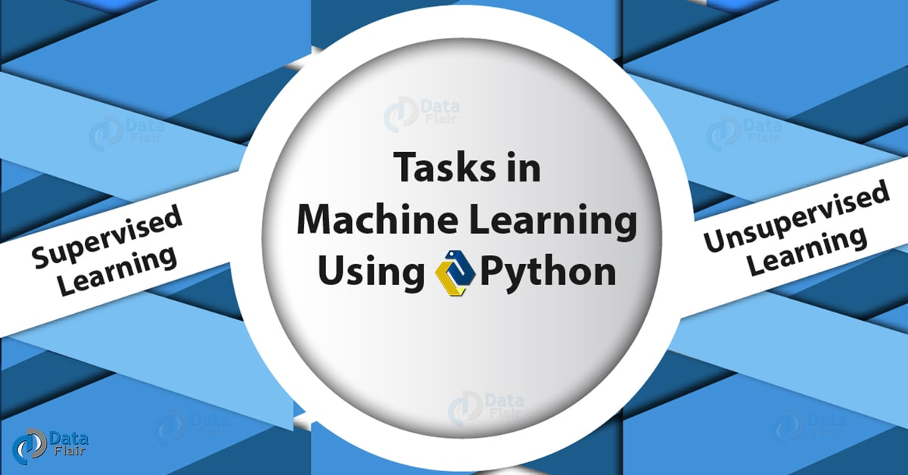
Python Machine Learning Tutorial – Tasks of Machine learning

a. Supervised Learning
Here, a learning signal/ feedback is available to the system; we give it to sample data to learn from. The computer holds example inputs and desired outputs with the goal of learning a general rule that maps inputs to outputs. One such example of Python Machine Learning will be to search for images on Facebook using keywords centered around the contents of the image. Under Supervised Learning, we have the following kinds of Python machine Learning-
- Semi-Supervised Learning- The computer receives an incomplete training signal. This is a training set with some target outputs missing.
- Active Learning- The computer can secure training labels for only some instances. It also needs to make an optimal choice of objects to secure labels.
- Reinforcement Learning- In this, the training data comes as feedback on how a program acts in a dynamic environment. Examples of this include driving a vehicle or playing against an opponent.
Steps involved in Supervised Machine Learning-
- Training
- testing
Among many Supervised Machine Learning Algorithms for beginners we observe, here we list some-
Let’s discuss Machine Learning Applications
- Decision trees
- Support Vector Machines
- Naïve Bayes
- k-nearest neighbor
- Linear regression

b. Unsupervised Learning
In unsupervised learning, the Python Machine Learning Algorithm receives no labels; we only give the machine a set of inputs. It must rely on itself to find structure in its input. This kind of learning can be a goal or a means toward future learning. We can classify unsupervised learning as-
- Clustering- The act of grouping data inherently. One example of this will be to group consumers by their shopping habits so they can target the right consumers to advertise.
- Association- In association, we identify rules explaining large sets of our data. One example will be to associate books around author/ category.
Of the many Unsupervised Machine Learning Algorithms, we observe, here are a couple-
- K-means clustering
- Hierarchical clustering

4. Steps in Python Machine Learning
We follow the following steps in Machine Learning Using Python-
- Collecting data.
- Filtering data.
- Analyzing data.
- Training algorithms.
- Testing algorithms.
- Using algorithms for future predictions.

5. Applications of Python Machine Learning
Where does machine learning with Python come to use? Let’s learn Applications of Machine Learning with Python:
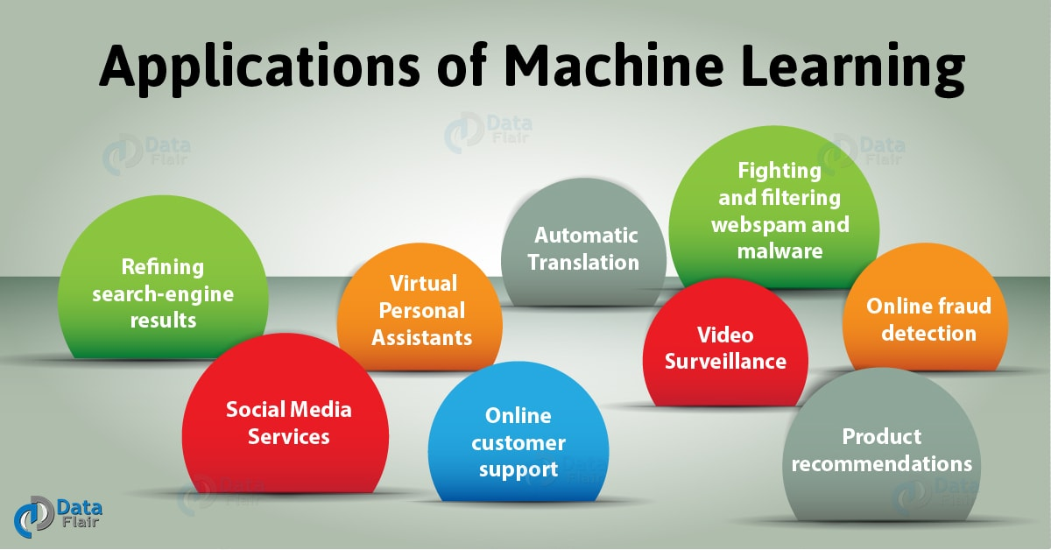
Python Machine Learning Tutorial – Applications of Machine learning

a. Fighting and filtering webspam and malware
With rule-based spam filtering, latest tricks by spammers can go unnoticed. e-mail clients make use of machine learning to ensure its spam filters stay updated. Other than that, imagine getting to Google and searching for something only to find irrelevant listings right at the top. To fight these situations, Google uses ‘deep learning’, a neural network that takes data from users and from NLP, and determines the nature of the email in question. Some spam-filtering techniques under ML are Multi-Layer Perceptron and C 4.5 Decision Tree Induction.
Let’s have a look at Python ML Techniques

b. Refining search-engine results
Suppose you went up to Google and typed in the keywords “DIY lampshade”. If you visit one or more of the top listings and stay for a while, Google assumes it did a good job serving your request. If, however, you end up on the third page and have not visited any result, Google knows it could have done better. So, it improves search results next time.

c. Virtual Personal Assistants
With assistants like Siri, Alexa, and Google Now, the term virtual personal assistant needs no explanation. This help finds information for you, make calls, set alarms, and check the weather among all other things they can do. And to make this easy for you, all they need you to do is use your voice and command them to do it for you. When you’ve got your hands filthy, or if you’ve just woken up and do not wish to lay your eyes on the light of a screen, this comes in handy. Not to forget the huge importance of this for those handicapped.
How you involve with them helps them collect and refine that information. This is machine learning and this is how they generate better results next time.

d. Social Media Services
On social media, facilities like ‘People You May Know’ and ‘Face Recognition’ work via machine learning. Considering your activity like the profiles you visit, the people you befriend, the people you tag, Facebook curates a list of suggestions for you to enrich your experience and make you stay.

e. Online customer support
Some websites will pop a live chat option up to make your stay in case you need a query to be answered. For some, it isn’t live but is a chatbot. Such a bot pulls information from the website and delivers it to the customer. The machine learning algorithms make it possible to improve this experience.
Let’s discuss Train and Test Set in Python ML

f. Product recommendations
Shopping giants like Jabong and Amazon curate a list of products similar to the ones you’re visiting. They also mail you shopping suggestions. This is machine learning behind the scenes; it pays attention to your past purchases, wishlist, cart contents, brand preferences, and so.

g. Online fraud detection
Companies like PayPal use ML to fight against issues like money laundering. They compare millions of transactions to differentiate between those legitimate and illegitimate.

h. Video Surveillance
With ML, video surveillance systems can detect a possible crime ahead of it. Risque behavior like people standing motionless for a while monitoring a situation, napping on a bench, and following another individual can alert human attendants. When this can prevent a mishap and save a life, incidents like these help improve such surveillance services.
Let’s know why we should learn Machine Learning

i. Automatic Translation
ML makes it possible to translate text from one language to another. The algorithm learns how words fit together and use that to improve the translation. This is also possible to text on images. This is done with neural networks to identify letters in the images. It translates the text and then puts it back onto the picture.

6. Companies Using Python Machine Learning
Of many others, the following 10 companies make use of machine learning tools and technologies to grow and improve their functions.
Python Machine Learning Tutorial – Companies

a. Apple
Apple was the first to ship a voice assistant on a smartphone. And with HomePod, it aspires to take this a step further.
Python Machine Learning Tutorial – Apple
With the rising competition, it is the technology and the end user that benefits. Apple paid $200 to purchase Lattice Data, which can convert unstructured data into a structured form using ML. It also develops in-house machine learning systems.

b. Google
Python Machine Learning Tutorial – Google
Google offers, to developers, multiple cloud-based services. One of these is the Google Cloud AI machine learning tools. Recently, Google launched an AI chatbot that will answer messages for you. This is like a sophisticated auto-response email.

c. Microsoft
Python Machine Learning Tutorial – Microsoft
Microsoft purchased LinkedIn a few years ago at $26 billion and has lately been the third-biggest spender on acquisitions. Maluuba, a Canadian tech company that houses a very impressive deep learning research lab for Natural Language Understanding.

d. Twitter
Python Machine Learning Tutorial – Twitter
Ever since Facebook changed its algorithm to favor posts from friends and family over news articles from reputed sources, Twitter’s profitability has raised. Here, machine learning makes it possible to find out what people might be interested in and curate content for them.

e. Intel
Python Machine Learning Tutorial – Intel
Intel is the largest chipmaker in the world. In the last few years, it acquired Nervana Systems (manufacturer of chips for data center servers) at a capital of $400 million. Nervana chips can transfer data at around 2.4 terabytes per second at a low latency.
Have a look at the advantages & disadvantages of Machine learning

f. Baidu
Python Machine Learning Tutorial – Baidu
Baidu is a Chinese search giant and takes a keen interest in Natural Language Processing. It also aims to develop a functioning voice-activated search facility. Recently, it acquired Kitt.ai, which has a portfolio of chatbots and voice-based applications. Very easily, Baidu is the 10th largest spender on acquisitions.

g. IBM
Python Machine Learning Tutorial – IBM
Back in the 1990s, IBM challenged Garry Kasparov, Russia’s greatest chess player, to a match against Deep Blue, a computer by IBM. Kasparov won the first match and flunked the next few. Later, computer Watson AI beat contestants on the quiz show Jeopardy!. More recently, the machine won the ancient board game ‘Go’ in a recent human-vs-machine contest.

h. Salesforce
Python Machine Learning Tutorial – Salesforce
Salesforce is the sixth-largest buyer of AI companies over the last five years, CB Insights claims. Recently, it said it had a year of ‘Einstein’ technology- one that analyzes each aspect of a customer’s relationship with a company.

i. Pindrop
Python Machine Learning Tutorial – Pindrop
Pindrop claims to present a pioneering technology for recognizing fraudulent activity over the phone channel. In what it calls ‘phoneprinting’, for every call, it analyzes 1,300 unique call features and creates an audio fingerprint for each. Such features include noise, location, number history, and call type. It flags suspicious calls and can spot ID spoofing, voice distortion, and social engineering.

j. Qubit
Python Machine Learning Tutorial- Qubit
Qubit has an AI-powered personalized shopping app, Aura. This has a database of products in a range of categories like fashion, clothing, and cosmetics. Pending patents suggest an Instagram-like feed of product images.
So, this was all in Python Machine Learning Tutorial. Hope you like our explanation of Machine Learning Python Course.

7. Python Machine Learning Tutorial – Conclusion
Hence, in this Python Machine Learning Tutorial, we discussed what is Python Machine Learning and tasks in Python and Machine Learning. Moreover, we discussed applications of Python Machine Learning. Also, we saw companies using Machine Learning with Python. By now, we realize machine learning is powerful. Let’s delve into the world of ML and learn something new. Still, if you have any doubt regarding Python Machine Learning, ask in the comment tab.
See also –
Data Processing in Python ML
For reference
Tags: Learn Python Machine LearningMachine Learning AlgorithmsMachine Learning tutorialMachine Learning using PythonPython and Machine LearningPython machine LearningPython machine Learning StepsSupervised LearningUnsupervised Learning

Leave a Reply

*
*

This site is protected by reCAPTCHA and the Google Privacy Policy and Terms of Service apply.

Home About us Contact us Terms and Conditions Cancellation and Refund Privacy Policy Disclaimer Blogs Write For Us Careers Success Stories

Python – Importance for ML
Python ML – Environment Setup
Machine Learning TutorialsPython Tutorials
Python Machine Learning Tutorial – Tasks and Applications
❮ Prev
Next ❯

Popular Courses
Hadoop + Spark Course
Big Data Hadoop Course
Spark Scala Course
Apache Flink Course
Python Course

Popular Tutorials
Hadoop Tutorials
Spark Tutorials
Flink Tutorials
Tableau Tutorials
Power BI Tutorials
QlikView Tutorials

Popular Tutorials
Data Science Tutorials
Machine Learning Tutorials
Python Tutorials
R Tutorials
SAS Tutorials
SQL Tutorials
DataFlair © 2020. All Rights Reserved.

We use cookies to provide the best services. By using our site, you comply with our cookies policy. Learn more

Blog Home
- Courses
- Data Science
- Big Data
- Categories
- Interview Questions
- Job Portal
- Write For Us
Blog Home » Machine Learning Tutorials » Python Machine Learning Environment Setup – Installation Process
- 3

Python Machine Learning Environment Setup – Installation Process
by DataFlair Team · Updated ·

1. Python Machine Learning Environment Setup
In this tutorial of Python Machine Learning Environment Setup, we will show you the way with setting your machine up for a Machine Learning environment with Python. Moreover, for Python Machine Learning installation, we will see the process to install Python and the needed Python Libraries such as NumPy, SciPy, Matplotlib etc.
So, let’s start the Python Machine Learning Environment Setup.
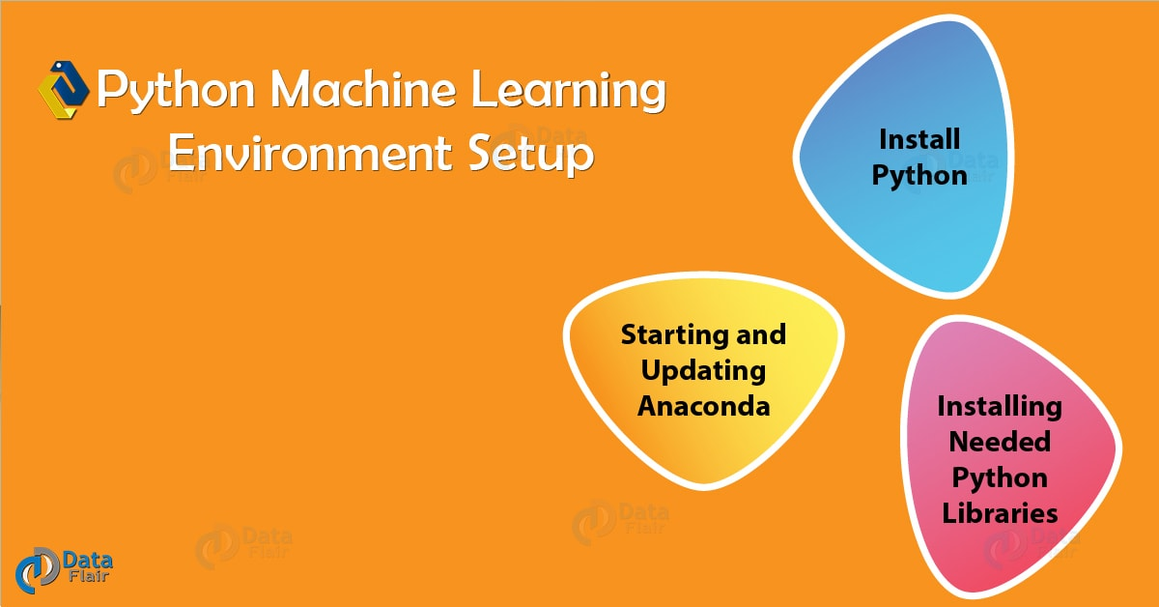

2. How to Install Python?
Before anything else, you will need to Install Python on your machine. So, here are the steps to install Python.

a. Plain download
You can download from the official website-
https://www.python.org/downloads/
At the time of writing, the latest version of Python is Python 3.7. This is what the installer looks like-
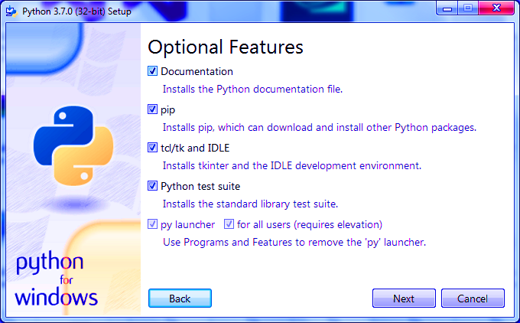
For a detailed guide on how to set up Python for your machine, read up on A Step-by-Step Guide to Install Python for Windows.

b. Installing with Anaconda
Or you can install it with Anaconda-
https://www.anaconda.com/download/
This downloads Anaconda for us. Now to install it, we run the installer-
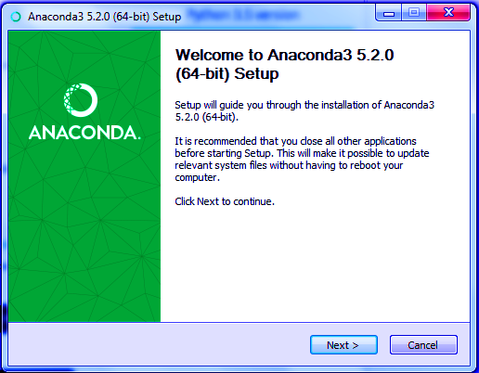
Installing With Anaconda

Installing With Anaconda
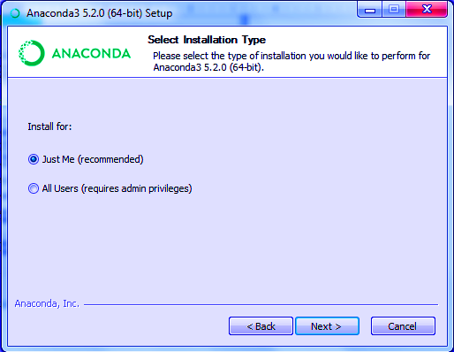
Installing With Anaconda
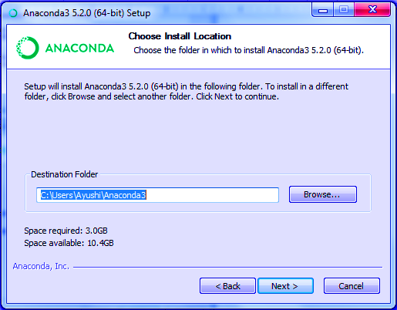
Python Machine Learning Environment Setup
And for the final options-
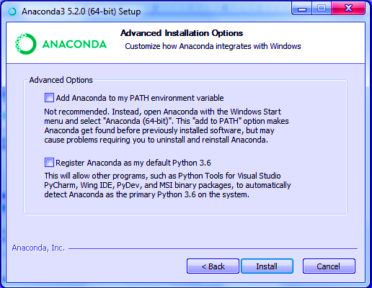
Installing Anaconda
And then, it installs Anaconda-
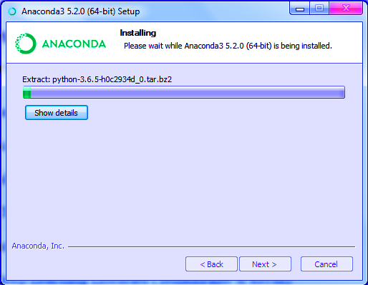
Installing Anaconda

3. Starting and Updating Anaconda
To confirm that your Anaconda environment is up to date, follow these steps-
1. Open Anaconda Prompt and type the following-
- (base) C:\Users\Ayushi>conda -V
conda 4.5.8
2. Now the following command tells you about your Python environment-
- (base) C:\Users\Ayushi>python -V
Python 3.6.5 :: Anaconda, Inc
3. Then, to confirm that the conda environment you hold is up to date-
Have a look at the future of Machine Learning
- (base) C:\Users\Ayushi>conda update conda
Solving environment: done
# All requested packages already installed.
- (base) C:\Users\Ayushi>conda update anaconda
Solving environment: done
# All requested packages already installed.

4. Installing Needed Python Libraries
Working with machine learning, we will need a few Python Libraries often. Here’s a list of some of those-

a. NumPy
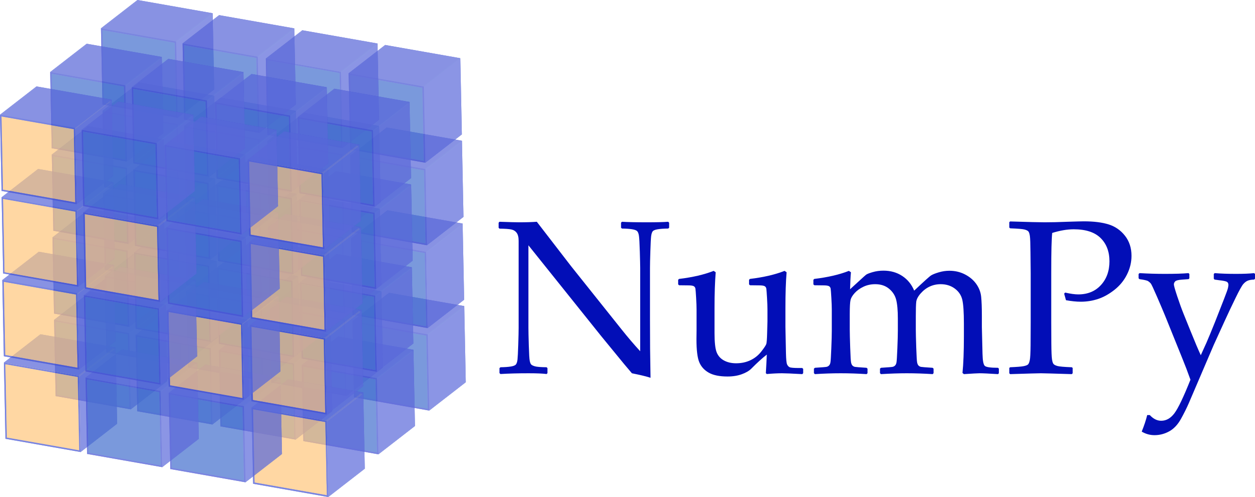
Python Libraries – NumPy
NumPy, a Python library that will let you handle multi-dimensional arrays and matrices. It also offers multiple high-level mathematical functions to operate on these.
You can install it as-
- conda install numpy

b. SciPy

Python Libraries – SciPy
SciPy is a scientific- and technical- computing Python library that is free and open-source. Install it as-
- conda install scipy

c. Matplotlib

Python Library – Matplotlib
Matplotlib, a Python library for plotting and has NumPy as its numerical mathematics extension. Install it as-
- conda install matplotlib

d. pandas
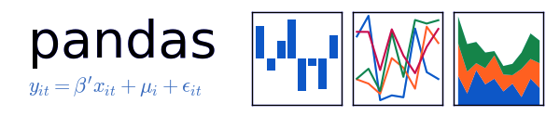
Python Library – Pandas
pandas is a software library for Python that comes in handy when working with data manipulation and analysis. Install it with the following command-
- conda install pandas

e. statsmodels

Python Library – StatsModels
This is a Python package that lets users explore data, estimate statistical models, and carry out statistical tests. You can install it as-
- conda install statsmodels

f. seaborn

Python Library – Seaborn
This is a Python library for data visualization and is based on Matplotlib. It offers a high-level interface for plotting statistical graphs that are attractive and informative. You can install it with the following command-
- conda install seaborn

g. scikit-learn

Python Library – Scikiy Learn
This is a free software ML library for Python. It offers facilities like classification, regression, and clustering algorithms.
Let’s discuss Machine Learning Algorithms
To find out which version of a library you’re using, you can run the following piece of code in the interpreter-
- >>> import scipy
- >>> scipy.__version__
‘1.1.0’
The command to install scikit-learn is conda install scikit-learn.
So, this was all in Python Machine Learning Environment Setup. Hope you like our explanation.

5. Conclusion
Hence, in this Python Machine Learning Environment Setup, we discussed how to install Python. Moreover, we saw the starting and updating of Anaconda. Also, in this Python machine Learning Environment Setup, we learned about the need libraries. If you follow all the steps mentioned above, you will successfully set up a machine learning environment for Python at a beginner level. Still, if any doubt regarding Python Machine Learning Environment Setup, ask in the comment tab. We will definitely get back to you.
See also –
Python Web Framework
For reference
Tags: Anaconda machine Learning tutorialinstalling anacondaInstalling Needed Librariesinstalling pythonInstalling with AnacondaPython librariesPython Machine Learning InstallationStarting and Updating Anacondastatsmodels

3 Responses
- Comments3
- Pingbacks0

selvapriya
January 4, 2019 at 10:30 am
What are the libraries required for invoice extraction? And how to include Jupyter?
Reply
- Vineet Chauhan
January 21, 2020 at 2:42 pm
Please add below line:
conda install scikit-learn
Reply
- daniel
February 26, 2020 at 12:56 am
what happen if i am not updating the anaconda,, becuase my pc does not update it?
Reply

Leave a Reply

*
*

This site is protected by reCAPTCHA and the Google Privacy Policy and Terms of Service apply.

Home About us Contact us Terms and Conditions Cancellation and Refund Privacy Policy Disclaimer Blogs Write For Us Careers Success Stories

Python ML – Tutorial
Python ML – Data Pre-Processing
Machine Learning TutorialsPython Tutorials
Python Machine Learning Environment Setup – Installation Process
❮ Prev
Next ❯

Popular Courses
Hadoop + Spark Course
Big Data Hadoop Course
Spark Scala Course
Apache Flink Course
Python Course

Popular Tutorials
Hadoop Tutorials
Spark Tutorials
Flink Tutorials
Tableau Tutorials
Power BI Tutorials
QlikView Tutorials

Popular Tutorials
Data Science Tutorials
Machine Learning Tutorials
Python Tutorials
R Tutorials
SAS Tutorials
SQL Tutorials
DataFlair © 2020. All Rights Reserved.

We use cookies to provide the best services. By using our site, you comply with our cookies policy. Learn more

Blog Home
- Courses
- Data Science
- Big Data
- Categories
- Interview Questions
- Job Portal
- Write For Us
Blog Home » Machine Learning Tutorials » Data Preprocessing, Analysis & Visualization – Python Machine Learning
- 2

Data Preprocessing, Analysis & Visualization – Python Machine Learning
by DataFlair Team · Updated ·

1. Objective
Today in this Python Machine Learning Tutorial, we will discuss Data Preprocessing, Analysis & Visualization. Moreover in this Data Preprocessing in Python machine learning we will look at rescaling, standardizing, normalizing and binarizing the data. Also, we will see different steps in Data Analysis, Visualization and Python Data Preprocessing Techniques.
So, let’s start machine Learning with Python Data Preprocessing.
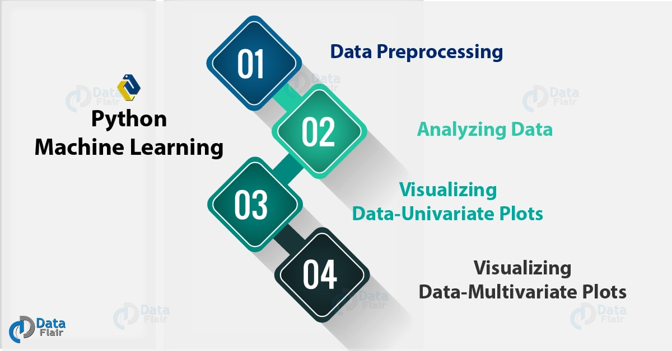
Data Preprocessing, Analysis & Visualization – Python Machine Learning

2. Data Preprocessing in Python Machine Learning
Machine Learning algorithms don’t work so well with processing raw data. Before we can feed such data to an ML algorithm, we must preprocess it. In other words, we must apply some transformations on it. With data preprocessing, we convert raw data into a clean data set.
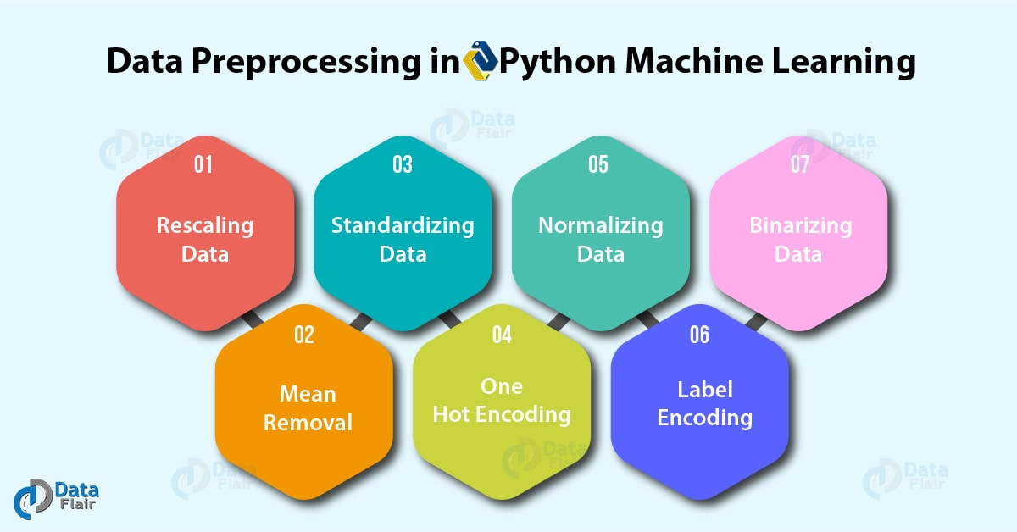
Some ML models need information to be in a specified format. For instance, the Random Forest algorithm does not take null values. To preprocess data, we will use the library scikit-learn or sklearn in this tutorial.

3. Python Data Preprocessing Techniques
Let’s talk about seven such techniques for Data Preprocessing in Python Machine Learning.
Let’s have a look at data Structure in Python

a. Rescaling Data
For data with attributes of varying scales, we can rescale attributes to possess the same scale. We rescale attributes into the range 0 to 1 and call it normalization. We use the MinMaxScaler class from scikit-learn. Let’s take an example.
- >>> import pandas, scipy, numpy
- >>> from sklearn.preprocessing import MinMaxScaler
- >>> df=pandas.read_csv( 'http://archive.ics.uci.edu/ml/machine-learning-databases/wine-quality/winequality-red.csv ',sep=';')
- >>> array=df.values
- >>> #Separating data into input and output components
- >>> x=array[:,0:8]
- >>> y=array[:,8]
- >>> scaler=MinMaxScaler(feature_range=(0,1))
- >>> rescaledX=scaler.fit_transform(x)
- >>> numpy.set_printoptions(precision=3) #Setting precision for the output
- >>> rescaledX[0:5,:]
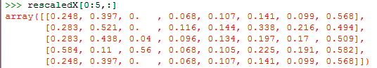
This gives us values between 0 and 1. Rescaling data proves of use with neural networks, optimization algorithms and those that use distance measures like k-nearest neighbors and weight inputs like regression.

b. Standardizing Data
With standardizing, we can take attributes with a Gaussian distribution and different means and standard deviations and transform them into a standard Gaussian distribution with a mean of 0 and a standard deviation of 1. For this, we use the StandardScaler class. Let’s take an example.
Do you know about Python Statistics
- >>> from sklearn.preprocessing import StandardScaler
- >>> scaler=StandardScaler().fit(x)
- >>> rescaledX=scaler.transform(x)
- >>> rescaledX[0:5,:]

c. Normalizing Data
In this task, we rescale each observation to a length of 1 (a unit norm). For this, we use the Normalizer class. Let’s take an example.
- >>> from sklearn.preprocessing import Normalizer
- >>> scaler=Normalizer().fit(x)
- >>> normalizedX=scaler.transform(x)
- >>> normalizedX[0:5,:]
Normalizing Data in Data Preprocessing

d. Binarizing Data
Using a binary threshold, it is possible to transform our data by marking the values above it 1 and those equal to or below it, 0. For this purpose, we use the Binarizer class. Let’s take an example.
Learn about Python Data Science Environment Setup
- >>> from sklearn.preprocessing import Binarizer
- >>> binarizer=Binarizer(threshold=0.0).fit(x)
- >>> binaryX=binarizer.transform(x)
- >>> binaryX[0:5,:]
This marks 0 over all values equal to or less than 0, and marks 1 over the rest. When you want to turn probabilities into crisp values, this functionality comes handy.
Binarizing Data in Data Preprocessing

e. Mean Removal
We can remove the mean from each feature to center it on zero.
- >>> from sklearn.preprocessing import scale
- >>> data_standardized=scale(df)
- >>> data_standardized.mean(axis=0)
array([ 3.555e-16, 1.733e-16, -8.887e-17, -1.244e-16, 3.910e-16,
-6.221e-17, 4.444e-17, 2.364e-14, 2.862e-15, 6.754e-16,
1.066e-16, 8.887e-17])
- >>> data_standardized.std(axis=0)
array([1., 1., 1., 1., 1., 1., 1., 1., 1., 1., 1., 1.])

f. One Hot Encoding
When dealing with few and scattered numerical values, we may not need to store these. Then, we can perform One Hot Encoding. For k distinct values, we can transform the feature into a k-dimensional vector with one value of 1 and 0 as the rest values.
- >>> from sklearn.preprocessing import OneHotEncoder
- >>> encoder=OneHotEncoder()
- >>> encoder.fit([[0,1,6,2],
- [1,5,3,5],
- [2,4,2,7],
- [1,0,4,2]
- ])
OneHotEncoder(categorical_features=’all’, dtype=<class ‘numpy.float64’>,
handle_unknown=’error’, n_values=’auto’, sparse=True)
- >>> encoder.transform([[2,4,3,4]]).toarray()
array([[0., 0., 1., 0., 0., 1., 0., 0., 1., 0., 0., 0., 0., 0.]])

g. Label Encoding
Some labels can be words or numbers. Usually, training data is labelled with words to make it readable. Label encoding converts word labels into numbers to let algorithms work on them. Let’s take an example.
Let’s discuss Python Packages
- >>> from sklearn.preprocessing import LabelEncoder
- >>> label_encoder=LabelEncoder()
- >>> input_classes=['Havells','Philips','Syska','Eveready','Lloyd']
- >>> label_encoder.fit(input_classes)
LabelEncoder()
- >>> for i,item in enumerate(label_encoder.classes_):
- print(item,'-->',i)
Eveready –> 0
Havells –> 1
Lloyd –> 2
Philips –> 3
Syska –> 4
This gives us a set of numeric labels that map to these words. Let’s confirm this:
- >>> labels=['Lloyd','Syska','Philips']
- >>> label_encoder.transform(labels)
array([2, 4, 3], dtype=int32)
- >>> label_encoder.inverse_transform(label_encoder.transform(labels))
array([‘Lloyd’, ‘Syska’, ‘Philips’], dtype='<U8′)

4. Analyzing Data in Python Machine Learning
Assuming that you have loaded your dataset using pandas (which if you haven’t, refer to Python Pandas Tutorial to learn how), let’s find out more about our data.

a. Describing the dataset
Using the method describe(), we can find out parameters like count, mean, std, and max.
- >>> df.describe()
Analyzing Data in Python Machine Learning

b. Shape of the dataset
Simply, the shape tuple will give us the dimensions of the dataset.
- >>> df.shape
(1599, 12)

c. Extracting data from the dataset
Now if we want only the first ten rows from the dataset, we can call the head() method on it. To this, we can pass it the argument 10.
- >>> df.head(10)
Extracting data from the dataset – Data Analyzing

d. Performing operations around a variable
We can perform certain operations on a variable. For instance, here, we demonstrate how to group data on a variable. For this, we use the groupby() function.
Have a look at Python NumPy
- >>> df.groupby('quality').size()
Performing operations around a variable in data Analyzing

5. Visualizing Data-Univariate Plots in Python Machine Learning
Finally, when we want to visualize data as plots and charts to learn more about it, we can use pandas with Matplotlib. We will discuss two kinds of plots- univariate and multivariate.
A univariate plot suggests we’re only examining one variable.

a. Histograms
Since histograms group data into bins and give us an idea of how many observations each bin holds, this is a good way to visualize data for ML. The shapes of the bins tell us whether an attribute is Gaussian, skewed, or has an exponential distribution. It also hints us about outliers.
- >>> import matplotlib.pyplot as plt
- >>> df.hist()
- >>> plt.show()
Histograms in Python Machine Learning
Perhaps the attributes ‘total sulfur dioxide’, ‘free sulfur dioxide’, and ‘residual sugar’ have an exponential distribution. Attributes ‘density’, ‘pH’, ‘fixed acidity’, and ‘Volatile acidity’ have Gaussian or nearly Gaussian distributions.
Let’s discuss Python Descriptive Statistics

b. Density Plots
A density plot appears to be an abstracted histogram. Each bin has a smooth curve drawn through its top. Your eyes can rest now.
- >>> df.plot(kind='density',subplots=True,sharex=False)
- >>> plt.show()
Density Plots in Python Machine Learning
Density Plot in Python Machine Learning
This gives us a clearer idea.

c. Box and Whisker Plots
A box plot summarizes how each attribute is distributed. It also draws a line for the median and a box around the 25th and 75th percentiles. Whiskers tell us how the data is spread, and the dots outside the whiskers give candidate outlier values. Let’s plot this for our dataset.
- >>> df.plot(kind='box',subplots=True,sharex=False,sharey=False)
fixed acidity AxesSubplot(0.125,0.11;0.0545775×0.77)
volatile acidity AxesSubplot(0.190493,0.11;0.0545775×0.77)
citric acid AxesSubplot(0.255986,0.11;0.0545775×0.77)
residual sugar AxesSubplot(0.321479,0.11;0.0545775×0.77)
chlorides AxesSubplot(0.386972,0.11;0.0545775×0.77)
free sulfur dioxide AxesSubplot(0.452465,0.11;0.0545775×0.77)
total sulfur dioxide AxesSubplot(0.517958,0.11;0.0545775×0.77)
density AxesSubplot(0.583451,0.11;0.0545775×0.77)
pH AxesSubplot(0.648944,0.11;0.0545775×0.77)
sulphates AxesSubplot(0.714437,0.11;0.0545775×0.77)
alcohol AxesSubplot(0.77993,0.11;0.0545775×0.77)
quality AxesSubplot(0.845423,0.11;0.0545775×0.77)
dtype: object
- >>> plt.show()
Box and Whisker Plots in Python Machine Learning
Here, attributes like ‘total sulfur dioxide’, ‘sulphates’, and ‘residual sugar’ appear skewed toward smaller values.
Do you know about Python Machine Learning Techniques

6. Visualizing Data-Multivariate Plots in Python Machine Learning
A multivariate analysis examines more than two variables. For two variables, we call it bivariate.

a. Correlation Matrix Plot
Such a plot denotes how changes between two variables relate. Two variables that change in the same direction are positively correlated. A change in opposite directions implies negative correlation. Let’s plot a correlation matrix.
- >>> correlations=df.corr()
- >>> fig=plt.figure()
- >>> ax=fig.add_subplot(111)
- >>> cax=ax.matshow(correlations,vmin=-1,vmax=1)
- >>> fig.colorbar(cax)
<matplotlib.colorbar.Colorbar object at 0x086D7A30>
- >>> ticks=numpy.arange(0,9,1)
- >>> ax.set_xticks(ticks)
- >>> ax.set_yticks(ticks)
- >>> plt.show()
Correlation Matrix Plot in Visualizing Data
This matrix is symmetrical around a left diagonal.

b. Scatterplot Matrix
Scatterplot matrices depict how two variables relate as dots in two dimensions. Plotting all scatterplots for a data together in one place results in a scatterplot matrix. These plots can spot structured relationships between variables. Let’s take an example.
Let’s learn about Python Compilers
- >>> pandas.plotting.scatter_matrix(df)
Scatterplot Matrix in Data Visualizing
This is symmetrical too. The left diagonal has histograms of the attributes because it doesn’t make much sense to plot an attribute’s scatterplot with itself.
So, this was all in Python machine Learning Data Preprocessing, Visualizing and Analyzing. Hope you like our explanation

7. Conclusion
Hence, in this Python Machine Learning Tutorial, we discussed Machine Learning with Python data Preprocessing. Also, we discussed the Data Analysis and Data Visualization for Python Machine Learning. We saw rescaling, normalizing, binarizing, and standardizing the data in Python machine Learning Data Preprocessing. Still, if you have any doubt regarding Data Preprocessing, ask in the comment tab.
See also –
Python Machine Learning Train & Test
For reference
Tags: data analysis for PythonData Preprocessing oin PythonData Visualization in Pythonlearning python data VisualizationPython Data AnalysisPython Data Preprocessing Techniqueswhat is Data Preprocessing

2 Responses
- Comments2
- Pingbacks0

Mohammad shoib
June 24, 2019 at 2:57 pm
i want learn Machine learning .
Reply
  - DataFlair Team
June 25, 2019 at 9:50 am
Hello Mohammad,
You can learn Machine Learning easily, refer to Free Machine Learning Tutorials
Reply

Leave a Reply

*
*

This site is protected by reCAPTCHA and the Google Privacy Policy and Terms of Service apply.

Home About us Contact us Terms and Conditions Cancellation and Refund Privacy Policy Disclaimer Blogs Write For Us Careers Success Stories

Python ML – Environment Setup
Python ML – Train and Test Set
Machine Learning TutorialsPython Tutorials
Data Preprocessing, Analysis & Visualization – Python Machine Learning
❮ Prev
Next ❯

Popular Courses
Hadoop + Spark Course
Big Data Hadoop Course
Spark Scala Course
Apache Flink Course
Python Course

Popular Tutorials
Hadoop Tutorials
Spark Tutorials
Flink Tutorials
Tableau Tutorials
Power BI Tutorials
QlikView Tutorials

Popular Tutorials
Data Science Tutorials
Machine Learning Tutorials
Python Tutorials
R Tutorials
SAS Tutorials
SQL Tutorials
DataFlair © 2020. All Rights Reserved.

We use cookies to provide the best services. By using our site, you comply with our cookies policy. Learn more

Blog Home
- Courses
- Data Science
- Big Data
- Categories
- Interview Questions
- Job Portal
- Write For Us
Blog Home » Python Tutorials » Train and Test Set in Python Machine Learning – How to Split
- 23

Train and Test Set in Python Machine Learning – How to Split
by DataFlair Team · Updated ·

1. Objective
In our last session, we discussed Data Preprocessing, Analysis & Visualization in Python ML. Now, in this tutorial, we will learn how to split a CSV file into Train and Test Data in Python Machine Learning. Moreover, we will learn prerequisites and process for Splitting a dataset into Train data and Test set in Python ML.
So, let’s begin How to Train & Test Set in Python Machine Learning.
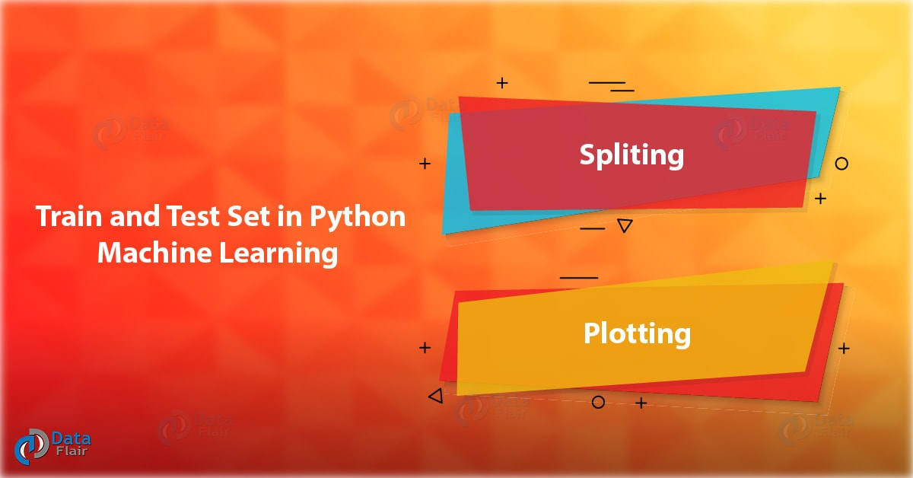
Train and Test Set in Python Machine Learning – How to Split

2. Training and Test Data in Python Machine Learning
As we work with datasets, a machine learning algorithm works in two stages. We usually split the data around 20%-80% between testing and training stages. Under supervised learning, we split a dataset into a training data and test data in Python ML.
Train and Test Set in Python Machine Learning
a. Prerequisites for Train and Test Data
We will need the following Python libraries for this tutorial- pandas and sklearn.
We can install these with pip-
- pip install pandas
- pip install sklearn
We use pandas to import the dataset and sklearn to perform the splitting. You can import these packages as-
- >>> import pandas as pd
- >>> from sklearn.model_selection import train_test_split
- >>> from sklearn.datasets import load_iris
Do you Know about Python Data File Formats – How to Read CSV, JSON, XLS

3. How to Split Train and Test Set in Python Machine Learning?
Following are the process of Train and Test set in Python ML. So, let’s take a dataset first.
How to Split Train and Test Set in Python Machine Learning

a. Loading the Dataset
Let’s load the forestfires dataset using pandas.
- >>> data=pd.read_csv('forestfires.csv')
- >>> data.head()
Train and Test Set in Python Machine Learning

b. Splitting
Let’s split this data into labels and features. Now, what’s that? Using features, we predict labels. I mean using features (the data we use to predict labels), we predict labels (the data we want to predict).
- >>> y=data.temp
- >>> x=data.drop('temp',axis=1)
Temp is a label to predict temperatures in y; we use the drop() function to take all other data in x. Then, we split the data.
- >>> x_train,x_test,y_train,y_test=train_test_split(x,y,test_size=0.2)
- >>> x_train.head()
Train and Test Set in Python Machine Learning
- >>> x_train.shape
(413, 12)
Do you Know How to Work with Relational Database with Python
- >>> x_test.head()
Train and Test Set in Python Machine Learning
- >>> x_test.shape
(104, 12)
The line test_size=0.2 suggests that the test data should be 20% of the dataset and the rest should be train data. With the outputs of the shape() functions, you can see that we have 104 rows in the test data and 413 in the training data.

c. Another Example
Let’s take another example. We’ll use the IRIS dataset this time.
- >>> iris=load_iris()
- >>> x,y=iris.data,iris.target
- >>> x_train,x_test,y_train,y_test=train_test_split(x,y,
- train_size=0.5,
- test_size=0.5,
- random_state=123)
- >>> y_test
array([1, 2, 2, 1, 0, 2, 1, 0, 0, 1, 2, 0, 1, 2, 2, 2, 0, 0, 1, 0, 0, 2,
0, 2, 0, 0, 0, 2, 2, 0, 2, 2, 0, 0, 1, 1, 2, 0, 0, 1, 1, 0, 2, 2,
2, 2, 2, 1, 0, 0, 2, 0, 0, 1, 1, 1, 1, 2, 1, 2, 0, 2, 1, 0, 0, 2,
1, 2, 2, 0, 1, 1, 2, 0, 2])
- >>> y_train
array([1, 1, 0, 2, 2, 0, 0, 1, 1, 2, 0, 0, 1, 0, 1, 2, 0, 2, 0, 0, 1, 0,
0, 1, 2, 1, 1, 1, 0, 0, 1, 2, 0, 0, 1, 1, 1, 2, 1, 1, 1, 2, 0, 0,
1, 2, 2, 2, 2, 0, 1, 0, 1, 1, 0, 1, 2, 1, 2, 2, 0, 1, 0, 2, 2, 1,
1, 2, 2, 1, 0, 1, 1, 2, 2])
Let’s explore Python Machine Learning Environment Setup

4. Plotting of Train and Test Set in Python
We fit our model on the train data to make predictions on it. Let’s import the linear_model from sklearn, apply linear regression to the dataset, and plot the results.
- >>> from sklearn.linear_model import LinearRegression as lm
- >>> model=lm().fit(x_train,y_train)
- >>> predictions=model.predict(x_test)
- >>> import matplotlib.pyplot as plt
- >>> plt.scatter(y_test,predictions)
<matplotlib.collections.PathCollection object at 0x0651CA30>
- >>> plt.xlabel('True values')
Text(0.5,0,’True values’)
- >>> plt.ylabel('Predictions')
Text(0,0.5,’Predictions’)
Read about Python NumPy – NumPy ndarray & NumPy Array
- >>> plt.show()
Train and Test Set in Python Machine Learning
0.9396299518034936
So, this was all about Train and Test Set in Python Machine Learning. Hope you like our explanation.

5. Conclusion
Today, we learned how to split a CSV or a dataset into two subsets- the training set and the test set in Python Machine Learning. We usually let the test set be 20% of the entire data set and the rest 80% will be the training set. Furthermore, if you have a query, feel to ask in the comment box.
Related Topic- Python Geographic Maps & Graph Data
For reference
Tags: how to train data in pythonhow to train data set in pythonPlotting of Train and Test Set in PythonPrerequisites for Train and Test Datasklearn train test split stratifiedtrain test split numpytrain test split pythontrain_test_split random_stateTraining and Test Data in Python Machine Learning

23 Responses
- Comments23
- Pingbacks0

Jeff Yang
January 10, 2019 at 3:16 pm
In item 4, it’s missing
from sklearn.linear_model import LinearRegression
Reply
  - DataFlair Team
February 2, 2019 at 4:59 pm
Hello Jeff,
Thanks for connecting us with Train & Test set in Python Machine Learning. We have made the necessary changes. Hope, you are enjoying our other Python tutorials.
Keep learning and keep sharing
DataFlair
Reply

- amilcar dsilva
January 17, 2019 at 2:37 pm
>>> model=lm.fit(x_train,y_train)
>>> predictions=lm.predict(x_test)
What is “lm” use for?
Reply
  - DataFlair Team
February 2, 2019 at 5:01 pm
Hey Amilcar
Thanks for the query. In this Python Train and Test, article lm stands for Linear Model. You’ll need to import it from sklearn:
>>> from sklearn import linear_model as lm
Hope, it will help you!
Regards
DataFlair
Reply

- carlos2
March 20, 2019 at 8:14 pm
in spider need
from sklearn.linear_model import LinearRegression
lm = LinearRegression()
Reply
  - DataFlair Team
March 30, 2019 at 5:41 pm
Hi Carlos,
That’s right, we have made the changes to the code. Now, you can learn the train test set in Python ML easily.
Reply

- simran kaur jolly
March 24, 2019 at 6:56 pm
‘module’ object has no attribute ‘fit’
on running lm.fit i am getting following error.
Reply
  - DataFlair Team
March 30, 2019 at 6:13 pm
Hello Simran,
Thanks for connecting us through this query. We have made the necessary changes. Now, you can enjoy your learning.
Reply

- rathankar rao
May 10, 2019 at 8:04 pm
is it possible to set the test and training set with the same pattern
Eg: if training test has weight ranging from 50kg to 70kg and that too with a certain frequency distribution, is it possible to have a similar distribution in the test set too
Reply
- Kun Thaung
July 9, 2019 at 3:29 pm
I just found the error in you post.
i learn from this post.
model=lm.fit(x_train,y_train)
there is an error in this model.
we have to use lm().fit(x_train,y_train)
>>> model=lm.fit(x_train,y_train)
it is error to use lm in this predict here
>>> predictions=lm.predict(x_test)
we should write the code
predictions=model.predict(x_test)
i had fixed like this to get our output correctly
Thank you for this post
Reply
  - DataFlair Team
July 11, 2019 at 9:27 am
Hi Kun Thaung
Thank you for pointing it out! Careful readers like you help make our content accurate and flawless for many others to follow. We have made the necessary corrections in the text.
Reply

- Tushar Kadam
July 19, 2019 at 1:29 am
I have been given a task to predict the missing ratings. I have done that using the cosine similarity and some functions used in collaborative recommendations.
So, now I have two datasets.
1. The training set which was already 80% of the original data.
2. The test data set which is 20% and the non-zero ratings are available.
Now, I want to calculate the RMSE between the available ratings in test set and the predicted ratings in training dataset. Please guide me how should I proceed.
The testdata set and train data set are nothing but the data of user*item matrix. Where indexes of the rows represent the users and indexes of the column represent the items.
Reply
- YUVAKUMAR R
August 12, 2019 at 7:18 pm
hi
am getting the error “ValueError: could not convert string to float: ‘sep'” against the line “model = lm().fit(x_train, y_train)”. Can you pls help . I have imported all required packages, and am using pycharm ide.
Thanks
Reply
  - DataFlair Team
August 21, 2019 at 11:06 am
Hello Yuvakumar R,
Maybe you have issues with your dataset- like missing values. Try downloading the forestfires dataset from Kaggle and run the code again, it should work. Or maybe you’re missing a step?
Reply

- Sudhanshu varun
September 5, 2019 at 2:57 pm
Hello
Can you please tell me how i can use this sklearn for training python with another language i have the dataset need i am not able to understand how do i split it into test and train dataset.
Reply
  - DataFlair Team
September 5, 2019 at 3:25 pm
Hello Sudhanshu,
The above article provides a solution to your query. Please read it carefully. Or you can also enroll for DataFlair Python Course with a flat 50% applying the promo code PYTHON50
Reply

- Francine
September 15, 2019 at 3:40 am
thank you for your post, it helps more. but i have a question, why we predict on x_test i think we can predict on y_test? is it the same? please help me .
thanks
Reply
  - DataFlair Team
September 17, 2019 at 10:49 am
Hi Francine
Thanks for commenting. x_test is the test data set and y_test is the set of labels to the data in x_test. We cannot predict on y_test- only on x_test.
Reply

- vinu
October 18, 2019 at 12:58 pm
give a api for tarining a model
Reply
- Anih John
January 24, 2020 at 7:42 pm
Is the promo still on? And does the enrollment include someone to assist you with?
Reply
  - DataFlair Team
January 25, 2020 at 4:01 pm
Hey Anih John,
Please drop a mail on info@data-flair.training regarding your query. Our team will guide you about the course and current offers.
Reply

- Waqar
March 18, 2020 at 2:12 pm
Hi!! AoA!
I am here to request that please also do mention in comments against any function that you used. Lile what is the job of data.shap and what if we write data.shape() and simultaneously for all other functions etc that you have used.
Thank you!
Reply
- Sk
April 15, 2020 at 9:01 pm
Hi Jeff,
As in your code it randomly assigns the data for training and testing but can it be done sequentially means like first 80 to train data set and remaining 20 to test data set if there are overall 100 observations.
Reply

Leave a Reply

*
*

This site is protected by reCAPTCHA and the Google Privacy Policy and Terms of Service apply.

Home About us Contact us Terms and Conditions Cancellation and Refund Privacy Policy Disclaimer Blogs Write For Us Careers Success Stories

Python ML – Data Pre-Processing
Python ML – Techniques
Python Tutorials
Train and Test Set in Python Machine Learning – How to Split
❮ Prev
Next ❯

Popular Courses
Hadoop + Spark Course
Big Data Hadoop Course
Spark Scala Course
Apache Flink Course
Python Course

Popular Tutorials
Hadoop Tutorials
Spark Tutorials
Flink Tutorials
Tableau Tutorials
Power BI Tutorials
QlikView Tutorials

Popular Tutorials
Data Science Tutorials
Machine Learning Tutorials
Python Tutorials
R Tutorials
SAS Tutorials
SQL Tutorials
DataFlair © 2020. All Rights Reserved.

We use cookies to provide the best services. By using our site, you comply with our cookies policy. Learn more

Blog Home
- Courses
- Data Science
- Big Data
- Categories
- Interview Questions
- Job Portal
- Write For Us
Blog Home » Machine Learning Tutorials » 4 Machine Learning Techniques with Python
- 0

4 Machine Learning Techniques with Python
by DataFlair Team · Updated ·

1. Python Machine Learning Techniques
In our last session, we discussed Train and Test Set in Python ML. Here, In this Machine Learning Techniques tutorial, we will see 4 major Machine Learning Techniques with Python: Regression, Classification, Clustering, and Anomaly Detection.
So, let’s look at Python Machine Learning Techniques.
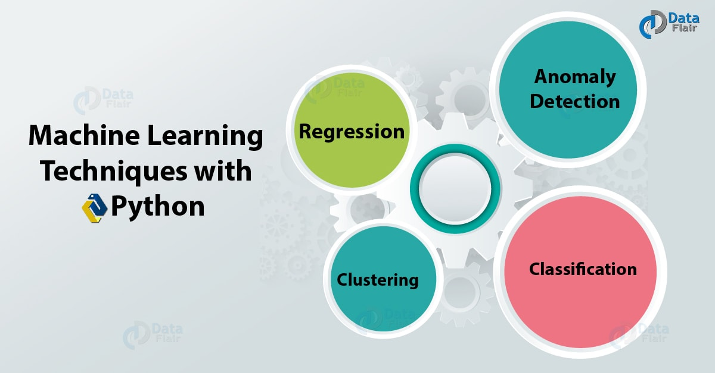
4 Machine Learning Techniques with Python

2. Machine Learning Techniques vs Algorithms
While this tutorial is dedicated to Machine Learning techniques with Python, we will move over to algorithms pretty soon. But before we can begin focussing on techniques and algorithms, let’s find out if they’re the same thing.
A technique is a way of solving a problem. This is quite generic as a term. But when we say we have an algorithm, we mean we have an input and we desire certain output from it. We have clearly defined what steps to follow to get there. We will go the lengths to say an algorithm may make use of multiple techniques to get to the output.
Do you know Applications of Machine Learning
Now that we have distinguished between the two, let’s find out more about Machine Learning techniques.

3. Machine Learning Techniques with Python
Python Machine Learning Techniques are 4 types, let’s discuss them:

a. Machine Learning Regression
The dictionary will tell you that to regress is to return to a former state- one that is often less developed. In books of statistics, you will find regression to be a measure of how one variable’s mean and corresponding values of other values relate to each other. But let’s talk about it how you will see it.
Also, Read Python Linear Regression & Chi-Square Test

Python Machine Learning Techniques – Machine Learning Regression

i. Regressing to the Mean
Francis Galton, Charles Darwin’s half-cousin, observed sizes of sweet peas over generations. What he concluded was that letting nature do its job will result in a range of sizes. But if we selectively breed sweet peas for size, it makes for larger ones. With nature at the steering wheel, even bigger peas begin to produce smaller offsprings with time. We have a certain size for peas that varies, but we can map these values to a specific line or curve.

ii. Another Example- Monkeys and Stocks
In 1973, Burton Malkiel, Princeton University Professor put a claim in his book. A Random Walk Down Wall Street, which was a bestseller, insisted that a blindfolded monkey could do an equally good job as experts at selecting a portfolio by throwing darts at a newspaper’s financial pages. In such stock-picking competitions, monkeys have beaten pros. But this was for once or twice. With enough events, the monkeys’ performance declines; it regresses to the mean.
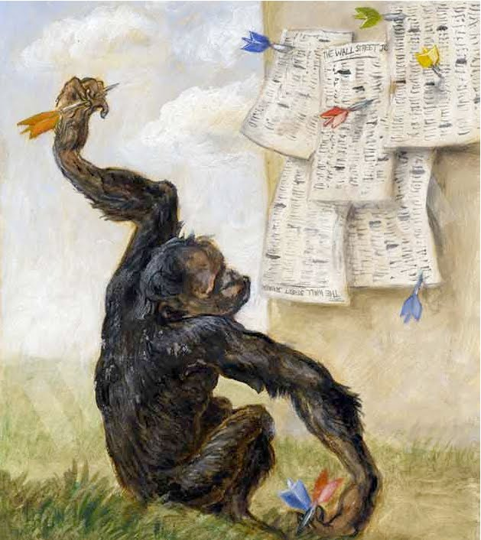
Python Machine Learning Techniques – Monkeys and Stocks

iii. What is Machine Learning Regression?
In this plot, the line best fits all the data marked by the points. Using this line, we can predict what values we will find for x=70 (with a degree of uncertainty).
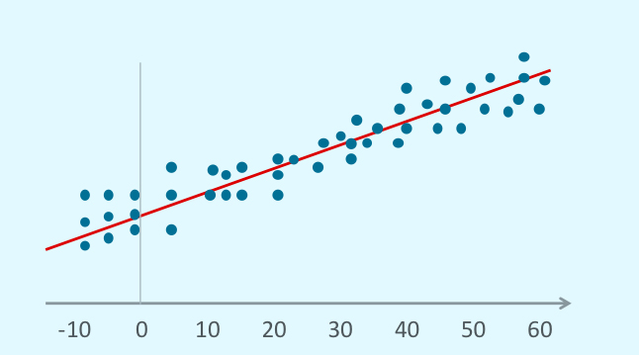
Machine Learning Techniques with Python – What is Machine Learning Regression
As a Machine Learning technique, regression finds its foundation in supervised learning. We use it to predict a continuous and numerical target and begins by working on the data set values we already know. It compares known and predicted values and labels the difference between the expected and predicted values as the error/residual.

iv. Types of Regression in Machine Learning
We generally observe two kinds of regression-
- Linear Regression- When we can denote the relationship between a target and a predictor in a straight line, we use linear regression-
y=P1x+P2+e
- Non-Linear Regression- When we observe a non-linear relationship between a target and a predictor, we cannot denote it as a straight line.

b. Machine Learning Classification

i. What is Machine Learning Classification?
Classification is a data mining technique that lets us predict group membership for data instances. This uses labelled data in advance and falls under supervised learning. This means we train data and expect to predict its future. By ‘prediction’, we mean we classify data into the classes they can belong. We have two kinds of attributes available-
- Output Attribute- Aka Dependent attribute.
- Input Attribute- Aka Independent attribute.

ii. Methods of Classification
- Decision Tree Induction- We build a decision tree from the class labelled tuples. This has internal nodes, branches, and leaf nodes. The internal nodes denote the test on an attribute, the branches- the test outcome, and the leaf nodes- the class label. The two steps involved are learning and testing, and these are fast.
- Rule-based Classification- This classification is based on a set of IF-THEN rules. A rule is denoted as-
IF condition THEN conclusion
- Classification by Backpropagation- Neural network learning, often called connectionist learning, builds connections. Backpropagation is a neural-network learning algorithm, one of the most popular ones. It iteratively processes data and compares the target value with the results to learn.
- Lazy Learners- In a lazy learner approach, the machine stores the training tuple and waits for a test tuple. This supports incremental learning. This contrasts with the early learner approach.

iii. ML Classification Example
Let’s take an example. Consider we’re here to teach you about different kinds of codes. We present to you ITF Barcodes, Code 93 Barcodes, QR codes, Aztecs, and data matrices among others. Once through most of the examples, it is now your turn to identify the kind of code it is when we show you one. This is supervised learning and we use parts of the examples of both- training and testing.
Notice how some stars of each type end up on the other side of the curve.
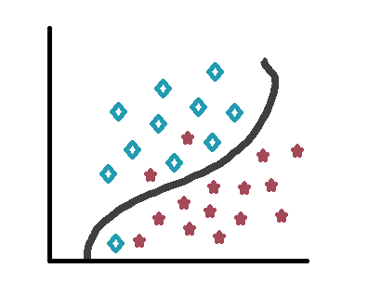
Machine Learning Techniques with Python – ML Classification Example

c. Clustering
Clustering is an unsupervised classification. This is an exploratory data analysis with no labelled data available. With clustering, we separate unlabeled data into finite and discrete sets of data structures that are natural and hidden. We observe two kinds of clustering-
- Hard Clustering- One object belongs to a single cluster.
- Soft Clustering- One object may belong to multiple clusters.
In clustering, we first select features, then design the clustering algorithm and then validate the clusters. Finally, we interpret the results.
a. Example
Recall the example in section b.iii. You could group these codes together. QR code, Aztec, and Data Matrix would be in a group, we could call this 2D Codes. ITF Barcodes and Code 39 Barcodes would group into a ‘1D Codes’ category. This is what a cluster looks like-
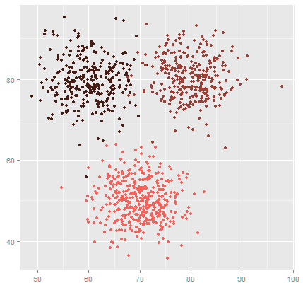
Machine Learning Techniques with Python – Clustering

d. Anomaly Detection
An anomaly is something that deviates from its expected course. With machine learning, sometimes, we may want to spot an outlier. One such example would be to detect a dentist bill 85 fillings per hour. This amounts to 42 seconds per patient. Another would be to find a particular dentist bill only on Thursdays. Such situations raise suspicion and anomaly detection is a great way to highlight these anomalies since this isn’t something we’re looking for specifically.
So, this was all about Machine Learning Techniques with Python. Hope you like our explanation.

4. Conclusion
Hence, in this tutorial, we learned about four techniques of machine learning with Python- Regression, Classification, Clustering, and Anomaly Detection. Furthermore, if you have any query, feel free to ask in the comment box.
Related Topic- Data Preprocessing, Analysis & Visualization in Python ML
For reference
Tags: machine learning algorithms in rMachine Learning Applicationsmachine learning examplesmachine learning modelsMachine Learning RegressionMachine Learning tutorialmachine learning typesPython Machine Learning Techniques

Leave a Reply

*
*

This site is protected by reCAPTCHA and the Google Privacy Policy and Terms of Service apply.

Home About us Contact us Terms and Conditions Cancellation and Refund Privacy Policy Disclaimer Blogs Write For Us Careers Success Stories

Python ML – Train and Test Set
Python ML – Application
Machine Learning TutorialsPython Tutorials
4 Machine Learning Techniques with Python
❮ Prev
Next ❯

Popular Courses
Hadoop + Spark Course
Big Data Hadoop Course
Spark Scala Course
Apache Flink Course
Python Course

Popular Tutorials
Hadoop Tutorials
Spark Tutorials
Flink Tutorials
Tableau Tutorials
Power BI Tutorials
QlikView Tutorials

Popular Tutorials
Data Science Tutorials
Machine Learning Tutorials
Python Tutorials
R Tutorials
SAS Tutorials
SQL Tutorials
DataFlair © 2020. All Rights Reserved.

We use cookies to provide the best services. By using our site, you comply with our cookies policy. Learn more

Blog Home
- Courses
- Data Science
- Big Data
- Categories
- Interview Questions
- Job Portal
- Write For Us
Blog Home » Machine Learning Tutorials » 17 Top Applications of Machine Learning with Python
- 1

17 Top Applications of Machine Learning with Python
by DataFlair Team · Updated ·

1. Objective
In our last tutorial, we discuss Machine learning Techniques with Python. Today, we dedicate this Python Machine Learning tutorial to learn about the applications of Machine Learning with Python Programming. Let’s take a look at the areas where Machine is used in the industry.
So, start the Applications of Machine Learning with Python.
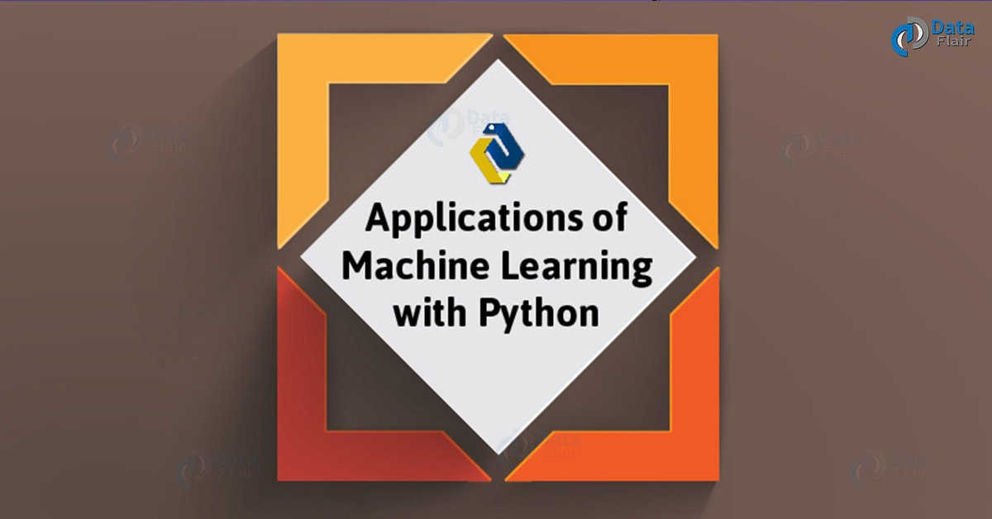
17 Top Applications of Machine Learning with Python

2. Why Python for Machine Learning Used?
Before we proceed to the applications of Machine Learning with Python, you’re probably asking yourself- why Python? Among tools like R programming and SAS, here’s why we’ll go with Python-
Follow this link to know about Machine Learning

a. Simple
The sole reason why Python is often chosen as an introductory language to programming is its simplicity. It is simple, yet powerful. Python is easy to write, and simple to understand. This behaviour of its makes it intuitive. Situations like getting your code from another developer that uses third-party components mean you need very little cognitive overhead. It is also true that code is read more often than it is written. Therefore, simplicity serves to be a great asset to Python.

b. Huge Set of Relevant Libraries
Python has a wide collection of libraries for machine learning purposes. These include Python NumPy, SciPy, scikit-learn, and many more. These are good with all intrinsic tasks of machine learning.
- scikit-learn- Good for data mining, data analysis, and machine learning.
- pylearn2- More flexible than scikit-learn.
- PyBrain- Modular ML library with flexible, easy, and powerful ML algorithms and predefined environments to test and compare algorithms.
- Orange- Open-source data visualization and analysis, has components for machine learning, has extensions for biometrics and text mining, has features for data analytics, supports data mining through visual programming or Python scripting.
- PyML- The Interactive object-oriented framework for machine learning, written in Python.
- Milk- Machine learning toolkit, has SVMs, k-NN, random forests, decision trees, performs feature selection.
- Shogun- Machine learning toolbox, focuses on large-scale kernel methods and SVMs.
- Tensorflow- High-level Neural Network Library.
Follow this link to know about Tensorflow Tutorial

3. Applications of Machine Learning with Python
17 Top Applications of Machine Learning with Python

a. Virtual Personal Assistants
Names like Siri and Alexa bring to mind the capabilities of virtual assistants. We can ask Siri to make a call for you or play music. You can request Alexa for today’s weather forecast. You can even set an alarm or send an SMS. What makes this easier on you is that you only need to speak to it and it will listen to your command. This comes in handy for those differently abled. Such assistants take note of how you interact with them and use that to make your next experience with them better.
Applications of Machine Learning with Python

b. Social Media Services
By now, you would have noticed several features of Facebook- ‘People You May Know’ and ‘Face Recognition’. It uses machine learning to monitor your activity- what profiles you visit, which people to send requests to, which ones you accept requests of, the people you tag, among much more. With this, Facebook hopes to provide you with a richer experience on its platform so you will use it regularly.
Applications of Machine Learning with Python
Do you know the Reasons Why Should we Learn Python

c. Online Customer Support
Websites like educators and shopping platforms will often pop a live chat up to help you with your questions. A visitor with a head full of questions is more likely to leave than stay and possibly make a purchase. Some websites use a chatbot instead to pull information to the website and try to address the customer’s queries.
Applications of Machine Learning with Python

d. Online Fraud Detection
If you’re familiar with PayPal, you realize your trust with it. It uses machine learning to stand in defence against illegal acts like money laundering. By comparing millions of transactions, it can find out which ones are illegitimate.
Applications of Machine Learning with Python

e. Product Recommendations
Shopping platforms like Amazon and Jabong notice what products you look at and suggest similar products to you. If this gets a favourite product across to you and results in a purchase you make with them, it’s a win for them. For this, it also uses your wishlist and cart contents.
Applications of Machine Learning with Python
Read about Python Functions with Syntax and Examples

f. Refining Search Engine Results
The searches you make in search engines like Google monitor your response. Do you visit a top listing and stick around for a while? Do you get to the third page and leave without clicking any link? Google makes note of the findings and aims to improve your search next time.
Applications of Machine Learning with Python

g. Fighting Web Spam
Many email clients use rule-based spam filtering. Spammers develop new tricks to get around this. So, clients like Gmail use machine learning to keep their spam filters updated. This is also a problem with Google search results and other search engines. Common spam-filtering techniques are Multi-Layer Perceptron and C 4.5 Decision Tree Induction.
Applications of Machine Learning with Python

h. Automatic Translation
Machine Learning lets us translate text into another language. The ML algorithm for this figures how words fit together and then uses this information to improve the quality of a translation. With this, we can also translate the text on images using neural networks to identify letters.
Applications of Machine Learning with Python
Let’s Explore Python PyQt5 Tutorial

i. Video Surveillance
Some crimes can be avoided by sensing them way before they can happen. Behaviour, like standing motionless, napping on a bench, and following another individual, can alert human attendants via a video surveillance system.
Applications of Machine Learning with Python

j. Predicting Music Choices
Products like Genius by Apple Music monitors what you listen to. Later, it can suggest you a list of songs you are likely to prefer. It also picks songs from your playlist to create libraries that sound good together.
Applications of Machine Learning with Python

k. Drug Discovery and Disease Diagnosis
With ML algorithms, we can perform the following tasks-
Applications of Machine Learning with Python
- Initial screening of drug compounds.
- Predicting success rate based on biological factors.
- R&D technologies like Next-Generation Sequencing.
- Understand disease processes.
- Design effective treatments for diseases.
- Personalizing drug combinations.
- Produce cheaper drugs with improved replication.
- Research and develop diagnostics and therapeutic treatments.
Read about Python Statistics – p-Value, Correlation, T-test, KS Test

l. Face Recognition
Facilities like face detection are often something we see with Facebook. When we want to tag a photo, Facebook automatically suggests us a few names. Most of the times, the first name is accurate for the face it has detected. This has machine learning to credit.
Applications of Machine Learning with Python

m. Pricing Insurance Plans
Machine Learning can detect if a driver is likely to cause a large-loss case during the term of insurance. This lets insurance firms price insurance plans accordingly.

n. Autonomous, Self-Driving Cars
These cars receive data on nearby objects and their sizes and speeds via sensors. Based on how they behave, it categorizes objects as cyclists, pedestrians, and other cars among others. It uses this data to compare stored maps to current conditions. Such cars make use of Machine Vision algorithms.
Applications of Machine Learning with Python
Do you know the Python Data Science Environment Setup

4. More Machine Learning Applications
Other than what we just mentioned, we can use Machine Learning for the following purposes-
- Identifying human genes that predispose people to cancer.
- Identifying what consumers respond to.
- Trading stocks and derivatives.
- Packet inspection for anti-virus software.
- Delayed aeroplane flights.
- Factory maintenance diagnostics.
- Behavioural advertisement for products.
So, this was all about Applications of Machine Learning with Python. Hope you like our explanation.

5. Conclusion
Hence, we conclude our tutorial on applications of machine learning with Python. Got more to add? Feel free to drop it in the comments below.
Related Topic-
Machine Learning Techniques
For reference
Tags: Applications of Machine LearningMachine Learning ApplicationsWhy Python for Machine Learning

1 Response
- Comments1
- Pingbacks0

MAMINA SAHU
December 13, 2018 at 4:44 pm
NICE BLOGS POSTS
Reply

Leave a Reply

*
*

This site is protected by reCAPTCHA and the Google Privacy Policy and Terms of Service apply.

Home About us Contact us Terms and Conditions Cancellation and Refund Privacy Policy Disclaimer Blogs Write For Us Careers Success Stories

Python ML – Techniques
Python ML – Algorithms
Machine Learning TutorialsPython Tutorials
17 Top Applications of Machine Learning with Python
❮ Prev
Next ❯

Popular Courses
Hadoop + Spark Course
Big Data Hadoop Course
Spark Scala Course
Apache Flink Course
Python Course

Popular Tutorials
Hadoop Tutorials
Spark Tutorials
Flink Tutorials
Tableau Tutorials
Power BI Tutorials
QlikView Tutorials

Popular Tutorials
Data Science Tutorials
Machine Learning Tutorials
Python Tutorials
R Tutorials
SAS Tutorials
SQL Tutorials
DataFlair © 2020. All Rights Reserved.

We use cookies to provide the best services. By using our site, you comply with our cookies policy. Learn more

Blog Home
- Courses
- Data Science
- Big Data
- Categories
- Interview Questions
- Job Portal
- Write For Us
Blog Home » Machine Learning Tutorials » 8 Machine Learning Algorithms in Python – You Must Learn
- 2

8 Machine Learning Algorithms in Python – You Must Learn
by DataFlair Team · Updated ·

1. Objective
Previously, we discussed the techniques of machine learning with Python. Going deeper, today, we will learn and implement 8 top Machine Learning Algorithms in Python.
Let’s begin the journey of Machine Learning Algorithms in Python Programming.
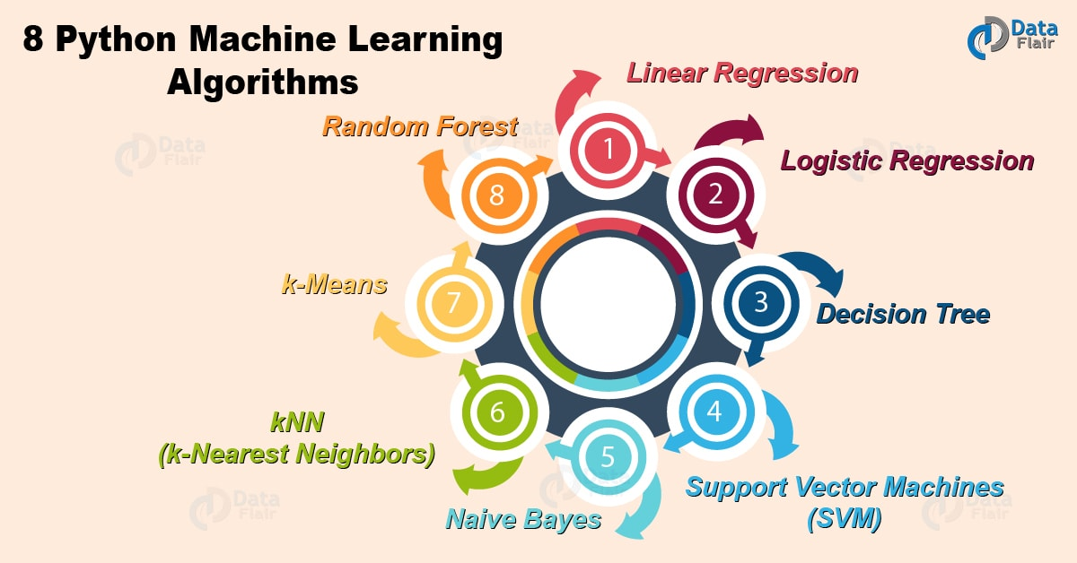
Machine Learning Algorithms in Python – You Must LEARN

2. Machine Learning Algorithms in Python
Followings are the Algorithms of Python Machine Learning:

a. Linear Regression
Linear regression is one of the supervised Machine learning algorithms in Python that observes continuous features and predicts an outcome. Depending on whether it runs on a single variable or on many features, we can call it simple linear regression or multiple linear regression.
This is one of the most popular Python ML algorithms and often under-appreciated. It assigns optimal weights to variables to create a line ax+b to predict the output. We often use linear regression to estimate real values like a number of calls and costs of houses based on continuous variables. The regression line is the best line that fits Y=a*X+b to denote a relationship between independent and dependent variables.
Do you know about Python Machine Learning Environment Setup
Let’s plot this for the diabetes dataset.
- >>> import matplotlib.pyplot as plt
- >>> import numpy as np
- >>> from sklearn import datasets,linear_model
- >>> from sklearn.metrics import mean_squared_error,r2_score
- >>> diabetes=datasets.load_diabetes()
- >>> diabetes_X=diabetes.data[:,np.newaxis,2]
- >>> diabetes_X_train=diabetes_X[:-30] #splitting data into training and test sets
- >>> diabetes_X_test=diabetes_X[-30:]
- >>> diabetes_y_train=diabetes.target[:-30] #splitting targets into training and test sets
- >>> diabetes_y_test=diabetes.target[-30:]
- >>> regr=linear_model.LinearRegression() #Linear regression object
- >>> regr.fit(diabetes_X_train,diabetes_y_train) #Use training sets to train the model
LinearRegression(copy_X=True, fit_intercept=True, n_jobs=1, normalize=False)
- >>> diabetes_y_pred=regr.predict(diabetes_X_test) #Make predictions
- >>> regr.coef_
array([941.43097333])
- >>> mean_squared_error(diabetes_y_test,diabetes_y_pred)
3035.0601152912695
- >>> r2_score(diabetes_y_test,diabetes_y_pred) #Variance score
0.410920728135835
- >>> plt.scatter(diabetes_X_test,diabetes_y_test,color ='lavender')
<matplotlib.collections.PathCollection object at 0x0584FF70>
- >>> plt.plot(diabetes_X_test,diabetes_y_pred,color='pink',linewidth=3)
[<matplotlib.lines.Line2D object at 0x0584FF30>]
- >>> plt.xticks(())
([], <a list of 0 Text xticklabel objects>)
- >>> plt.yticks(())
([], <a list of 0 Text yticklabel objects>)
- >>> plt.show()
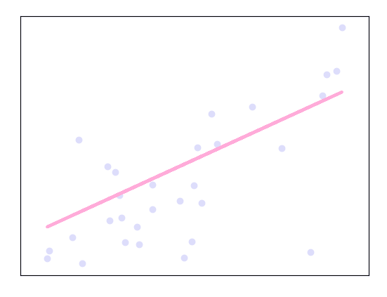
Machine Learning Algorithms in Python – Linear Regression
Python Machine Learning – Data Preprocessing, Analysis & Visualization

b. Logistic Regression
Logistic regression is a supervised classification is unique Machine Learning algorithms in Python that finds its use in estimating discrete values like 0/1, yes/no, and true/false. This is based on a given set of independent variables. We use a logistic function to predict the probability of an event and this gives us an output between 0 and 1.
Although it says ‘regression’, this is actually a classification algorithm. Logistic regression fits data into a logit function and is also called logit regression. Let’s plot this.
- >>> import numpy as np
- >>> import matplotlib.pyplot as plt
- >>> from sklearn import linear_model
- >>> xmin,xmax=-7,7 #Test set; straight line with Gaussian noise
- >>> n_samples=77
- >>> np.random.seed(0)
- >>> x=np.random.normal(size=n_samples)
- >>> y=(x>0).astype(np.float)
- >>> x[x>0]*=3
- >>> x+=.4*np.random.normal(size=n_samples)
- >>> x=x[:,np.newaxis]
- >>> clf=linear_model.LogisticRegression(C=1e4) #Classifier
- >>> clf.fit(x,y)
- >>> plt.figure(1,figsize=(3,4))
- <Figure size 300x400 with 0 Axes>
- >>> plt.clf()
- >>> plt.scatter(x.ravel(),y,color='lavender',zorder=17)
<matplotlib.collections.PathCollection object at 0x057B0E10>
- >>> x_test=np.linspace(-7,7,277)
- >>> def model(x):
- return 1/(1+np.exp(-x))
- >>> loss=model(x_test*clf.coef_+clf.intercept_).ravel()
- >>> plt.plot(x_test,loss,color='pink',linewidth=2.5)
[<matplotlib.lines.Line2D object at 0x057BA090>]
- >>> ols=linear_model.LinearRegression()
- >>> ols.fit(x,y)
LinearRegression(copy_X=True, fit_intercept=True, n_jobs=1, normalize=False)
- >>> plt.plot(x_test,ols.coef_*x_test+ols.intercept_,linewidth=1)
[<matplotlib.lines.Line2D object at 0x057BA0B0>]
- >>> plt.axhline(.4,color='.4')
<matplotlib.lines.Line2D object at 0x05860E70>
- >>> plt.ylabel('y')
Text(0,0.5,’y’)
- >>> plt.xlabel('x')
Text(0.5,0,’x’)
- >>> plt.xticks(range(-7,7))
- >>> plt.yticks([0,0.4,1])
- >>> plt.ylim(-.25,1.25)
(-0.25, 1.25)
- >>> plt.xlim(-4,10)
(-4, 10)
- >>> plt.legend(('Logistic Regression','Linear Regression'),loc='lower right',fontsize='small')
<matplotlib.legend.Legend object at 0x057C89F0>
Do you know How to Split Train and Test Set in Python Machine Learning
- >>> plt.show()
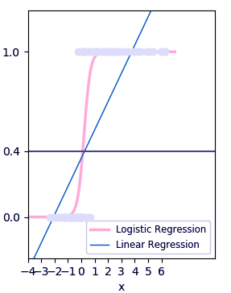
Machine Learning Algorithms in Python -Logistic

c. Decision Tree
A decision tree falls under supervised Machine Learning Algorithms in Python and comes of use for both classification and regression- although mostly for classification. This model takes an instance, traverses the tree, and compares important features with a determined conditional statement. Whether it descends to the left child branch or the right depends on the result. Usually, more important features are closer to the root.
Decision Tree, a Machine Learning algorithms in Python can work on both categorical and continuous dependent variables. Here, we split a population into two or more homogeneous sets. Let’s see the algorithm for this-
- >>> from sklearn.cross_validation import train_test_split
- >>> from sklearn.tree import DecisionTreeClassifier
- >>> from sklearn.metrics import accuracy_score
- >>> from sklearn.metrics import classification_report
- >>> def importdata(): #Importing data
- balance_data=pd.read_csv('https://archive.ics.uci.edu/ml/machine-learning-'+
- 'databases/balance-scale/balance-scale.data',
- sep= ',', header = None)
- print(len(balance_data))
- print(balance_data.shape)
- print(balance_data.head())
- return balance_data
- >>> def splitdataset(balance_data): #Splitting data
- x=balance_data.values[:,1:5]
- y=balance_data.values[:,0]
- x_train,x_test,y_train,y_test=train_test_split(
- x,y,test_size=0.3,random_state=100)
- return x,y,x_train,x_test,y_train,y_test
- >>> def train_using_gini(x_train,x_test,y_train): #Training with giniIndex
- clf_gini = DecisionTreeClassifier(criterion = "gini",
- random_state = 100,max_depth=3, min_samples_leaf=5)
- clf_gini.fit(x_train,y_train)
- return clf_gini
- >>> def train_using_entropy(x_train,x_test,y_train): #Training with entropy
- clf_entropy=DecisionTreeClassifier(
- criterion = "entropy", random_state = 100,
- max_depth = 3, min_samples_leaf = 5)
- clf_entropy.fit(x_train,y_train)
- return clf_entropy
- >>> def prediction(x_test,clf_object): #Making predictions
- y_pred=clf_object.predict(x_test)
- print(f"Predicted values: {y_pred}")
- return y_pred
- >>> def cal_accuracy(y_test,y_pred): #Calculating accuracy
- print(confusion_matrix(y_test,y_pred))
- print(accuracy_score(y_test,y_pred)*100)
- print(classification_report(y_test,y_pred))
- >>> data=importdata()
625
(625, 5)
0 1 2 3 4
0 B 1 1 1 1
1 R 1 1 1 2
2 R 1 1 1 3
3 R 1 1 1 4
4 R 1 1 1 5
- >>> x,y,x_train,x_test,y_train,y_test=splitdataset(data)
- >>> clf_gini=train_using_gini(x_train,x_test,y_train)
- >>> clf_entropy=train_using_entropy(x_train,x_test,y_train)
- >>> y_pred_gini=prediction(x_test,clf_gini)
Machine Learning Algorithms in Python – Decision Tree
- >>> cal_accuracy(y_test,y_pred_gini)
[[ 0 6 7]
[ 0 67 18]
[ 0 19 71]]
73.40425531914893
Machine Learning Algorithms in Python – Decision Tree
- >>> y_pred_entropy=prediction(x_test,clf_entropy)
Machine Learning Algorithms in Python – Decision Tree
- >>> cal_accuracy(y_test,y_pred_entropy)
[[ 0 6 7]
[ 0 63 22]
[ 0 20 70]]
70.74468085106383
Machine Learning Algorithms in Python – Decision Tree Algorithm i
Let’s explore 4 Machine Learning Techniques with Python

d. Support Vector Machines (SVM)
SVM is a supervised classification is one of the most important Machines Learning algorithms in Python, that plots a line that divides different categories of your data. In this ML algorithm, we calculate the vector to optimize the line. This is to ensure that the closest point in each group lies farthest from each other. While you will almost always find this to be a linear vector, it can be other than that.
In this Python Machine Learning tutorial, we plot each data item as a point in an n-dimensional space. We have n features and each feature has the value of a certain coordinate.
First, let’s plot a dataset.
- >>> from sklearn.datasets.samples_generator import make_blobs
- >>> x,y=make_blobs(n_samples=500,centers=2,
- random_state=0,cluster_std=0.40)
- >>> import matplotlib.pyplot as plt
- >>> plt.scatter(x[:,0],x[:,1],c=y,s=50,cmap='plasma')
<matplotlib.collections.PathCollection object at 0x04E1BBF0>
- >>> plt.show()
Machine Learning Algorithms in Python – SVM
- >>> import numpy as np
- >>> xfit=np.linspace(-1,3.5)
- >>> plt.scatter(X[:, 0], X[:, 1], c=Y, s=50, cmap='plasma')
<matplotlib.collections.PathCollection object at 0x07318C90>
- >>> for m, b, d in [(1, 0.65, 0.33), (0.5, 1.6, 0.55), (-0.2, 2.9, 0.2)]:
- yfit = m * xfit + b
- plt.plot(xfit, yfit, '-k')
- plt.fill_between(xfit, yfit - d, yfit + d, edgecolor='none',
- color='#AFFEDC', alpha=0.4)
[<matplotlib.lines.Line2D object at 0x07318FF0>]
<matplotlib.collections.PolyCollection object at 0x073242D0>
[<matplotlib.lines.Line2D object at 0x07318B70>]
<matplotlib.collections.PolyCollection object at 0x073246F0>
[<matplotlib.lines.Line2D object at 0x07324370>]
<matplotlib.collections.PolyCollection object at 0x07324B30>
- >>> plt.xlim(-1,3.5)
(-1, 3.5)
- >>> plt.show()
Machine Learning Algorithms in Python – Support Vector Machine
Follow this link to know about Python PyQt5 Tutorial

e. Naive Bayes
Naive Bayes is a classification method which is based on Bayes’ theorem. This assumes independence between predictors. A Naive Bayes classifier will assume that a feature in a class is unrelated to any other. Consider a fruit. This is an apple if it is round, red, and 2.5 inches in diameter. A Naive Bayes classifier will say these characteristics independently contribute to the probability of the fruit being an apple. This is even if features depend on each other.
For very large data sets, it is easy to build a Naive Bayesian model. Not only is this model very simple, it performs better than many highly sophisticated classification methods. Let’s build this.
- >>> from sklearn.naive_bayes import GaussianNB
- >>> from sklearn.naive_bayes import MultinomialNB
- >>> from sklearn import datasets
- >>> from sklearn.metrics import confusion_matrix
- >>> from sklearn.model_selection import train_test_split
- >>> iris=datasets.load_iris()
- >>> x=iris.data
- >>> y=iris.target
- >>> x_train,x_test,y_train,y_test=train_test_split(x,y,test_size=0.3,random_state=0)
- >>> gnb=GaussianNB()
- >>> mnb=MultinomialNB()
- >>> y_pred_gnb=gnb.fit(x_train,y_train).predict(x_test)
- >>> cnf_matrix_gnb = confusion_matrix(y_test, y_pred_gnb)
- >>> cnf_matrix_gnb
array([[16, 0, 0],
[ 0, 18, 0],
[ 0, 0, 11]], dtype=int64)
- >>> y_pred_mnb = mnb.fit(x_train, y_train).predict(x_test)
- >>> cnf_matrix_mnb = confusion_matrix(y_test, y_pred_mnb)
- >>> cnf_matrix_mnb
array([[16, 0, 0],
[ 0, 0, 18],
[ 0, 0, 11]], dtype=int64)

f. kNN (k-Nearest Neighbors)
This is a Python Machine Learning algorithms for classification and regression- mostly for classification. This is a supervised learning algorithm that considers different centroids and uses a usually Euclidean function to compare distance. Then, it analyzes the results and classifies each point to the group to optimize it to place with all closest points to it. It classifies new cases using a majority vote of k of its neighbors. The case it assigns to a class is the one most common among its K nearest neighbors. For this, it uses a distance function.

i. Training and testing on the entire dataset
- >>> from sklearn.datasets import load_iris
- >>> iris=load_iris()
- >>> x=iris.data
- >>> y=iris.target
- >>> from sklearn.linear_model import LogisticRegression
- >>> logreg=LogisticRegression()
- >>> logreg.fit(x,y)
LogisticRegression(C=1.0, class_weight=None, dual=False, fit_intercept=True,
intercept_scaling=1, max_iter=100, multi_class=’ovr’, n_jobs=1,
penalty=’l2′, random_state=None, solver=’liblinear’, tol=0.0001,
verbose=0, warm_start=False)
- >>> logreg.predict(x)
array([0, 0, 0, 0, 0, 0, 0, 0, 0, 0, 0, 0, 0, 0, 0, 0, 0, 0, 0, 0, 0, 0,
0, 0, 0, 0, 0, 0, 0, 0, 0, 0, 0, 0, 0, 0, 0, 0, 0, 0, 0, 0, 0, 0,
0, 0, 0, 0, 0, 0, 1, 1, 1, 1, 1, 1, 1, 1, 1, 1, 1, 1, 1, 1, 1, 1,
2, 1, 1, 1, 2, 1, 1, 1, 1, 1, 1, 1, 1, 1, 1, 1, 1, 2, 2, 2, 1, 1,
1, 1, 1, 1, 1, 1, 1, 1, 1, 1, 1, 1, 2, 2, 2, 2, 2, 2, 2, 2, 2, 2,
2, 2, 2, 2, 2, 2, 2, 2, 2, 2, 2, 2, 2, 2, 2, 2, 2, 2, 2, 1, 2, 2,
2, 2, 2, 2, 2, 2, 2, 2, 2, 2, 2, 2, 2, 2, 2, 2, 2, 2])
- >>> y_pred=logreg.predict(x)
- >>> len(y_pred)
150
- >>> from sklearn import metrics
- >>> metrics.accuracy_score(y,y_pred)
0.96
- >>> from sklearn.neighbors import KNeighborsClassifier
- >>> knn=KNeighborsClassifier(n_neighbors=5)
- >>> knn.fit(x,y)
KNeighborsClassifier(algorithm=’auto’, leaf_size=30, metric=’minkowski’,
metric_params=None, n_jobs=1, n_neighbors=5, p=2,
weights=’uniform’)
- >>> y_pred=knn.predict(x)
- >>> metrics.accuracy_score(y,y_pred)
0.9666666666666667
- >>> knn=KNeighborsClassifier(n_neighbors=1)
- >>> knn.fit(x,y)
KNeighborsClassifier(algorithm=’auto’, leaf_size=30, metric=’minkowski’,
metric_params=None, n_jobs=1, n_neighbors=1, p=2,
weights=’uniform’)
- >>> y_pred=knn.predict(x)
- >>> metrics.accuracy_score(y,y_pred)
1.0

ii. Splitting into train/test
- >>> x.shape
(150, 4)
- >>> y.shape
(150,)
- >>> from sklearn.cross_validation import train_test_split
- >>> x.shape
(150, 4)
- >>> y.shape
(150,)
- >>> from sklearn.cross_validation import train_test_split
- >>> x_train,x_test,y_train,y_test=train_test_split(x,y,test_size=0.4,random_state=4)
- >>> x_train.shape
(90, 4)
- >>> x_test.shape
(60, 4)
- >>> y_train.shape
(90,)
- >>> y_test.shape
(60,)
- >>> logreg=LogisticRegression()
- >>> logreg.fit(x_train,y_train)
- >>> y_pred=knn.predict(x_test)
- >>> metrics.accuracy_score(y_test,y_pred)
0.9666666666666667
- >>> knn=KNeighborsClassifier(n_neighbors=5)
- >>> knn.fit(x_train,y_train)
KNeighborsClassifier(algorithm=’auto’, leaf_size=30, metric=’minkowski’,
metric_params=None, n_jobs=1, n_neighbors=5, p=2,
weights=’uniform’)
- >>> y_pred=knn.predict(x_test)
- >>> metrics.accuracy_score(y_test,y_pred)
0.9666666666666667
- >>> k_range=range(1,26)
- >>> scores=[]
- >>> for k in k_range:
- knn = KNeighborsClassifier(n_neighbors=k)
- knn.fit(x_train, y_train)
- y_pred = knn.predict(x_test)
- scores.append(metrics.accuracy_score(y_test, y_pred))
- >>> scores
[0.95, 0.95, 0.9666666666666667, 0.9666666666666667, 0.9666666666666667, 0.9833333333333333, 0.9833333333333333, 0.9833333333333333, 0.9833333333333333, 0.9833333333333333, 0.9833333333333333, 0.9833333333333333, 0.9833333333333333, 0.9833333333333333, 0.9833333333333333, 0.9833333333333333, 0.9833333333333333, 0.9666666666666667, 0.9833333333333333, 0.9666666666666667, 0.9666666666666667, 0.9666666666666667, 0.9666666666666667, 0.95, 0.95]
- >>> import matplotlib.pyplot as plt
- >>> plt.plot(k_range,scores)
[<matplotlib.lines.Line2D object at 0x05FDECD0>]
- >>> plt.xlabel('k for kNN')
Text(0.5,0,’k for kNN’)
- >>> plt.ylabel('Testing Accuracy')
Text(0,0.5,’Testing Accuracy’)
- >>> plt.show()
Machine Learning Algorithms in Python – k-Nearest Neighbors
Read about Python Statistics – p-Value, Correlation, T-test, KS Test

g. k-Means
k-Means is an unsupervised algorithm that solves the problem of clustering. It classifies data using a number of clusters. The data points inside a class are homogeneous and heterogeneous to peer groups.
- >>> import numpy as np
- >>> import matplotlib.pyplot as plt
- >>> from matplotlib import style
- >>> style.use('ggplot')
- >>> from sklearn.cluster import KMeans
- >>> x=[1,5,1.5,8,1,9]
- >>> y=[2,8,1.7,6,0.2,12]
- >>> plt.scatter(x,y)
<matplotlib.collections.PathCollection object at 0x0642AF30>
- >>> x=np.array([[1,2],[5,8],[1.5,1.8],[8,8],[1,0.6],[9,11]])
- >>> kmeans=KMeans(n_clusters=2)
- >>> kmeans.fit(x)
KMeans(algorithm=’auto’, copy_x=True, init=’k-means++’, max_iter=300,
n_clusters=2, n_init=10, n_jobs=1, precompute_distances=’auto’,
random_state=None, tol=0.0001, verbose=0)
- >>> centroids=kmeans.cluster_centers_
- >>> labels=kmeans.labels_
- >>> centroids
array([[1.16666667, 1.46666667],
[7.33333333, 9. ]])
- >>> labels
array([0, 1, 0, 1, 0, 1])
- >>> colors=['g.','r.','c.','y.']
- >>> for i in range(len(x)):
- print(x[i],labels[i])
- plt.plot(x[i][0],x[i][1],colors[labels[i]],markersize=10)
[1. 2.] 0
[<matplotlib.lines.Line2D object at 0x0642AE10>]
[5. 8.] 1
[<matplotlib.lines.Line2D object at 0x06438930>]
[1.5 1.8] 0
[<matplotlib.lines.Line2D object at 0x06438BF0>]
[8. 8.] 1
[<matplotlib.lines.Line2D object at 0x06438EB0>]
[1. 0.6] 0
[<matplotlib.lines.Line2D object at 0x06438FB0>]
[ 9. 11.] 1
[<matplotlib.lines.Line2D object at 0x043B1410>]
- >>> plt.scatter(centroids[:,0],centroids[:,1],marker='x',s=150,linewidths=5,zorder=10)
<matplotlib.collections.PathCollection object at 0x043B14D0>
- >>> plt.show()
Machine Learning Algorithms in Python – K-Means
Have a Look at Python Descriptive Statistics – Measuring Central Tendency

h. Random Forest
A random forest is an ensemble of decision trees. In order to classify every new object based on its attributes, trees vote for class- each tree provides a classification. The classification with the most votes wins in the forest.
- >>> import numpy as np
- >>> import pylab as pl
- >>> x=np.random.uniform(1,100,1000)
- >>> y=np.log(x)+np.random.normal(0,.3,1000)
- >>> pl.scatter(x,y,s=1,label='log(x) with noise')
<matplotlib.collections.PathCollection object at 0x0434EC50>
- >>> pl.plot(np.arange(1,100),np.log(np.arange(1,100)),c='b',label='log(x) true function')
[<matplotlib.lines.Line2D object at 0x0434EB30>]
- >>> pl.xlabel('x')
Text(0.5,0,’x’)
- >>> pl.ylabel('f(x)=log(x)')
Text(0,0.5,’f(x)=log(x)’)
- >>> pl.legend(loc='best')
<matplotlib.legend.Legend object at 0x04386450>
- >>> pl.title('A basic log function')
Text(0.5,1,’A basic log function’)
- >>> pl.show()
Machine Learning Algorithms in Python – Random Forest
- >>> from sklearn.datasets import load_iris
- >>> from sklearn.ensemble import RandomForestClassifier
- >>> import pandas as pd
- >>> import numpy as np
- >>> iris=load_iris()
- >>> df=pd.DataFrame(iris.data,columns=iris.feature_names)
- >>> df['is_train']=np.random.uniform(0,1,len(df))<=.75
- >>> df['species']=pd.Categorical.from_codes(iris.target,iris.target_names)
- >>> df.head()
sepal length (cm) sepal width (cm) … is_train species
0 5.1 3.5 … True setosa
1 4.9 3.0 … True setosa
2 4.7 3.2 … True setosa
3 4.6 3.1 … True setosa
4 5.0 3.6 … False setosa
[5 rows x 6 columns]
- >>> train,test=df[df['is_train']==True],df[df['is_train']==False]
- >>> features=df.columns[:4]
- >>> clf=RandomForestClassifier(n_jobs=2)
- >>> y,_=pd.factorize(train['species'])
- >>> clf.fit(train[features],y)
RandomForestClassifier(bootstrap=True, class_weight=None, criterion=’gini’,
max_depth=None, max_features=’auto’, max_leaf_nodes=None,
min_impurity_decrease=0.0, min_impurity_split=None,
min_samples_leaf=1, min_samples_split=2,
min_weight_fraction_leaf=0.0, n_estimators=10, n_jobs=2,
oob_score=False, random_state=None, verbose=0,
warm_start=False)
- >>> preds=iris.target_names[clf.predict(test[features])]
- >>> pd.crosstab(test['species'],preds,rownames=['actual'],colnames=['preds'])
preds setosa versicolor virginica
actual
setosa 12 0 0
versicolor 0 17 2
virginica 0 1 15
So, this was all about Machine Learning Algorithms in Python Tutorial. Hope you like our explanation.

3. Conclusion
Hence, today we discussed eight important Python Machine Learning Algorithms. Which one do you think bears the most potential? Drop your suggestions in the comments below. We will surely get back to you!
Related Topic- Python NumPy Tutorial
For reference
Tags: Decision Treek-MeanskNN (k-Nearest Neighbors)Linear RegressionLogistic RegressionNaive BayesPython Machine learning algorithmRandom ForestSupport Vector Machines (SVM)

2 Responses
- Comments2
- Pingbacks0

pavi
January 6, 2020 at 1:13 pm
Cluster vs classifier
Reply
- DN
March 16, 2020 at 11:01 pm
what is the meaning of this line
“matplotlib.collections.PathCollection object at 0x057B0E10”
Reply

Leave a Reply

*
*

This site is protected by reCAPTCHA and the Google Privacy Policy and Terms of Service apply.

Home About us Contact us Terms and Conditions Cancellation and Refund Privacy Policy Disclaimer Blogs Write For Us Careers Success Stories

Python ML – Application
Python Deep Learning Tutorial
Machine Learning TutorialsPython Tutorials
8 Machine Learning Algorithms in Python – You Must Learn
❮ Prev
Next ❯

Popular Courses
Hadoop + Spark Course
Big Data Hadoop Course
Spark Scala Course
Apache Flink Course
Python Course

Popular Tutorials
Hadoop Tutorials
Spark Tutorials
Flink Tutorials
Tableau Tutorials
Power BI Tutorials
QlikView Tutorials

Popular Tutorials
Data Science Tutorials
Machine Learning Tutorials
Python Tutorials
R Tutorials
SAS Tutorials
SQL Tutorials
DataFlair © 2020. All Rights Reserved.

We use cookies to provide the best services. By using our site, you comply with our cookies policy. Learn more

Blog Home
- Courses
- Data Science
- Big Data
- Categories
- Interview Questions
- Job Portal
- Write For Us
Blog Home » Machine Learning Tutorials » Deep Learning With Python Tutorial For Beginners – DNN & ANN
- 0

Deep Learning With Python Tutorial For Beginners – DNN & ANN
by DataFlair Team · Updated ·

1. Deep Learning With Python
Today, we will see Deep Learning with Python Tutorial. Deep Learning, a Machine Learning method that has taken the world by awe with its capabilities. In this Python Deep Learning Tutorial, we will discuss the meaning of Deep Learning With Python. Also, we will learn why we call it Deep Learning. Moreover, this Python Deep learning Tutorial will go through artificial neural networks and Deep Neural Networks, along with deep learning applications.
So, let’s start Deep Learning with Python.
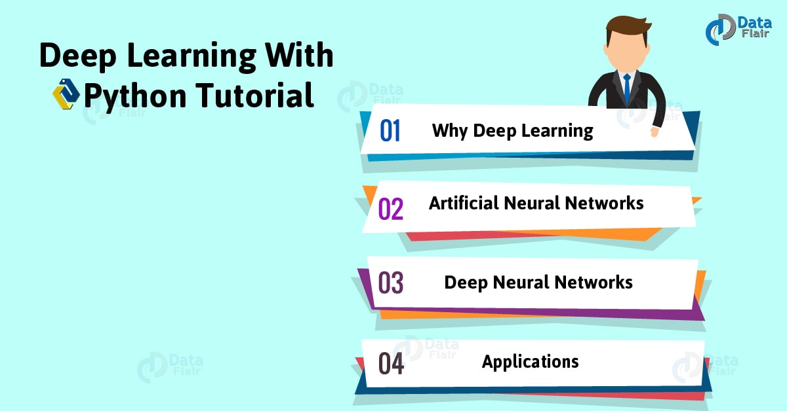
Deep Learning With Python Tutorial For Beginners – 2018

2. What is Deep Learning with Python?

a. Deep Learning Definition
To define it in one sentence, we would say it is an approach to Machine Learning. To elaborate, Deep Learning is a method of Machine Learning that is based on learning data representations (or feature learning) instead of task-specific algorithms. We also call it deep structured learning or hierarchical learning, but mostly, Deep Learning. For feature learning, we observe three kinds of learning- supervised, semi-supervised, or unsupervised.
The patterns we observe in biological nervous systems inspires vaguely the deep learning models that exist.

b. Characteristics of Deep Learning With Python
Some characteristics of Python Deep Learning are-
- They use a cascade of layers of nonlinear processing units to extract features and perform transformation; the output at one layer is the input to the next.
- These learn in supervised and/or unsupervised ways (examples include classification and pattern analysis respectively).
- These learn multiple levels of representations for different levels of abstraction.
Do you read Machine Learning With Python

3. Deep Learning With Python – Why Deep Learning?
Deep Learning uses networks where data transforms through a number of layers before producing the output. This is something we measure by a parameter often dubbed CAP. The Credit Assignment Path depth tells us a value one more than the number of hidden layers- for a feedforward neural network. But we can safely say that with Deep Learning, CAP>2. Each layer takes input and transforms it to make it only slightly more abstract and composite.

4. Deep Learning With Python – (ANN)
Now, let’s talk about neural networks. An Artificial Neural Network is a connectionist system. It is a computing system that, inspired by the biological neural networks from animal brains, learns from examples. When an ANN sees enough images of cats (and those of objects that aren’t cats), it learns to identify another image of a cat.

a. Structure
An Artificial Neural Network is nothing but a collection of artificial neurons that resemble biological ones. Synapses (connections between these neurons) transmit signals to each other. A postsynaptic neuron processes the signal it receives and signals the neurons connected to it further.
Have a look at Machine Learning vs Deep Learning
Deep Learning With Python – Structure of Artificial Neural Networks
A neuron can have state (a value between 0 and 1) and a weight that can increase or decrease the signal strength as the network learns. We see three kinds of layers- input, hidden, and output. There may be any number of hidden layers. Typically, such networks can hold around millions of units and connections. Note that this is still nothing compared to the number of neurons and connections in a human brain.

5. Deep Learning With Python – Deep Neural Networks
A Deep Neural Network is but an Artificial Neural Network with multiple layers between the input and the output. At each layer, the network calculates how probable each output is. A DNN will model complex non-linear relationships when it needs to. With extra layers, we can carry out the composition of features from lower layers.
Deep Neural Networks
Typically, a DNN is a feedforward network that observes the flow of data from input to output. It never loops back. Deep Neural Network creates a map of virtual neurons and assigns weights to the connections that hold them together. It multiplies the weights to the inputs to produce a value between 0 and 1. When it doesn’t accurately recognize a value, it adjusts the weights. This is to make parameters more influential with an ulterior motive to determine the correct mathematical manipulation so we can fully process the data.
Two kinds of ANNs we generally observe are-
- Recurrent Neural Networks- Where data can flow in any direction. We use concepts like LSTM (Long Short-Term Memory) from these in areas like language modeling.
- Convolutional Deep Neural Networks- A deep, feedforward ANN. We use these in areas like analyzing visual imagery, computer vision, and acoustic modeling for ASR (Automatic Speech Recognition)

6. Deep Learning With Python – Deep Learning Applications
We observe the use of Deep Learning with Python in the following fields-
- Automatic speech recognition.
- Image recognition.
- Visual art processing.
- Natural Language Processing (NLP).
- Drug discovery and toxicology.
- Customer Relationship Management (CRM).
- Recommendation systems.
- Bioinformatics.
- Mobile advertising.
- Image Restoration.
- Financial fraud detection.
For more applications, refer to 20 Interesting Applications of Deep Learning with Python.
Before we bid you goodbye, we’d like to introduce you to Samantha, an AI from the movie Her.
Deep Learning With Python tutorial
In the film, Theodore, a sensitive and shy man writes personal letters for others to make a living. Samantha is an OS on his phone that Theodore develops a fantasy for. What starts with a friendship takes the form of love.
Python Deep Learning Tutorial
Will deep learning get us from Siri to Samantha in real life? Well, at least Siri disapproves.
Deep Learning Tutorial Python
So, this was all in Deep Learning with Python tutorial. Hope you like our explanation.

7. Conclusion
Hence, in this Deep Learning Tutorial Python, we discussed what exactly deep learning with Python means. Also, we saw artificial neural networks and deep neural networks in Deep Learning With Python Tutorial. Moreover, we discussed deep learning application and got the reason why Deep Learning. See you again with another tutorial on Deep Learning. Furthermore, if you have any query regarding Deep Learning With Python, ask in the comment tab.
See also –
Learning rules in Neural Network
For reference
Tags: Artificial Neural NetworksCharacteristics of Deep LearningDeep learning applicationsdeep learning tutorial for beginnersDeep Learning With Python TutorialDeep Neural NetworksPython deep Learning tutorialwhat is deep learningwhy deep learning

Leave a Reply

*
*

This site is protected by reCAPTCHA and the Google Privacy Policy and Terms of Service apply.

Home About us Contact us Terms and Conditions Cancellation and Refund Privacy Policy Disclaimer Blogs Write For Us Careers Success Stories

Python ML – Algorithms
Python DL – Environment Setup
Machine Learning TutorialsPython Tutorials
Deep Learning With Python Tutorial For Beginners – DNN & ANN
❮ Prev
Next ❯

Popular Courses
Hadoop + Spark Course
Big Data Hadoop Course
Spark Scala Course
Apache Flink Course
Python Course

Popular Tutorials
Hadoop Tutorials
Spark Tutorials
Flink Tutorials
Tableau Tutorials
Power BI Tutorials
QlikView Tutorials

Popular Tutorials
Data Science Tutorials
Machine Learning Tutorials
Python Tutorials
R Tutorials
SAS Tutorials
SQL Tutorials
DataFlair © 2020. All Rights Reserved.

We use cookies to provide the best services. By using our site, you comply with our cookies policy. Learn more

Blog Home
- Courses
- Data Science
- Big Data
- Categories
- Interview Questions
- Job Portal
- Write For Us
Blog Home » Machine Learning Tutorials » Python Deep Learning Environment Setup – Python Text Editor & Hardware
- 0

Python Deep Learning Environment Setup – Python Text Editor & Hardware
by DataFlair Team · Updated ·

1. Python Deep Learning Environment Setup
Moving on from introducing Deep Learning, now, we guide you to set up your machine for your journey with Deep Learning using Python. So, today in this Deep Learning with Python Tutorial, we will see Python Deep Learning Environment Setup. Moreover, we will see how to install Python. Also, we will learn about Python Libraries such as NumPy, Keras, TensorFlow, Matplotlib, Theano. After this, we will look at Python Hardware i.e. GPU and CPU. Next, in Python Deep Learning Environment Setup Tutorial, we also discuss the Python Text Editor and Python Pip.
You will have every necessary library installed, an environment created, and you will be able to implement deep learning.
So, let’s begin Python Deep Learning Environment Setup.
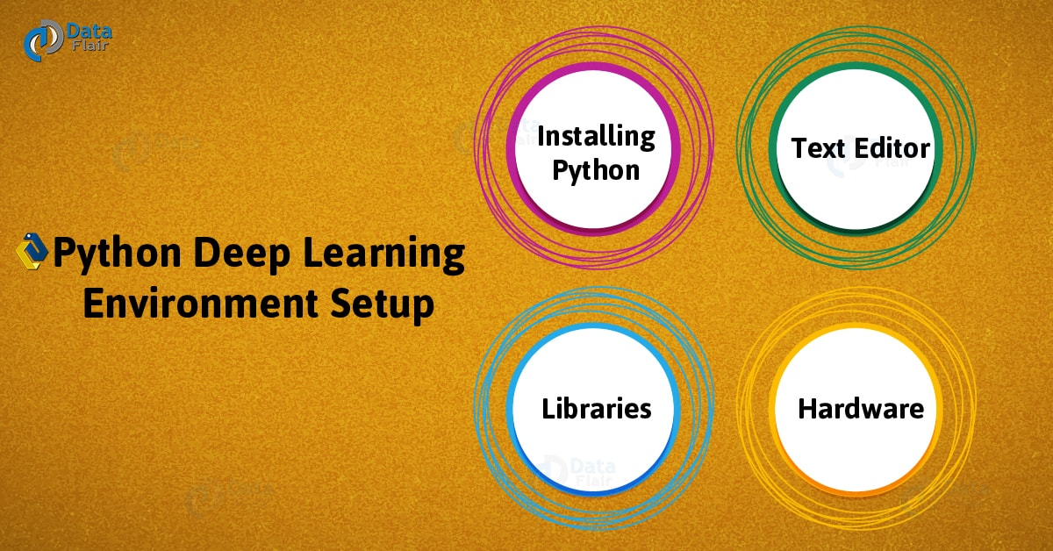
Python Deep Learning Environment Setup

2. How to Install Python?
Before moving to Python Deep Learning Environment Setup, you will need to install Python. You can download it from Python’s official website-
https://www.python.org/downloads/
The latest version at the time of writing is 3.7.
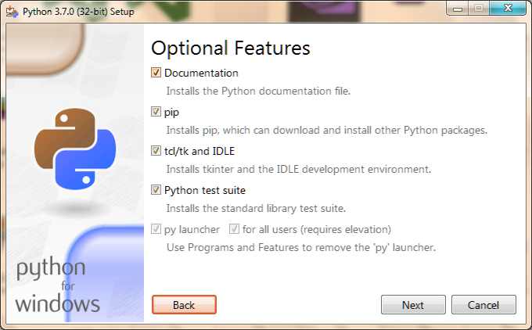
How to Install Python?

a. Installing with Anaconda Python
Alternatively, you can get Python with Anaconda:
https://www.anaconda.com/download/
Install Anaconda Python
In both cases of installing Python and Anaconda Python, choose the configurations that support your machine.
For a detailed guide on how to install Python on Windows, read A Step-by-Step Guide to Install Python Windows.

3. Python Libraries
Now, in Python Deep Learning Environment Setup, first, take a look at what libraries we will need for deep learning with Python. We will show you how to install these Python Libraries.

a. Python NumPy
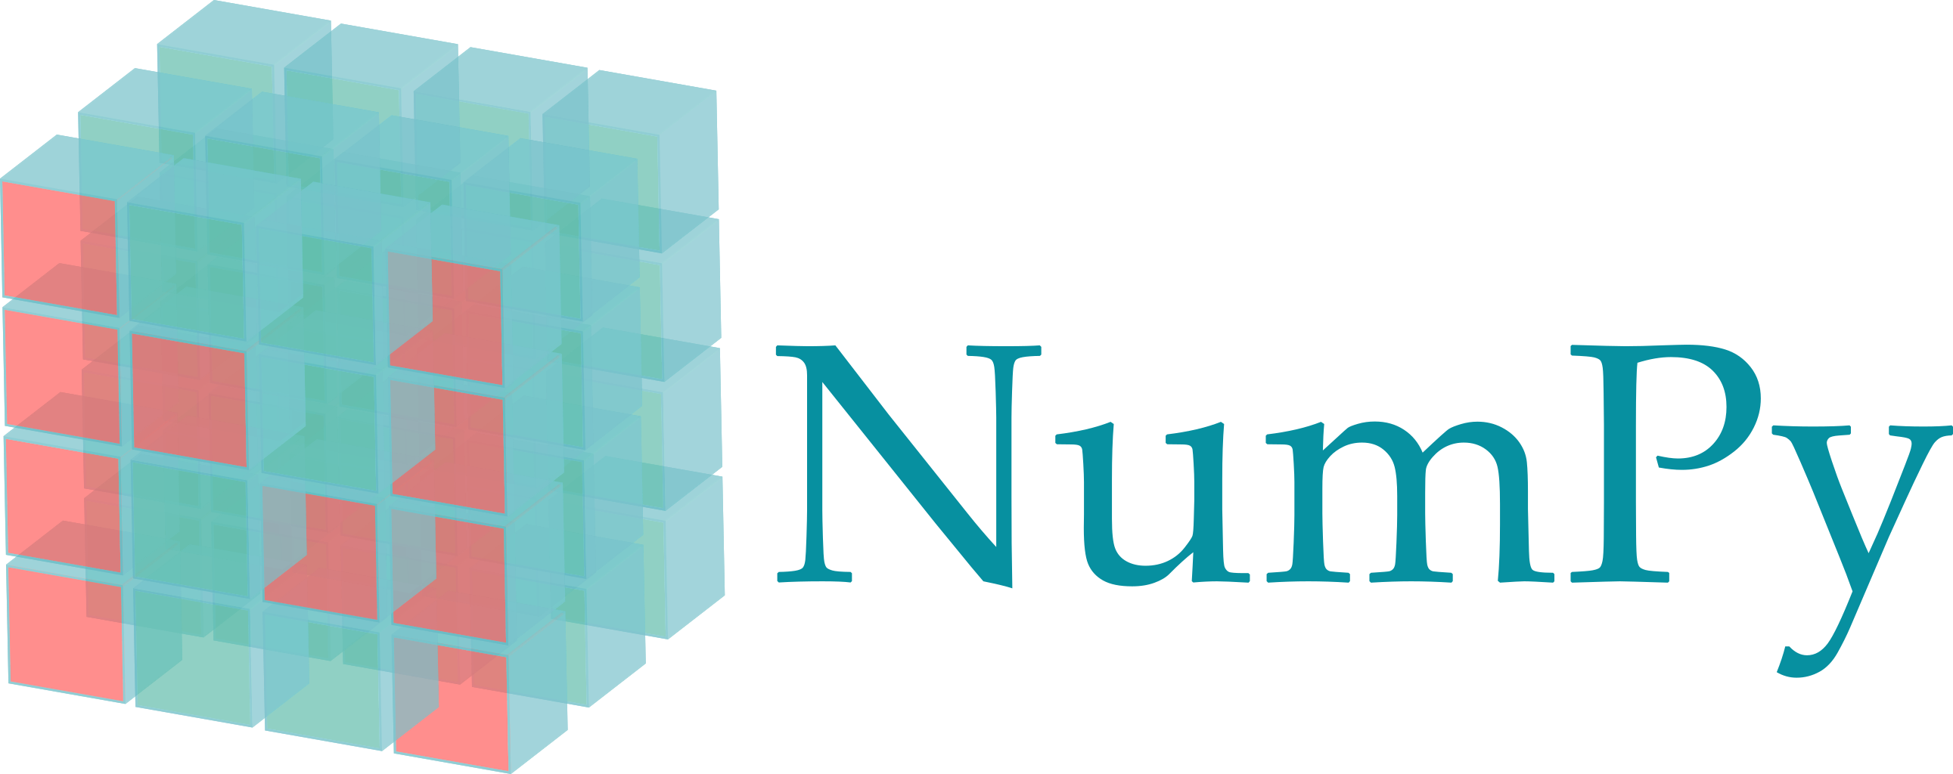
Python NumPy
NumPy is a Python library for working on large, multi-dimensional arrays and matrices. Python NumPy also supports many high-level mathematical functions to operate on these.
To install this, use Python pip-
- pip install numpy

b. Keras Python
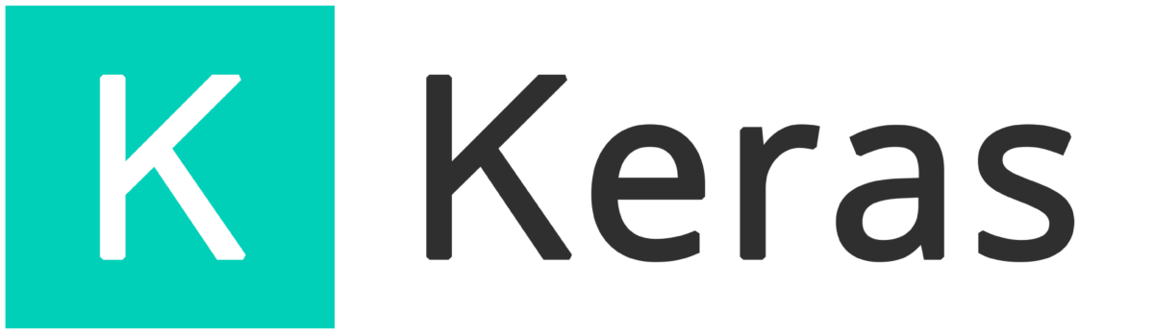
Keras Python
Keras is a neural network library for Python that is open-source and written in Python. Python Keras can run on top of TensorFlow, Theano Python, or Microsoft Cognitive Toolkit.
You can install it with Python pip-
- pip install keras

c. Theano Python

Theano Python
Theano is a Python library for numerical computation. Python Theano uses a NumPy-esque syntax to express computation; it compiles these to run efficiently on CPU or GPU architectures.
Install it using Python pip-
- pip install theano

d. TensorFlow Python
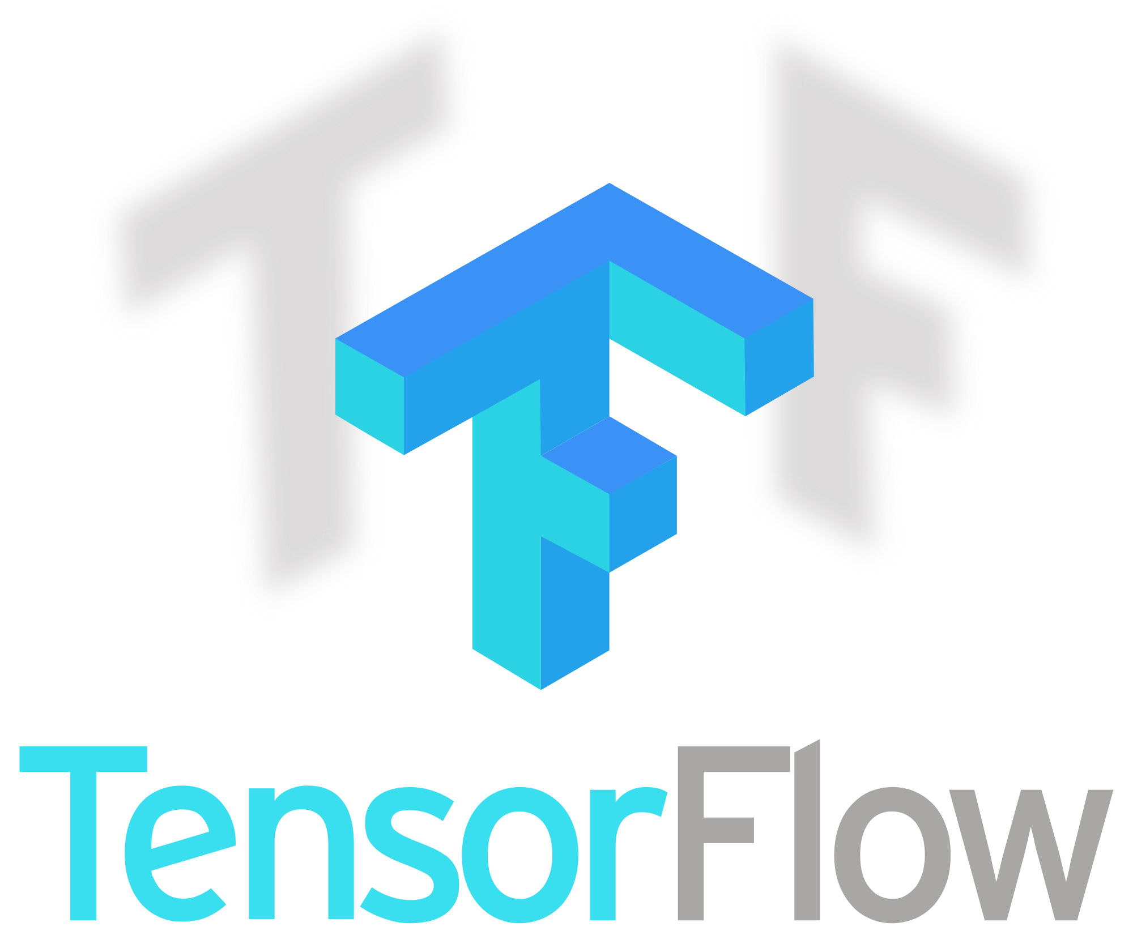
TensorFlow Python
TensorFlow is a Python library by Google that aims at fast numerical computing. We can use TensorFlow Python to create Deep Learning models either directly or by using wrapper libraries.

e. Python Matplotlib
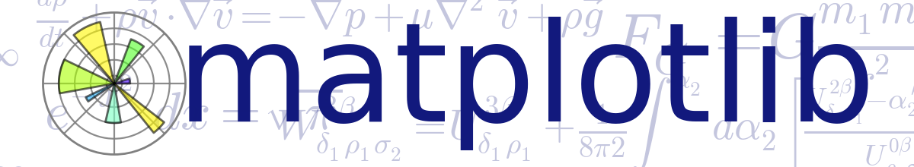
Python Matplotlib
Matplotlib is a Python library for 2D plotting and can work together with NumPy. Install it with Python pip-
- pip install matplotlib

4. Python Text Editor

Python Text Editor – Jupyter Notebook
For Python Deep Learning Environment Setup, we recommend you to use the Jupyter Notebook. It observes the following benefits:
- Thoroughly record steps and results.
- Isolate code by splitting the file into cells.
- Automatic terminal statements below code cells.
- Ability to write Markdown, LaTeX, and Python code in one file.
Have a look at Python Deep Learning Computational Graphs
You can later save your code as a .pTensorFlowy file.
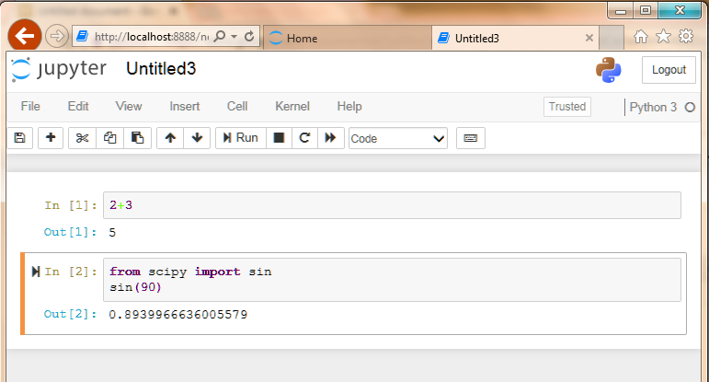
Jupyter Notebook

5. Python Hardware
To run your deep learning code in Python, you can use Python Hardware either a CPU or a GPU.

a. Central Processing Unit (CPU)
CPUs perform narrow and serially. You would need at least a recent quad-core CPU to not bottleneck the GPU.

b. Graphics Processing Unit (GPU)
Although a GPU is meant for video simulation and gaming, they have a parallel architecture. This makes them suitable for vector and matrix operations.
So, this was all in Python Deep Learning Environment Setup. Hope you like our explanations.

6. Conclusion
Hence, in this Python Deep Learning Environment Setup Tutorial, we discussed Python Installation, Python Libraries i.e. NumPy, Keras, TensorFlow, Matplotlib, Theano. Moreover, we discussed Python text editor and Python Hardware such as GPU and CPU. Still, if any doubt regarding Deep Learning with Python, ask in the comment tab.
See also –
Python Machine Learning Tutorial
Reference – Python Deep Learning
Tags: deep learning with pythongpugraphics processing unitHow to install pythonInstall PythonKerasKeras PythonMatplotlibNumpyPython Deep learning environment setupPython Deep Learning InstallationPython HardwarePython librariesPython matplotlibPython NumPyPython pipPython SciPypython text editorScipyTensorFlowTensorflow PythonTheanoTheano Python

Leave a Reply

*
*

This site is protected by reCAPTCHA and the Google Privacy Policy and Terms of Service apply.

Home About us Contact us Terms and Conditions Cancellation and Refund Privacy Policy Disclaimer Blogs Write For Us Careers Success Stories

Python Deep Learning Tutorial
Python DL – Application
Machine Learning TutorialsPython Tutorials
Python Deep Learning Environment Setup – Python Text Editor & Hardware
❮ Prev
Next ❯

Popular Courses
Hadoop + Spark Course
Big Data Hadoop Course
Spark Scala Course
Apache Flink Course
Python Course

Popular Tutorials
Hadoop Tutorials
Spark Tutorials
Flink Tutorials
Tableau Tutorials
Power BI Tutorials
QlikView Tutorials

Popular Tutorials
Data Science Tutorials
Machine Learning Tutorials
Python Tutorials
R Tutorials
SAS Tutorials
SQL Tutorials
DataFlair © 2020. All Rights Reserved.

We use cookies to provide the best services. By using our site, you comply with our cookies policy. Learn more

Blog Home
- Courses
- Data Science
- Big Data
- Categories
- Interview Questions
- Job Portal
- Write For Us
Blog Home » Machine Learning Tutorials » 20 Interesting Applications of Deep Learning with Python
- 0

20 Interesting Applications of Deep Learning with Python
by DataFlair Team · Updated ·

1. Top Python Deep Learning Applications
Today, in this Deep Learning with Python Tutorial, we will see Applications of Deep Learning with Python. In this tutorial, we will discuss 20 major applications of Python Deep Learning. So far, we have seen what Deep Learning is and how to implement it. Now let’s find out all that we can do with deep learning using Python- its applications in the real world.
So, let’s start exploring Applications of Deep Learning with Python.
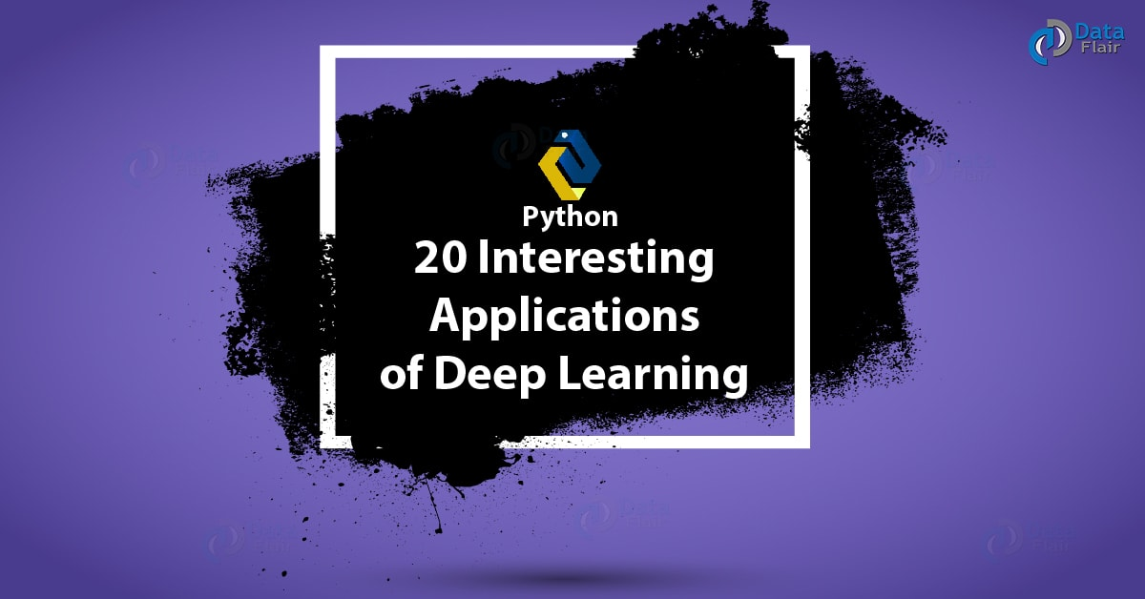
20 Interesting Applications of Deep Learning with Python

2. Applications of Deep Learning WIth Python
Below, we are discussing 20 best applications of deep learning with Python, that you must know. Let’s discuss them one by one:

i. Restoring Color in B&W Photos and Videos
With Deep Learning, it is possible to restore color in black and white photos and videos. This can give a new life to such media. The ACM Digital Library is one such project that colorizes grayscale images combining global priors and local image features. This is based on Convolutional Neural Networks.

Applications of Deep Learning with Python – Restoring Color
The Deep Learning network learns patterns that naturally occur within photos. This includes blue skies, white and gray clouds, and the greens of grasses. It uses past experience to learn this. Although sometimes, it can make mistakes, it is efficient and accurate most of the times.
Do you know about important Deep Learning Terminologies?

ii. Pixel Restoration
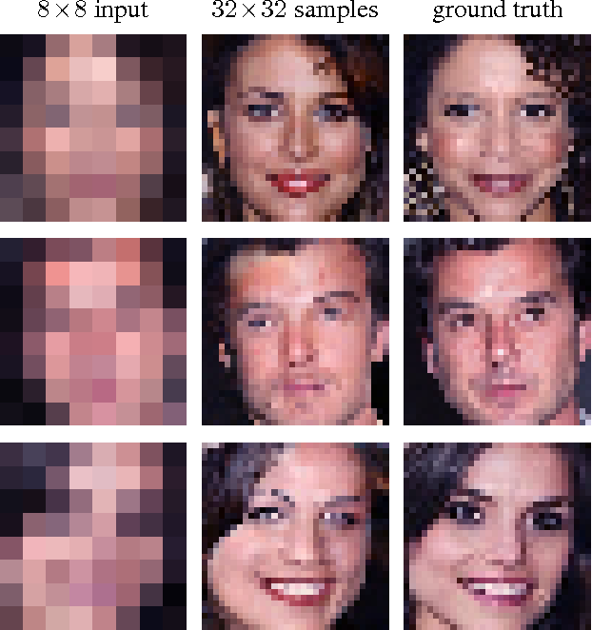
Applications of Deep Learning with Python – Pixel Restoration
With deep learning, we can even zoom into a video beyond its resolution. In 2017, researchers from Google Brain trained a Deep Learning network to predict faces from their low-resolution images. The Pixel Recursive Super Resolution works on photos to enhance their resolution to a great extent.

iii. Describing Pictures
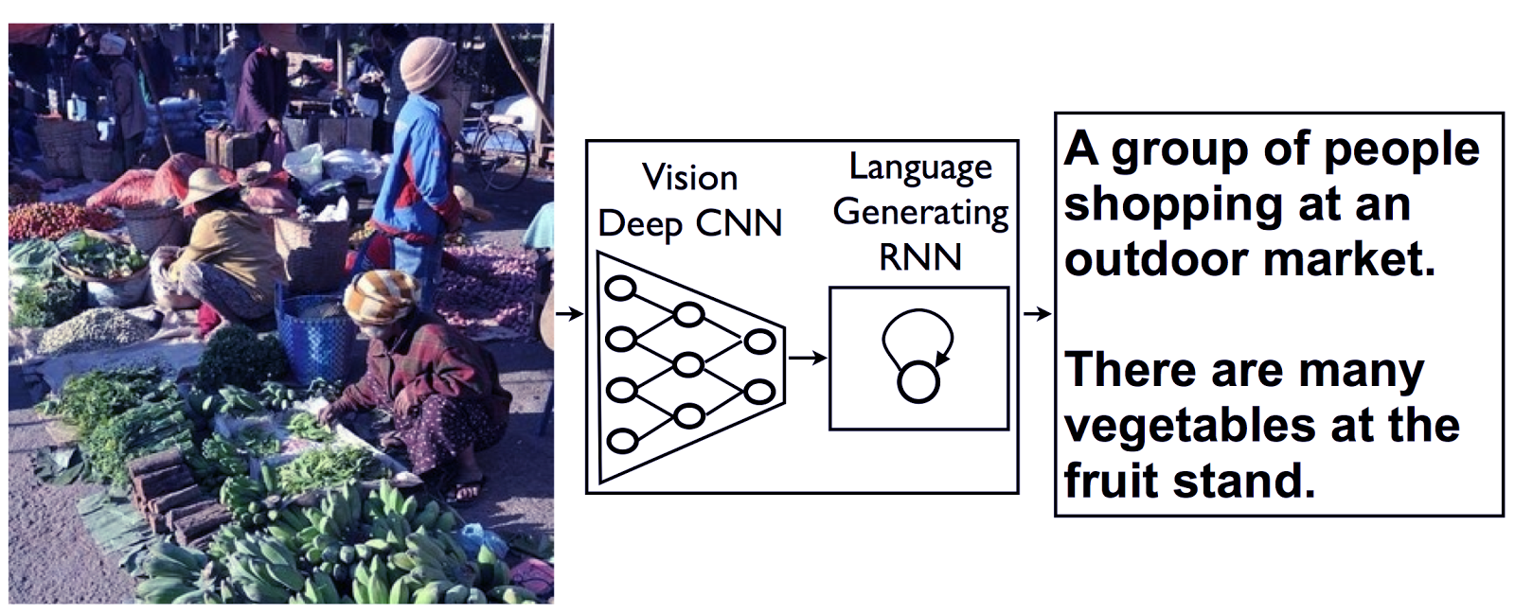
Applications of Deep Learning with Python – Describing Pictures
By now, you have noticed how Facebook can tag photos and Google can label them for easier search. Deep Learning can describe all the elements in a picture. A deep learning network can identify many areas in an image and can describe each area in words. This is using accurate English grammar.

iv. Changing Gaze in Photos

Applications of Deep Learning – Changing Gaze in photos
A Deep Learning network can alter the direction in which a person looks in a picture.

v. Real-Time Analysis of Behavior

Applications of Deep Learning with Python – Analysis of Behavior
Deep Learning networks can recognize and describe pictures, we know that. But they can also analyze poses of people in these pictures. They can get real-time insights about behaviors of people, cars, and other objects.

vi. Translation

Python deep learning – Translation
It is now possible to translate text on images in real-time. The Google Translate app can do this- you hold your camera on an object and a deep learning network OCRs the image to translate it.

vii. Generating Pictures of Galaxies and Volcanoes

Applications of Deep Learning with Python – Galaxies and Volcanoes
Using Deep Learning with Python, astronomers can create pictures of volcanoes and galaxies.
Have a look at Deep Learning vs machine Learning

viii. Creating New Images
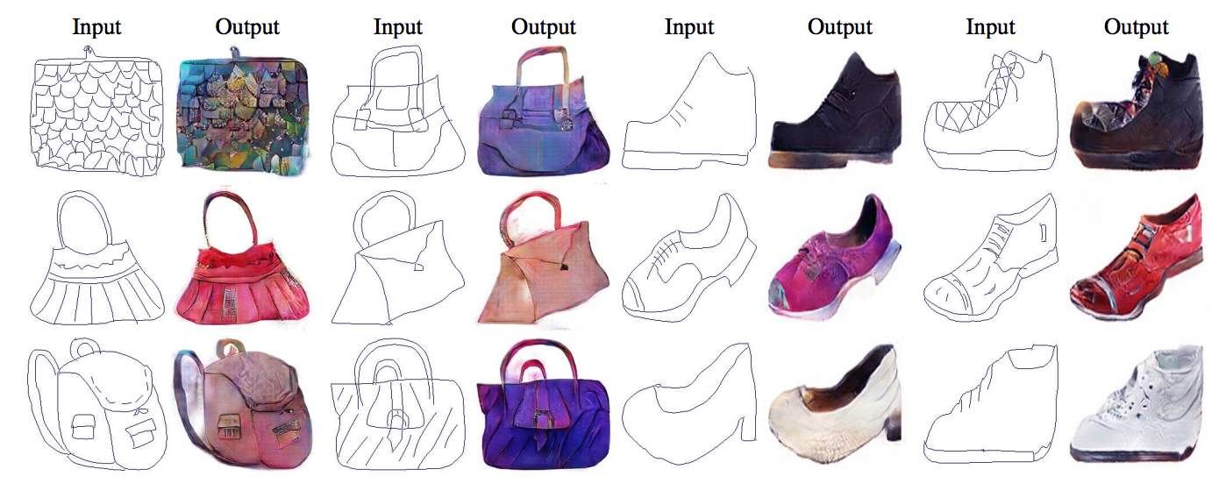
Applications of Deep Learning with Python – Creating New Images
Pix2Pix taught a deep learning network to perform activities like creating real street scenes from colored blobs, creating a map from a real aerial picture, fill colors between edges of objects, and even turn day scenes into night scenes.

ix. Searching for Text in Images and Videos

Searching for text in images and videos
The Oxford Visual Geometry group can search for text in pictures and videos using deep learning. It searches for text in BBC News videos. Check out http://zeus.robots.ox.ac.uk/textsearch/#/search/
We searched for ‘Glitter’ and it did a less than perfect job, but is accurate pretty much most of the time.

x. Outperforming Humans in Computer Games
Outperforming Humans in Computer Games
The Deep Learning community trains humans to beat humans at games like Space Invaders, Pong, and Doom. The computers learned the rules on their own by playing for a few hours.

xi. Robotics
Applications Deep Learning With Python – Robotics
With the capabilities of Deep Learning, robots can get up when they fall, carry out tasks that need them to be gentle, and even react to the people who push them around.

xii. Self-Driving Cars
Applications of Deep Learning with Python – Self Driving Cars
One name we’ve all heard is the Google Self-Driving Car. Such vehicles can differentiate objects, people, and road signs. These also make use of the lidar technology.

xiii. Generating Voice
Applications of Deep Learning With Python – Generating Voice
Deep Learning networks like WaveNet by Google and Deep Speech by Baidu can automatically generate voice. They can learn to mimic human voices so they can improve over time.
Let’s revise Python Applications

xiv. Composing Music
Like the previous application, we can train a deep learning network to produce music compositions. The computer learns the patterns and statistics of artists and creates a unique piece.

xv. Restoring Sound in Videos
Applications of Deep Learning with Python – Restoring Sound in Videos
Deep learning makes it possible to restore sound in muted videos. The computer can add sounds like scratching objects with a drumstick. This uses supervised learning. Apart from this, software like LipNet can read people’s lips with 93% success.

xvi. Handwriting
Handwriting in Python Deep Learning
With deep learning, computers can not only produce digital text and art, it can handwrite. A computer can have its own handwriting. You can try it out here-
http://www.cs.toronto.edu/~graves/handwriting.cgi

xvii. Deep Dreaming
Applications of Deep Learning with Python – Deep Dreaming
This Python Deep Learning Application can enhance features in images. Deep Dreaming makes the computer hallucinate on the top of an image. This results in dreamy images.

xviii. Inventing and Hacking own Crypto
Google Brain has devised two neural networks- one to generate a cryptographic algorithm to protect their messages. The other attempts to crack this. It performed well at devising, but not so much at hacking it.

xix. Deep Learning Networks Creating Deep Learning Networks
Applications of Deep Learning with Python – Deep Learning Networks
Deep Learning products like Neural Complete can produce new deep learning networks. It is written in Python and is trained to generate code in Python.
Let’s discuss Python Machine Learning Tutorial

xx. Writing Wikipedia articles, computer code, math papers, and Shakespeare
Long Short-Term Memory (LSTM) is an architecture that can generate Wikipedia-like articles, fake math papers, and much more. Not all the times does this make sense, but there will be progress.
So, this was all in Applications of Deep Learning With Python. Hope you like our explanation.

3. Conclusion
Hence, in this Python Deep Learning Tutorial, we have tried to bring to you some of the most interesting Applications of Deep Learning with Python. Still, if you feel any query, you can ask in the comment tab.
See also –
Python Machine Learning Environment Setup
For reference
Tags: Applications of deep learning using PythonDeep Learning Tutorial PythonDeep Learning With Python TutorialPython Deep Learning Applications'Python deep Learning tutorial

Leave a Reply

*
*

This site is protected by reCAPTCHA and the Google Privacy Policy and Terms of Service apply.

Home About us Contact us Terms and Conditions Cancellation and Refund Privacy Policy Disclaimer Blogs Write For Us Careers Success Stories

Python DL – Environment Setup
Python DL – Python Libraries
Machine Learning TutorialsPython Tutorials
20 Interesting Applications of Deep Learning with Python
❮ Prev
Next ❯

Popular Courses
Hadoop + Spark Course
Big Data Hadoop Course
Spark Scala Course
Apache Flink Course
Python Course

Popular Tutorials
Hadoop Tutorials
Spark Tutorials
Flink Tutorials
Tableau Tutorials
Power BI Tutorials
QlikView Tutorials

Popular Tutorials
Data Science Tutorials
Machine Learning Tutorials
Python Tutorials
R Tutorials
SAS Tutorials
SQL Tutorials
DataFlair © 2020. All Rights Reserved.

We use cookies to provide the best services. By using our site, you comply with our cookies policy. Learn more

Blog Home
- Courses
- Data Science
- Big Data
- Categories
- Interview Questions
- Job Portal
- Write For Us
Blog Home » Machine Learning Tutorials » 11 Deep Learning With Python Libraries and Frameworks
- 0

11 Deep Learning With Python Libraries and Frameworks
by DataFlair Team · Updated ·

1. Deep Learning With Python Libraries & Frameworks
Today, in this Deep Learning with Python Libraries and Framework Tutorial, we will discuss 11 libraries and frameworks that are a go-to for Deep Learning with Python. In this Deep Learning with Python Libraries, we will see TensorFlow, Keras, Apache mxnet, Caffe, Theano Python and many more.
A library is a collection of modules that implement the related functionality. A framework defines inversion of control- it manages the flow of control and the flow of data.
So, let’s begin Deep Learning with Python Libraries and Framework.
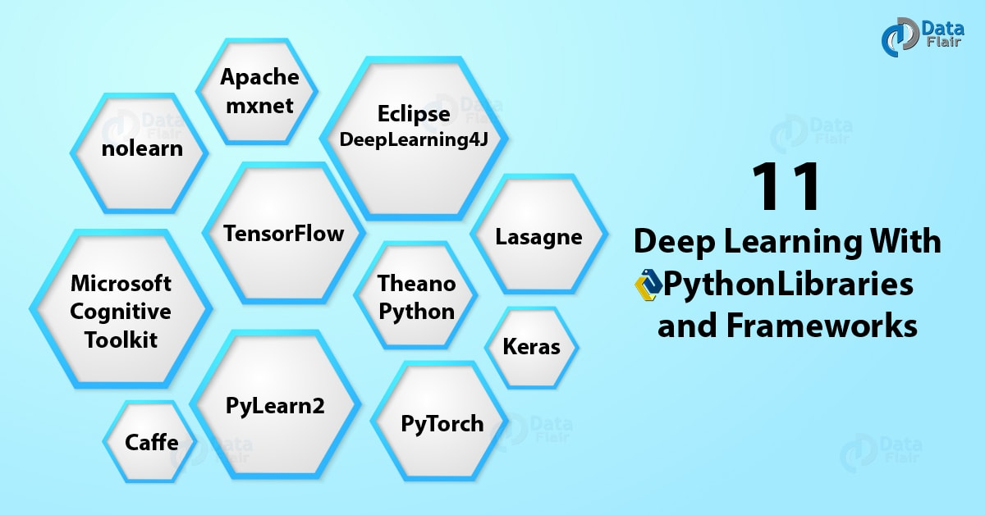
11 Deep Learning With Python Libraries and Frameworks

2. TensorFlow Python
TensorFlow is an open-source library for numerical computation, for which it uses data flow graphs. The Google Brain Team researchers developed this with the Machine Intelligence research organization by Google. TensorFlow is open-source and available to the public. It is also good for distributed computing.
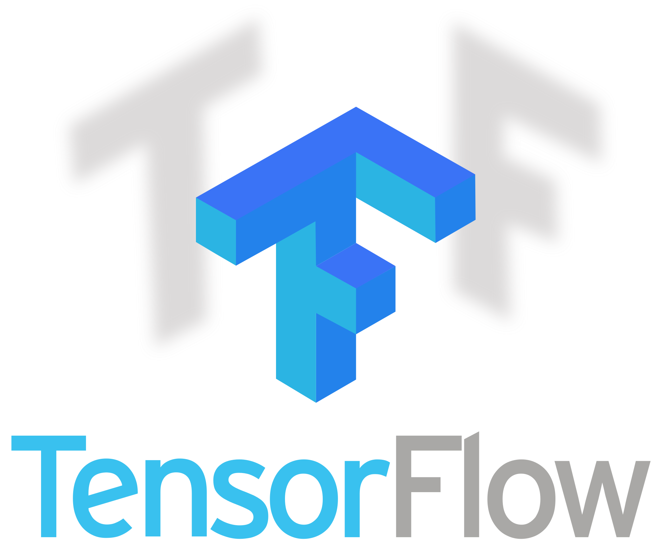
TensorFlow Python in Python Deep Learning Libraries
Do you know about Python Machine Learning?
You can install it using pip with conda Python-
- pip install tensorflow

3. Keras Python
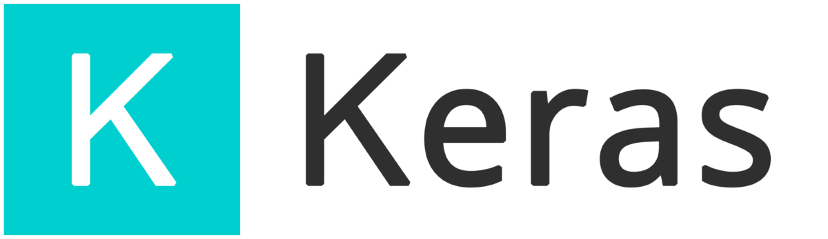
Keras in Deep Learning With Python Libraries and Frame work
A minimalist, modular Neural Network library, Keras uses Theano or TensorFlow as a backend. It makes it easy and faster to experiment and implement ideas into results.
Have a look at Machine Learning Frameworks
Keras has algorithms for optimizers, normalization, and activation layers. It also deals with Convolutional Neural Networks. It lets you build sequence-based and graph-based networks. One limitation is that it doesn’t support multi-GPU environments for training a network in parallel.
You can install it with Python pip-
- pip install keras

4. Apache mxnet
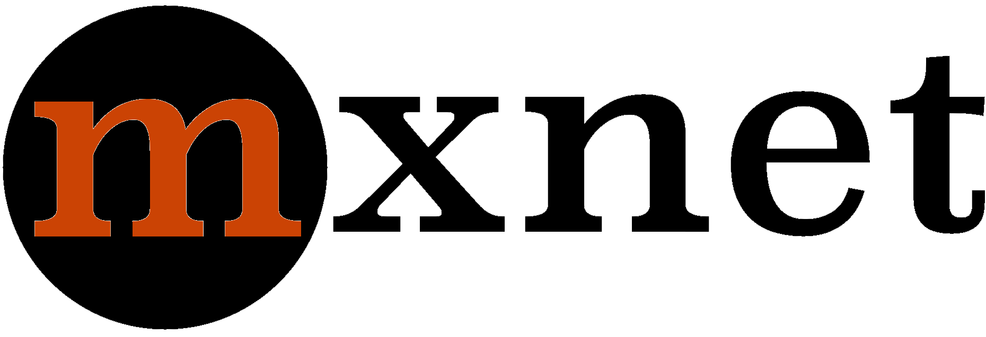
Apache mxnet in Deep Learning with Python Libraries
mxnet delivers an amazing number of language bindings for languages like C++, Python, R, JavaScript, and more. It does great with distributed computing and lets us train a network across CPU/GPU machines. The only downside is that we need a little more code to run an experiment in it.
Install it using Python pip-
- pip install mxnet
Let’s discuss more in Python Libraries

5. Caffe

Caffe in Python Deep Learning Libraries and Framework
Caffe is a deep learning framework that is fast and modular. This isn’t a library but provides bindings into Python. Caffe can process nearly 60 million images per day on a K40 GPU. However, it isn’t as easy to turn hyperparameters with it programmatically.

6. Theano Python
Deep Learning With Python Libraries and Framework – Theano
Without NumPy, we couldn’t have SciPy, scikit-learn, and scikit-image. Similarly, Theano serves as a base for many. It is a library that will let you define, optimize, and evaluate mathematical expressions that involve multidimensional arrays. It is tightly integrated with NumPy and transparently uses the GPU.
Theano can act as a building block for scientific computing. Install it with Python pip-
- pip install theano
Let’s discuss Python machine Learning Algorithms

7. Microsoft Cognitive Toolkit
Microsoft Cognitive Toolkit
The Microsoft Cognitive Toolkit is a unified Deep Learning toolkit. It describes neural networks using a directed graph in computational steps.
You can install cntk using Python pip-
- pip install cntk

8. PyTorch
Deep Learning With Python Libraries and Framework – PyTorch
PyTorch is a Tensor and Dynamic neural network in Python. It observes strong GPU acceleration, is open-source, and we can use it for applications like natural language processing. You can refer to this link to install PyTorch-
https://pytorch.org/#pip-install-pytorch

9. Eclipse DeepLearning4J
Deep Learning With Python Libraries and Framework – Eclipse DeepLearning4J

DeepLearning4J is a deep learning programming library by Eclipse. It is written for Java and the JVM; It is also a computing framework for good support with deep learning algorithms.

10. Lasagne
Deep Learning With Python Libraries and Framework – Lasagne
Lasagne is a lightweight Python library that helps us build and train neural networks in Theano. You can install it using Python pip-
- pip install lasagne

11. nolearn
Deep Learning With Python Libraries and Framework – nolearn
nolearn wraps Lasagna into an API that is more user-friendly. All code it holds is compatible with scikit-learn. We can use it for applications like Deep Belief Networks (DBNs).
Do you know about Python Machine Learning Techniques
Install it using Python pip-
- pip install nolearn

12. PyLearn2
Pylearn2
PyLearn2 is a machine learning library with most functionality built on top of Theano. It is possible to write PyLearn2 plugins making use of mathematical expressions. Theano optimizes and stabilizes these for us and compiles them to the backend we want.
So, this was all in Deep Learning with Python Libraries and Framework. Hope you like our explanation.

13. Conclusion: Deep Learning With Python Libraries & Frameworks
Hence, today in this Deep Learning with Python Libraries and Framework tutorial, we discussed 11 libraries and frameworks for you to get started with deep learning. Each Deep Learning Python Library and Framework has its own benefits and limitations. Moreover, in this, we discussed PyTorch, TensorFlow, Keras, Theano etc. That’s all for today. we will come back with the new tutorial of Deep Learning With Python. Tell us about your experience with us on Deep Learning with Python Libraries and Framework through comments.
See also –
Computational Graphs in Deep Learning With Python
For reference
Tags: Apache mxnetbest Deep Learning Framework 2018Caffedeep learning with pythonDeep Learning with Python FrameworkDeep Learning with Python LibrariesDeep Learning with Python Libraries and FrameworkEclipse Deeplearning4jKerasKeras PythonLasagnelibraries is mainly design for machine visionmachine learning framework pythonmachine learning frameworksmachine learning libraryMicrosoft Cognitive ToolkitnolearnPyLearn2Python Deep LearningPython Deep Learning LibrariesPython librariesPython pipPyTorchTensorFlowTensorflow PythonTheanoTheano Python

Leave a Reply

*
*

This site is protected by reCAPTCHA and the Google Privacy Policy and Terms of Service apply.

Home About us Contact us Terms and Conditions Cancellation and Refund Privacy Policy Disclaimer Blogs Write For Us Careers Success Stories

Python DL – Application
Python DL – Deep Neural Networks
Machine Learning TutorialsPython Tutorials
11 Deep Learning With Python Libraries and Frameworks
❮ Prev
Next ❯

Popular Courses
Hadoop + Spark Course
Big Data Hadoop Course
Spark Scala Course
Apache Flink Course
Python Course

Popular Tutorials
Hadoop Tutorials
Spark Tutorials
Flink Tutorials
Tableau Tutorials
Power BI Tutorials
QlikView Tutorials

Popular Tutorials
Data Science Tutorials
Machine Learning Tutorials
Python Tutorials
R Tutorials
SAS Tutorials
SQL Tutorials
DataFlair © 2020. All Rights Reserved.

Blog Home
- Courses
- Data Science
- Big Data
- Categories
- Interview Questions
- Job Portal
- Write For Us
Blog Home » Machine Learning Tutorials » Deep Neural Networks With Python – Deep Belief Networks
- 0

Deep Neural Networks With Python – Deep Belief Networks
by DataFlair Team · Updated ·

1. Deep Neural Networks With Python
In this Deep Learning with Python tutorial, we will learn about Deep Neural Networks with Python and the challenges they face. Moreover, we will see types of Deep Neural Networks and Deep Belief Networks.
So, let’s start Deep Neural Networks Tutorial.
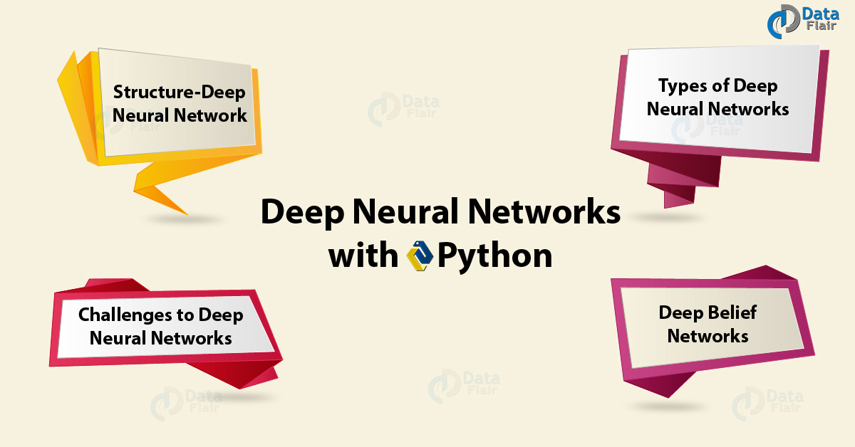
Deep Neural Networks With Python

2. Define Deep Neural Network with Python?
Before finding out what a deep neural network in Python is, let’s learn about Artificial Neural Networks.

a. Artificial Neural Networks
An ANN (Artificial Neural Network) is inspired by the biological neural network. It can learn to perform tasks by observing examples, we do not need to program them with task-specific rules. An ANN can look at images labeled ‘cat’ or ‘no cat’ and learn to identify more images itself.
Such a network is a collection of artificial neurons- connected nodes; these model neurons in a biological brain. A connection is like a synapse in a brain and is capable of transmitting signals from one artificial neuron to another. This neuron processes the signal it receives and signals to more artificial neurons it is connected to.
Deep Neural Networks With Python – ANN
This way, we can have input, output, and hidden layers.
Some applications of Artificial Neural Networks have been Computer Vision, Speech Recognition, Machine Translation, Social Network Filtering, Medical Diagnosis, and playing board and video games.
Do you know about Python machine Learning

b. Deep Neural Networks
Coming back, a Deep Neural Network is an ANN that has multiple layers between the input and the output layers. Such a network sifts through multiple layers and calculates the probability of each output.
A DNN is capable of modeling complex non-linear relationships.

3. Structure of Deep Neural Network
A DNN is usually a feedforward network. This means data from the input layer flows to the output layer without looping back.
Structure of deep Neural Networks with Python
Such a network with only one hidden layer would be a non-deep(or shallow) feedforward neural network. But in a deep neural network, the number of hidden layers could be, say, 1000. But it must be greater than 2 to be considered a DNN.
Have a look at Python Machine Learning Algorithms
A DNN creates a map of virtual neurons and randomly assigns weights to the connections between these neurons. It multiplies the weights with the inputs to return an output between 0 and 1. If it fails to recognize a pattern, it uses an algorithm to adjust the weights.

4. Types of Deep Neural Networks with Python
Broadly, we can classify Python Deep Neural Networks into two categories:

a. Recurrent Neural Networks- RNNs
Deep Neural Networks with Python – Recurrent Neural Networks(RNNs)
A Recurrent Neural Network is a sort of ANN where the connections between its nodes form a directed graph along a sequence. An RNN can use its internal state/ memory to process input sequences. Thus we can use it for tasks like unsegmented, connected handwriting recognition and speech recognition. Kinds of RNN-
- Finite Impulse Recurrent Network- A Directed Acyclic Graph (DAG) that we can replace with a strictly feedforward neural network.
- Infinite Impulse Recurrent Network- A Directed Cyclic Graph that we cannot unroll.
Do you know about Neural Networks Algorithms
A basic RNN is a network of neurons held into layers where each node in a layer connects one-way (and directly) to every other node in the next layer. In an RNN, data can flow in any direction. We make use of LSTM (Long Short-Term Memory) and use RNNs in applications like language modeling.

b. Convolutional Neural Network (CNN or ConvNet)
Deep Neural Networks with Python – Convolutional Neural Network (CNN or ConvNet)
A CNN is a sort of deep ANN that is feedforward. We use it for applications like analyzing visual imagery, Computer Vision, acoustic modeling for Automatic Speech Recognition (ASR), Recommender Systems, and Natural Language Processing (NLP).
A CNN uses multilayer perceptrons for minimal preprocessing. In such a network, the connectivity pattern between neurons mimics how an animal visual cortex is organized. A CNN learns the filters and thus needs little preprocessing. It has the following architecture-
Deep Neural Networks with Python – Architecture of CNN

5. Challenges to Deep Neural Networks
Two major challenges faced by Deep Neural Networks with Python –

a. Overfitting
Challenges to Deep Neural Networks with Python
Since a DNN possesses added layers of abstraction, it can model rare dependencies in the training data. To fight this, we can-
Have a look at train and test set in Python ML
- Use regularization methods like Ivakhnenko’s unit pruning, weight decay, or sparsity.
- Using dropout regularization to randomly omit units from hidden layers when training.
- Using methods like cropping and rotating to augment data; to enlarge smaller training sets.

b. Computation Time
To sweep through the parameter space (size, learning rate, initial weights) may lead to a need for more computational resources and time. To battle this, we can-
- Perform Batching to compute the gradient to multiple training examples at once.
- Use many-core architectures for their large processing capabilities and suitability for matrix and vector computations.

6. Deep Belief Networks
Before we can proceed to exit, let’s talk about one more thing- Deep Belief Networks. A DBN is a sort of deep neural network that holds multiple layers of latent variables or hidden units. Such a network observes connections between layers rather than between units at these layers.
Deep Belief Networks
If we train a DBN on a set of examples without supervision, we can let it learn to reconstruct input probabilistically. You can call the layers feature detectors. After this, we can train it with supervision to carry out classification.
Let’s discuss Python Deep Learning Environment Setup
So, this was all in Deep Neural Networks with Python. Hope you like our explanation.

7. Conclusion
In this Python Deep Neural Networks tutorial, we looked at Deep Learning, its types, the challenges it faces, and Deep Belief Networks. Leave your suggestions and queries in the comments.
See also –
Python Deep Learning Libraries and Framework
For reference
Tags: Artificial Neural NetworksConvolutional Neural NetworkDeep Belief NetworksDeep Neural NetworksDeep Neural Networks With PythonDNNRecurrent Neural NetworksRNNStructure- Deep Neural NetworkTypes of Deep Neural NetworksWhat are Python Deep Neural Networks?

Leave a Reply

*
*

This site is protected by reCAPTCHA and the Google Privacy Policy and Terms of Service apply.

Home About us Contact us Terms and Conditions Cancellation and Refund Privacy Policy Disclaimer Blogs Write For Us Careers Success Stories

Python DL – Python Libraries
Python DL – Computational Graphs
Machine Learning TutorialsPython Tutorials
Deep Neural Networks With Python – Deep Belief Networks
❮ Prev
Next ❯

Popular Courses
Hadoop + Spark Course
Big Data Hadoop Course
Spark Scala Course
Apache Flink Course
Python Course

Popular Tutorials
Hadoop Tutorials
Spark Tutorials
Flink Tutorials
Tableau Tutorials
Power BI Tutorials
QlikView Tutorials

Popular Tutorials
Data Science Tutorials
Machine Learning Tutorials
Python Tutorials
R Tutorials
SAS Tutorials
SQL Tutorials
DataFlair © 2020. All Rights Reserved.

We use cookies to provide the best services. By using our site, you comply with our cookies policy. Learn more

Blog Home
- Courses
- Data Science
- Big Data
- Categories
- Interview Questions
- Job Portal
- Write For Us
Blog Home » Machine Learning Tutorials » Computational Graphs in Deep Learning With Python
- 0

Computational Graphs in Deep Learning With Python
by DataFlair Team · Updated ·

1. Computational Graphs – Objective
In this Deep Learning With Python tutorial, we will tell you about computational graphs in Deep Learning. We will show you how to implement those Computational graphs with Python. Moreover, while implementing Deep Learning Computational Graphs in Python, we will look at dynamics and Forward-Backward Propagation.
So, let’s begin Computation Graphs in Deep Learning With Python.
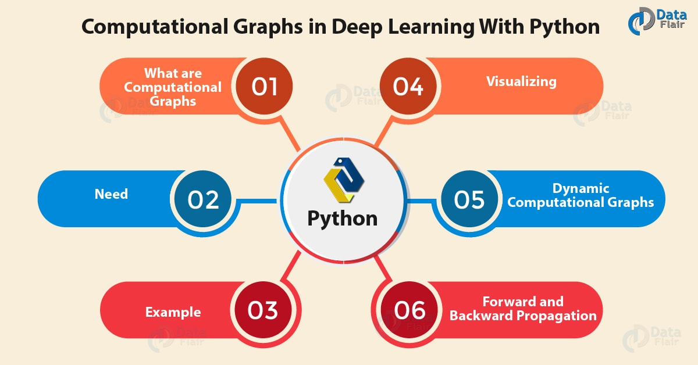
Computational Graphs in Deep Learning With Python

2. Deep Learning Computational Graphs
In fields like Cheminformatics and Natural Language Understanding, it is often useful to compute over data-flow graphs. Computational Graph form an integral part of Deep Learning. Not only do they help us simplify working with large datasets, they’re simple to understand. So in this tutorial, we will introduce them to you and then show you how to implement them using Python. For this, we will use the Dask library from Python PyPI.
Do you know about Python Library

3. What are Computational Graphs in Deep Learning?
A computational graph is a way to represent a mathematical function in the language of graph theory. Nodes are input values or functions for combining them; as data flows through this graph, the edges receive their weights.
What is Computational Graph
So we said we have two kinds of nodes- input nodes and function nodes. Outbound edges from input nodes bear the input value, and those from function nodes bear the composite of the weights of the inbound edges. The graph above represents the following expression:
f(x,y,z)=(x+y)*z
Have a look at deep Learning vs Machine Learning
Of the five nodes, the leftmost three are input nodes; the two on the right are function nodes. Now if we’d have to compute f(1,2,3), we’d get the following computation graph-
Computational Graphs Deep Learning

4. Need of Computational Graph
Well, this was a simple computational graph with 5 nodes and 5 edges. But even simpler deep neural networks observe hundreds of thousands of nodes and edges- say, more than one million? In such a case, it would be practically impossible to calculate a function expression for it. Then, computational graphs come in handy.
Such graphs also help us describe backpropagation more precisely.

5. Computational Graphs Example – Composite Function
We take an example of the function f(x)=esin(x**2). Let’s decompose this-
f(x)=ex
g(x)=sin x
h(x)=x2
f(g(h(x)))=eg(h(x))
Let’s revise the Python Machine Learning Tutorial
We have the following computational graph for this-
Example of Computational Graphs

6. Visualizing a Computation Graph in Python
Now let’s use the Dask library to produce such a graph.
- >>> from dask import delayed,compute
- >>> import dask
- >>> @delayed
- def square(num):
- print("Square function:",num)
- print()
- return num*num
- >>> @delayed
- def sum_list(args):
- print("Sum_list function:",args)
- return sum(args)
- >>> items=[1,2,3]
- >>> computation_graph = sum_list([square(i) for i in items])
- >>> computation_graph.visualize()
<IPython.core.display.Image object>
- >>> computation_graph.visualize(filename='sumlist.svg')
<IPython.core.display.SVG object>
Visualizing Computational Graphs in Python
Note that for this code to work, you will need to perform three tasks-
- Install the dask library with pip:
- pip install dask
- Download and unzip the Windows packages for Dask-
https://graphviz.gitlab.io/_pages/Download/Download_windows.html
- Add the first line of code to your User Path and the next to your system path in environment variables:
C:\Users\Ayushi\Desktop\graphviz-2.38\release\bin (Use your own path for bin)
C:\Users\Ayushi\Desktop\graphviz-2.38\release\bin\dot.exe

7. Dynamic Deep Learning Python Computational Graphs
DCGs suffer from the issues of inefficient batching and poor tooling. When each data in a data set has its type or shape, it becomes a problem to have the neural network batch such data with a static graph. As a workaround, we use an algorithm we call Dynamic Batching.
In other words, a Dynamic Computational Graph is a mutable directed graph with operations as vertices and data as edges. In effect, it is a system of libraries, interfaces, and components. These deliver a flexible, programmatic, runtime interface that lets us construct and modify systems by connecting operations.
Have a look at the Python Machine Learning Environment Set up

8. Forward and Backward Propagation in Computational Graphs
First, let’s talk about forward propagation. Here, we loop over nodes in a topological order. In other words, we pass the values of the variables in the forward direction (left to right). Given a node’s inputs, we compute its value.
In backward propagation, however, we start at a final goal node and loop over the nodes in a reverse topological order. Here, we compute the derivatives of the final goal node value with respect to each edge’s tail node.
So, this was all in Computational Graphs Deep Learning With Python. Hope you like our explanation.

9. Conclusion: Computational Graphs
Hence, we wind up computational graphs for deep learning with Python. Moreover, we discussed Computational Graphs Propagation and implementing graphs in Python. Furthermore, if you have any query, feel free to ask in the comment box.
See also –
Deep Learning With Python Applications
For reference
Tags: Composite FunctionComputational graphcomputational graph exampleComputational graphsDeep Learning Tutorial Pythondeep learning with pythonPython machine Learning

Leave a Reply

*
*

This site is protected by reCAPTCHA and the Google Privacy Policy and Terms of Service apply.

Home About us Contact us Terms and Conditions Cancellation and Refund Privacy Policy Disclaimer Blogs Write For Us Careers Success Stories

Python DL – Deep Neural Networks
Python AI Tutorial
Machine Learning TutorialsPython Tutorials
Computational Graphs in Deep Learning With Python
❮ Prev
Next ❯

Popular Courses
Hadoop + Spark Course
Big Data Hadoop Course
Spark Scala Course
Apache Flink Course
Python Course

Popular Tutorials
Hadoop Tutorials
Spark Tutorials
Flink Tutorials
Tableau Tutorials
Power BI Tutorials
QlikView Tutorials

Popular Tutorials
Data Science Tutorials
Machine Learning Tutorials
Python Tutorials
R Tutorials
SAS Tutorials
SQL Tutorials
DataFlair © 2020. All Rights Reserved.

We use cookies to provide the best services. By using our site, you comply with our cookies policy. Learn more

Blog Home
- Courses
- Data Science
- Big Data
- Categories
- Interview Questions
- Job Portal
- Write For Us
Blog Home » Artificial Intelligence Tutorials » Python AI Tutorial | Artificial Intelligence Programming Python
- 1

Python AI Tutorial | Artificial Intelligence Programming Python
by DataFlair Team · Updated ·

1. Python AI Tutorial
Today, in this Python AI Tutorial, we will take on an introduction to Artificial Intelligence. Moreover, in this Artificial Intelligence Programming, we will see AI Problems, Tools in AI, and Artificial Intelligence approaches.
So, let’s start the Python AI Tutorial.
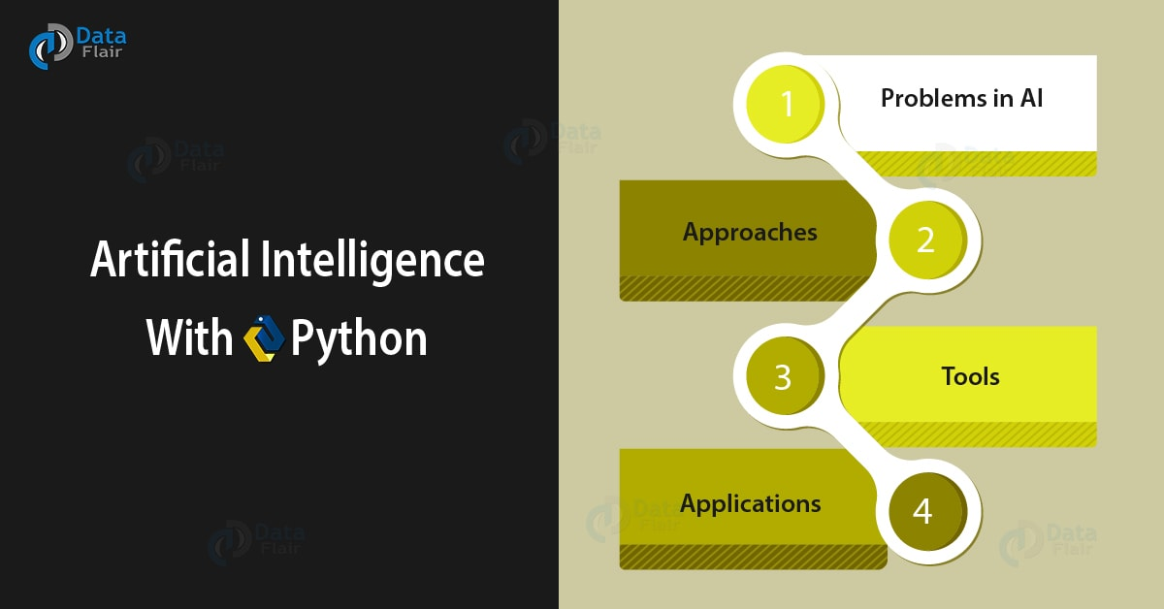
Python AI Tutorial | Artificial Intelligence Programming Python

2. What is Artificial Intelligence?
Artificial Intelligence, often dubbed AI, is the intelligence a machine demonstrates. With machine intelligence, it is possible to give a device the ability to discern its environment and act to maximize its chances of success in achieving its goals. In other words, AI is when a machine can mimic cognitive functions like learning and problem-solving.
“AI is whatever hasn’t been done yet.”
As we said, an AI takes in its environment and acts to maximize its chances of success in achieving its goals. A goal can be simple or complex, explicit or induced. It is also true that many algorithms in AI can learn from data, learn new heuristics to improve and write other algorithms.
Do you know about AI Algorithms
One difference to humans is that AI does not possess the features of human commonsense reasoning and folk psychology. This makes it end up making different mistakes than a human would.

3. Python AI Tutorial – AI Problems
When simulating or creating AI, we may run into problems around the following traits-
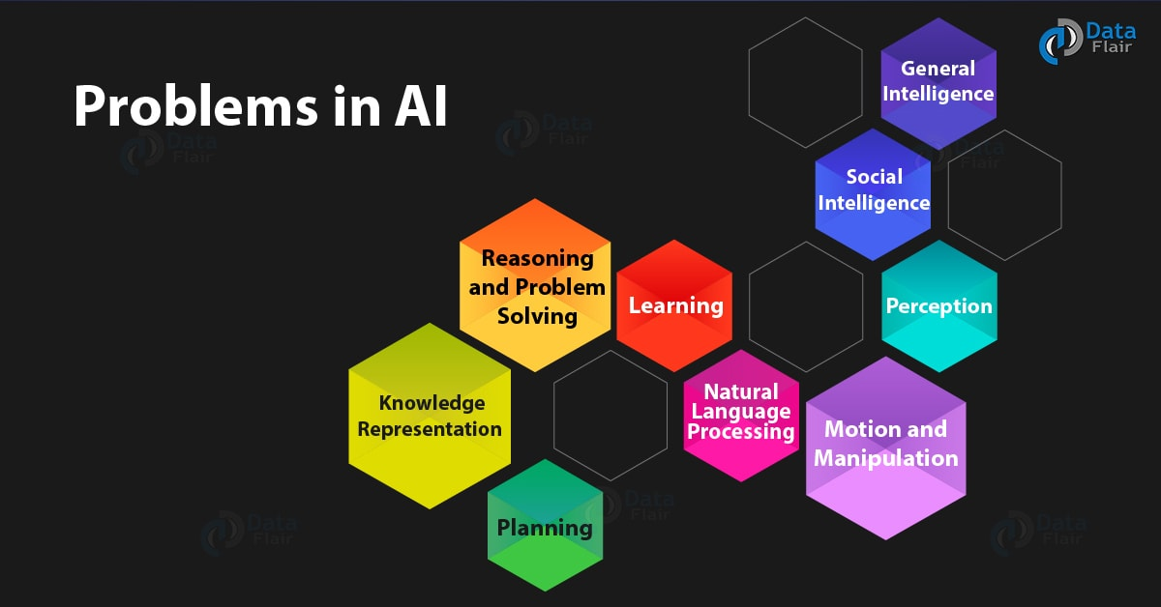
Python AI Tutorial – AI Problems

a. Reasoning and Problem Solving
Earlier, algorithms mimicked step-by-step reasoning that humans display. AI research later introduced methods to work with incomplete and uncertain information. However, as the problems grew larger, these algorithms became exponentially slower. Humans often use fast, intuitive judgments instead of a step-by-step deduction.

b. Knowledge Representation
Some expert systems accumulate esoteric knowledge from experts. A comprehensive commonsense knowledge base holds many things including- objects, properties, categories, relations between objects, situations, events, states, time, causes, effects, knowledge about knowledge, and other domains. When we talk about ontology, we talk about what exists. Under knowledge representation, we observe the following domains-
Have a look at Robotics and Artificial Intelligence
- Default reasoning; Qualification problem
- The breadth of commonsense knowledge
- The subsymbolic form of some commonsense knowledge

c. Planning
An intelligent agent should be capable of setting goals, achieving them, and visualizing the future. Assuming it is the only system in the world, an agent can be certain of their actions’ consequences. If there are more actors, the agent should be able to reason under uncertainty. For this, it should be able to assess its environment, make predictions, evaluate predictions, and adapt according to its assessment. With multi-agent planning, we observe multiple agents cooperate and compete to achieve a goal.

d. Learning
AI is related to Machine Learning in some way. We have often talked about unsupervised learning- the ability to take a stream of input and find patterns in it. This includes classification and numerical regression. We classify things into categories and produce a function that describes how inputs and outputs relate and change each other. These function approximators.

e. Natural Language Processing
NLP is an area of Computer Science that gives machines the ability to read the human language and understand it. With it, we can retrieve information, mine text, answer questions, and translating using machines. We use strategies like keyword spotting and lexical affinity.

f. Perception
With machine perception, we can take input from sensors like cameras, microphones, and lidar to recognize objects. We can use it for applications like speech recognition, facial recognition, and object recognition. We can also analyze visual input with Computer Vision.

g. Motion and Manipulation
With AI, we can develop advanced robotic arms and more for modern factories. These can use the experience to learn to deal with friction and gear slippage. The term Motion Planning means dividing a task into primitives like individual joint movements.

h. Social Intelligence
“Should I go to bed, Siri?”, I ask as I reach home from a busy day. “I think you should sleep on it”, Siri quips back. Affective Computing, an umbrella term, encompasses systems that can recognize, interpret, process, or simulate human affects/ emotions. In this domain, we have observed textual sentiment analysis and multimodal affect analysis. The aim is to allow AI to understand others’ motives and emotional states to predict their actions. It can mimic human emotion and expressions to appear sensitive and interact with humans. A robot with rudimentary social skills is Kismet, developed at MIT by Dr. Cynthia Breazeal.
Do you know expert systems in Artificial Intelligence to Solve Problems

i. General Intelligence
Lately, many AI researchers have begun working on tractable narrow AI applications like a medical diagnosis. The future could hold machines with Artificial General Intelligence(AGI) that combines such narrow skills. Google’s DeepMind will be an example of this.

4. Python AI Tutorial – Approaches
We observe four different approaches to AI-
Python AI Tutorial – Approaches

a. Cybernetics and Brain Simulation
Some machines exist that use electronic networks to display rudimentary intelligence.

b. Symbolic
This approach considers reducing human intelligence to symbolic manipulation. This includes cognitive simulation, logic-based, anti-logic or scruffy, and knowledge-based approaches.

c. Sub-Symbolic
For processes of human cognition like perception, robotics, learning, and pattern recognition, sub-symbolic approaches came into picture. This includes approaches like embodied intelligence and computational intelligence and soft computing.
Let’s discuss Data Science vs AI vs Machine Learning

d. Statistical Learning
Statistical learning techniques like HMM and neural networks deliver better accuracy in practical domains like data mining. Limitations of HMM include that it cannot model the infinite possible combinations of natural language.

5. Python AI Tutorial – Artificial Intelligence Tools
In this section of the Python AI Tutorial, we will study the different tools used in Artificial Intelligence:
Python AI Tutorial – Artificial Intelligence Tools

a. Search and Optimization
To intelligently search through possible solutions and use reasoning to do so is a tool for AI. For real-world problems, simple exhaustive searches rarely suffice. This is because these have really large search spaces. This leads to a slow search or one that never ends. To get around this, we can use heuristics.

b. Logic
AI research uses different forms of logic. Propositional logics use truth functions like ‘or’ and ‘not’. The fuzzy set theory holds a degree of truth (values between 0 and 1) to vague statements. First-order logic adds quantifiers and predicates. Fuzzy logic helps with control systems to contribute vague rules.

c. Probabilistic Methods for Uncertain Reasoning
We often use tools like Bayesian networks for reasoning, learning, planning, and perception. We can also use probabilistic algorithms to filter, predict, smoothen, and explain streams of data.

d. Classifiers and Statistical Learning Methods
Classifiers and controllers work together. Consider an object. If it is shiny, the classifier knows it is a diamond. If it is shiny, the controller picks it up. But before inferring an action, a controller classifies conditions. As a function, a classifier matches patterns to find the closest match. Supervised learning puts each pattern into a predefined class.

e. Artificial Neural Networks
ANNs are collections of nodes that are interconnected- inspired by the huge network of neurons in the human brain.
Python AI Tutorial – Artificial Neural Networks
Under these, we have categories like feedforward neural networks and recurrent neural networks. We will take up ANNs as a separate topic in another tutorial.

f. Evaluating Progress
Since AI is general purpose, there is no way to find out which domains it excels in. Games are a good benchmark to assess progress. Some of these include AlphaGo and StarCraft.

6. Python AI Tutorial – Applications of Artificial Intelligence
Like we said, AI is pretty general-purpose. Here are a few domains it finds use in-
- Automotive
- Healthcare
- Video games
- Military
- Finance and Economics
- Art
- Auditing
- Advertising
Follow the link to learn more about AI Applications
So, this was all in Python AI Tutorial. Hope you like our explanation.

7. Conclusion
Hence, in this Python AI Tutorial, we learned about artificial intelligence. We talked about its problems, approaches, tools, and applications. That’s all for today; we’ll be back with more. Tell us about your experience of Python AI Tutorial in the comments.
Reference
Tags: AI Pythonapplications of artificial intelligenceartificial intelligence programmingArtificial Intelligence ToolsIntroduction to Artificial IntelligenceProblems in AIPython AI ProgrammingPython AI Tutorialwhat is AIWhat is Artificial Intelligence

1 Response
- Comments1
- Pingbacks0

Nichom
March 17, 2019 at 5:14 pm
this web site teaches me a lot, thanks
need more example programs
Reply

Leave a Reply

*
*

This site is protected by reCAPTCHA and the Google Privacy Policy and Terms of Service apply.

Home About us Contact us Terms and Conditions Cancellation and Refund Privacy Policy Disclaimer Blogs Write For Us Careers Success Stories

Python DL – Computational Graphs
Python AI – NLTK
Artificial Intelligence TutorialsPython Tutorials
Python AI Tutorial | Artificial Intelligence Programming Python
❮ Prev
Next ❯

Popular Courses
Hadoop + Spark Course
Big Data Hadoop Course
Spark Scala Course
Apache Flink Course
Python Course

Popular Tutorials
Hadoop Tutorials
Spark Tutorials
Flink Tutorials
Tableau Tutorials
Power BI Tutorials
QlikView Tutorials

Popular Tutorials
Data Science Tutorials
Machine Learning Tutorials
Python Tutorials
R Tutorials
SAS Tutorials
SQL Tutorials
DataFlair © 2020. All Rights Reserved.

We use cookies to provide the best services. By using our site, you comply with our cookies policy. Learn more

Blog Home
- Courses
- Data Science
- Big Data
- Categories
- Interview Questions
- Job Portal
- Write For Us
Blog Home » Artificial Intelligence Tutorials » NLTK Python Tutorial (Natural Language Toolkit)
- 0

NLTK Python Tutorial (Natural Language Toolkit)
by DataFlair Team · Updated ·

1. NLTK Python Tutorial
In our last session, we discussed the NLP Tutorial. Today, in this NLTK Python Tutorial, we will learn to perform Natural Language Processing with NLTK. We will perform tasks like NLTK tokenize, removing stop words, stemming NLTK, lemmatization NLTK, finding synonyms and antonyms, and more.
So, let’s start NLTK Python Tutorial.
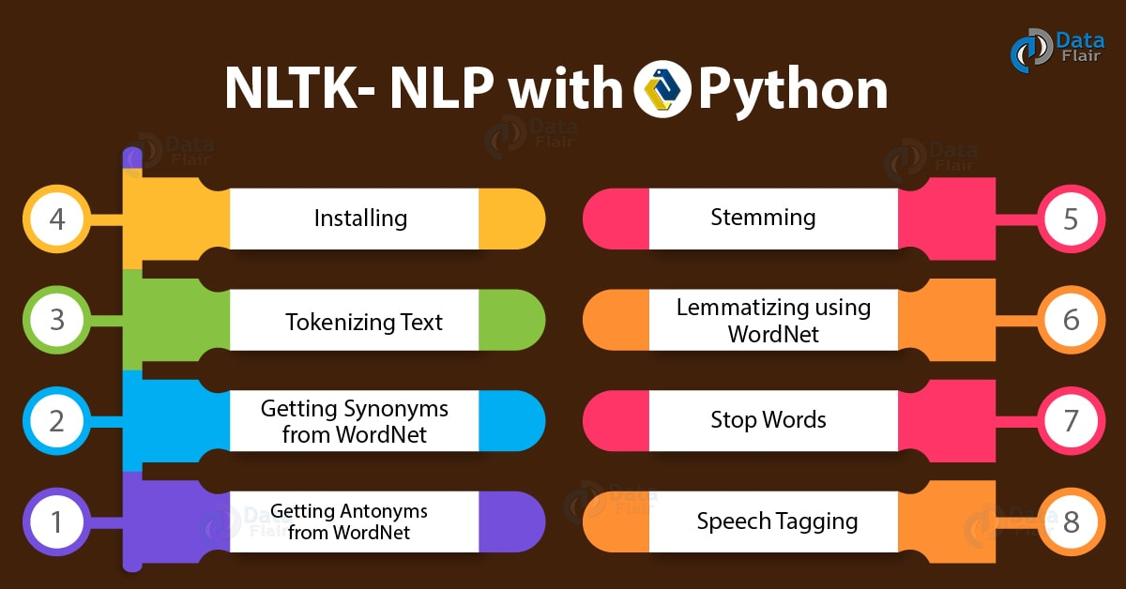
NLTK Python Tutorial (Natural Language Toolkit)

2. What is NLTK?
NLTK stands for Natural Language Toolkit. This is a suite of libraries and programs for symbolic and statistical NLP for English. It ships with graphical demonstrations and sample data. First getting to see the light in 2001, NLTK hopes to support research and teaching in NLP and other areas closely related. These include Artificial Intelligence, empirical linguistics, cognitive science, information retrieval, and Machine Learning.

3. How to Install NLTK?
To install NLTK, you can use Python pip-
- pip install nltk
Then to import it, you can type in the interpreter-
You must know about Python Libraries
- >>> import nltk
Finally, to install packages from NLTK, you need to use its downloader. Try this-
- >>> nltk.download()
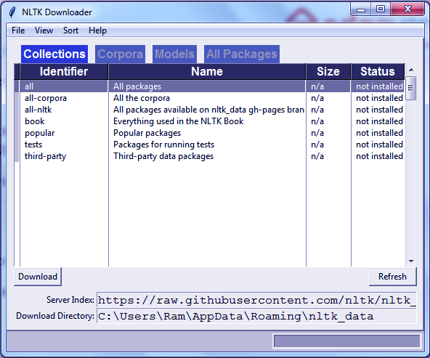
NLTK Python Tutorial – How to Install NLTK?
You can download all packages or choose the ones you wish to download. Explore the ‘All Packages’ tab.
Have a look at Python Packages

4. NLTK Python Tutorial – NLTK Tokenize Text
Before processing the text in NLTK Python Tutorial, you should tokenize it. What we mean is you should split it into smaller parts- paragraphs to sentences, sentences to words. We have two kinds of tokenizers- for sentences and for words.

a. NLTK Sentence Tokenizer
Let’s try tokenizing a sentence.
- >>> text="Today is a great day. It is even better than yesterday. And yesterday was the best day ever."
- >>> from nltk.tokenize import sent_tokenize
- >>> sent_tokenize(text)
[‘Today is a great day.’, ‘It is even better than yesterday.’, ‘And yesterday was the best day ever.’]
Let’s try another? We’ll use an exchange of dialogues this time.
- >>> sent_tokenize("Hi, how are you? I'm good, you? Great!")
[‘Hi, how are you?’, “I’m good, you?”, ‘Great!’]
Okay, one more in NLTK Python Tutorial. How about we use words like Mrs. and Martinez’s in the text? Will the tokenizer be able to catch it?
- >>> nltk.sent_tokenize("Last night, I went to Mrs. Martinez's housewarming. It was a disaster.")
[“Last night, I went to Mrs. Martinez’s housewarming.”, ‘It was a disaster.’]
- Tokenizing for a language other than English-
- >>> sent_tokenize("Enchanté, comment allez-vous? Tres bien. Mersi, et vous?","french")
[‘Enchanté, comment allez-vous?’, ‘Tres bien.’, ‘Mersi, et vous?’]
- Issues while tokenizing-
Do you know about Python NumPy
One issue we face while tokenizing is abbreviations-
- >>> sent_tokenize("She holds an MDS. in Oral Pathology")
[‘She holds an MDS.’, ‘in Oral Pathology’]
Whoops! That was supposed to be one complete sentence it split into two.

b. NLTK Word Tokenizer
First, let’s tokenize text in NLTK Python Tutorial.
- >>> nltk.word_tokenize(text)
[‘Today’, ‘is’, ‘a’, ‘great’, ‘day’, ‘.’, ‘It’, ‘is’, ‘even’, ‘better’, ‘than’, ‘yesterday’, ‘.’, ‘And’, ‘yesterday’, ‘was’, ‘the’, ‘best’, ‘day’, ‘ever’, ‘.’]
Now, let’s try it for Mrs. Martinez’s housewarming.
- >>> nltk.word_tokenize("Last night, I went to Mrs. Martinez's housewarming. It was a disaster.")
[‘Last’, ‘night’, ‘,’, ‘I’, ‘went’, ‘to’, ‘Mrs.’, ‘Martinez’, “‘s”, ‘housewarming’, ‘.’, ‘It’, ‘was’, ‘a’, ‘disaster’, ‘.’]
Notice how it judged Mrs. to be one word but Martinez’s to be two? NLTK uses PunktSentenceTokenizer for this.
Have a look at Python Charts

5. Find Synonyms From NLTK WordNet
WordNet is an NLP database with synonyms, antonyms, and brief definitions. We downloaded this with the NLTK downloader.
- >>> from nltk.corpus import wordnet
- >>> syn=wordnet.synsets('love')
- >>> syn
[Synset(‘love.n.01’), Synset(‘love.n.02’), Synset(‘beloved.n.01’), Synset(‘love.n.04’), Synset(‘love.n.05’), Synset(‘sexual_love.n.02’), Synset(‘love.v.01’), Synset(‘love.v.02’), Synset(‘love.v.03’), Synset(‘sleep_together.v.01’)]
Let’s choose the first member from this-
- >>> syn[0].definition()
‘a strong positive emotion of regard and affection’
- >>> syn[0].examples()
[‘his love for his work’, ‘children need a lot of love’]
But love isn’t the only thing we’re chasing after. Do you know the meaning of life? 42?
- >>> syn=wordnet.synsets('life')
- >>> syn[0].definition()
‘a characteristic state or mode of living’
- >>> syn[0].examples()
[‘social life’, ‘city life’, ‘real life’]
Nope, still doesn’t answer our questions. But Python does a good job. Okay, one more example.
- >>> syn=wordnet.synsets('AI')
- >>> syn
[Synset(‘army_intelligence.n.01’), Synset(‘artificial_intelligence.n.01’), Synset(‘three-toed_sloth.n.01’), Synset(‘artificial_insemination.n.01’)]
- >>> syn[1].definition()
‘the branch of computer science that deal with writing computer programs that can solve problems creatively’
- >>> syn[1].examples()
[‘workers in AI hope to imitate or duplicate intelligence in computers and robots’]
Let’s revise Python Linear Regression
- To get the list of synonyms:
- >>> synonyms=[]
- >>> for syn in wordnet.synsets('AI'):
- for lemma in syn.lemmas():
- synonyms.append(lemma.name())
- >>> synonyms
[‘Army_Intelligence’, ‘AI’, ‘artificial_intelligence’, ‘AI’, ‘three-toed_sloth’, ‘ai’, ‘Bradypus_tridactylus’, ‘artificial_insemination’, ‘AI’]

6. Find Antonyms From NLTK WordNet
To get the list of antonyms, we first need to check the lemmas- are there antonyms?
- >>> from nltk.corpus import wordnet
- >>> antonyms=[]
- >>> for syn in wordnet.synsets('depressed'):
- for l in syn.lemmas():
- if l.antonyms():
- antonyms.append(l.antonyms()[0].name())
- >>> antonyms
[‘elate’]
One more?
- >>> for syn in wordnet.synsets('ugly'):
- for l in syn.lemmas():
- if l.antonyms():
- antonyms.append(l.antonyms()[0].name())
- >>> antonyms
[‘beautiful‘]

7. NLTK Python Tutorial – Stemming NLTK
We have talked of stemming before this. Check Stemming and Lemmatization with Python. Well, stemming involves removing affixes from words and returning the root. Search engines like Google use this to efficiently index pages. The most common algorithm for stemming is the PorterStemmer. Let’s take an example.
- >>> stemmer.stem('loving')
‘love’
- >>> stemmer.stem('trainee')
‘traine’
By now, you have figured we don’t settle for just one example. So here’s more.
- >>> stemmer.stem('syllabi')
‘syllabi’
- >>> stemmer.stem('alibi')
‘alibi’
- >>> stemmer.stem('formulae')
‘formula’
You must read Python Heatmap
- >>> stemmer.stem('criteria')
‘criteria’
- >>> stemmer.stem('believes')
‘believ’
- >>> stemmer.stem('writes')
‘write’
- >>> stemmer.stem('writing')
‘write’
- >>> stemmer.stem('write')
‘write’
NLTK Python Tutorial – Stemming
Other algorithms include Lancaster and Snowball.

a. Stemming Words from Other Languages
- >>> from nltk.stem import SnowballStemmer
- >>> SnowballStemmer.languages
(‘arabic’, ‘danish’, ‘dutch’, ‘english’, ‘finnish’, ‘french’, ‘german’, ‘hungarian’, ‘italian’, ‘norwegian’, ‘porter’, ‘portuguese’, ‘romanian’, ‘russian’, ‘spanish’, ‘swedish’)
- >>> rom_stemmer=SnowballStemmer('romanian')
- >>> rom_stemmer.stem('englezească') #English
‘englez’
- >>> rom_stemmer.stem('cocoș') #Cocks
‘cocoș’
- >>> rom_stemmer.stem('frigidere') #Refrigerators
‘frigid’
Let’s discuss Python Deep Learning
- >>> rom_stemmer.stem('frigider') #Refrigerator
‘frigider’
- >>> rom_stemmer.stem('goi') #Empty- plural
‘goi’
- >>> rom_stemmer.stem('goale') #Empty- plural
‘goal’
- >>> rom_stemmer.stem('frumoasă') #Beautiful- female
‘frumoas’
- >>> rom_stemmer.stem('frumoase') #Beautiful- plural
‘frumoas’
- >>> rom_stemmer.stem('frumoși') #Beautiful- plural
‘frumoș’
Psst., please let us know if you catch an incorrect depiction of the language Romanian!

8. Python NLTK Tutorial – Lemmatizing NLTK Using WordNet
If you noticed, some words that stemming gave us weren’t actual words you could look up in the dictionary. So we come to lemmatizing- this will return real words. Let’s do this too.
Do you know about Python Statistics
- >>> from nltk.stem import WordNetLemmatizer
- >>> lemmatizer=WordNetLemmatizer()
- >>> lemmatizer.lemmatize('believes')
‘belief’
Stemming gave us ‘believ’ for this; lemmatizing gave us ‘belief’. See the clear difference? Where stemming returned ‘thi’, see what lemmatizer gives us:
- >>> lemmatizer.lemmatize('this')
‘this’
With ‘believes’, to work with a verb instead of a noun, use the ‘pos’ argument-
- >>> lemmatizer.lemmatize('believes',pos='v')
‘believe’
And now, how about some adjectives?
- >>> lemmatizer.lemmatize('crossing',pos='a') #adjective
‘crossing’
- >>> lemmatizer.lemmatize('crossing',pos='v') #verb
‘cross’
- >>> lemmatizer.lemmatize('crossing',pos='n') #noun
‘crossing’
- >>> lemmatizer.lemmatize('crossing',pos='r') #adverb
‘crossing’
Since lemmatizing gives us better results within context, it is often slower than stemming.
Let’s take a tour to Python SciPy

9. Python NLTK Tutorial – NLTK Stop Words
We can filter NLTK stop words from text before processing it.
- >>> from nltk.corpus import stopwords
- >>> stopwords.words('english')
[‘i’, ‘me’, ‘my’, ‘myself’, ‘we’, ‘our’, ‘ours’, ‘ourselves’, ‘you’, “you’re”, “you’ve”, “you’ll”, “you’d”, ‘your’, ‘yours’, ‘yourself’, ‘yourselves’, ‘he’, ‘him’, ‘his’, ‘himself’, ‘she’, “she’s”, ‘her’, ‘hers’, ‘herself’, ‘it’, “it’s”, ‘its’, ‘itself’, ‘they’, ‘them’, ‘their’, ‘theirs’, ‘themselves’, ‘what’, ‘which’, ‘who’, ‘whom’, ‘this’, ‘that’, “that’ll”, ‘these’, ‘those’, ‘am’, ‘is’, ‘are’, ‘was’, ‘were’, ‘be’, ‘been’, ‘being’, ‘have’, ‘has’, ‘had’, ‘having’, ‘do’, ‘does’, ‘did’, ‘doing’, ‘a’, ‘an’, ‘the’, ‘and’, ‘but’, ‘if’, ‘or’, ‘because’, ‘as’, ‘until’, ‘while’, ‘of’, ‘at’, ‘by’, ‘for’, ‘with’, ‘about’, ‘against’, ‘between’, ‘into’, ‘through’, ‘during’, ‘before’, ‘after’, ‘above’, ‘below’, ‘to’, ‘from’, ‘up’, ‘down’, ‘in’, ‘out’, ‘on’, ‘off’, ‘over’, ‘under’, ‘again’, ‘further’, ‘then’, ‘once’, ‘here’, ‘there’, ‘when’, ‘where’, ‘why’, ‘how’, ‘all’, ‘any’, ‘both’, ‘each’, ‘few’, ‘more’, ‘most’, ‘other’, ‘some’, ‘such’, ‘no’, ‘nor’, ‘not’, ‘only’, ‘own’, ‘same’, ‘so’, ‘than’, ‘too’, ‘very’, ‘s’, ‘t’, ‘can’, ‘will’, ‘just’, ‘don’, “don’t”, ‘should’, “should’ve”, ‘now’, ‘d’, ‘ll’, ‘m’, ‘o’, ‘re’, ‘ve’, ‘y’, ‘ain’, ‘aren’, “aren’t”, ‘couldn’, “couldn’t”, ‘didn’, “didn’t”, ‘doesn’, “doesn’t”, ‘hadn’, “hadn’t”, ‘hasn’, “hasn’t”, ‘haven’, “haven’t”, ‘isn’, “isn’t”, ‘ma’, ‘mightn’, “mightn’t”, ‘mustn’, “mustn’t”, ‘needn’, “needn’t”, ‘shan’, “shan’t”, ‘shouldn’, “shouldn’t”, ‘wasn’, “wasn’t”, ‘weren’, “weren’t”, ‘won’, “won’t”, ‘wouldn’, “wouldn’t”]
- >>> from nltk.corpus import stopwords
- >>> text="Today is a great day. It is even better than yesterday. And yesterday was the best day ever!"
- >>> stopwords=set(stopwords.words('english'))
- >>> from nltk.tokenize import word_tokenize
- >>> words=word_tokenize(text)
- >>> wordsFiltered=[]
- >>> for w in words:
- if w not in stopwords:
- wordsFiltered.append(w)
- >>> wordsFiltered
[‘Today’, ‘great’, ‘day’, ‘.’, ‘It’, ‘even’, ‘better’, ‘yesterday’, ‘.’, ‘And’, ‘yesterday’, ‘best’, ‘day’, ‘ever’, ‘!’]

10. NLTK Python Tutorial – Speech Tagging
NLTK can classify words as verbs, nouns, adjectives, and more into one of the following classes:
Python NLTK Tutorial – Speech Tagging
- >>> import nltk
- >>> from nltk.tokenize import PunktSentenceTokenizer
- >>> text='I am a human being, capable of doing terrible things'
- >>> sentences=nltk.sent_tokenize(text)
- >>> for sent in sentences:
- print(nltk.pos_tag(nltk.word_tokenize(sent)))
[(‘I’, ‘PRP’), (‘am’, ‘VBP’), (‘a’, ‘DT’), (‘human’, ‘JJ’), (‘being’, ‘VBG’), (‘,’, ‘,’), (‘capable’, ‘JJ’), (‘of’, ‘IN’), (‘doing’, ‘VBG’), (‘terrible’, ‘JJ’), (‘things’, ‘NNS’)]
Let’s revise Python Matplotlib
Match the arguments at position 1 with the table to figure out the output.
So, this was all in NLTK Python Tutorial. Hope you like our explanation.

11. Conclusion – NLTK Python Tutorial
Hence, in this NLTK Python Tutorial, we discussed the basics of Natural Language Processing with Python using NLTK. Moreover, we discussed tokenizing, stemming, lemmatization, finding synonyms and antonyms, speech tagging, and filtering out stop words. Still, if you have any query regarding NLTK Python Tutorial, ask in the comment tab. You can also share your experience of reading this article through comments.
See also –
Python Machine Learning Tutorial
For reference
Tags: find antonymshow to install NLTKInstall NLTKNatural Language Toolkitnlp TutorialNLTK Sentence TokenizerNLTK Stop WordsNLTK Stopwordsnltk tokenizenltk word_tokenizeNLTK WordnetPython pipSpeech TaggingStemming NLTKwhat is nltk

Leave a Reply

*
*

This site is protected by reCAPTCHA and the Google Privacy Policy and Terms of Service apply.

Home About us Contact us Terms and Conditions Cancellation and Refund Privacy Policy Disclaimer Blogs Write For Us Careers Success Stories

Python AI Tutorial
Python AI – Speech Recognition
Artificial Intelligence TutorialsPython Tutorials
NLTK Python Tutorial (Natural Language Toolkit)
❮ Prev
Next ❯

Popular Courses
Hadoop + Spark Course
Big Data Hadoop Course
Spark Scala Course
Apache Flink Course
Python Course

Popular Tutorials
Hadoop Tutorials
Spark Tutorials
Flink Tutorials
Tableau Tutorials
Power BI Tutorials
QlikView Tutorials

Popular Tutorials
Data Science Tutorials
Machine Learning Tutorials
Python Tutorials
R Tutorials
SAS Tutorials
SQL Tutorials
DataFlair © 2020. All Rights Reserved.

We use cookies to provide the best services. By using our site, you comply with our cookies policy. Learn more

Blog Home
- Courses
- Data Science
- Big Data
- Categories
- Interview Questions
- Job Portal
- Write For Us
Blog Home » Artificial Intelligence Tutorials » Python Speech Recognition – Artificial Intelligence
- 4

Python Speech Recognition – Artificial Intelligence
by DataFlair Team · Updated ·

1. Python Speech Recognition
Welcome to our Python Speech Recognition Tutorial. In this tutorial of AI with Python Speech Recognition, we will learn to read an audio file with Python. We will make use of the speech recognition API to perform this task. Moreover, we will discuss reading a segment and dealing with noise.
So, let’s start the Python Speech recognition Tutorial.
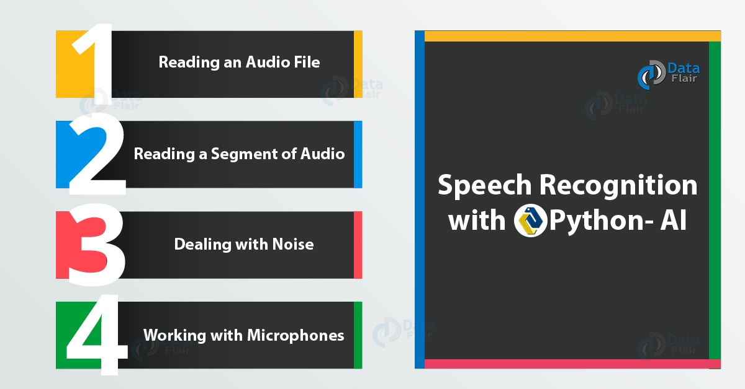
Python Speech Recognition – Artificial Intelligence

2. What is Python Speech Recognition?
From systems facilitating single speakers and limited vocabularies of around a dozen words, to systems that recognize from multiple speakers and possess huge vocabularies in various languages, we have come a long way. What we do here is- we convert speech from physical sound to electrical signals using a microphone. Then, we use an analogue-to-digital converter to convert this to digital data. Finally, we use multiple models to transcribe audio to text. In the Hidden Markov Model (HMM), we divide the speech signal into 10-millisecond fragments.
Do you know about Recursion in Python

a. Available APIs in Python Speech Recognition
With Python, we have several APIs available:
- apiai
- assemblyai
- google-cloud-speech
- pocketsphinx
- SpeechRecognition
- watson-developer-cloud
- wit
Some Python packages like wit and apiai offer more than just basic speech recognition. Here, though, we will demonstrate SpeechRecognition, which is easier to use. This hard-codes a default API key for the Google Web Speech API.

b. Supported File Types in Python Speech Recognition
- WAV- PCM/LPCM format
- AIFF
- AIFF-C
- FLAC

c. Prerequisites for Python Speech Recognition
You can use pip to install this-
pip install SpeechRecognition
To test the installation, you can import this in the interpreter and check the version-
- >>> import speech_recognition as sr
- >>> sr.__version__
‘3.8.1’
We also download a sample audio from here-
http://www.voiptroubleshooter.com/open_speech/american.html

3. Reading an Audio File in Python

a. The Recognizer class
First, we make an instance of the Recognizer class.
- >>> r=sr.Recognizer()
With Recognizer, we have a method for each API-
- recognize_bing()- Microsoft Bing Speech
- recognize_google()- Google Web Speech API
- recognize_google_cloud()- Google Cloud Speech
- recognize_houndify()- Houndify
- recognize_ibm()- IBM Speech to Text
- recognize_sphinx- CMU Sphinx
- recognize_wit()- Wit.ai
Exempting recognize_sphinx(), you need an Internet connection for anything else you’re working with.
You must read the Python web framework

b. Capturing data with record()
We can have the context manager open the file and read its contents, then record it into an AudioData instance.
- >>> demo=sr.AudioFile('demo.wav')
- >>> with demo as source:
- audio=r.record(source)
To confirm this, try:
- >>> type(audio)
<class ‘speech_recognition.AudioData’>

c. Recognizing Speech in the Audio
Finally, you can call recognize_google() to perform the transcription.
- >>> r.recognize_google(audio)
“The Purge can use within The Smurfs the sheet without playback Mount delivery date habitat of a Vow these days it’s okay microwave devices are installed in Windows to use of lemons next find the password on the site that the houses such hard core in a garbage for the study core exercises talking is hard disk”
Well, you can read audio of a different language using the language parameter-
- r.recognize_google(audio,language='ro-RO') #for Romanian

4. Reading a Segment of Audio
When you only want to read a part of your audio file, you can use the arguments offset– telling it where to begin (in seconds), and duration– telling it how long to listen.
Let’s take a tour of Python Datetime Module
- >>> with demo as source:
- audio=r.record(source,offset=4,duration=3)
- >>> r.recognize_google(audio)
‘clear the sheet without me back’
Note that this caused issues at the extremes. It heard ‘murfs’, which it translated to ‘clear’. It also heard ‘me back’ instead of ‘playback’ because of the noise in the audio.
If we set the offset to 3.3,
- >>> with demo as source:
- audio=r.record(source,offset=3.3,duration=3)
- >>> r.recognize_google(audio)
‘clear the sheet with Ok’
But check what happens when we set the offset to 2.5-
- >>> with demo as source:
- audio=r.record(source,offset=2.5,duration=3)
- >>> r.recognize_google(audio)
‘National thanks’

5. Python Speech Recognition – Dealing with Noise
Okay, let’s face it. There will always be noise, no matter how professional appliances you use to record your audio. So let’s better learn to deal with it. The method adjust_for_ambient_noise() reads the first second of a file stream to calibrate the recognizer to the audio’s noise level. This often consumes that part of the audio, and it doesn’t make it to the transcription.
Do you know about Python Property
- >>> with demo as source:
- r.adjust_for_ambient_noise(source)
- audio=r.record(source,offset=2.5,duration=3)
- >>> r.recognize_google(audio)
‘clear the sheet’
We can provide this an argument for how long it should listen for noise so it can calibrate the recognizer. Let’s see how it produces two entirely different outputs for a difference as low as 0.005-
- >>> with demo as source:
- r.adjust_for_ambient_noise(source,duration=0.51)
- audio=r.record(source,offset=2.5,duration=3)
- >>> r.recognize_google(audio)
‘National thanks’
- >>> with demo as source:
- r.adjust_for_ambient_noise(source,duration=0.515)
- audio=r.record(source,offset=2.5,duration=3)
- >>> r.recognize_google(audio)
‘clear the sheet’
As you can see, adjust_for_ambient_noise() is definitely not a miracle worker. To get around this, you can use an audio-editing software like Audacity to preprocess the audio.

6. Working With Microphones
To be able to work with your own voice with speech recognition, you need the PyAudio package. You can install it with pip-
pip install PyAudio
Or you can download and install the binaries with pip. Download link-
https://www.lfd.uci.edu/~gohlke/pythonlibs/#pyaudio
Then:
pip install [file_name_for_binary]
For example:
pip install PyAudio-0.2.11-cp37-cp37m-win32.whl

a. The Microphone class
Like Recognizer for audio files, we will need Microphone for real-time speech data. Since we installed new packages, let’s exit our interpreter and open another session.
- >>> import speech_recognition as sr
- >>> r=sr.Recognizer()
Now, let’s create an instance of Microphone.
- >>> mic=sr.Microphone()
Microphone has a static method to list out all microphones available-
- >>> sr.Microphone.list_microphone_names()
[‘Microsoft Sound Mapper – Input’, ‘Microphone (Realtek High Defini’, ‘Microsoft Sound Mapper – Output’, ‘Speakers (Realtek High Definiti’, ‘Primary Sound Capture Driver’, ‘Microphone (Realtek High Definition Audio)’, ‘Primary Sound Driver’, ‘Speakers (Realtek High Definition Audio)’, ‘Speakers (Realtek High Definition Audio)’, ‘Microphone (Realtek High Definition Audio)’, ‘Speakers (Realtek HD Audio output)’, ‘Line In (Realtek HD Audio Line input)’, ‘Microphone (Realtek HD Audio Mic input)’, ‘Stereo Mix (Realtek HD Audio Stereo input)’]
Now it is possible to select a certain microphone by its device index with likes of the following piece of code-
- >>> mic=sr.Microphone(device_index=3)
But let’s stick with the default for now.
Get the best guide for Python Career

b. Capturing Microphone Input
With the context manager, we capture input using the listen() method.
- >>> with mic as source:
- audio=r.listen(source)
You shall now speak into your microphone. When it detects silence, it stops listening. It then displays the interpreter prompt (>>>).
- >>> r.recognize_google(audio)
decease a test
You can call the adjust_for_ambient_noise() method with Microphone too.
- >>> with mic as source:
- r.adjust_for_ambient_noise(source)
- audio=r.listen(source)
- >>> r.recognize_google(audio)
this is a test

c. Unintelligible Speech
When Python cannot match some audio to text, it raises an UnknownValueError exception.
Get prepare yourself for upcoming Python Interview
- >>> r.recognize_google(audio)
Traceback (most recent call last):
File “<pyshell#7>”, line 1, in <module>
r.recognize_google(audio)
File “C:\Users\Ram\AppData\Local\Programs\Python\Python37-32\lib\site-packages\speech_recognition\__init__.py”, line 858, in recognize_google
if not isinstance(actual_result, dict) or len(actual_result.get(“alternative”, [])) == 0: raise UnknownValueError()
speech_recognition.UnknownValueError
Some pieces of audio that would lead to this will be- coughing sounds, gagging sounds, hand claps, and tongue clicks.
So, this was all in Python Speech Recognition. Hope you like our explanation.

7. Conclusion – Python Speech Recognition
Did you see how easy it was to recognize speech with Python? The APIs made it possible. Well, why we stuffed this into the AI tutorial doesn’t need explanation. Python Speech recognition forms an integral part of Artificial Intelligence. What would Siri or Alexa be without it?. So, in conclusion to this Python Speech Recognition, we discussed Speech Recognition API to read an Audio file in Python. Moreover, we saw reading a segment and dealing with noise in Speech Recognition Python tutorial. You can freely tell us the reading experience of this article through comments.
See also –
Python Interview Questions and Answers
For reference
Tags: google speech recognition Pythonhow to convert speech to text in PythonPython speech RecognitionPython voice recognitionPython with AIspeech recognition

4 Responses
- Comments4
- Pingbacks0

Ustadhi Mustafa
January 8, 2020 at 12:24 pm
Thanks, My first successful project.
Reply
  - DataFlair Team
January 8, 2020 at 12:58 pm
Hey Ustadhi Mustafa,
We are happy to help you. You can also refer our sidebar for more such interesting articles.
Reply

- Sijin John
February 25, 2020 at 11:41 am
Its is giving only half text of my audio
Reply
- ramesh
March 10, 2020 at 8:09 pm
i went clear explin
Reply

Leave a Reply

*
*

This site is protected by reCAPTCHA and the Google Privacy Policy and Terms of Service apply.

Home About us Contact us Terms and Conditions Cancellation and Refund Privacy Policy Disclaimer Blogs Write For Us Careers Success Stories

Python AI – NLTK
Python AI – NLP Tutorial
Artificial Intelligence TutorialsPython Tutorials
Python Speech Recognition – Artificial Intelligence
❮ Prev
Next ❯

Popular Courses
Hadoop + Spark Course
Big Data Hadoop Course
Spark Scala Course
Apache Flink Course
Python Course

Popular Tutorials
Hadoop Tutorials
Spark Tutorials
Flink Tutorials
Tableau Tutorials
Power BI Tutorials
QlikView Tutorials

Popular Tutorials
Data Science Tutorials
Machine Learning Tutorials
Python Tutorials
R Tutorials
SAS Tutorials
SQL Tutorials
DataFlair © 2020. All Rights Reserved.

We use cookies to provide the best services. By using our site, you comply with our cookies policy. Learn more

Blog Home
- Courses
- Data Science
- Big Data
- Categories
- Interview Questions
- Job Portal
- Write For Us
Blog Home » Artificial Intelligence Tutorials » NLP Tutorial AI with Python | Natural Language Processing
- 1

NLP Tutorial AI with Python | Natural Language Processing
by DataFlair Team · Updated ·

1. NLP Tutorial – Objective
Today, in our journey of Artificial Intelligence with Python, we will discuss NLP Tutorial, we will discuss the rudiments of Natural Language Processing. We will start our NLP tutorial with NLP definition and a brief introduction. Then, we will move towards components, libraries, and benefits of natural processing language. Also, we will discuss Natural Language Processing Applications, NLP examples, and tools.
So, let’s start NLP Tutorial.
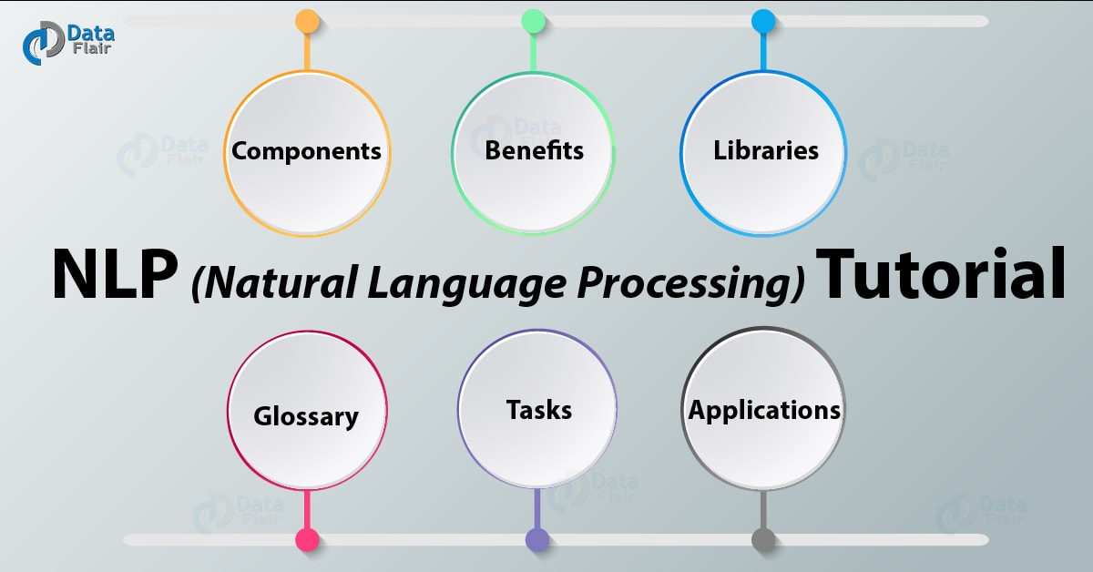
NLP Tutorial AI with Python | Natural Language Processing

2. Introduction to Natural Language Processing
Natural Language Processing is casually dubbed NLP. It is a field of AI that deals with how computers and humans interact and how to program computers to process and analyze huge amounts of natural language data. This faces some challenges like speech recognition, natural language understanding, and natural language generation.
Let’s have a look at Python AI Tutorial
Well, NLP is all about developing applications and services that can understand human languages.

3. NLP Tutorial – What is NLP?
In layman terms, NLP is a way for computers to analyze human language and derive useful meaning from it. It lets you organize and structure knowledge to let you perform the following tasks-
- Automatic Summarization
- Translation
- Named Entity Recognition
- Relationship Extraction
- Sentiment Analysis
- Speech Recognition
- Topic Segmentation
NLP analyzes text and allows machines to understand how we speak. It considers the hierarchical structure of language and performs tasks like correcting the grammar, converting speech to text, and translating between languages. In computer science, it is a hard problem.
Have a look at Neural Network in Artificial Intelligence
“What do words mean, how do they link together, and what meaning do they make?”
The greatest challenge to NLP is to accurately judge the intention of words keeping in mind the ambiguity of the language.

4. NLP Tutorial – Components of NLP
While talking of NLP in NLP Tutorial, we come across two main Components of NLP-
NLP Tutorial – Components of NLP

a. Natural Language Understanding (NLU)
Natural Language Understanding revolves around machine reading comprehension. This is an AI-hard problem. An NLU system needs the following components-
- Lexicon, Parser, and Grammar rules.
- Semantic theory- to guide comprehension.

b. Natural Language Generation (NLG)
NLG is concerned with generating natural language. It uses a machine representation system like a knowledge base or a logical form. You can think of it as a translator between data and natural language representation; this is the opposite or NLU. This involves three tasks-
- Text Planning- To extract relevant content from the knowledge base.
- Sentence Planning- To choose appropriate words, form meaningful phrases, and set sentence tone.
- Text Realization- To map the sentence plan into sentence structure.

5. NLP Tutorial – Benefits of NLP
Among the numerous benefits of NLP, here, we list out a few-
- To improve the efficiency of the documentation process.
- NLP is used to improve the accuracy of the documentation process.
- To identify pertinent information from large databases.
Together with Machine Learning, we don’t need to hand-code large sets of rules.

6. NLP Tutorial – Libraries for NLP
Many open-source libraries let us work with Natural Language Programming. Some of those are-
- Natural Language ToolKit (NLTK)- Written in Python; allows modules for processing text, classifying, tokenizing, stemming, parsing, tagging, and more.
- Apache OpenNLP- Machine Learning toolkit; allows for tokenizers, sentence segmentation, part-of-speech tagging, chunking, parsing, named entity extraction, and more.
- Stanford NLP Suite- Tools for part-of-speech tagging, named entity recognizer, sentiment analysis, conference resolution system, and more.
- Gate NLP Library.
- MALLET- Java package for latent dirichlet allocation, clustering, topic modeling, information extraction, document classification, and more.

7. NLP Tutorial – Glossary in NLP
Talking of NLP, we talk:
NLP Tutorial – Glossary in NLP
a. Phonology
Study of organizing sound systematically.
b. Morphology
Study of constructing words from primitive meaningful units.
c. Morpheme
Primitive unit of meaning in a language.
d. Syntax
Arranging words to form a sentence; determining the structural role of words in sentences and phrases.
e. Semantics
Studying the meanings of words and combining them to make meaningful phrases and sentences.
f. Pragmatics
Using and understanding sentences in various situations; determining how this affects sentence interpretation.
g. Discourse
Understanding how a sentence can affect the next.
h. World Knowledge
General knowledge about the world.
Do you know about Search Algorithms in Artificial Intelligence

8. NLP Tutorial – Tasks in NLP
With Natural Language Processing, we carry out five different tasks-
NLP Tutorial – Tasks in NLP

a. Lexical Analysis
Lexical analysis deals with identifying and analyzing word structure. We divide the whole chunk of text into paragraphs, sentences, and words.

b. Syntactic Analysis
Also called parsing, it involves analyzing words in sentences for grammar and rearranging them to determine how they relate to each other. It rejects sentences like “The apple eats the girl”.

c. Semantic Analysis
This deals with extracting the dictionary meanings from text. It also maps syntactic structures and objects in the task domain to check for meaningfulness. It rejects statements like “tall stub”.

d. Discourse Integration
It analyzes the previous sentence to guess the meaning of the current sentence and the one after it.

e. Pragmatic Analysis
This reinterprets the statement to ensure it determines correctly what the statement means. It tries to retrieve aspects of the language that requires knowledge of the real world.
Have a look at Python Machine Learning Tutorial

9. NLP Tutorial – NLP Applications
With NLP, we can do the following-
- Summarizing blocks of text.
- Creating chatbots.
- Machine translation.
- Fighting spam.
- Extracting information.
- Automatically generating keyword tags.
- Identifying types of entities extracted.
- Identifying the sentiment of a string with sentiment analysis.
- Reducing words to their roots.
- Summarizing.
- Question-answering.
- Customer service.
- Market analysis.
So, this was all in NLP Tutorial. Hope you like our explanation of Natural Processing Language.

10. Conclusion: NLP Tutorial
And with this, we conclude our introduction to Natural Language Processing with Python. In this Natural language Processing Tutorial, we discussed NLP Definition, AI natural language processing, and example of NLP. Moreover, we talked about its fundamentals, components, benefits, libraries, terminologies, tasks, and applications. Next, we will demonstrate the use of NLTK to implement NLP with Python. Still, if any doubt regarding NLP Tutorial, ask in the comment tab.
For reference
Tags: ai natural language processingbenefits of nlpcomponents of nlpnatural language processingnlpnlp applicationsnlp examplesnlp in artificial intelligencenlp natural language processingnlp Pythonnlp tasksnlp technologynlp with Pythonwhat is nlp

1 Response
- Comments1
- Pingbacks0

Indrajeet
December 18, 2019 at 7:08 pm
This is excellent. Can an example of NLTK of log data analysis and get similar type of logs and search logs by giving some words or phrase or sentence as input will be great.
Reply

Leave a Reply

*
*

This site is protected by reCAPTCHA and the Google Privacy Policy and Terms of Service apply.

Home About us Contact us Terms and Conditions Cancellation and Refund Privacy Policy Disclaimer Blogs Write For Us Careers Success Stories

Python AI – Speech Recognition
Python AI – Heuristic Search
Artificial Intelligence TutorialsPython Tutorials
NLP Tutorial AI with Python | Natural Language Processing
❮ Prev
Next ❯

Popular Courses
Hadoop + Spark Course
Big Data Hadoop Course
Spark Scala Course
Apache Flink Course
Python Course

Popular Tutorials
Hadoop Tutorials
Spark Tutorials
Flink Tutorials
Tableau Tutorials
Power BI Tutorials
QlikView Tutorials

Popular Tutorials
Data Science Tutorials
Machine Learning Tutorials
Python Tutorials
R Tutorials
SAS Tutorials
SQL Tutorials
DataFlair © 2020. All Rights Reserved.

We use cookies to provide the best services. By using our site, you comply with our cookies policy. Learn more

Blog Home
- Courses
- Data Science
- Big Data
- Categories
- Interview Questions
- Job Portal
- Write For Us
Blog Home » Artificial Intelligence Tutorials » What is Heuristic Search – Techniques & Hill Climbing in AI
- 3

What is Heuristic Search – Techniques & Hill Climbing in AI
by DataFlair Team · Updated ·

1. Objective – Heuristic Search
In this Python AI tutorial, we will discuss the rudiments of Heuristic Search, which is an integral part of Artificial Intelligence. We will talk about different techniques like Constraint Satisfaction Problems, Hill Climbing, and Simulated Annealing. Also, we will implement CSP in Python.
So, let’s begin Heuristic Search in AI Tutorial.
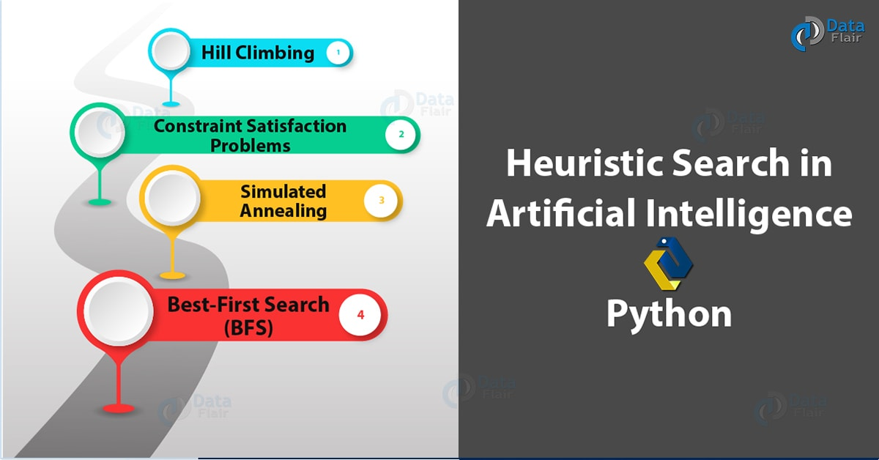
Heuristic Search in Artificial Intelligence – Python
First, let’s revise the Artificial Intelligence Tutorial

2. What is a Heuristic Search?
A Heuristic is a technique to solve a problem faster than classic methods, or to find an approximate solution when classic methods cannot. This is a kind of a shortcut as we often trade one of optimality, completeness, accuracy, or precision for speed. A Heuristic (or a heuristic function) takes a look at search algorithms. At each branching step, it evaluates the available information and makes a decision on which branch to follow. It does so by ranking alternatives. The Heuristic is any device that is often effective but will not guarantee work in every case.
You must take a look at NLP Tutorial
So why do we need heuristics? One reason is to produce, in a reasonable amount of time, a solution that is good enough for the problem in question. It doesn’t have to be the best- an approximate solution will do since this is fast enough. Most problems are exponential. Heuristic Search let us reduce this to a rather polynomial number. We use this in AI because we can put it to use in situations where we can’t find known algorithms.
We can say Heuristic Techniques are weak methods because they are vulnerable to combinatorial explosion.

3. Heuristic Search Techniques in Artificial Intelligence
Briefly, we can taxonomize such techniques of Heuristic into two categories:
Heuristic Search Techniques in Artificial Intelligence

a. Direct Heuristic Search Techniques in AI
Other names for these are Blind Search, Uninformed Search, and Blind Control Strategy. These aren’t always possible since they demand much time or memory. They search the entire state space for a solution and use an arbitrary ordering of operations. Examples of these are Breadth First Search (BFS) and Depth First Search (DFS).
Do you know about NLTK Python

b. Weak Heuristic Search Techniques in AI
Other names for these are Informed Search, Heuristic Search, and Heuristic Control Strategy. These are effective if applied correctly to the right types of tasks and usually demand domain-specific information. We need this extra information to compute preference among child nodes to explore and expand. Each node has a heuristic function associated with it. Examples are Best First Search (BFS) and A*.
Before we move on to describe certain techniques, let’s first take a look at the ones we generally observe. Below, we name a few.
- Best-First Search
- A* Search
- Bidirectional Search
- Tabu Search
- Beam Search
- Simulated Annealing
- Hill Climbing
- Constraint Satisfaction Problems

4. Hill Climbing in Artifical Intelligence
First, let’s talk about Hill Climbing in Artifical Intelligence. This is a heuristic for optimizing problems mathematically. We need to choose values from the input to maximize or minimize a real function. It is okay if the solution isn’t the global optimal maximum.
Heuristic Search Techniques – Hill Climbing
Let’s discuss Python Speech Recognition
One such example of Hill Climbing will be the widely discussed Travelling Salesman Problem- one where we must minimize the distance he travels.

a. Features of Hill Climbing in AI
Let’s discuss some of the features of this algorithm (Hill Climbing):
- It is a variant of the generate-and-test algorithm
- It makes use of the greedy approach
This means it keeps generating possible solutions until it finds the expected solution, and moves only in the direction which optimizes the cost function for it.

b. Types of Hill Climbing in AI
Heuristic Search – Types of Hill Climbing in Artifical Intelligence
- Simple Hill Climbing- This examines one neighboring node at a time and selects the first one that optimizes the current cost to be the next node.
- Steepest Ascent Hill Climbing- This examines all neighboring nodes and selects the one closest to the solution state.
- Stochastic Hill Climbing- This selects a neighboring node at random and decides whether to move to it or examine another.
Let’s revise Python Unit testing
Let’s take a look at the algorithm for simple hill climbing.
- Evaluate initial state- if goal state, stop and return success. Else, make initial state current.
- Loop until the solution reached or until no new operators left to apply to current state:
a. Select new operator to apply to the current producing new state.
b. Evaluate new state:
- If a goal state, stop and return success.
- If better than the current state, make it current state, proceed.
- Even if not better than the current state, continue until the solution reached.
- Exit.

c. Problems with Hill Climbing in AI
We usually run into one of three issues-
- Local Maximum- All neighboring states have values worse than the current. The greedy approach means we won’t be moving to a worse state. This terminates the process even though there may have been a better solution. As a workaround, we use backtracking.
- Plateau- All neighbors to it have the same value. This makes it impossible to choose a direction. To avoid this, we randomly make a big jump.
- Ridge- At a ridge, movement in all possible directions is downward. This makes it look like a peak and terminates the process. To avoid this, we may use two or more rules before testing.
Do you know about Python Assert Statements

5. Constraint Satisfaction Problems (CSP)
A constraint is nothing but a limitation or a restriction. Working with AI, we may need to satisfy some constraints to solve problems. Let’s try solving a problem this way, shall we?
Let’s talk of a magic square. This is a sequence of numbers- usually integers- arranged in a square grid. The numbers in each row, each column, and each diagonal all add up to a constant which we call the Magic Constant. Let’s implement this with Python.
- def magic_square(matrix):
- size=len(matrix[0])
- sum_list=[]
- for col in range(size): #Vertical sum
- sum_list.append(sum(row[col] for row in matrix))
- sum_list.extend([sum(lines) for lines in matrix])#Horizontal sum
- result1=0
- for i in range(0,size):
- result1+=matrix[i][i]
- sum_list.append(result1)
- result2=0
- for i in range(size-1,-1,-1):
- result2+=matrix[i][i]
- sum_list.append(result2)
- if len(set(sum_list))>1:
- return False
- return True
Now let’s run this code.
- >>> magic_square([[1,2,3],[4,5,6],[7,8,9]])
False
This is not a magic square. The numbers in the rows/columns/diagonals do not add up to the same value. Let’s try another list of lists.
Have a look at AI Neural Networks
- >>> magic_square([[2,7,6],[9,5,1],[4,3,8]])
True
Heuristic Search – Magic
Since the values add up to the constant 15 in all directions, surely, this is a magic square!

6. Simulated Annealing Heuristic Search
In metallurgy, when we slow-cool metals to pull them down to a state of low energy gives them exemplary amounts of strength. We call this annealing. While high temperatures observe much random movement, low temperatures notice little randomness.
In AI, we take a cue from this to produce something called simulated annealing. This is a way of optimization where we begin with a random search at a high temperature and reduce the temperature slowly. Eventually, as the temperature approaches zero, the search becomes pure greedy descent. At each step, this processes randomly selects a variable and a value. It accepts the assignment only when it is an improvement or doesn’t lead to more conflict. If not, it checks if the temperature is much worse than the current assignment to accept the assignment with some probability.
Do you know about Python ternary Operators
An annealing schedule defines how the temperature drops as the search progress. A very common schedule is geometric cooling. If we begin with a temperature of 10 and multiply by 0.97 after every step, then after 100 steps, we’re left with a temperature of 0.48.

7. Best-First Search (BFS) Heuristic Search
Often dubbed BFS, Best First Search is an informed search that uses an evaluation function to decide which adjacent is the most promising before it can continue to explore. Breadth- and Depth- First Searches blindly explore paths without keeping a cost function in mind. Things aren’t the same with BFS, though. Here, we use a priority queue to store node costs. Let’s understand BFS Heuristic Search through pseudocode.
- Define list OPEN with single node s– the start node.
- IF list is empty, return failure.
- Remove node n (node with best score) from list, move it to list CLOSED.
- Expand node n.
- IF any successor to n is the goal node, return success and trace path from goal node to s to return the solution.
- FOR each successor node:
- Apply evaluation function f.
- IF the node isn’t in either list, add it to list OPEN.
- Loop to step 2.
Let’s learn about Python Slice
So, this was all in Heuristic Search Techniques in AI. Hope you like our explanation.

8. Conclusion – Heuristic Search Techniques
Hence, in this Python AI tutorial, we discussed the Heuristic Search in AI. While we named a few techniques that fall under that, we also discussed, in brief, those like BFS, Hill Climbing, Simulated Annealing, and CSP. We also implemented CSP in Python. Still, if you have any query in Heuristic Search Techniques, feel free to ask in the comment tab.
See also –
Copy in Python
For reference
Tags: heuristic functionHeuristic Searchheuristic search algorithmheuristic search in aiheuristic search techniquesHeuristic search typesheuristic techniquesproperties of Heuristic function

3 Responses
- Comments3
- Pingbacks0

USMAN KHAN
September 5, 2018 at 1:01 pm
How to solve shuffled frog leaping algorithm (SFLA) through python ,i am asking about implementation of coding SFLA in python?
Reply
- laraib
May 20, 2019 at 10:09 am
explanation was too good
Reply
- Nish
April 19, 2020 at 6:21 pm
Why the hell you people can’t let the reader concentrate?, popping up completely out of the subject topics in between!! WHEN You can give them at the bottom of the page!
Reply

Leave a Reply

*
*

This site is protected by reCAPTCHA and the Google Privacy Policy and Terms of Service apply.

Home About us Contact us Terms and Conditions Cancellation and Refund Privacy Policy Disclaimer Blogs Write For Us Careers Success Stories

Python AI – NLP Tutorial
Python AI – Genetic Algorithms
Artificial Intelligence TutorialsPython Tutorials
What is Heuristic Search – Techniques & Hill Climbing in AI
❮ Prev
Next ❯

Popular Courses
Hadoop + Spark Course
Big Data Hadoop Course
Spark Scala Course
Apache Flink Course
Python Course

Popular Tutorials
Hadoop Tutorials
Spark Tutorials
Flink Tutorials
Tableau Tutorials
Power BI Tutorials
QlikView Tutorials

Popular Tutorials
Data Science Tutorials
Machine Learning Tutorials
Python Tutorials
R Tutorials
SAS Tutorials
SQL Tutorials
DataFlair © 2020. All Rights Reserved.

We use cookies to provide the best services. By using our site, you comply with our cookies policy. Learn more

Blog Home
- Courses
- Data Science
- Big Data
- Categories
- Interview Questions
- Job Portal
- Write For Us
Blog Home » Artificial Intelligence Tutorials » Python Genetic Algorithms With Artificial Intelligence
- 0

Python Genetic Algorithms With Artificial Intelligence
by DataFlair Team · Updated ·

1. Objective – Python Genetic Algorithms
In our last Python AI tutorial, we discussed AI Python Logic Programming. Today, we will see AI Python Genetic Algorithms. In this Python Genetic Algorithms tutorial, we will learn the actual meaning of the Genetic Algorithm. Also, we will look at the benefits, limitations, and applications of Genetic Algorithms with Python. At last, we will see Python Genetic Algorithm example.
So, let’s start the Python Genetic Algorithms tutorial.
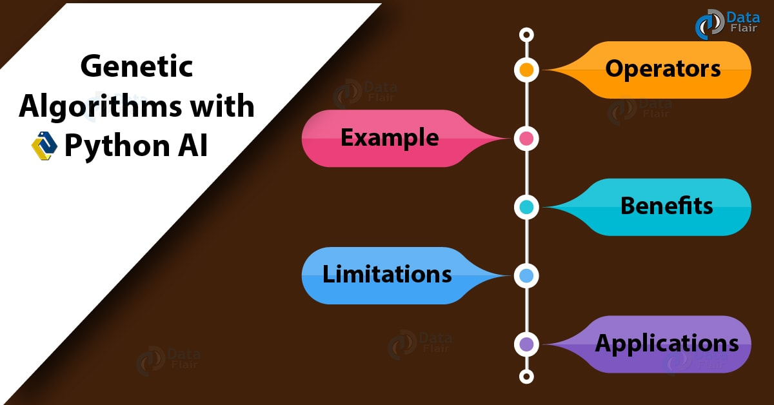
Python Genetic Algorithms With AI

2. What are Genetic Algorithms With Python?
A Genetic Algorithm (GA) is a metaheuristic inspired by natural selection and is a part of the class of Evolutionary Algorithms (EA). We use these to generate high-quality solutions to optimization and search problems, for which, these use bio-inspired operators like mutation, crossover, and selection. In other words, using these, we hope to achieve optimal or near-optimal solutions to difficult problems. Such algorithms simulate natural selection.
Have a look at Python Machine Learning Algorithms
For any problem, we have a pool of possible solutions. These undergo processes like recombination and mutation to bear new children over generations. The search space is the set of all possible solutions and values the inputs may take. In optimization, we try to find within this search space the point or set of points that gives us the optimal solution. Each individual is like a string of characters/integers/floats and the strings are like chromosomes.
What are Genetic Algorithms With Python
The fitness value (from a fitness function) for a candidate tells us how close it is to the optimal solution. This is on the lines of Darwin’s theory of ‘Survival of the Fittest’ and is how we keep producing better (evolving) individuals/ solutions over generations before reaching a criterion where to stop. These algorithms work in four steps:
- Individuals in population compete for resources, mate
- Fittest individuals mate to create more offsprings than others
- Fittest parent propagates genes through generation; parents may produce offsprings better than either parent
- Each successive generation evolves to suit its ambience
Since the population size is constant, some individuals must die to make room for newer ones. We arrive at a situation of convergence when the difference between offsprings produced by the current and ancestral populations is no longer significant. Then, the algorithm converges to a set of solutions for the problem.
Do you know about Python NLTK

3. Operators of Python Genetic Algorithms
To evolve through the generations, an algorithm may make use of one of many operators. Some of those are:
Operators in Python Genetic Algorithms

a. Selection Operator
It prefers individuals with better fitness scores and lets them pass genes on to successive generations.

b. Crossover Operator
This lets individuals mate. We apply the selection operator to select two individuals, and randomly choose crossover sites. We then exchange the genes at these sites- this produces an entirely new individual.
Crossover Operator in Python Genetic Algorithms
You must know about Python Ternary Operators

c. Mutation Operator
In mutation, we insert random genes in offsprings to maintain diversity and avoid premature convergence.
Mutation Operator in Python Genetic Algorithms

4. Python Genetic Algorithm Example
Let’s try to build a Genetic Algorithm in Python that can play something like Guess the Number better than us humans. This is a game where I randomly select a number between 1 and 10 (both inclusive) and you guess what number I have picked.
Is it 7? No
Is it 3? No
Is it 6? No
Is is 2? Yes
Seems like no big deal, but when we start talking about 100 or 1000 numbers, it quickly becomes a problem. How do we improve our guesses? What can we do but depend on sheer luck? This ultimately turns into a mechanical process. Maybe we could decide if a certain guess is closer to the solution in a certain direction?
Is it 7? Lower
Is it 1? Higher
Is it 5? Lower
Is it 4? Lower
Is it 3? Yes
Possession of such domain knowledge means we can get to the solution faster. To make informed and improved guesses, the algorithms make use of random exploration of the problem space. Along with that, they also use evolutionary processes like mutation and crossover (see above). Without experience in the problem domain, they also try out things humans never would dare attempt.
Have a look at Python AI Heuristic Search
Okay, now let’s try implementing this in Python. Bear in mind that the fitness value for a candidate is how close it is to the optimal. Here, it means how many letters match what it should be- “Hello World!”. Let’s start with building a gene set.
- >>> geneSet="abcdefghijklmnopqrstuvwxyzABCDEFGHIJKLMNOPQRSTUVWXYZ!."
- >>> target="Hello World!"
Now, let’s generate a guess.
- >>> import random
- >>> def gen_parent(length):
- genes=[]
- while len(genes)<length:
- sampleSize=min(length-len(genes),len(geneSet))
- genes.extend(random.sample(geneSet,sampleSize))
- return ''.join(genes)
Here, random.sample() chooses sampleSize random elements from geneSet. Now, let’s do something to calculate the fitness value.
- >>> def get_fitness(guess):
- return sum(1 for expected,actual in zip(target,guess) if expected==actual)
With zip(), we can iterate over two lists at once. Now, let’s perform mutation.
- >>> def mutate(parent):
- index=random.randrange(0,len(parent))
- childGenes=list(parent)
- newGene,alternate=random.sample(geneSet,2)
- childGenes[index]=alternate if newGene==childGenes[index] else newGene
- return ''.join(childGenes)
This is to convert the parent into an array with list(parent). Then, we replace 1 letter with one that we randomly select from geneSet. Finally, we recombine the result into a string with .join(). To avoid wasted guesses, this uses an alternate replacement if the randomly selected newGene is equal to that we expect it to replace. The next function lets us display what is happening.
- >>> def display(guess):
- timeDiff=datetime.datetime.now()-startTime
- fitness=get_fitness(guess)
- print("{}\t{}\t{}".format(guess,fitness,timeDiff))
We’re all set. Let’s begin with the main program now.
- >>> random.seed()
- >>> startTime=datetime.datetime.now()
- >>> bestParent=gen_parent(len(target))
- >>> bestFitness=get_fitness(bestParent)
- >>> display(bestParent)
umaBL.WdlUYj 1 0:00:51.469944
And now, a loop to generate a guess, request its fitness, compare that to that of the previous best guess, and keep the guess with the better fitness.
- >>> while True:
- child=mutate(bestParent)
- childFitness=get_fitness(child)
- if bestFitness>=childFitness:
- continue
- display(child)
- if childFitness>=len(bestParent):
- break
- bestFitness=childFitness
- bestParent=child
umaBL.WolUYj 2 0:00:55.974065
umaBL.WollYj 3 0:00:56.032069
umaBL.WollY! 4 0:00:56.044069
umlBL.WollY! 5 0:00:56.061070
HmlBL.WollY! 6 0:00:56.078071
HelBL.WollY! 7 0:00:56.086072
HellL.WollY! 8 0:00:56.095072
HellL.WorlY! 9 0:00:56.105073
Hello.WorlY! 10 0:00:56.112073
Hello.World! 11 0:00:56.127074
Did you see how the fitness gradually developed?

5. Benefits of Python Genetic Algorithms
Genetic Algorithms in Python observe the following advantages:
- No need for derivative information
- Faster and more efficient than traditional methods
- Good parallel capabilities
- Deliver a list of good solutions instead of just one
- Optimize continuous as well as discrete functions and multi-objective problems
- Always deliver a solution and improves that with time
- Useful for very large search spaces with many parameters involved
Let’s revise the Python AI Speech Recognition

6. Limitations of Python Genetic Algorithms
With all those benefits, we also have certain limitations in Genetic Algorithms with Python-
- Not suitable for simple problems with available derivative information
- Stochastic; no guarantee of the result solution being optimal
- Frequent calculation of fitness value is computationally expensive for some problems
- No guarantee of convergence to the optimal solution if not implemented properly

7. Applications of Python Genetic Algorithms
Finally, let’s talk about where we typically use such Genetic Algorithms with Python.
- Recurrent Neural Network
- Mutation testing
- Code breaking
- Filtering and signal processing
- Learning fuzzy rule base
So, this was all in Python Genetic Algorithms. Hope you like our explanation.

8. Conclusion
Today, we learned about Python Genetic Algorithms and their operators- selection, crossover, and mutation. We talked about the fitness function and took an example problem to demonstrate such Genetic Algorithms Python. Finally, we learned of benefits, limitations, and applications of Python Genetic Algorithms. Still, if you have any doubt, feel free to ask in the comment tab.
See also –
Python Computer Vision Tutorial
Reference for Python
Tags: Applications of Genetic AlgorithmsBenefits of Genetic Algorithmsgenetic algorithm applicationsgenetic algorithm pythongenetic algorithm python exampleGenetic Algorithm Python LibraryGenetic Algorithm with Pythongenetic programming pythonLimitations of Genetic AlgorithmsOperators of Genetic AlgorithmsPython Genetic algorithm

Leave a Reply

*
*

This site is protected by reCAPTCHA and the Google Privacy Policy and Terms of Service apply.

Home About us Contact us Terms and Conditions Cancellation and Refund Privacy Policy Disclaimer Blogs Write For Us Careers Success Stories

Python AI – Heuristic Search
Python AI – Computer Vision
Artificial Intelligence TutorialsPython Tutorials
Python Genetic Algorithms With Artificial Intelligence
❮ Prev
Next ❯

Popular Courses
Hadoop + Spark Course
Big Data Hadoop Course
Spark Scala Course
Apache Flink Course
Python Course

Popular Tutorials
Hadoop Tutorials
Spark Tutorials
Flink Tutorials
Tableau Tutorials
Power BI Tutorials
QlikView Tutorials

Popular Tutorials
Data Science Tutorials
Machine Learning Tutorials
Python Tutorials
R Tutorials
SAS Tutorials
SQL Tutorials
DataFlair © 2020. All Rights Reserved.

We use cookies to provide the best services. By using our site, you comply with our cookies policy. Learn more

Blog Home
- Courses
- Data Science
- Big Data
- Categories
- Interview Questions
- Job Portal
- Write For Us
Blog Home » Python Tutorials » AI – Python Computer Vision Tutorial with OpenCV
- 1

AI – Python Computer Vision Tutorial with OpenCV
by DataFlair Team · Updated ·

1. Objective – Python Computer Vision
In this Python tutorial, we will talk about Python Computer Vision and OpenCV. Moreover, we’ll see how to use Python to do basic tasks with OpenCV. Also, we will see detecting edges, drawing with Python OpenCV, detecting faces, and eye detection.
So, let’s start the Python Computer Vision tutorial.

2. What is Computer Vision in Python?
Computer Vision is a field of multiple disciplines that care about how computers can gain high-level understanding from digital images/videos. This is an attempt to automate tasks that the human visual system is able to perform. This is a process of acquiring, processing, analyzing, and understanding digital images, and extracting high-dimensional data from real world (to produce numerical/symbolic information.)
You must read Python AI Tutorial
Typical tasks involved Python Computer Vision are:
- Recognition
- Motion Analysis
- Scene Reconstruction
- Image Restoration
Fields related to Python Computer Vision:
- Artificial Intelligence
- Solid-state Physics
- Neurobiology
- Signal Processing
- Statistics, Optimization, Geometry
Some of the applications of Python Computer Vision:
- Automatic inspection in manufacturing applications
- Assisting humans in identification tasks (eg, species identification system)
- Controlling processes (eg, an industrial robot)
- Detecting events (eg, visual surveillance)
- Interaction (eg, input to the device for computer-human interaction)
- Modeling objects/ environments (eg, medical image analysis)
- Navigation (eg, autonomous vehicle)
- Organizing information (eg, indexing databases of images and image sequences)

3. OpenCV Python Computer Vision
Gary Bradsky started OpenCV at Intel in 1999. While it supports a gamut of languages like C++, Python, and more, and OpenCV-Python is an API for OpenCV to unleash the power of Python and the OpenCV C++ API at once.
Learn more about Python Library
For Python, this is a library of bindings with the aim to solve computer vision problems. This library uses NumPy and all its array structures convert to and from NumPy arrays. This also means we can integrate it easily with other libraries like SciPy and Matplotlib (these make use of NumPy).

a. Install OpenCV Python
Before you can install OpenCV, make sure you have Python and NumPy installed on your machine.
You can download the wheel for OpenCV here (unofficially), so you don’t run into some DLL Hell:
https://www.lfd.uci.edu/~gohlke/pythonlibs/#opencv
Then, you can install this file using pip:
pip install [path_of_wheel_file]

b. Importing OpenCV in Python
Get to the IDLE and import OpenCV:
- >>> import cv2
You can also check which version you have:
- >>> cv2.__version__
‘3.4.3’

4. Python Computer Vision – Working with Images
Now that we’ve successfully installed OpenCV, let’s get started with it.
Have a look at Image Processing with Python SciPy & NumPy
Note that prior to this, we have moved to the directory that holds this image.
We can also pass a value for a flag, which is the second argument-
- cv2.IMREAD_COLOR- To load a color image neglecting existing transparency (default flag)
- cv2.IMREAD_GRAYSCALE- To load a grayscale image
- cv2.IMREAD_UNCHANGED- To load an image including an alpha channel
We can pass integers 1, 0, or -1.
- >>> img=cv2.imread('py.jpg',0)
If you pass an incorrect image path, this gives us no error, but print(img) gives us None.
Let’s revise Python Data Structures

b. Displaying Images in Python
The function/method cv2.imshow() lets us display an image in a window which fits itself to the size of the image. The first argument is the window name- a string; the second is the image.
- >>> img=cv2.imread('py.jpg')
- >>> cv2.imshow('Python',img)
How about we display this in grayscale?
Python Computer Vision – Displaying Images in Python
Notice that it let us have two windows at once because we didn’t try to name them the same thing.
Working in scripts, a call to waitKey(0) is beneficial. This is a keyboard-binding function/method with time in milliseconds. This function waits for certain milliseconds for a keyboard event, within which, if we press any key, the program continues. When we pass 0, we make it wait indefinitely for a keystroke. We can also make it wait for specific keys.
Let’s discuss Python Rename File
cv2.destroyAllWindows() is another function/method to destroy all windows we created. cv2.destroyWindow() destroys a specific window.

c. Writing Images in Python
For this, we have the function/method cv2.imwrite(). The first argument is the file name and the second is the image to save.
- >>> cv2.imwrite('pygray.png',img)
True
This saves the image in grayscale with the name ‘pygray.png’ in the current directory. This image is in the PNG format.
<matplotlib.image.AxesImage object at 0x0584C630>
- >>> plt.xticks([]),plt.yticks([])
(([], <a list of 0 Text xticklabel objects>), ([], <a list of 0 Text yticklabel objects>))
- >>> plt.show()
(35, 10, 0)
- >>> img[y,x]=(0,0,255) #Setting pixel color to red; BGR scheme
- >>> region_of_interest=img[y:y+50,x:x+50] #Region of interest at (x,y) of dimensions 50x50
- >>> cv2.imshow('image',img)
True
- >>> cv2.imshow('edges',cv2.imread('edges_py.jpg'))
True
Let’s revise Pythpn Regular Expressions
- >>> cv2.imshow('edges',cv2.imread('edges_py.jpg'))
- >>> import numpy as np
- >>> fd=cv2.CascadeClassifier('C:\\Users\\Ayushi\\Downloads\\opencv\\sources\\data\\haarcascades_cuda\\haarcascade_frontalface_default.xml')
- >>> img=cv2.imread('mel.jpg')
- >>> gray=cv2.cvtColor(img,cv2.COLOR_BGR2GRAY) #Converting it to grayscale
- >>> faces=fd.detectMultiScale(gray,1.3,5) #Performing the detection
- >>> for (x,y,w,h) in faces:
- img=cv2.rectangle(img,(x,y),(x+w,y+h),(255,0,0),3)
- >>> cv2.imwrite('face_mel.jpg',img)
True
True
Here, you can see that it detected three eyes! one of which is her lips. Anyway, this is accurate many times, we happened to stumble upon one of the pictures that make the exception. Tell us in the comments below if this has happened to you.
So, this was all in Python Computer Vision Tutorial. Hope you like our explanation.

10. Conclusion
Hence, in this Python Computer Vision tutorial, we discussed the meaning of Computer Vision in Python AI. Also, we saw drawing with OpenCV, Detecting Edges, and Faces. Moreover, we learned eye detection in Computer Vision Python. Is this explanation helpful to you? Give your feedback in the comments.
See also –
Speech Recognition with Python AI
For reference
Tags: computer vision PythonComputer Vision Tutorial PythonComputer vision with Pythoninstall opencvopencvopencv python documentationPython Computer Visionpython opencv

1 Response
- Comments1
- Pingbacks0

george mathew
May 27, 2019 at 3:52 pm
The blog is awesome ,Really interesting
Thanks for sharing the information
Reply

Leave a Reply

*
*

This site is protected by reCAPTCHA and the Google Privacy Policy and Terms of Service apply.

Home About us Contact us Terms and Conditions Cancellation and Refund Privacy Policy Disclaimer Blogs Write For Us Careers Success Stories

Python AI – Genetic Algorithms
Python AI – Logic Programming
Python Tutorials
AI – Python Computer Vision Tutorial with OpenCV
❮ Prev
Next ❯

Popular Courses
Hadoop + Spark Course
Big Data Hadoop Course
Spark Scala Course
Apache Flink Course
Python Course

Popular Tutorials
Hadoop Tutorials
Spark Tutorials
Flink Tutorials
Tableau Tutorials
Power BI Tutorials
QlikView Tutorials

Popular Tutorials
Data Science Tutorials
Machine Learning Tutorials
Python Tutorials
R Tutorials
SAS Tutorials
SQL Tutorials
DataFlair © 2020. All Rights Reserved.

We use cookies to provide the best services. By using our site, you comply with our cookies policy. Learn more

Blog Home
- Courses
- Data Science
- Big Data
- Categories
- Interview Questions
- Job Portal
- Write For Us
Blog Home » Artificial Intelligence Tutorials » AI – Python Logic Programming With Example
- 2

AI – Python Logic Programming With Example
by DataFlair Team · Updated ·

1. Objective – Python Logic Programming
Previously with AI, we have learned about Computer Vision, Today, we will see AI with Python Logic Programming. We will learn how to match mathematical expressions and how to check for and generate prime numbers. Also, we will see the example of Python Logic Programming.
So, let’s start the Python Logic Programming Tutorial.
AI – Python Logic Programming With Example

2. What is Logic Programming in Python?
Python Logic programming is a programming paradigm that sees computation as automatic reasoning over a database of knowledge made of facts and rules. It is a way of programming and is based on formal logic. A program in such a language is a set of sentences, in logical form, one that expresses facts and rules about a problem domain. Among others, Datalog is one such major logic programming language family.
You must read about NLP in Python AI

a. Structure of Python Logic Programming
Let’s talk about facts and rules. Facts are true statements- say, Bucharest is the capital of Romania. Rules are constraints that lead us to conclusions about the problem domain. These are logical clauses that express facts. We use the following syntax to write a rule (as a clause):
H :- B1, …, Bn.
We can read this as:
H if B1 and … and Bn.
Here, H is the head of the rule and B1, …, Bn is the body. A fact is a rule with no body:
H.
An example would be:
Have a look at Python Computational Graphs
fallible(X) :- human(X)
Every logic program needs facts based on which to achieve the given goal. Rules are constraints that get us to conclusions.

b. Logic and Control
Think of an algorithm as a combination of logic and control.
Algorithm=Logic+Control
In a pure logic programming language, the logic component gets to the solution alone. We can, however, vary the control component for other ways to execute a logic program.

3. Getting Started With Python Logic Programming
Gearing up for logic programming with Python, we will install a couple of packages. Let’s use pip for this.
- Kanren- It lets us express logic as rules and facts and simplifies making code for business logic.
- >>> pip install kanren
- SymPy- This is a Python library for symbolic mathematics. It is nearly a full-featured Computer Algebra System.
- >>> pip install sympy
Let’s revise the Python Library

4. Python Logic Programming Example
With logic programming, we can compare expressions and find out unknown values. Consider the following piece of code:
- >>> from kanren import run,var,fact
- >>> from kanren.assoccomm import eq_assoccomm as eq
- >>> from kanren.assoccomm import commutative,associative
- >>> add='add' #Defining operations
- >>> mul='mul'
- >>> fact(commutative,mul) #Addition and multiplication are commutative and associative
- >>> fact(commutative,add)
- >>> fact(associative,mul)
- >>> fact(associative,add)
- >>> a,b,c=var('a'),var('b'),var('c') #Defining variables
- >>> #2ab+b+3c is the expression we have'
- >>> expression=(add, (mul, 2, a, b), b, (mul, 3, c))
- >>> expression=(add,(mul,3,-2),(mul,(add,1,(mul,2,3)),-1)) #Expression
- >>> expr1=(add,(mul,(add,1,(mul,2,a)),b),(mul,3,c)) #Expressions to match
- >>> expr2=(add,(mul,c,3),(mul,b,(add,(mul,2,a),1)))
- >>> expr3=(add,(add,(mul,(mul,2,a),b),b),(mul,3,c))
- >>> run(0,(a,b,c),eq(expr1,expression)) #Calls to run()
((3, -1, -2),)
- >>> run(0,(a,b,c),eq(expr2,expression))
((3, -1, -2),)
Do you know about Python Web Framework
- >>> run(0,(a,b,c),eq(expr3,expression))
()
You’ll see that the third expression gives us nothing. It is mathematically the same, but structurally different.

5. Checking for Prime Numbers in Python Logic Programming
If we have a list of numbers, we can find out which ones are prime and also generate such numbers. Let’s see how.
- >>> from kanren import isvar,run,membero
- >>> from kanren.core import success,fail,goaleval,condeseq,eq,var
- >>> from sympy.ntheory.generate import prime,isprime
- >>> import itertools as it
- >>> def prime_test(n): #Function to test for prime
- if isvar(n):
- return condeseq([(eq,n,p)] for p in map(prime,it.count(1)))
- else:
- return success if isprime(n) else fail
- >>> n=var() #Variable to use
- >>> set(run(0,n,(membero,n,(12,14,15,19,21,20,22,29,23,30,41,44,62,52,65,85)),(prime_test,n)))
{41, 19, 29, 23}
- >>> run(7,n,prime_test(n))
(2, 3, 5, 7, 11, 13, 17)
Let’s take a tour to Python Charts
So, this was all in Python Logic Programming. Hope you like our explanation.

6. Conclusion
Hence, in this Python AI Logic Programming tutorial, we discussed the meaning of logic programming in Python. Moreover, we saw the example of Python Logic Programming. Also, we discussed the checking for Prime Numbers. Still, if you have any doubt regarding Python Logic Programming, ask in the comment tab.
See also –
Speech Recognition with Python – AI
For reference
Tags: AI - Python Logic ProgrammingAI with PythonGetting Started with PythonPython AI TutorialPython Logic ProgrammingPython with AIWhat is Logic Programming?

2 Responses
- Comments2
- Pingbacks0

VINCENT ODHIAMBO OGUTU
January 7, 2020 at 3:28 pm
GOOD
Reply
- Rishav Sil
March 26, 2020 at 6:04 pm
How to build logic
Reply

Leave a Reply

*
*

This site is protected by reCAPTCHA and the Google Privacy Policy and Terms of Service apply.

Home About us Contact us Terms and Conditions Cancellation and Refund Privacy Policy Disclaimer Blogs Write For Us Careers Success Stories

Python AI – Computer Vision
Python – Interesting Facts
Artificial Intelligence TutorialsPython Tutorials
AI – Python Logic Programming With Example
❮ Prev
Next ❯

Popular Courses
Hadoop + Spark Course
Big Data Hadoop Course
Spark Scala Course
Apache Flink Course
Python Course

Popular Tutorials
Hadoop Tutorials
Spark Tutorials
Flink Tutorials
Tableau Tutorials
Power BI Tutorials
QlikView Tutorials

Popular Tutorials
Data Science Tutorials
Machine Learning Tutorials
Python Tutorials
R Tutorials
SAS Tutorials
SQL Tutorials
DataFlair © 2020. All Rights Reserved.

We use cookies to provide the best services. By using our site, you comply with our cookies policy. Learn more

